Group#

Names _______________________________
Homework due to February 19th 2007

Read each question carefully. Answer each question with the most concise, requested information (ONLY!! This means no excess)

1. The energy ΔU required to polarize a small unit volume in a solid can be calculated from the integral

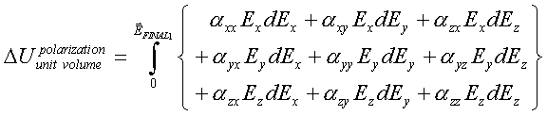

Consider now that you build up the electric field $\vec{E}=(E_{x},E_{y},E_{z})$ in a particular sequence: first you ramp up E_{x}, then E_{y}, and finally E_{z}. Each ramp starts only when the prior one is done. Given this fact,

a) What will the ΔU look like?

b) Now repeat the calculation (obtain ΔU again) by using the sequence E_{y} then E_{x} then E_{z}.

c) By comparing the energies you attained in parts a) and b), and by noting the fact that the energy must be the same (and independent of the path or sequence), argue that this proves that the polarizability matrix (tensor) must be symmetric, i.e., α_{xy}=α_{yx}.

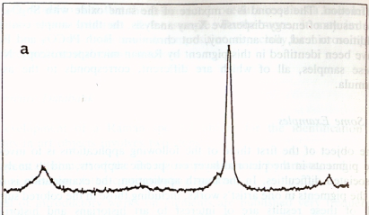
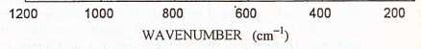
2. A Raman analysis of ink used in a medieval manuscript reveals the following spectrum
Medieval Ink

Utilize web resources to identify the mineral used to create this pretty valuable blue ink.

3. You are in charge of supervising an undergraduate student. In order to teach how to prepare and characterize glasses, you asked the student to melt borophosphate, phosphate and germanate sulfide based glasses. Unfortunately, the student mixed the glasses during the polishing. To identify the glasses, you measured the Raman and IR spectra of the glasses which are presented below
i) By performing a literature review on the web (www.sciencedirect.com for example), can you match the IR and Raman spectra to the glass? Justify your answer
ii) The student prepared multiple glasses in the same glass system. However, you noticed also that the series of glasses present different Raman and IR spectra as seen in Figures a, b and c indicating that the student added an unknown element in the batch changing the structure of the glasses. From the Raman and IR spectra, can you explain how the structure changes when the content of the new element (x) increases? Do you have enough information to discover what was added in the glass network?
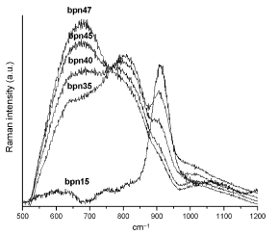
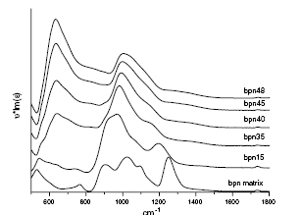
a)

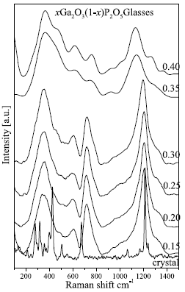
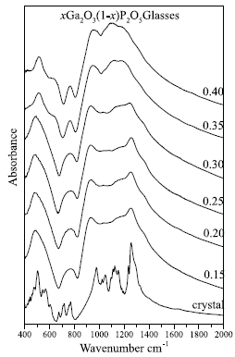
b)

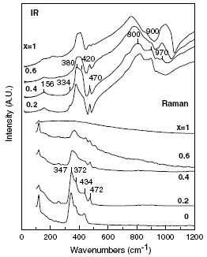
c)

