C.A.R.E.
Conservative Agriculture for Rural Empowerment
IR 322: Poverty and Development
Professor Bruce Moon
Lehigh University
Bethlehem, PA
Project Proposal: Nigeria

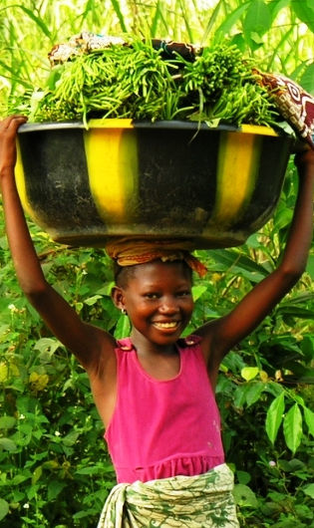

Glen DeVillafranca
Nicholas Lancaster
Daniel Letts
Kate McCarthy
Diego Molina

Table of Contents

Project Overview . . . . . . . . . . . . . . . . . . . . . . . . . . . . . . . . . . . . . . . . . . . . . . . | 4
A Brief Background of Nigeria . . . . . . . . . . . . . . . . . . . . . . . . . . . . . . . . . . . . . | 5
Constraints on Development . . . . . . . . . . . . . . . . . . . . . . . . . . . . . . . . . . . . . . . . | 5
Potential for Development . . . . . . . . . . . . . . . . . . . . . . . . . . . . . . . . . . . . . . . . . . | 8
Our Proposal . . . . . . . . . . . . . . . . . . . . . . . . . . . . . . . . . . . . . . . . . . . . . . . . . . | 11
Conservative Agriculture . . . . . . . . . . . . . . . . . . . . . . . . . . . . . . . . . . . . . . . . . . | 11
The Benefits . . . . . . . . . . . . . . . . . . . . . . . . . . . . . . . . . . . . . . . . .. . . . . . | 13
The Challenges . . . . . . . . . . . . . . . . . . . . . . . . . . . . . . . . . . . . . . . . . . . . . | 16
C.A.R.E.: Conservative Agriculture for Rural Empowerment . . . . . . . . . . . . . . . | 16
Step 1: Preparation . . . . . . . . . . . . . . . . . . . . . . . . . . . . . . . . . . . . . . . . . . . . . . . . | 18
Choosing a Location . . . . . . . . . . . . . . . . . . . . . . . . . . . . . . . . . . . . . . . . . . . . | 18
Selecting a School . . . . . . . . . . . . . . . . . . . . . . . . . . . . . . . . . . . . . . . . . . . . . . | 18
Selecting Crops . . . . . . . . . . . . . . . . . . . . . . . . . . . . . . . . . . . . . . . . . . . . . . . . | 19
Cassava . . . . . . . . . . . . . . . . . . . . . . . . . . . . . . . . . . . . . . . . . . . . . . . . . . | 20
Egusi . . . . . . . . . . . . . . . . . . . . . . . . . . . . . . . . . . . . . . . . . . . . . . . . . . . . | 21
Cowpeas . . . . . . . . . . . . . . . . . . . . . . . . . . . . . . . . . . . . . . . . . . . . . . . . . . | 23
Bambara Bear . . . . . . . . . . . . . . . . . . . . . . . . . . . . . . . . . . . . . . . . . . . . . . . | 24
Further Preparations . . . . . . . . . . . . . . . . . . . . . . . . . . . . . . . . . . . . . . . . . . . . | 25
Implementation . . . . . . . . . . . . . . . . . . . . . . . . . . . . . . . . . . . . . . . . . . . . . . . . . | 26
Step 2: Education and Training . . . . . . . . . . . . . . . . . . . . . . . . . . . . . . . . . . . . . | 26
Step 3: Preparing the Land . . . . . . . . . . . . . . . . . . . . . . . . . . . . . . . . . . . . . . . . . | 27
Step 4: Cover Crops . . . . . . . . . . . . . . . . . . . . . . . . . . . . . . . . . . . . . . . . . . . . . | 27
Step 5: Staple Crops . . . . . . . . . . . . . . . . . . . . . . . . . . . . . . . . . . . . . . . . . . . . . | 29
Cassava . . . . . . . . . . . . . . . . . . . . . . . . . . . . . . . . . . . . . . . . . . . . . . . . . . | 30
Egusi . . . . . . . . . . . . . . . . . . . . . . . . . . . . . . . . . . . . . . . . . . . . . . . . . . . . | 31
Cowpeas . . . . . . . . . . . . . . . . . . . . . . . . . . . . . . . . . . . . . . . . . . . . . . . . . | 33
Bambara Bean . . . . . . . . . . . . . . . . . . . . . . . . . . . . . . . . . . . . . . . . . . . . . | 33
Crop Cycle . . . . . . . . . . . . . . . . . . . . . . . . . . . . . . . . . . . . . . . . . . . . . . . . . . . . | 34
Budget . . . . . . . . . . . . . . . . . . . . . . . . . . . . . . . . . . . . . . . . . . . . . . . . . . . . . . . | 35
Conclusion . . . . . . . . . . . . . . . . . . . . . . . . . . . . . . . . . . . . . . . . . . . . . . . . . . . . | 38

Project Overview
The current state of Nigeria is such that, despite a strong macro economy, Nigeria remains underdeveloped. There is sufficient empirical evidence that Nigeria’s economy is thriving yet over 70 percent of Nigerians are currently living on less than one dollar per day. This paradoxical phenomenon raises the question, "how can this be?" What we find, and what will be proven below, is that this state of vast disparity and inequity disguising what is actually an extremely promising country. While currently most of Nigeria is exceptionally underdeveloped, it has distinct natural advantages rare in the third world. We believe that the most unexplored and underperforming of these advantages is the potential currently dormant in the agricultural sector of Nigeria. Despite 80% of Nigerian land being potentially arable and 70% of the work force being employed in the agricultural sector, inefficient practices, poor rural education and poor resource allocation are holding back this promising sector.
Therefore, in order to take advantage of the vast agricultural potential in Nigeria, we plan to advocate the practice of conservative agriculture through the creation of a farm at a rural school in Kogi State. The practice of conservative agriculture over conventional agriculture has been known to increase both the efficiency and yields of farms over time. The vast majority of Kogi State residents are impoverished farmers that can benefit greatly from the gains associated with this farming technique. As there is generally, however, both a steep learning curve associated with adopting new practices and a hesitance to abandon conventional practices, residents must be shown both the methods and the efficacy of conservative agriculture. Our school, therefore, will educate not only the students, but also the local community in this manner. In this paper, we 1) discuss the constraints and potential for development in Nigeria, 2) review the positive aspects of conservative agriculture, and 3) outline our plan for the institution of a conservative agriculture farm plot.

Definition of Development
We believe that all people should have the freedom and opportunity to improve their own lives and to pursue ends according to their unique personal interests. Hungry, impoverished people have such freedoms and opportunities constrained by the necessity of survival. We have found that these devastating conditions are prevalent throughout Nigeria. Therefore, in order to achieve development in Nigeria our project aims to break the cycle of poverty by empowering rural farm communities and creating new freedoms and opportunities.

A Brief Background of Nigeria
Constraints on Development
Oil and the Patron-Client System
Endowed with what Jeffery Sachs describes as “the curse of natural resources,” Nigeria’s lucrative oil industry comes at an extraordinarily high cost to the people of Nigeria. The expansion and development of Nigeria’s oil industry have caused Nigeria to suffer from the economic phenomenon referred to as Dutch Disease. During the oil boom of the 1970s, the allure of profits from the oil industry fostered an enormous influx of petrodollars to the Nigerian economy. Smith contends that this influx “created an illusion of instant and seemingly unending prosperity,” and so is responsible for the subsequent decline of investment in manufacturing and, more importantly, agriculture. Thus, the economy of Nigeria has become drastically less diverse, wealth continues to be consolidated in the hands of few, and state and local government dependency on the federal government has intensified; each of these quandaries tremendously impedes development.
The overwhelming control elites have over the political, economic and social systems of Nigeria hinders development as it perpetuates Nigeria’s patron-client system and exacerbates inequity. Figure cpi/oil supports this contention as the success of the Nigerian oil industry is directly correlated with the level of corruption in Nigeria, as measured by Transparency International. Planning School proponents Wilber and Jameson contend that elitist ruling classes are fully aware that, “if social and economic development comes, their power, status and way of life will be threatened.” Therefore it is in the interest of Nigerian elites to continue to promote patron-client relations so as to keep the Nigerian populous in a position of inferiority. In what Jean-Francios Bayart describes as “the reciprocal assimilation of elites,” politicians and oil officials regularly, “loot the state in mutually beneficial bargains that unify government and business elites while perpetuating Nigeria’s dramatic inequalities.” Again, inequity allows for the preservation of the status quo and prevents any permanent development; this analysis provides an explanation as to why, despite its promises, the federal government has yet to allocate the resources necessary to stimulate development.
Figure 1 Oil Prices and Corruption
Inequity
Development in Nigeria is hindered by the inequity that is fostered and sustained by the influence of the oil industry and patron-client system. Anand and Ravallion note that, “the importance of growth lies in the way that its benefits are distributed between people.” Concordantly, we believe that an unequal society prevents development by hindering social welfare. Social welfare entails providing society with the opportunity to expand their quality of life in a sustainable manner; when social welfare is absent, the majority of the population cannot free themselves from poverty and thus development is impossible. Inequity manifests itself in a variety of forms from discrepancies in consumption trends and wealth distribution to the promotion of a rural-urban divide and the subsequent effects on education. While each of these indicators is significant, we have found that the rural-urban divide has promoted rural poverty that, in turn, has had dire effects on development.
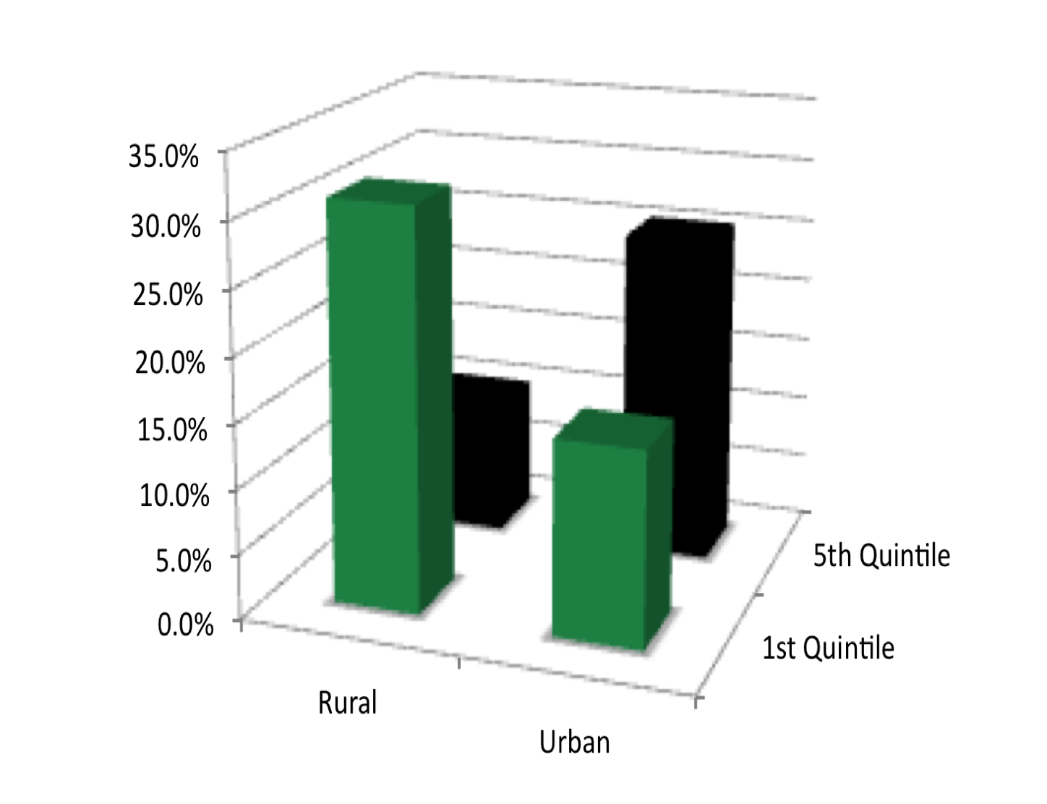
Inequity in Nigeria engenders a rural-urban divide that intensifies the severity of rural poverty. With a great deal of the wealth concentrated into urban areas and the majority of the poorest people living in the much greater rural ambit, analyzing the distribution of wealth in Nigeria by sector offers insight as to why Nigeria is so unequal and ultimately less developed. Figure 2 shows that of those classified as living in the urban sector, only about 15 percent are in the poorest (first) quintile of income distribution. Comparatively, a much larger one third of the rural sector is that same quintile. Income divisions between the rural and urban sectors of Nigeria mirror divisions in revenue allocation by the federal government. This allocation creates “pockets of prosperity” that channel wealth into the hands of few. Consequently, 92 percent of the Nigerian population survives on less than two dollars per day. When survival is one’s top priority, development is nearly impossible.
Figure 2 The Rural Urban Divide in Nigeria

Education
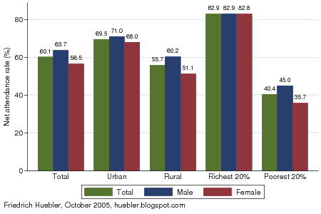
The enormous impact poverty and inequity have on Nigerian education can be most vividly seen through analysis of enrollment rates. As observed in Figure edu by divide, primary education attendance is heavily dependent on income and residence. Nearly 83 percent of Nigeria’s most wealthy population attended primary education institutions in comparison to merely 40 percent of the poorest Nigerian peoples. Furthermore, as shown in Figure 3, 27 percent of the poorest quintile of Nigerians have no education while only 11 percent of the richest quintile of Nigerians have no education. The correlation between income inequity and educational inequity demonstrates that poverty-stricken Nigerians have far fewer opportunities to be educated than the wealthy elite.
Figure 3 Inequity and Education
The current state of impoverishment plaguing rural Nigeria has caused many Nigerians to give low priority to education. Survival, especially in rural sectors of Nigeria, takes priority over education and thus much of the rural population is uneducated. Figure 4 provides an account of the factors that impede primary school attendance in Nigeria as perceived by parents. Parents, for example, among other reasons stated that, “it is no use sending children to school when there is no hope for employment.” It is reasonable to assume that these conditions will persist (and perhaps be exacerbated) for secondary education. The survey also illustrates that poverty is the primary encumbrance to school enrollment as four of the top five impediments to attendence cited by parents reflected monetary implications.

Figure 4 Impediments to Enrollment Survey
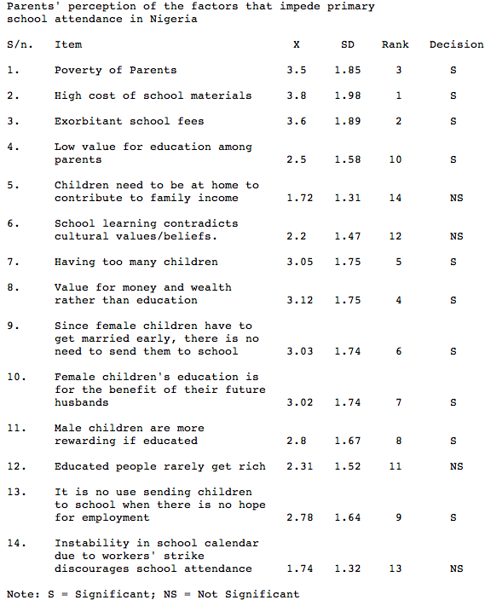
Potential for Development
There is a myriad of means by which Nigeria could begin to develop. As we have maintained, the failure of the Nigerian state and its unassailable linkage to the patron-client system is the greatest impediment to its people pursuing a lifestyle that reflects their own interests, preferences, and needs. Rather than subscribe to fatalist notion of inevitable failure, we find many key elements within Nigerian society that promise real potential to change this situation – potential that is rare in the third world. Conscious of the fact that we are simply five students seeking to assist Nigerian development, we understand that we lack the ability to completely restructure established Nigerian political and economic institutions. Therefore, we have chosen to combat Nigerian underdevelopment by amalgamating two sectors—education and agriculture.

Nigerian Agriculture
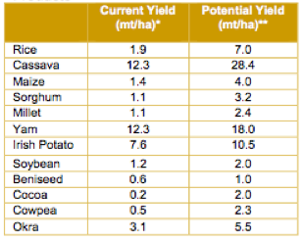
Nigeria’s agriculture sector has prodigious potential. Over 70 percent of the Nigerian labor force is employed by Nigeria’s agriculture sector, over three times any other sector in the Nigerian economy. The diversity of Nigeria’s three agro-ecological zones provides Nigeria the opportunity to produce nearly every agricultural product that is conducive to tropical and semitropical climates. Between 72 and 82 million of Nigeria’s 91 million hectares of land are arable; even the 20 million hectares of land covered by forests and woodlands have the potential to support crops. Astonishingly, while over 80 percent of Nigeria is arable, only one third of this land is actually cultivated. Furthermore, as Figure 5 demonstrates, the potential yield of crops remains significantly higher than their actual yield. Even though, for example, FAO statistics have consistently ranked Nigeria as the number one cassava producer in the world, the current yield of cassava is less than half its potential. This is but one example of how the shortcomings of Nigeria’s agriculture sector are not due to inadequate natural resources or manpower.
Figure 5 Crop Yields
Farming in Nigeria, characterized by outdated techniques and instruments, is typically of the subsistence variety. Farming in Nigeria, characterized by outdated techniques and instruments, is typically of the subsistence variety. The United Nations Development Program currently ranks the soil quality of Nigeria as low to medium in productivity. However, the Food and Agriculture Organization of the UN also contends that most soil in the country would be ranked medium to good if it were managed properly. The mismanagement of Nigerian soil is due, primarily, to the impoverished conditions of most farmers. The vast majority of Nigerian farmers use bush fallow cultivation, a type of subsistence farming in which plots are used for cultivation then left fallow to allow time for topsoil regeneration. Those farmers fortunate enough to have the resources to farm beyond subsistence practice conventional methods such as tilling. For reasons we will fully explain later, both of these methods are inefficient and labor intensive. In order for Nigerian agricultural to reach its potential and directly benefit rural Nigerians, alternative, efficient agricultural practices must be taught, applied and adopted in Nigeria.
Rural Education
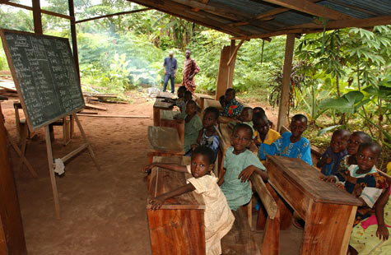
Education is not an end to development; it is a means. Educated peoples possess the knowledge and skills necessary to make informed choices about their futures. As we have ascertained, the greatest impediment to enrollment rates in Nigeria’s rural primary and secondary schools is the fact that the current curriculum has little to no relevance in agricultural communities. As James Lindsey explains, “For the individual family, the belief in the advancement of children through education not only hinders the present individual production and accumulation process, but also…creates a tremendous number of liabilities to the families, in the form of children who cannot function within the existing rural society because they have never learned the required skills within the family and community structure.” In short, for Nigerian families, many of whom are living at subsistence levels, educating children requires enormous sacrifice. Nigerian parents (understandably) do not see the correlation between education and increased opportunity. In order for parents to believe that sending their children to school is worth their sacrifice they must be assured of two things: that their children will benefit from their education and that sending their children to school will not permanently cripple their lifestyle.
Figure 6 bankstreet.wordpress.com
Our Proposal
Having identified agriculture and education as the sectors of Nigerian society with the most potential to stimulate development, our goal was to design a project that had the greatest, most sustainable impact on the rural poor. That being said, we recognize that we are in no position to tackle Nigeria’s problems from a “top-down” approach, nor do we think that this is the proper course of action given the institutions in place. We deduced that the most appropriate means of stimulating development would be a grassroots project, designed for and in the interests of rural Nigerians.
Any development proposal for Nigeria must be attuned to the immediate needs of the Nigerian people. Our research has shown that rampant poverty and poor enrollment rates perpetuate underdevelopment as they cyclically reinforce one another. Concordantly, combating one of these issues but not the other would achieve moderate development at best. Thus we seek to simultaneously tackle both issues by providing incentives for parents to send their children to school and by tailoring the curriculum to rural life in Nigeria. We believe we can achieve this goal through the introduction and implementation of conservative agriculture.

Conservative Agriculture
Conservative agriculture is an application of modern agricultural technologies to improve production while protecting and enhancing the land resources on which production depends. Conservative agriculture relies on three sustainable and environmentally friendly principles: no-tillage, crop rotations, and the usage of cover crops.
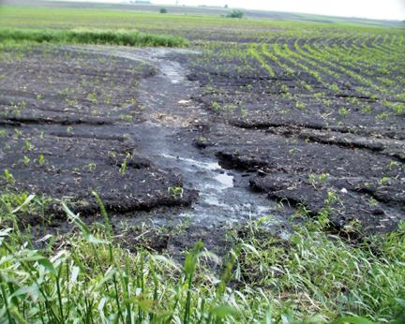
Conventional agriculture is normally based around the principles of tillage and plowing. The use of ploughs and machinery to turn up land before sowing seeds is widely thought to bring higher yields to farmers. While this may be true in the short term, these methods have been proven to reduce soil quality rapidly over time, leading to decreased yields in the medium and long run. Tilling the soil is also extremely labor intensive and expensive, especially for small farmers without adequate equipment. The erosion of soil that occurs as a result of conventional practices also creates a problem that affects both the farmers and the local environment.
Erosion as a result of conventional agricultural practices
Instead, in conservative agriculture, seeds are planted directly into the soil. This not only reduces labor time by avoiding the labor-intensive process of tilling, but also increases the quality of soil. In a soil that is consistently not tilled, residue from past crops decomposes to add a layer of highly nutritious natural mulch. This layer protects the rest of the soil from runoff caused by heavy rains, stabilizes the temperature of the soil, and, perhaps most importantly, helps to retain moisture inside the soil. This layer also becomes a habitat for organisms, ranging from worms to bacteria, that help to fortify the soil by decomposing organic material and incorporating it into the soil. Thus, the soil becomes tilled in a biological sense rather than in a mechanical sense; this process creates a far more sustainable and productive farm over time.
Another tenet of conservative agriculture is the rotation of crops. While conventional agriculture usually designates one crop per plot without variation, in the practice of conservative agriculture, crops are “rotated” around a field from harvest to harvest in order to promote diversification. Because different crops have roots of different sizes and depths, and because different roots excrete various chemical substances into the soil around them, crop rotation allows soil that has been leeched at certain depths to regenerate while simultaneously sustaining new crops. Also, because insect infestations tend to be specific to certain plants, the rotation of crops reduces the chance of losing harvests to pests. Consequently, soil stability and fertility is improved and the amount of labor required is decreased through this process when compared to conventional agriculture.
The third tenet of conservative agriculture is the maintenance of a permanent ground cover. In the period during which conventional agriculture farms are kept fallow, farms utilizing conservative agriculture principles are sown with cover crops. Cover crops are plants sown not for their yield, but rather to prevent erosion and maintain appropriate levels of nitrogen and other nutrients in the soil. They are allowed to grow continuously until one or two weeks prior to the planting of food crops when they are crushed or killed. The residues are left scattered over the soil to decompose and add nutrients into the soil, which assists in the growth of food crops. Like crop rotation and direct planting, cover crops assist in maintaining quality soil conditions from year to year.
The Benefits of Conservative Agriculture
As we mentioned briefly above conservative agriculture has a number of tangible benefits when compared with conventional agricultural practices. Perhaps the most noticeable improvement over conventional agriculture is the increased efficiency of labor. In conventional agriculture the process of plowing and upheaving the land is an extremely time consuming procedure that is absent in conservative agriculture. As FIGURE XX shows, labor hours are dramatically reduced in non-tillage agricultural practices.
Operation | Conservative Agriculture | Conventional Tillage
Knife Roller | 0.89 | -
Direct Seeding | 0.76 | -
Harvest | 0.93 | 0.93
Ploughing/disking | - | 1.37
Leveling | - | 1.38
Conventional Planting | - | 0.89
Ridging | - | 1
Total | 2.58 | 5.57

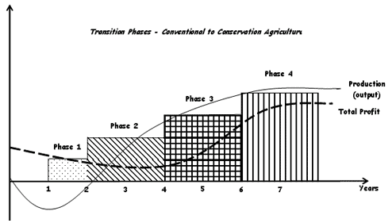
Additionally, long term yields increase as a result of conservative agricultural practices. While short term yields may not show immediate improvement over those of conventional agricultural processes, in many cases long term yields from conservative agriculture plots have been proven to be superior. As detailed by the Food and Agriculture Organization of the United Nations, yields produced by a newly-created conservative agriculture farm are categorized into four stages. In the first stage, while yields stay largely constant, labor inputs are decreased due to the absence of tilling. In the second stage, the crops begin to benefit from improved soil qualities. Yields increase and labor decreases further as weeding and pest control become less necessary. The third stage allows for increased crop diversification through increased farmer experience. Soil fertility and crop yields continue to increase. The fourth and final stage is when the full economic benefits of conservative agriculture are realized. Soil fertility, crop stability, and crop yields reach their apex. At this point, farmers will see a marked increase in the productivity of their fields in conjunction with a significant decrease in labor inputs.
Figure 7 Phases of Conservative Agriculture Adoption

Conservative agriculture additionally benefits the surrounding environment. While small farmers are generally more concerned with economic benefits over environmental ones, it is important to note that the implementation of conservative agriculture will be beneficial, rather than detrimental, to the environment. Conservative agriculture plots absorb more water into the soil, thus reducing runoff and resulting in cleaner water in rivers and other water sources. Increased water intake as a result of no-tillage farming has also been shown to revitalize dried-up wells and other underground water supplies. Additionally, conservative agriculture increases the amount of organic matter in the soil. As a result, more carbon is taken out of the atmosphere and stored in the soil—a process that, if carried out on a global scale, could significantly reduce greenhouse gasses. In all, conservative agriculture can bring noticeable benefits, not just to farmers, but also to the ecosystem in which they farm.
Furthermore, we believe that educating people in more efficient and productive farming methods is an important step towards the greater development of Nigeria. Though seemingly small in scale, the benefits from even a minute increase in household incomes can have a profound effect on the lives of poor farmers throughout the country. When properly applied, for example, income levels have been known to rise to the point where parents who could not previously afford to send their children to school could now do so. As one director of a conservative agriculture program in Ghana noted after the implementation of the new practices, "many of the farmers have acquired livelihood support property such as corn mills and plots of lands, whereas others had been able to put up decent houses." Additionally, due to the high percentage of poor farmers as a portion of Nigeria's workforce, a small increase in the productivity of each farmer would have enormous implications for a country that is currently undergoing a serious hunger crisis. It is possible that if adopted on a larger scale, Nigeria would not only be able to adequately feed its population, but regain its status as a net exporter of food.
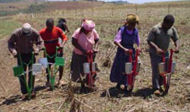
The topographical and geopolitical landscape of Nigeria is especially conducive to conservative agriculture. Physically, Nigeria has a suitable climate (mild, substantial rainfall, fertile soil) and a large amount of unused, arable land. Because conservative agriculture would improve the efficiency of labor, many farmers would be able to expand their plots in order to take advantage of this unused land, with little increase in capital or labor required. Additionally, the lower amount of labor required by conservative agriculture is particularly helpful in a country with high incidences of malaria and HIV. Due to these favorable conditions, it is likely that once the efficacy of conservative agriculture is proven through its practice, it will begin to replace conventional agriculture throughout Nigeria. As this begins to happen, Nigeria will be able to realize the potential of its currently dormant agricultural sector.
Farmers using jab-planters

Challenges of Implementation
Despite the advantages of conservative agriculture in the long run, it is important to note that there are several obstacles that must be overcome for this method of farming to be successful. First, the importance of no-tillage planting must be conveyed to farmers. In many cases, a serious change in mentality is necessary for farmers who have tilled the soil of their farms their entire life, and who associate the neat, rowed, lines of a tilled farm with success and production. Because no-tillage plots do not often produce increased yields in their first one or two years, it requires a leap of faith from farmers to switch from conventional to conservative practices. Additionally, farmers must acquire different equipment. While they may be able to sell plows and other tillage-related equipment that they no longer need to purchase direct seeding equipment such as jab-planters, it is likely that farmers will have to incur a start-up cost to conservative agriculture. Finally, the success of conservative agriculture is directly related to the knowledge and technical familiarity of its farmers. The concept of conservative agriculture is so different from conventional agriculture that its adoption is likely to have a steep learning curve.
C.A.R.E.: Conservative Agriculture for Rural Empowerment
We believe that the best way to overcome these challenges is to establish a plot at a school in Nigeria where students will raise a farm using conservative agricultural techniques. While there are many benefits to this plan, as we will discuss later, two primary benefits will help overcome the aforementioned challenges. First, farmers will see the benefits of conservative agriculture without having to take the risk themselves. Because many farmers in poor countries rely on their farming for survival, they are unlikely to take on any sort of a risk or make any dramatic adjustments to their practices. By using the school as a demonstration plot, however, farmers will see first-hand that conservative agriculture is more efficient, less labor intensive and more sustainable; alleying their fears and making the transition to conservative agriculture more likely.
Moreover, the school will provide the education and training that is often seen as an impedement to implementing conservative agriculture. The school's farm will serve two purposes in educating the community. First, the school will teach these techniques and its benefits, through hands on practice, to children going through the school. This will provide practical and useful education to the children, educate succeeding generations in better agricultural practices, and demonstrate the relative ease of such techniques. Adults can also be educated at the school. Because the farm will already be established and functioning, and because implementation of the practices across the region would benefit all involved, it will be both easy and useful to use the farm to educate interested farmers in the skills and techniques required to successfully implement these techniques.
The benefits of establishing a conservative agriculture farm at a school go beyond promoting community implementation. For the children of the school, the farm would provide two benefits. Through hands on, non-traditional education students will gain valuable skills applicable to rural life. This type of education is exceptionally beneficial in the developing world as, while useful, the applicability of formal education may sometimes be wanting in areas with few white-collar job opportunities.
Additionally, by managing, cultivating, and eventually harvesting a farm on the school grounds, the students will be providing themselves with day-time nutrition that is often absent in schools. The harvested crops could be used for lunch or snacks to be distributed throughout the day. Providing sustenance to children during the school day not only provides obvious nutritional benefits absent in the country and an incentive to attend school, but also increases the effectiveness of the schooling.

Step 1: Preparation
In order to achieve the benefits of conservative agriculture discussed above, it is necessary to account and plan for a number of variables that will contribute to the success or failure of such a program. Accordingly, we must first determine where such a farm can be successful, understand what crops are best suited to the program, plan out the logistics of starting and managing a farm of this type, and account for all costs, both in money and labor. Throughout each of these analyses it will be important to appreciate and account for the cultural and social nuances of the people involved. While this may be difficult from a western perspective it is necessary as such details, if unaccounted for, could cripple such an operation.
Choosing a Location
The success of any agricultural project is naturally contingent on location, and, even though conservative agriculture has been proven effective in most environments, the necessity of initial success to prove the long term viability of such a program means that location, too, is extremely important for our project. A poorly chosen location could jepordize the optimazation of the demonstration plot, leading to poor harvests and subsequent resistance from the local communities and farmers.
For Nigeria, we have determined that while most of the country will take well to these techniques, the Kogi state is an ideal location. This is because Kogi combines a number of important variables that would make the project most impactful. It is mostly rural, in southern half of the country (and thus absent the constraints of Sharia law), extremely impoverished (optimizing value-added and the impact of small, initial successes), receives moderate rainfall and is thus absent extreme erosion or degredation, is not exceptionally hilly or mountainous and has adequately fertile soil. Additionally, the vast majority of Kogi residents are poor farmers who would benefit greatly from more efficient farming techniques. All of these factors will not only make the project more likely to succeed but also, because of the extreme poverty of the region, magnify the results of a successful farm.
Selecting a School
It is also then important to determine what sort of a school will be the best candidate to cooperate with. While at first glance it might seem that any school would do, there are a number of characteristics that we will look for. Foremost, the curriculum of the school must promote ideals consistent with our definition of development. This project must help people acquire a set of skills to increase their access to opportunities. It is important to emphasize that this program should supplement the existing curriculum, not replace it. It follows that the staff of such a school must be open to receiving the technical training that our program would provide and willing to implement educational training programs about conservative agriculture into the curriculum.
For our purposes, the ratio of students to usable land does not need to be accounted for when selecting a school. This is because our project can adjust to variations in these factors and still achieve the primary goal of educating and raising awareness about the benefits of conservative agriculture. Though a school with more available land per student will be able to feed each student more, a school with a large number of students and only a small plot available for cultivation will still effectively accomplish the higher goal of education through the demonstration of improved farming techniques.
Selecting Crops
The first step in preparation will be to select what crops will work best. It is important to select crops that are grown easily in the area, are easy to harvest, produce significant yields, have multiple uses once harvested, have varied root depths, are diverse, have a variety of nutrients, are cheap and fit well together into an efficient and manageable crop cycle. Though conservative agriculture is proven to work well with most crop types, the selection of which crops work best together is enormously important to our specific project. That is because our project will be, at least partly, managed by staff and students and the proliferation of conservative agriculture throughout the community is especially dependent on the success of the initial years of harvest.
The crops we have chosen are well known both internationally as staple “African” foods and more locally as principal regional crops. They have all been chosen in recognition of the three sustainable and environmentally friendly principles of conservative agriculture – no-tillage, crop rotation, and the usage of cover crops – as well as many of Nigeria’s most fundamental problems.
Given our desire to institute this farm on the grounds of a school, in choosing which crops to have the children focus on, there were many vital considerations to bear in mind. For instance, the most intensive labor, during the planting and harvesting seasons, must align with the school’s calendar to ensure proper attention and care is being paid to these crucial periods. Furthermore, because the primary purpose of this project is to teach conservative agriculture to students and not to use them merely as a source of labor, the crops that are chosen should not be particularly labor intensive.
Another important determination was that the crops should provide an important source of nutrition for children who, in many cases, are malnourished. The straightforward, relatively undemanding post-harvest uses of the crops chosen provide great benefits to children who often may not eat from the time they leave home in the morning until the time they return in the late afternoon. As noted by Lynn Parker, “[Vitamin] deficiency and anemia lead to shortened attention span, irritability, fatigue, and difficulty with concentration. Consequently, anemic children tend to do poorly on vocabulary, reading, and other tests.” With this in mind, nutritional value was among our highest priorities when choosing crops for our project.
We have chosen four crops that best meet the requirements listed above. For Kogi state, we have determined that cassava, egusi, cowpeas, and bambara are best suited for our project.

Cassava
o Botanical Name - Manihot esculenta
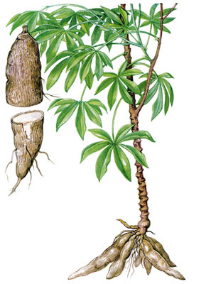
o Nigerian Names – cassava, akpu ugburu
Nigeria is the world's largest producer in Cassava and, as a highly nutritious, easily grown and renewable crop, its incorporation into our farm is as necessary as it is obvious.
The nutritional benefits of Cassava are two fold. First, the large, white, tuber-like root is one of the best sources of carbohydrates in the world. It is also rich in calcium, phosphorous and vitamin C. Additionally, the above ground leaves of the cassava plant are edible and good sources of protein; thus making the crop, overall, an extremely valuable source of nutrients for students. There are also many different varieties of cassava that can be used, but given their yield potential, rate of growth, and susceptibility to pests and diseases we have identified NR 8082 to be the most appropriate variety for Nigeria, and the Kogi state more specifically because of their fast growth rate, high yield potential, ground storability, and tolerance to major diseases and pests.
Following the harvest, there are more ways to prepare cassava than can be mentioned. For our purposes, we feel that processing it into lafun (cassava chips) would be the easiest and most useful method, increasing the usual shelf life from only a few days up to one year. The preparation of lafun first involves peeling the roots and steeping them for three to four days (until the roots become soft in texture). Subsequently, the roots are cut up to small pieces and sun dried. The purpose of this practice is to increase the surface area and thus allow them to dry faster. Nigerians dry the lafun by utilizing leenga, a wooden platform raised on wooden poles approximately 1.5 to 2 meters tall, or drying them on the roofs of houses. The drying process takes two to four days, depending on the climatic conditions. Once this is completed, lafun can be stored on traditional Kanbon and indoors in jute sacks, among other methods. When ready to consume, lafun is ground up into flour and mixed into a paste with hot water, making fufu. This method of cooking cassava roots is the easiest for children to partake in, will last the longest, and is easiest to prepare as for food. Additionally, cassava leaves can be eaten as green vegetables, accounting for a rich source of protein, usually lacking in Nigerian diet.

Egusi
o Botanical Name - Citrullus lanatus (Thunb.) Matsum. & Nakai var. lanatus
- Nigerian Names – egusi, guna shanu (Hausa); deene nai (Fulani); ibara, bara, ito (Yorbuba)
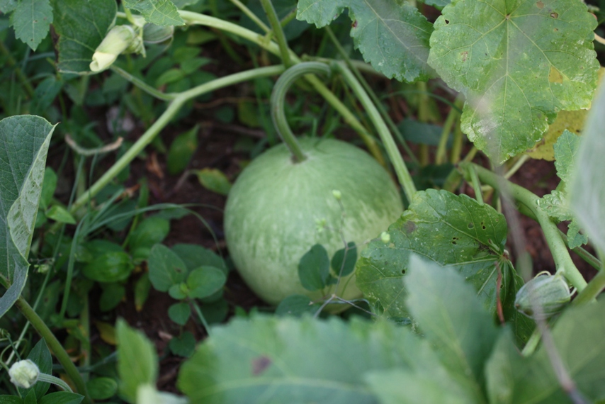
In our decision to include egusi as part of the plot’s diverse set of crops, we were particularly impressed with how much nutrition and yield came from a crop that was so simple to cultivate and harvest. Despite its striking resemblance to a watermelon, egusi plants are neither red inside, nor sweet. In fact, the dry, white interior is regarded as so bitter, even some animals are repulsed by it. Yet for all that egusi is not, the white seeds it produces, larger than those of watermelons, are exceptionally nutritious and capable of seemingly endless uses. Another benefit of the egusi plant is that its seeds require little to no preparation before they can be consumed. One of the main uses of egusi seeds in Nigeria revolves around their function once they are separated from the pulp of the vegetable and parched. They are commonly eaten as a snack, similar to that of sunflower, squash, or melon seeds. Both the ease of preparation and the high nutritional value of egusi make it extremely valuable in a school where many students lack proper nutrition.
The National Research Council’s Panel on African Fruits and Vegetables notes about egusi, “It doesn’t take much of any food that is half oil and almost a third protein to provide the calories and amino acids that stressed, sick, and fast-growing bodies need each day” (157). The levels of oil, in particular, are exceptionally high relative to other foods, rivaled only by peanuts. In comparison, soybeans offer approximately 18 percent oil of the oil egusi does. As a highly polyunsaturated lipid, oil provides extraordinary benefits, making the high levels found in egusi extremely benefitial. Further, the high levels of protein (nearly 30 percent) will provide additional nutrition. John Cherry, the research leader of a USDA team of scientists researching the seed’s nutritional advantages reported that, “The essential amino acids in the proteins of the flour make it a good vegetable protein” (158).

Cowpeas
o Botanical Name - vigna unguiculata
Cowpeas are also great source of nutrition and are easily grown. They provide significant amounts of vitamins A and C, calcium, iron and fiber. They are also a great source of protei with up to 24 percent protein and 2 percent oil. Another great advantage of this legume is its versatility, given that it “can be consumed at different stages in ts development: fresh green leaves, dry leaves, green pods, green beans, or dry grain.“ The plant is also well adapted to the climate and soil conditions in Nigeria, the largest producer and consumer of cowpeas in the world.
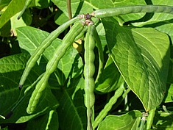
Cowpeas are also more resistant to disease than other comparable crops. Recently, the International Institute of Tropical Agriculture (IITA) in Nigeria has developed two new varieties of improved cowpeas. One of them, now referred to as SAMPEA-11, “has a combined resistance to major diseases including septoria leaf spots, scabs, and bacterial blights, as well as to nematodes, and improved tolerance to Nigeria’s strain of Striga gesnerioides (a parasitic weed that severely lowers yield.) It also has a yield advantage of at least 80% over local varieties.“ Although unimproved cowpeas exposed to insects, parasites and weeds usually yield 100 to 300 kilograms per hectare, the better management practices characteristic of conservative agriculture offer potential yields from 500 to 1,000 kilograms per hectare.
The simplest form of cooking cowpeas is by soaking them in a pot with water overnight as to soften them. Another traditional Nigerian food made from cassava is kosai or akara (bean cake). The preparation of cowpeas is exceptionally simple, making this crop ideal for feeding large numbers of students.

Bambara Bean
o Botanical Name – Vigna Subterranea (L.) Verdc.
o Nigerian names – epi roro, guijiya, gujuya, okboli ede
As with other crops selected, the main reasoning employed for the inclusion of bambara was its immense nutritional potential. Despite conventionally being classified as a bean, it is similar to the peanut in almost every aspect including that its seeds are pulled from the ground. Bambara is regarded by Nigerians as exceptionally tasty and its nutritional benefits are well understood.
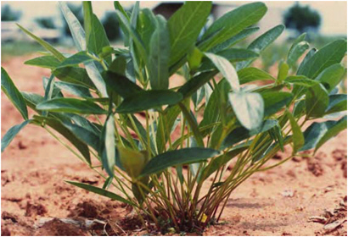
Like egusi, bambara beans offer a wide range of potential uses, all perfectly reasonable for a school to translate into a finished product ready to consume. The beans can actually be eaten fresh, but the most preparation is to simply boil the beans whole. Their natural flavor, similar to a garden pea, allows for such a rudimentary process to be all that is necessary in their preparation. Depending on preference, once the beans are boiled, they can also be roasted or even crushed into a paste-like substance and fried. These basic methods are ideal for a school in which the beans can be used as a healthy midday snack complete with nutrients vital to any Nigerian, particularly developing children.
The nutritional potential bambara offers is so great that the National Research Council’s Panel (NRC) on African Fruits and Vegetables emphatically notes that the plant, “is a rare [example] of a complete food. It has such a nice balance of nutrition that people supposedly can live on it alone” (14). Moreover, “the plant has the potential to cut to the heart of Africa’s great humanitarian problems” (56). Ripe or immature, the beans offer such a complete package of nutrients, its inclusion as part of the school-farm is straightforward to understand. Bombarsa beans are over 60 percent carbohydrates, 20 percent protein, 6 percent oil, and a variety of other vitamins and minerals including calcium, iron, zinc, vitamin A, and the amino acid, methione. This essential protein is the body’s main provider of sulfur and thus, makes bambara’s generous supply all the more attractive. Arguably more important than these nutrition facts is the reputation the plant has for being quite filling. “Its nutritional energy (per 100g) has been measured at 367-414 calories, an amount greater than that of common pulses such as cowpea, lentil, and pigeon pea.” (61)

Further Preparations
Because our opportunities to acquire tools and equipment once on site are limited, it is necessary to make arrangements for the purchase and transportation of all necessities beforehand. For the delivery of equipment to rural Kogi state, we have determined that it is easiest and most cost effective to purchase most items from the nearest city, Lokoja. Other, more difficult to obtain, equipment such as jab-planters will most likely need to be imported from abroad. Numbers of required equipment are variable on the size of farm plots and should be adjusted accordingly. In all, for a one-hectare plot evenly divided between four crops, we will require the following equipment:
- Jab-Planter 6
- Rake 6
- Trowel 10
- Shovel 4
- Watering Buckets 18
- Fertilizer 400kg
- Storage 24 bags
- Cassava stalks 15 bundles

On a yearly basis we will require:
- Egusi Seeds .625 kg
- Cowpea Seeds 18.75 kg
- Bambara Seeds 12.5
- Sorghum-Sudangrass Seeds 15 kg
Implementation
Step 2: Education and Training
Once a site is selected and arrangements have been made the next step will be to educate staff, volunteers, and all involved in the techniques and skills required to manage a conservative agriculture farm. The main challenge to establishing a conservative agriculture farm at a school is management. While the physical planting, cultivation and harvesting (particularly with the crops we have selected) is quite easy, management is relatively technical. This will be the most important part of our project because the short term success and long term sustainability of the plot will be completely dependent on staff.
We will first instruct school staff and volunteers in the merits and techniques of conservative agriculture. Explaining the new farming techniques like direct seeding, cover crop use and crop rotation will be the first steps. From this it will be explained why variations in plant types, root depths, yields, and harvesting methods are important. The crop cycle we will use on the school's demonstration plot will be an excellent example of this and the hands on practice that will follow will strongly reinforce these lessons. Additionally, we will establish modes of communication (phone, email, written letter) between the school and ourselves so that if any problems, questions or concerns arise in the future we will be aware and able to address and support the program from abroad—solidifying our committment to a long-term relationship.
Once the staff is fully educated in the practices, intricacies, and concepts of conservative agriculture it will be important to assist them in implementing these lessons into the school's curriculum. This will include lesson plans ranging from the basic concepts of conservative agriculture to the details of designing crop cycles. The complexity of these lesson plans will range corresponding to the level of education. For example, young children in basic levels of education will be introduced to the ideas of conservative agriculture that are fundamental are easy to grasp - like preventing erosion, saving time and direct seeding, while older students will be introduced to the benefits of biodiversity, the use of the decomposition of cover crops as mulch and the economic benefits of such methods. Additionally, lesson plans should include a substantial level of hands on training for the students where, depending on age and ability, students will manage different aspects of the farming.
After the general training of the staff it will be useful to hold workshops or seminars for interested members of the community. Because Kogi (and much of Nigeria and West Africa) is agrarian and, no doubt, farming methods have not changed recently and are relatively entrenched in society, there is likely to be concern or resistance from the community. At such workshops the lessons will be two fold. First, the focus will be on educating the community on the merits of conservative agriculture with an emphasis on why long-held conventional practices such as tillage are reducing the potential of their farms. It should be conveyed that the adoption of these techniques throughout the community can have enormous payoffs in the medium and long term both for the farmers and the environment in which they live.
Additionally, it will be important to explain that our plan is to establish a demonstration plot. We will not be forcing new farming methods on the community but simply providing valuable life skills to their children, teaching them basic farming techniques and lessons while at the same time providing them with some form of nutrition during their school day. It should be made clear that this is not a win-lose prospect for them or their children. While the worst case is that their children get practical education and a snack at school, the best case is that they are introduced to an enormously efficient and revolutionary method of farming that is cheap, less labor intensive and better for the environment.
Step 3: Preparing the Land
At this point, because all of the preparations have been made and all parties are sufficiently educated, farming can begin. The first step will be to prepare the land for cultivation. As discussed above, conservation agriculture requires little preparation and zero tillage. It would be beneficial in the early stages, however, to weed the plot, remove any rocks or clay and, if extremely compacted, rake some of the top layers of soil. This will not be universally applicable to all schools as an ideal selection would have an available plot that is already prepared for farming. Fortunatley, any topsoil preparation that is necessary will only have to be done at the very early stages because as conservative agricultural takes root, soil is naturally made increasingly stable and conducive to growing.
Step 4: Cover Crops
As one of the three main pillars to conservative agriculture, the proper usage of cover crops are essential to providing the crops that follow the proper nutrients. As stated by the FAO, “Cover crops improve the stability of the CA system, not only on the improvement of soil properties but also for their capacity to promote an increased biodiversity in the agro-ecosystem.” In order for cover crops to serve their function as an organic mulch or fertilizer, we must take into account a number of crucial factors whose implementation is the main determinant in how successful the subsequent yield of staple crops is.
For instance, the cover crops must be grown to a point near full-flowering and then quickly "controlled". Controlling involves either hacking, crushing or breaking the stem, in order to kill the plant and thus initiate the composting cycle that will convert it into fertilizer for the main crops. It is imperative this action be conducted at the appropriate time to ensure the regeneration of the cover crops does not take place in the case of premature “controlling” or total germination if it was to be delayed too long. Regeneration will prevent the successive crops from growing in that space and germination will expend the nutrients otherwise being deposited into the soil.
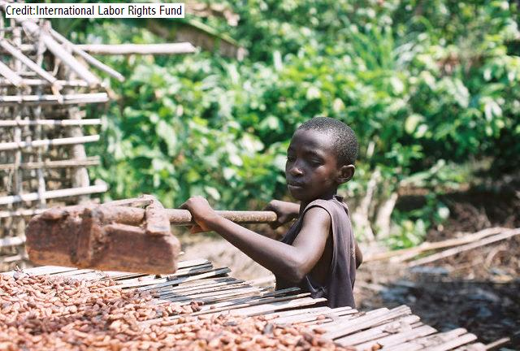
For the first few cycles, it is vital to choose a cover crop that deposits an abundant amount of residue onto the soil surface. This factor is determined through a plant’s given biomass, or the amount of biological matter derived from an organism either still living or recently passed. As an extension of this, the biomass must be decomposed slowly so as to continuously have a layer of cover still enriching the soil with nutrients. We determined this by choosing a cover crop in possession of a high C/N ratio. This is because the soil microbes used to decompose the crop residue employ Nitrogen to assemble the nutrient tissue using energy supplied by Carbon. The presence of a high C/N ratio forces the microbes to gather the necessary levels of Nitrogen from surrounding environments. Thus, the crop residue takes longer to decompose, concurrently serving as a weed-suppressant for this extended period of time.
Under these conditions, the most fitting crop family to utilize is grains/cereals. Legumes such as vegetables, while advantageous in their own way, do not present any tangible benefits until multiple cycles of soil enrichment have occurred. Therefore, we chose sorghum-sudangrass as the school farm’s cover crop.
Sorghum-sudangrass is a fast-growing hybrid or two of the world’s best known grains. This crop can grow to cover a large plot of land in a time far shorter than similar strains. In the process, it adds a great deal of biomass to the soil through its sheer height of roughly 5-12 feet. Ideally, this would yield 823 kg per hectare. Further, with its implementation, the farm would mark a 94% reduction in weeds compared to an equally plot without cover crop.
Propagating a component so crucial to the success of our crop rotation must be done rather carefully. To begin, 10-20 kg/ha must be directly implanted 1-5 cm into the ground in a fashion similar to our staple crops. The spacing of the seeds will not have a marked impact on biomass yield, but narrower rows would certainly be beneficial.
Approximately 17 days following its sowing, sorghum-sudangrass is expected to reach the proper stage of flowering in which to cut it down. To ensure the dead mulch covers the soil for as long as possible, the cover crop “control” will be completed using .

Step 5: Staple Crops
When the land has been sufficiently prepared and cover crops have established a substantial layer of residue direct planting of the staple crops can begin.
The benefits of conservative agriculture will prove enormously beneficial in this stage. Because labor is not very intensive for conservative agriculture, and because we have selected crops that are easier than most to plant, we believe that, under supervision, most of the farming can be done by students. It is important to note that this is also where the quality of the training will show. If teachers and volunteers are well trained, managing the farm will be exponentially easier and, overall, the farm will be successful.
We selected the crops that we did not only because of their enormous nutrional benefit, but also because they are relatively easy to farm and grow exceptionally well in Nigeria. Here we outline the farming and cultivation procedures for our plants:

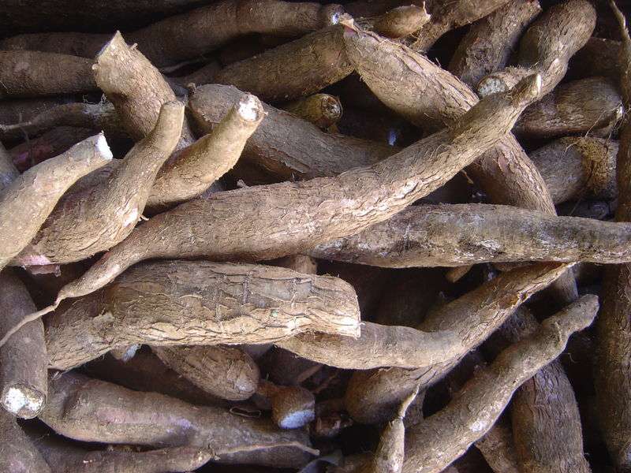
Cassava
We will require 15 bundles of cassava stems to plant one fourth of a hectare¹. Cassava is to be planted at the beginning of the rainy season for better results (if growth without prior cover crop disemination). Planting cassava at an angle provides for compactly arranged roots and thus we will be choosing this particular placement. If the cassava is planted as a sole crop, they grow best when planted one meter apart.
Cassava is ready to be harvested between 9 and 12 months (November to February). To remove the tuber simply lift the inferior part of the stem and pull the roots out of the ground. Subsequently, remove the roots from the base of the plant.
Cassava can be propagated by cutting the stems and replanting them, and it is important to pick healthy cassava stems to replant as to not propagate diseases and pests. Healthy cassava can be identified as those having “robust stems and branches, lush foliage, and minimal stem and leaf damage.” If some of the cuttings are slightly infested, submerging them in warm water for five to ten minutes before planting them can kill the pests on the surface. Cutting the middle brown-skinned section of the stem at least 20 to 25 centimeters long (having around five to eight nodes) will also help ensure a healthier cassava plant. Handling the stem cuttings carefully is imperative, as to not bruise the nodes. This can be accomplished by packing then with dry leaves while transporting them.
Cassava plants in Nigeria yield about 14.7 metric tons per hectare. Using certain varieties like NR 8082 can help ensure such high yields.
The pealing of the 14.7 metric tons of cassava roots will require 588 labor hours given a 25 kg per hour per person yield if done by hand, not counting the labor hours required for slicing. Utilizing a mechanical, pedal maneuvered, slicer will yield 500 kg of chipped cassava per hour and thus 29.4 labor hours will be required to process the 14.7 metric tons. If the slicer mechanical slicer is used for three hours per day (by different students at a time) then the slicing and cutting will be completed in 10 days. Elder students will be in charge of using the machine while the youngest ones dry them out in leenga and store them in Kanbon and the rest of the eldest and the middle aged students harvest cassava according to the rhythm dictated by the mechanical slicer.

While the older students focus on the pealing and slicing, the youngest ones can focus on the drying process while the middle-aged ones partake in the harvesting. All of the cassava will not be harvested at once but rather will be removed on a daily basis as to prevent the degradation of cassava that might be extracted and not pealed.

Egusi
After the cover crop is controlled and its residue has sufficiently decomposed, egusi seeds will be directly sown into the soil by hand or using a jab planter. Most of the actual planting is done following the first few heavy showers of the rainy season. Generally, two or three seeds are placed in holes around 2 cm deep. They are spaced about 1 meter apart in order to ensure the growth of two plants per hole. When considering one-quarter of a hectare of land, approximately .625 kg of seeds will be needed to plant. With assistance organizing and spacing, the planting of these seeds is very simple and can be managed by most students.
Most seeds germinate within a week and seedlings begin to emerge. Flowering starts about three weeks later when the vines nearly cover the ground. The plant is then ready to harvest anywhere from 120-150 days, or 4-5 months and typically yields five fruits per plant, or more importantly, 300-350 seeds per fruit³. To do this, the fruit must simply be picked from the vine which then withers and dies. This is, too, a very easy process that most students could handle quite easily.
For our purposes regarding conservative agriculture, egusi is especially useful. First, the withering of the vines post-harvest will contribute to the fertilization of the soil in the same way cover crop residue does. Also, egusi has a very deep root system. This both adds to the diversity of the crops in the crop cycle, increasing the overall fertility of the plot, and means that egusi is more easily raised as it requires less rainfall than most crops. Because the egusi plant naturally suppresses weeds it only requires mild maintenance during the first month. Additionally beneficial is that the timing of harvest is of little importance, however, as the mature crop can, within reason, remain in the field for some time without serious loss.
As the real benefit to farming egusi is found in the seeds, they must first be separated from the bitter pulp of the fruit itself. Fortunately, there are two rather simple, traditional methods to do this. The first of these is to use a hard stick to split the fruits open, laying the pieces on the soil pulp-side down for several days. This allows the pulp to decay, freeing the seeds in the process. The other method is to simply bury the fruit whole once it is harvested, leaving the outer shell and pulp to decompose over the course of a month. Choosing which technique to use is dependent on the most ideal time to consume the seeds.
Following either of these, the seeds are easily separated by hand or running water and laid out to dry in the sun. This is the only step necessary in preparing the seeds for consumption as a snack. Because egusi seeds contain no anti-nutritional ingredients (FOOTNOTE?), they can be consumed once the shell has been peeled away from the kernel. Another advantage to choosing to cultivate egusi is that the seeds can be stored for long periods of time without particular trouble from pestilence of degradations (BASICALLY THE SAME SENTENCE – CITE AGAIN?). In fact, if the supply is large enough, it can theoretically be stored and used as food year-round. Considering the length of the school year, as well as the rather short time for maturation, this advantage is particularly enticing.

Cowpea
The cowpea is to be planted in late August for best result. 18.75 kg of cowpea seeds are needed for planting one fourth of a hectare.⁴They can be planted in flat seedbeds with two seeds per hole spread 50 X 75 centimeters apart from each other and dug four to five centimeters deep.
After being planted cowpeas plants should be thinned on a biweekly basis. Harvesting of cowpeas occurs when the cowpea pods are dry, usually coinciding with the advent of the dry season. Dry pods should not be left on the field for more than two weeks after they have matured as to prevent the degradation of the cowpea.
Subsequently cowpeas are left to dry on an open hall. In regards to storage, the IITA has instructed farmers in Nigeria with triple bagging techniques. Initially, the cowpeas are put in a bag that is firmly sealed by tying it with twine. The second bag is then used to completely enclose the first one and is tightly wrapped as well. The same is done with the third one.⁵

Bambara Bean
The propagation of bambara beans is similar to that of egusi in that most farmers sow the fields relatively early in the rainy season. Two to four seeds are usually planted into a hole approximately 5 cm deep and, on average, 12.5 kilograms of bambara seeds are required for farming one fourth of a hectare⁶. Optimal spacing can range from 40x25 cm to 60x60 cm.
Germination usually takes places within 7 to 21 days. Full maturation then occurs anywhere from 90-180 days, with harvesting being achievable in 130-150 days, or about 2 months after the pods first appear. Depending on the intended use of the harvest, bambara beans are advantageous because precise timing is not necessarily important. They can be gathered early or late without serious consequence. However, considering our desire to utilize the crops as a midday snack, the beans must be harvested prior to yellowing of the leaves. In gathering the harvest, the entire plant is pulled out of the ground, with most pods remaining attached to the root. The roots, on average, extend from 0.1 mm to more than 1.9 mm, making it relatively short in comparison to other roots we will use.
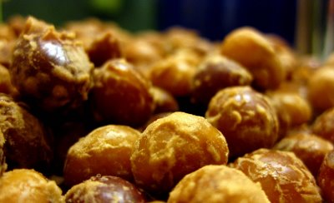
The most intriguing aspect of bambara bean farming is the variations different farms have experienced with yield. On average, it produces 560 kilograms per hectare of dried seed, but has the potential to dramatically increase this number. In countries that utilize more efficient agricultural techniques, yields per hectare improve to over 5,000 kilograms. Such advances can be realistically expected under the improved techniques of conservative agriculture. As stated by the NRC in regards to the employment of these enhanced methods, “The effect would in fact be revolutionary” (58).
Crop Cycle
The third major tennent of conservative agriculture is the design and management of a crop cycle. Crop rotation maximizes the quality of the land, preventing erosion, loss of nutrients, and the spread of weeds, among other things. As observed from the two-year crop rotation chart, crops are grown, harvested, and cover crops are then introduced during fallow periods. After a full harvest rotation, spanning from May to February, crops are rotated among the hectare. Roughly speaking cassava will be grown where cowpea was growing and vice verse. Accordingly, bambara and egusi will switch locations. It is important to note that cowpeas are now introduced (from February to April) at the bambaras’ and egusis’ location as to prevent a fallow period. Here, cowpeas can work both as a cover crop, because of their high nitrogen content, or as sources of food depending on food necessity and soil quality.

January |  | February | March | April |  | May | June
2nd term |  |  |  | 3rd term
 |  |  | cowpea
 | (harvest) |  | (plant) |  |  | (harvest)
 | cowpea |  |  |  | egusi
(hvst) |  |  |  |  | (plant)
 | cowpea |  |  |  | bambara
(hvst) |  |  |  |  | (plant)
 | cowpea |  |  |  | cassava
(hvst) |  |  |  |  | (plant)
July | August | September | October |  | November | December
 |  | 1st term
sorghum | cowpea |  |  |  | sorghum | cowpea
 | (plant) |  | (hvst) |  |  | (plant)
 |  | sorghum | egusi
 | (hvst) |  | (plant)
 |  | sorghum | bambara
 | (hvst) |  | (plant)

January |  | February | March | April |  | May | June
2nd term |  |  |  | 3rd term
 |  | sorghum | cassava
 | (hvst) |  | (plant)
 | cowpea |  |  |  | bambara
(hvst) | (plant) |  | (hvst) |  | (plant)
 | cowpea |  |  |  | egusi
(hvst) | (plant) |  | (hvst) |  | (plant)
 | sorghum | cowpea |  |  |  | sorghum
(hvst) |  | (plant) |  |  | (hvst)
July | August | September | October |  | November | December
 |  | 1st term
 |  |  |  |  |  | (hvst)
 |  | sorghum | bambara
 | (hvst) |  | (plant)
 |  | sorghum | egusi
 | (hvst) |  | (hvst)
cowpea |  |  | sorghum |  | cowpea
(plant) |  | (hvst) |  |  | (plant)

Budget
Throughout the formation of our project we kept in mind the availability of monetary resources, cutting down costs as much as possible when possible. By doing so we have managed to put together a plan that is economically feasible and thus appealing to prospective investors. Our projected initial cost is $2,867.82 while our annual cost is merely $110.25.
Budget: Initial Cost
Goods | Costs
15 bundles of cassava cuttings (only first year) | N 3,750 |  | $25.13
24 bags of cowpea, egusi, and bambara storage | N 604.48 |  | $4.02
18.75 kg of cowpea seeds | N 2,250 |  | $15.00
12.5 kg of bambara seeds | N 9,375 |  | $62.50
400 kg of NPK fertilizer per hectare | N 6,000 |  | $40.20
.625 kg of egusi/melon seeds | N 1,447 |  | $9.61
6 jab planters | N 112,777.5 |  | $750.00
6 rakes | N 17,430.89 |  | $115.92
4 shovels | N 6,315.54 |  | $42.00
10 trowels | N 7,518.5 |  | $50.00
18 watering buckets | N 6360.65 |  | $42.30
Mechanical Pedal Maneuvered Slicer | N 97,740.5 |  | $650.00
Cooking Utensils | N 90,222 |  | $600.00
15 kg of sorgum & sudingrass seeds | N 3,479.56 |  | $23.14
6 Crop Cutters | N 65,862.06 |  | $438.00
Total | N 431,234.09 |  | $2,867.82
Budget: Yearly Costs
Goods |  | Goods
18.75 kg of cowpea seeds |  | N 2,250 |  | $15.00
12.5 kg of bambara seeds |  | N 9,375 |  | $62.50
.625 kg of egusi/melon seeds |  | N 1,447 |  | $9.61
15 kg of sorgum & sudingrass seeds |  | N 3,479.56 |  | $23.14
Total |  | N 16,578.29 |  | $110.25

Conclusion
The formation and preservation of conservation agriculture in Nigeria will have multifaceted impacts on Nigerian development, particularly within the rural sector. In order for development in Nigeria to occur, institutions must be customized to suit the needs of Nigerians. Establishing a small farm at a rural school will have extensive long and short term impacts on the lives of those currently classified as the “rural poor.”

While we cannot predict the extent to which yields will increase over time, even gains well short of the most successful case studies will have a dramatic effect on the lives of poor farmers making less than two dollars per day. In the short term, produce harvested at the school will provide students with a nutritious, filling snack. Additionally, supplementing traditional curricula with the study and practice of conservative agriculture will simultaneously provide students with basic education as well as a skill set relevant to their current lifestyle.

As we have ascertained, farms of all size can easily practice our proposal. We recognize that adopting alternative methods of agriculture is an extremely risky investment, especially for those currently practicing subsistence-style farming. The proper execution of conservative agriculture as we have outlined will corroborate the efficacy of conservative agriculture.

We are confident that the adoption of conservative agriculture will give Nigerians the opportunities to live according to their interests, not the necessity of survival.

See Nigeria: The Persistence of Underdevelopment and Imperative for Change
Helen Chapin Metz, ed. Nigeria: A Country Study. Washington: GPO for the Library of Congress, 1991. http://www.worldbank.org/html/cgiar/newsletter/Mar96/4cas2.htm
Dutch Disease refers to the negative consequences that result from a large increase in national income. In the case of Nigeria it is characterized by the correlation between increasing exploitation of natural resources and the decline of the manufacturing sector.
Smith, D. (2007) A Culture of Corruption, Princeton, NJ: Princeton University Press. Pg 64.
Transparency International, Corruption Percentage Index 2009 (CPI); OPEC (Oil Prices)
"Corruption Trends: Nigeria." Global Corruption Report 2009. http://www.transparency.org/publications/gcr/gcr_2009.
Jameson, W. a. Pradigms of Economic Development and Beyond.
Smith, D. (2007.) A Culture of Corruption. Princeton, NJ: Princeton University Press. Pg.64
Anand and Revallion. “Human Development in Poor Countries: On the Role of Private Incomes and Public Services. The Journal of Economic Perspectives. 7:1. 1993. 133-50.
Nigerian Bureau of Statistics
Quintile distributions define the population in fifths based on ordering of wealth. Thus, the first quintile is the 20% of the population with the least amount of wealth and the fifth quintile is the richest fifth of the population.
See Nigeria: The Persistence of Underdevelopment and Imperative for Change
“UNESCO on Poverty in Nigeria.” The Daily Champion, 2010. AllAfrica.com 8 February 2010. http://allafrica.com/stories/201001280540
Friedrich Huebler, Primary School Net Attendance Rates 2003. huebler.blogspot.com
Nigerian Bureau of Statstics
Journal of Instructional Psychology, Obiunu Jude “The Dilema of Prmary School Attendance in Nigeria
Africa: Nigeria. (2010, April 22). Retrieved April 26, 2010, from CIA World Factbook: https://www.cia.gov/library/publications/the-world-factbook/geos/ni.html
Discrepancies in figures are due to whether or not land beneath forests is included as “arable.”
Helen Chapin Metz, ed. Nigeria: A Country Study. Washington: GPO for the Library of Congress, 1991.
Rilwani, Momoh Lawal. Geoinformatics in Agricultural Development: Challenges and Prospects in Nigeria. 2009. http://www.krepublishers.com/02-Journals/JSS/JSS-21-0-000-09-Web/JSS-21-1-000-09-Abst-PDF/JSS-21-1-049-09-705-Rilwani-M-L/JSS-21-1-049-09-705-Rilwani-M-L-Tt.pdf
Babaleye,Taye. "Cassava, Africa's Food Security Crop." International Institute of Tropical Agriculture. March 1996.
Nigeria’s Agriculture and Food Security Challenges. Food and Agriculture Organization, 2007. http://www.fao.org/tc/tca/work05/Nigeriappt.pdf
Helen Chapin Metz, ed. Nigeria: A Country Study. Washington: GPO for the Library of Congress, 1991. http://www.worldbank.org/html/cgiar/newsletter/Mar96/4cas2.htm
Lindsey, J. K. Rural Education and Under-Development: Aspects of the Politics of Education. United Nations Educational, Scientific, and Cultural Organization. Paris: International Inst. for Educational Planning.
Many Nigerian are impoverished because they cannot attend school; but they do not have the opportunity to escape poverty because they are uneducated.
Dumanski, J., R. Peiretti, J. Benetis, D. McGarry, and C. Pieri. 2006. The paradigm of conservation tillage. Proc. World Assoc. Soil and Water Conserv., P1: 58-64.
Scaling Up Conservation Agriculture in Africa: Strategies and Approaches. The FAO Subregional Office for Eastern Africa. http://www.fao.org/ag/ca/doc/conservation.pdf. July 2009
Scaling Up Conservation Agriculture in Africa: Strategies and Approaches. The FAO Subregional Office for Eastern Africa. http://www.fao.org/ag/ca/doc/conservation.pdf. July 2009
Scaling Up Conservation Agriculture in Africa: Strategies and Approaches. The FAO Subregional Office for Eastern Africa. http://www.fao.org/ag/ca/doc/conservation.pdf. July 2009
Scaling Up Conservation Agriculture in Africa: Strategies and Approaches. The FAO Subregional Office for Eastern Africa. http://www.fao.org/ag/ca/doc/conservation.pdf. July 2009
Scaling Up Conservation Agriculture in Africa: Strategies and Approaches. The FAO Subregional Office for Eastern Africa. http://www.fao.org/ag/ca/doc/conservation.pdf. July 2009
Derpsch, R. Sustainable Agriculture. In: The Environment and Zero Tillage. Edited by H. M. Saturnino and J. N. Landers: Translated by John N. Landers, Brasília, Associação de Plantio Direto no Cerrado, 2002. 144 p 31 - 52.
Ghana News Agency. “Ghana: Conservative agriculture saves Dangme East farmers.” ADRA International. 2005. http://www.adra.org/site/News2?page=NewsArticle&id=5867&security=1581&news_iv_ctrl=1584
Until recently, Nigeria was a net exporter of food. A rapidly increasing population has since made Nigeria a net importer with a yearly $3 Billion US deficit. “Nigeria to Reduce $3b Yearly Food Import Bill.” NetNewsPublisher. 2010. http://www.netnewspublisher.com/nigeria-to-reduce-3b-yearly-food-import-bill/
See Geography Report for more information.
Derpsch, R., Frontiers in Conservation Tillage and Advances in Conservation Practice. In: D. E. Stott, R. H. Mohtar and G. C. Steinhardt (eds). 2001, Sustaining the Global Farm. Selected papers from the 10th International Soil Conservation Organization Meeting held May 24 -29, 1999 at Purdue University and the USDA-ARS National Soil Erosion Research Laboratory, p 248-25
Successful applications have been reported from the Americas, Africa and South East Asia.
Scaling Up Conservation Agriculture in Africa: Strategies and Approaches. The FAO Subregional Office for Eastern Africa. http://www.fao.org/ag/ca/doc/conservation.pdf. July 2009
Lost Crops of Africa. Vol. II. Washington, D.C.: National Academy, 2006. Print. Vegetables.
Parker, L. (1989). The Relationship between Nutrition and Learning: A School Employee's Guide to Information and Action. Washington, DC: National Education Association. ED 309 207.
Helen Chapin Metz, ed. Nigeria: A Country Study. Washington: GPO for the Library of Congress, 1991. http://www.worldbank.org/html/cgiar/newsletter/Mar96/4cas2.htm
Yucca Root, Manioc, Cassava." Food Reference. N.p., n.d. Web. 26 Apr 2010. <http://www.foodreference.com/html/art-yucca-root-manioc-cassava.html>.
"Starting a Cassava Farm." international Institute of Tropical Agriculture. IITA, n.d. Web. 23 Apr 2010.
"Post-harvest loss due to pests in dried cassava chips and comparative methods for its assessment." Food and Agriculture Organization of the United Nations. N.p., n.d. Web. 24 Apr 2010. <http://www.fao.org/wairdocs/x5426e/x5426e00.htm#Contents>.
"Integrated Cassava Project." Cassavabiz. N.p., n.d. Web. 25 Apr 2010. <http://www.cassavabiz.org/postharvest/lafun01.htm>.
Post-harvest loss due to pests in dried cassava chips and comparative methods for its assessment." Food and Agriculture Organization of the United Nations. N.p., n.d. Web. 24 Apr 2010. <http://www.fao.org/wairdocs/x5426e/x5426e00.htm#Contents>.
“A cylindrical basket built on a wooden or stone platform or stand which is only slightly raised 0.2 m above the ground. The basket is made of grass mats (zanamats) and varies in size. The basket can be between 1 - 2 m high and 1.5 - 2.5 m in diameter. The traditional Kanbon is covered with a grass thatched lid which is normally removable and serves as an inlet and outlet for cassava chips. In many cases, a small grass door in the basket is used for the same purpose. The inside of a Kanbon can be plastered with a mud cover or cow dung. The cassava chips are loosely arranged in the basket.” (FAO, Post-harvest loss due to pests in dried cassava chips and comparative methods for its assessment)
Cassava Leaves as Human Food, by P. A. Lancaster and J. E. Brooks Economic Botany © 1983 New York Botanical Garden Press.
Lost Crops of Africa. Vol. II. Washington, D.C.: National Academy, 2006. Print. Vegetables.
Lost Crops of Africa. Vol. II. Washington, D.C.: National Academy, 2006. Print. Vegetables.
Lost Crops of Africa. Vol. II. Washington, D.C.: National Academy, 2006. Print. Vegetables
"Cowpea." Lost Crops of Africa. II. Washington D.C.: The National Academic Press, 2006. Print.
"Cowpea." Lost Crops of Africa. II. Washington D.C.: The National Academic Press, 2006. Print.
"A study of the Cowpea Value Chainin Kano State, Nigeria, from a Pro-Poor and Gender Perspective." USAID, n.d. Web. 27 Apr 2010. <http://www.usaid.gov/our_work/cross-cutting_programs/wid/pubs/GATE_Cowpea_Value_Chain_07-08.pdf>.
"Improved cowpea varieties hit Nigeria's savanna region." International Institute of Tropical Agriculture (2010): n. pag. Web. 23 Apr 2010.
"Growing Cowpea in Nigeria." Cassavabiz. USAID, n.d. Web. 27 Apr 2010. <http://www.cassavabiz.org/agroenterprise/ent%20images/cowpea_02.pdf>.
"Cowpeas." African Foods. N.p., n.d. Web. 28 Apr 2010. <http://www.africanfoods.co.uk/cowpeas.html>.
Roecklein, John C., and PingSun Leung. A Profile of Economic Plants. New Brunswick, U.S.A.: Transaction, 1987. Print.
Lost Crops of Africa. Vol. II. Washington, D.C.: National Academy, 2006. Print. Vegetables.
Ellis, Madeline. "Methionine: An Essential Sulfur-Containing Amino Acid." Health News. Web. 29 Apr. 2010. <http://www.healthnews.com/natural-health/amino-acids/methionine-essential-sulfur-containing-amino-acid-643.html>.
Uvere, Peter O., Eucharia U. Onyekwere, and Patrick O. Ngoddy. "Production of Maize-bambara Groundnut Complementary Foods Fortified Pre-fermentation with Processed Foods Rich in Calcium, Iron, Zinc and Provitamin A." Journal of the Science of Food and Agriculture 9. Web.
Lost Crops of Africa. Vol. II. Washington, D.C.: National Academy, 2006. Print. Vegetables
Note: fertilizer will only be used for the first two years
"What Is BIOMASS?" Web. 30 Apr. 2010. <http://www.biomassenergycentre.org.uk/portal/page?_pageid=76,15049&_dad=portal&_schema=PORTAL>.
Wilson, Dave. "Choosing Cover Crops for No-till Organic Soybeans." Rodale Institute, Leaders in Organic Solutions for Global Warming, Famine Prevention, and Nutrition since 1947 | Rodale Institute. Web. 30 Apr. 2010. <http://newfarm.rodaleinstitute.org/depts/weeds/features/1005/weeds_dw.shtml>.
Teasdale, J.R., L.O. Brandsaeter, A. Calegari, and F. Skora Neto. "Cover Crops and Weed Management." USDA, Agricultural Research Service (2007): 1-16. Web. <http://www.ars.usda.gov/sp2UserFiles/Place/12650400/Non-ChemWeedMgmt.pdf>.
"Cover Crop Database: Complete Crop Summary of Sorghum & Sudangrass." UC Sustainable Agriculture Research and Education Program. Web. 30 Apr. 2010. <http://www.sarep.ucdavis.edu/cgi-bin/ccrop.EXE/show_crop_36>.
"Sorghum-Sudangrass: a Vigorous Cover Crop." The University of Vermont. Web. 30 Apr. 2010. <http://www.uvm.edu/vtvegandberry/factsheets/Sudax.html>.
The rainy season runs from March to October in Kogi State
"Starting a Cassava Farm." international Institute of Tropical Agriculture. IITA, n.d. Web. 23 Apr 2010.
O'Hair, Stephen K. "Cassava." Purdue, n.d. Web. 29 Apr 2010. http://www.hort.purdue.edu/newcrop/CropFactSheets/cassava.html#Harvesting.
"Starting a Cassava Farm." international Institute of Tropical Agriculture. IITA, n.d. Web. 23 Apr 2010.
The Cassava Transformation in Africa." Food and Agriculture Organization of the United Nations. N.p., n.d. Web. 29 Apr 2010. <http://www.fao.org/docrep/009/a0154e/A0154E02.htm>.
"Business Opportunities in Africa." Business Africa n. pag. Web. 30 Apr 2010. <http://businessafrica.net/africabiz/arcvol1/is57front.php>.
Key Farmers Cameroon. Web. 30 Apr. 2010. <http://www.keyfarmers.org/egusi.html>.
"Growing Cowpea in Nigeria." Cassavabiz. USAID, n.d. Web. 27 Apr 2010. <http://www.cassavabiz.org/agroenterprise/ent%20images/cowpea_02.pdf>.
"Evaluation of yield stability of cowpea under sole and intercrop management in Nigeria." Springerling. Kluwer Academic Publishers, 1992. Web. 27 Apr 2010. <http://www.springerlink.com/content/q554h55424423118/fulltext.pdf>.
The dry season lasts from November to February in Kogi State
"How to grow a good cowpea crop in Nigeria." Food and Agriculture Organization of the United Nations. N.p., n.d. Web. 27 Apr 2010. <http://www.fao.org/SD/ERP/toolkit/BOOKS/cowpea_illust_guidebook.pdf>.

