Haiti
Development Proposal
Annie Feldman, Anthony Diaz, Ashley Trapp

Lehigh University
Professor Moon
April 24, 2008

To the Honorable Presidents of Fonkoze and O.R.E.,

Haiti is a country marked by high levels of governmental corruption and leaders who provide little effort to facilitate positive changes. Currently, Haiti is the poorest nation in the Western Hemisphere and is marked with the highest levels of corruption in the world. However, we believe that Haiti still has the potential to reach a level of positive growth and development regardless of the political climate. The development of the country must be put in the hands of NGOS and organizations which are not controlled by the government until the level of corruption subsides.
The purpose of our development plan is to concentrate on issues which directly affect the well-being of the people. By directly intervening to improve everyday life while being careful to allow the people to maintain their native identity, the standard of living will increase. We have seen potential in both of your organizations to combine missions to work together and achieve more positive effects for the people of Haiti. Within our proposal there are recommendations which are centered on bringing a portion of Haitian remittances into Fonkoze to initiate a matching program in which matched funds will be given to the Organization for the Rehabilitation of the Environment (ORE). ORE is non-profit NGO, established in 1985 that works to transform Haiti’s subsistence agriculture into commercial agriculture by planting high revenue tree crops, improving seed quality, and teaching marketing skills to farmers. Finally, ORE’s on the ground expertise will be bolstered by the matched donor funds our program will provide, placing importance on the humanitarian work to be done and not on financial constraints. Our proposal is fixed on the belief that agricultural inefficiency and deforestation are two of the greatest and most urgent problems which afflict Haiti.
In order to increase agricultural productivity, two goals are paramount in the creation of the NGO: 1) Stop and reverse the massive amount of deforestation 2) Provide famers with adequate tools, materials, and knowledge to increase their harvests. Since there are a large number of NGOs currently operating within Haiti, working with an organization which already exists and functions efficiency, such as ORE, instead of spending the time and money to set up a new organization will bring faster relief to the people.
Presidents, we respectfully propose to you our cooperative proposal to combine the strengths of both of your respective organizations to work together toward a sustainable Haitian future.

Table of Contents

Part One - Background Report
What is Development? 4
Values Foundation 4
Theoretical Foundation 4
Our Definition 5
Comparisons 5
How unequal is Haiti today? 6
Where did inequality come from? 7
Political Instability in Haiti 8
The Human side of Haitian Development 9
Geography and Agriculture 10
Migration: 11
Key Areas of Development 12
Food and Imports 12
Infrastructure 12
NGOs Currently in Operation 15
1-GAP: 16
2-GAP: 19
3-Gap 21
Conclusion 24

Part Two - Our Proposal
Proposal Background 25
Food Crisis 27
Deforestation 28
The Role of Fonkoze and ORE 29
Remittances: 30
Current Economic Market for Remittances: 31
Microeconomic Program for Remittances: 33
Impact Scenario 36
Incentives: 35
Region of Focus: Gonaïves 36
Agriculture Goals for ORE 38
Financing Our Development Proposal: 40
Remit and Match 40
ORE: 41
Proposal Conclusions 41

Background Introduction
The purpose of this background report is to provide a comprehensive assessment of Haiti’s economic and social progress since the mid 20th century. This assessment will show that the country has failed to progress economically, as evidenced most clearly by stagnation in the real Gross Domestic Product and continued high unemployment. Haiti’s acute social ills, which complete the picture of a country that is experiencing little development will be illustrated by political instability, low literacy rates, lack of basic yet essential infrastructure, a spreading HIV problem, infant mortality, poverty and hunger.

What is Development?

Values Foundation

Human development and improved quality of life is crucial in our definition of the nation’s development due to a moral foundation that all people have the natural born right to live a healthy and meaningful life. Without a genuine sense of well-being and self-respect, Haiti’s people will have little motivation to create new opportunities and improve their lives. Economic development should not be the singular goal but the necessary path to other avenues of social development and progress.

Theoretical Foundation

The theoretical foundations in our definition of development include theories of development such as modernization theory, dependency theory, world systems theory, and state theory. Although each theory possesses its own set of different and sometimes conflicting underlying values, each plays a role in determining what development does and does not include. Modernization theory emphasizes that modernization can be achieved through emulating the previously followed paths to development by established developed nations. Haiti cannot develop by simply emulating any developed western nation due to the fact that Haiti has its own unique history, geography, culture, and problems. In order to develop, Haiti must devise a specific plan to address all aspects of its distinctive needs. The relative prosperity of the Dominican Republic motivates the emulation of the neighboring country. The stark comparison only highlights the weaknesses in Haiti. Dependency theory explains that as long as the Third World is linked to the north they could never break free of their dependence and poverty. Consequently, Haiti depends on the United States for 80% of its exports and 46.5% of its imports. The perpetual link to western countries began as early as 1697 when Haiti became a colony of France and dependent on French economy, policy, and rulers; Haiti did not gain independence until1804. World Systems theory describes how periphery countries such as Haiti are exploited through the semi-periphery by the core. The inequality in Haiti which emerges from the unequal distribution of labor and exchange is caused by a concentration of wealth in the global North. Haiti must find a unique development plan which can allow the country to act as a self-sustaining system, one which is benefited by outward relations, not hindered by them. Finally, State Theory supports the fact that Haiti’s political instability must be eradicated in order for the country to provide an atmosphere for sustainable economic growth. After the tumultuous dictatorship of Francois ‘Papa Doc’ Duvalier ended in the early 1970s, the government switched hands multiple times before Jean-Bertrand Aristide was elected president in 1990. Consequently, small economic elite has supported a ‘predatory state’ that has made only negligible investments in human resources and basic infrastructure.

Our Definition

Development requires an amalgamation of economic growth and social transformation. Over the last half century Haiti failed to achieve consistent growth rates, make any real gains in political stability and respond to the dire health and poverty issues plaguing the country or improve literacy rates. Development should include sustained macro and micro economic levels to develop current economic growth trends such as Gross Domestic Product and Gross Domestic Product per capita.
In order for Haiti to develop, widespread income inequality and a persistent urban bias must be addressed. Under our definition, true development will only begin occur when all members of a society experience an increased standard of living. Therefore, a singular focus on economics which ignores social development is not a complete development plan. Investment in all levels of education, public health programs, and sound infrastructure are essential to an improved country when combined with economic growth. The definition of development evolves from the underlying principles of the two foundations, values and theory, which provide the framework for a complete development plan.

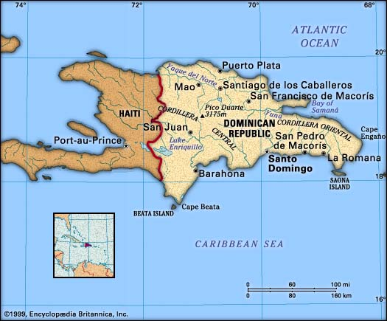
Comparisons
Throughout our paper we will use the Dominican Republic, Haiti’s only neighbor on the island of Hispaniola, as a reference of comparable study. Despite sharing the same basic geographic characteristics and similar history, Haiti and the Dominican Republic have a very peculiar, unexplained growth divergence. The Dominican Republic is radically more developed than Haiti in a number of ways. The Dominican Republic has consistently outperformed Haiti in terms of structural policies and lasting political stability. Our development plans hopes to improve Haiti’s circumstances and put it on the same, if not better, path toward development as its neighbor.

How unequal is Haiti today?

Haiti’s colonial past reflects the current structure of society today. Haiti is currently the poorest country in the Western Hemisphere, with 80% of the population living under the $1 US dollar a day poverty line and 54% in abject poverty. The Haitian population is divided into three distinct classes: the elite “neo-Duvalierist” faction of former military officers, warlords and politicians, a small middle class with neo-liberal tendencies, and a majority of socially democratic poor. Economic inequality between classes in Haiti today is high compared to other countries in the Caribbean. It is a truism, according to Seers, that poverty will be eliminated more rapidly if any given rate of economic growth is accompanied by a declining concentration of incomes. The commonly used measure of inequality is the Gini coefficient, which ranges from 0 to 1. A low Gini coefficient indicates more equal income distribution, while a high Gini coefficient indicates more unequal distribution. According to the UNDP-sponsored FAFO institute Haiti’s overall Gini coefficient in 1999/2000 was .509. This puts inequality well above that of Europe and North America, where Ginis are in the range from 0.25 to 0.35.

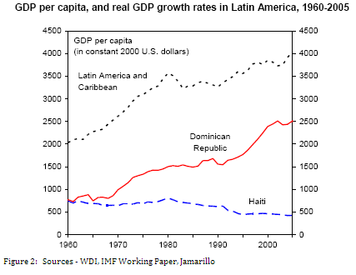
While income inequality is an important indicator of a country’s development, it is also a relative measure of poverty that has its drawbacks. In Haiti’s case the Gini coefficients reveal that its income inequality is high compared to others countries such as the Dominican Republic; however, the Gini coefficient does not take into account how each specific country deals with income inequality. For example, if a government provides food stamps to the poor, the Gini coefficient excludes that source of income in its measuring parameters but will include a government subsidy. An advantage of the Gini coefficient is information it provides on income trends within a country. In Haiti, the Gini coefficients of rural and urban areas reveal that the pattern of inequality is changing by region. While total inequality is constant, the Port-au-Prince area is experiencing increasing inequality (.416 to .586) and rural inequality has decreased (.489 to .449). While poverty in Haiti is high relative to other countries, it appears to have decreased within the country. The percentage below the poverty line was 59 in 1986/1987 and 48 in 1999/2000.
In 2006, the economy only had a 2.5% rate of growth which is not sufficient to achieve substantial future growth. Ownership of wealth has become concentrated in a small percentage of the population. By 2002, the richest four percent of the population controlled sixty-six percent of the country’s assets. Haiti’s government institutions remain weak and depend on external assistance to reform programs ranging from the economy to the education system. Most Haitian institutions lack the appropriately educated and technically skilled human resources to operate modern systems for government programs. One result is the mismanagement of financial assistance by international donors. Corruption is a major problem in all aspects of Haiti which is detrimental to the financial sector because investors are hesitant to supply capital into the country. Within our definition of development, we will attack the core problems within the economy, which is to fix the infrastructure, alleviate the hunger pains of labor workers, and improve the ability of Haitians to attain stable jobs. The GDP (ppp) in 2007 was $15.82 billion which is almost four times less than the GDP (ppp) of neighboring Dominican Republic which was $84.5 in 2007. Though on a historical decline, the growth rate grew in 2007 to 3.5% due to the help of macroeconomic programs of the IMF. It is not certain, however, that the growth rate will continue to improve in the future without help from Bretton Woods institutions. The GDP per capita (ppp) in Haiti in 2007 was $1,900 compared to the Dominican Republic GDP per capita (ppp) of $9,200. In comparison to the Dominican Republic, Haitians are living well below the means. Although it’s a good indication of Haiti’s economic progress, it fails to report on issues such as infant mortality rate and illiteracy that are important to our definition of development. Though GDP is used extensively in quantifying economic growth and industrial output, it cannot be used synonymously with the word ‘development’. Any measure of raw economic output misses the human side of national development.

Where did inequality come from?
Haiti gained independence from France in 1804, yet two centuries later the island’s colonial past is still extremely visible and influential. French colonists imported massive numbers of African slaves to work the sugar plantations bringing wealth to a small, white elite and entrenching socioeconomic inequality deep into the psychological fabric of Haiti. Constant intervention by foreign powers in Haiti’s internal affairs has proved disastrous over the years, leaving a mix of broken policies, factionalism and corruption. Ill fated interventions of the global North have stripped away faith in the government of Haiti. However poor the interventions on the North’s part were, domestically the government’s negative effects far exceed it. Between the years of 1844 and 1915, Haiti was lead by twenty-two different leaders, each of whom generally lost power due to disastrous coups. After a twenty year occupation by the American military, Francois ‘Papa Doc’ Duvalier declared himself president for life in 1957. Papa Doc’s fascist dictatorship was marked by corruption and rises in inequality. The dictator stole money from the people to build elaborate compounds for himself and pocketed loans from foreign government into personal bank accounts. After Papa Doc died and his son, Jean-Claude Duvalier took power and Haiti consequently experienced harsh economic conditions caused by the US recession in the early 80s. The economic poor economic climate causes social unrest throughout the country and the dictator was forced to flee the country.
In comparison to the rest of Latin American, Haiti has experienced the most regime changes between 1970 and 2003. The amount of regime changes represents the lack of stability—an important aspect in government required to foster any degree of economic growth. In general, the fewer regime changes a country experiences, the higher the growth rates. In contrast, the Dominican Republic has experienced about five times fewer regime changes and has experienced higher levels of growth than Haiti.
Transparency International’s Corruption Perception Index, which measures the level of corruption perceived by businessmen and country analysts, ranks Haiti as the fourth most corrupted nation in the world with a 1.6 out of ten, with zero being viewed as the most corrupt. With such a discouraging level of corruption in Haiti and the inevitable cynicism of investors, any long term solutions involving Haiti’s dependence on foreign investment for finances would be unlikely. Therefore an improvement in the CPI rating’s quantitative categories should be a goal in the development strategy of Haiti. To achieve this goal, Haiti must make strides in combating stability problems including rampant criminal gang violence, corruption within the police department, and drug trafficking.

Political Instability in Haiti

One of the main concerns which could prevent the adoption of a given development policy or could undermine the success of a new policy is the level of government corruption combined with social hostility. In the late 1800s and early 1900s there were twenty two regimes changes which occurred through violent coups. The constant government replacements make it impossible to have sustainable policies through regime changes. Even if a developmental policy is adopted by a particular administration, there is a very high probability that if a coup occurs the new government will throw out all previously existing policies. The large amount of violence which accompanies coups prevents the people from having faith in their government and, consequently, their government’s policies. The violence causes citizens to feel unsafe in their own country causing them tentative in playing an active role in government due the lack of transparency. Also, Haiti is considered one of the most corrupt nations in the world which brings into question how funds for developmental projects would be handled by the government. The level of corruption discourages all types of investment which is imperative for growth of the financial sector which is crucial in achieving sustainability.

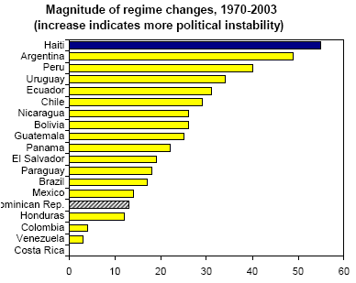
Haiti’s political instability and regime changes have hindered economic growth by causing the government to be incapable of implementing policies or even lasting long enough to devise economic policies. The amount of regime changes in Haiti over the last few decades were the greatest number in Latin America and South America; Argentina trailed Haiti’s number of regime changes slightly with 50 compared to Haiti’s 66 regime changes.

The Human side of Haitian Development
Particularly striking is Haiti’s losing battle with hunger, with a child malnutrition rate of 17.2% among 7.9 million. In order to develop physically and intellectually to the greatest potential, proper nutrition is vital. Growing up hungry stunts the human growth potential idealized in our vision of development. Malnutrition is a serious disadvantage in terms of economic growth, affecting the ability of the poor to work and improve their living environment. Alleviating the pains of hunger is not only a conscionable moral ideal but it also has a direct impact on productivity. Village improvements such as irrigation projects and road repairs are not on the government’s agenda because of the constant search for food. Though outside help from the World Food Program is considerable in Haiti, internal changes must be made to alleviate hunger and recognize the severity of a generation starved.

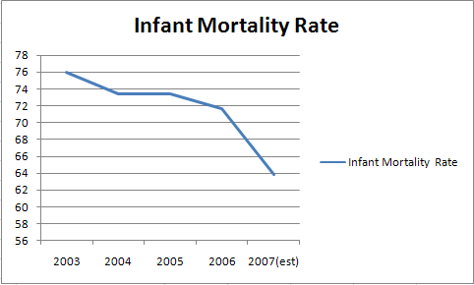
Hunger itself is not the only serious health problem in Haiti. Infant mortality rates are high in comparison to similar GDP related countries at 63.83 deaths for every 1,000 live births. Despite this high number, it’s more promising when compared to sky high rates in early 2000. Nonetheless, infant mortality in Haiti is comparatively high compared to a Latin American and Caribbean average of 28 per 1,000. Further reduction of the IMR requires heavy amounts of basic improvements made, specifically in the rural area. Chief among these improvements is access to safe water. Only 7.9% of Haitians living in rural areas access safe water, a disproportional amount to an even lower 28% in metropolitan areas. The government’s lack of investment in rural areas is apparent. Fortunately assistance by NGO’s and foreign aid programs has been high in the past twenty years. Road building and the construction of drinking wells and water filtration systems have given hope to many. Improving the lives of the poor in Haiti by providing water and food, the most natural and basic of needs is a key component in the social development of Haiti.

Geography and Agriculture
Geography and population measures play a vital role in shaping a country’s growth performance. According to the International Monetary Fund some of the determinants of geography include the quality of natural resources, productivity of land, the public health environment and the extent to which a country can become integrated with world markets. As mentioned before, one important implication of geography and climate is a country’s access to clean water. In Haiti, 54 percent of the population is without sustainable access to an improved water sources, compared to 14 percent in the Dominican Republic. This measure, however, is not independent of influences by the government’s allocations of resources. Haiti is the second most densely populated country in the western hemisphere with a population density of 797.4 per sq. mile in 2005. Although high population density is favorable for economic development in coastal regions with good access to trade, this high quantity does not bode well for Haiti’s limited number of trading partners and lagging economy. It was estimated by the Population Reference Bureau that 36 percent of the population lived in urban areas in 2001. According to the United Nations, the urban population growth rate for 2000–2005 was 3.4 percent while the rural population growth rate for those years was close to one percent. Population movement may be a result of a demise of an agrarian economy or simply an urban bias. Regardless of its source, this is an important trend that our assessment of Haiti’s development would like to explore further.
The majority of Haitians depends on the agricultural sector which includes subsistence farming and primary products such as sugarcane. Unfortunately, the decline of reliance on primary product expectation has caused sugarcane to face a constantly shrinking market and barriers to trade. Primary products are not a dependable sector to rely strongly on in light of the fact that the demand for primary products such as sugarcane is decreasing due to the emergence of artificial substitutes. Also, uncontrollable factors such as a famine or drought can ruin an entire season. Agriculture composes 28% of the economic sector while 66%, more than half, of the population is employed in the agricultural sector. These numbers indicate a lack of capital and efficiency. Haiti’s main primary products are coffee, mangoes, sugarcane, rice, corn, sorghum, and wood. Industry is relatively more efficient than agriculture; it comprises 20% of GDP and employs 9% of the labor force. However, most of the industry is export-oriented and does little to improve the internal welfare and consumption throughout Haiti. The main industries include sugar refining, flour milling, textiles, cement, light assembly based on imported parts. The service industry comprises 52% of the GDP while only employing 25% of the labor force. Clearly, industry is more efficient than agricultural production.

Migration
One characteristic that has played a vital role in the history, culture and economy in Haiti is migration. Over the last twenty years there has been an increasing number of Haitians leaving their home country to find employment and an overall better life abroad. These migration trends have had negative and positive impacts on Haiti’s economy and society in various ways. In our development report we will focus on the positive effects of emigration, specifically addressing ways to create opportunities to leverage funds from abroad for agricultural development in rural Haiti.
Migration from Haiti is a phenomenon that is a direct result of Haiti’s historical and economic position as a struggling developing nation. Recent migration trends indicate that the numbers of Haitian emigrants are only on the rise. Over 29 million people emigrate abroad from Latin American and the Caribbean and in Haiti, migration constitutes about one quarter of its population. Emigration trends over the years have been shaped by employment opportunities abroad as well as by prevailing violence and a repressive government. The Haitian Diaspora resides primarily in Canada, the Dominican Republic, and the United States, amounting to a total of two million people, compared to 8.5 million living in Haiti. A majority of these migrants maintain ties to their families in Haiti, and as a result the Haitian economy has become increasingly reliant on the money sent by the Haitian Diaspora.
Within Haiti there is also heavy rural-to-urban migration. Due to lack of resources and employment, people are moving from small farms to the cities. Haiti’s Capital, Port-au-Prince is overpopulated with nearly three million residents concentrated on only about an eight of the country’s land area. Rural-to-urban migration is likely a result of urban-bias in which government policies emphasize industrial growth and urban modernization, often to the detriment of the rural sector. Other consequences of urban-bias in Haiti are stagnant agricultural production, rising food imports and extreme rural poverty.

Key Areas of Development

Food and Imports
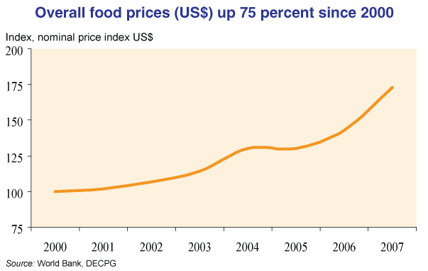
With the majority of Haitians living on or below the poverty line any upset in routine threatens lives and can further plunge the country into turmoil. Haitians, as well as all the world’s poor, make do with what they are blessed with having, yet certain things are completely out of their control. The global market, however distant most Haitians may seem from it, is making food completely unaffordable and unattainable. Haiti, a Caribbean island, relies on imports heavily to feed its population. Oil prices driven upwards because of fertilizer, irrigation and transportation demands, along with basic ingredients such as corn and wheat becoming more expensive, and an increasing global demand for bio-fuels all force food prices sky high. In addition, the 2007 Hurricane season destroyed most of Haiti’s crops and the subsequent flooding damaged food stocks. Heavy reliance on imported food opens Haiti to risk of fluctuations in food prices, placing Haitians in an even more precarious spot than they already are.

Infrastructure
Many studies find that infrastructure improvement drives economic growth (Calderón and Servén, 2004) as well as poverty reduction. However, Haiti has one of the worst infrastructures in the modern world. Use the graph below to compare Haiti with other Latin American countries and Sub-Sahara Africa and it is easy to see the massive divide. Haiti is cursed with an unstable environment, detrimental to even the smallest infrastructure projects. Constant hurricanes and tropical storms cause massive erosion, landslides, weaken top soil and cause pot holes. A dismal 5% of roads are listed as in “good” condition.
Access to water is an extreme problem, especially for the rural population. Though only 11% of households are piped to a reliable water source, virtually none of these houses are owned by Haiti’s poorest. Lack of potable water facilitates the already destructive health problems. Also, less than half the population has access to improved sanitation facilities. Consequently, potable water and clean sanitation facilities go hand in hand; lack of clean sanitation facilities pollutes the water supply. Electricity use is minimal throughout the country due to the fact that only 36kwh (kilowatt hours) of electricity are used per capita in a year. In sub-Saharan Africa people use 457kwh of power a year which is more than ten times the amount of power which is used in Haiti. The poor infrastructure of roads, water sanitation, and electricity use prevents Haiti from developing.
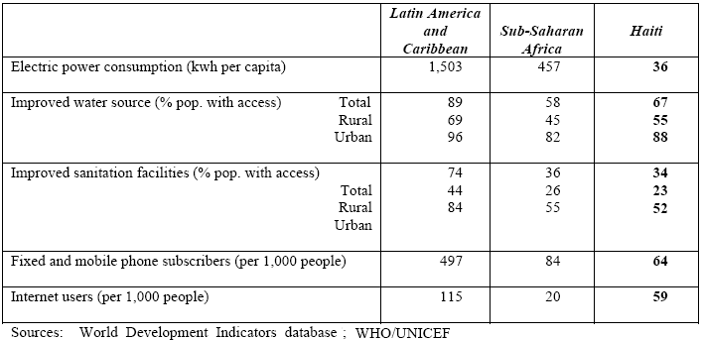

Education
Education is a crucial condition for growth that brings more than just skilled labor to an economy. Education also has beneficial impacts on nutrition, health, and empowerment of girls and poverty. It offers hope that children will help families break out of the vicious cycle of poverty. Access to education in Haiti has declined in recent years and disparities between urban and rural enrollment have worsened. The major deterrent that prevents enrollment is the cost of education. Despite continuous economic problems, there has been progress in school attainment. This is due to the fact that ninety-two percent of schools in Haiti are operated by a diverse group of private actors who have stepped in to “fill this gap” in the education sector. Figure 2.13 shows the attainment profile—percentages of students reaching each grade level by income group in two years. The profile shows progress at nearly all points. For example, while only 40 percent of 15-19 years old had completed 3rd grade in 1994-1995, that figure jumped to 56 percent in 2001. While there seems to be an increase in school attainment, this does not suggest that the quality of education has improved. Since investment in school is coming from private funds, there is little data that shows increased in learning and literacy.
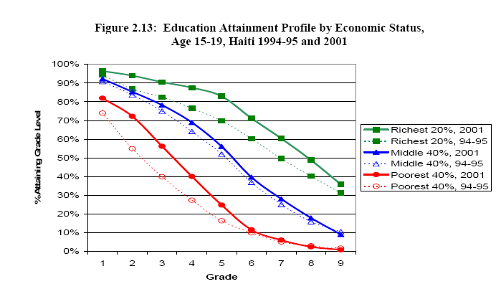

Healthcare
Healthcare in Haiti is in a state of crisis. Only about 60% of Haiti's 8 million residents have access to any form of health care services, according to the Pan American Health Organization (PAHO). The public healthcare system in the country is currently failing and has proved to be unable to handle the needs of the people. A 2003 Red Cross study indicates there is less than 1 hospital bed for every 1000 patients throughout Haiti and 209 surgical beds for the 6 million people living outside Port-au-Prince. The lack of health care does not only jeopardize people’s lives but promotes the spread of infectious diseases. The lack of sanitation also increases the risk of food and waterborne diseases such as Hepatitis A and E, typhoid fever, and bacterial and protozoal diarrhea. Also, poor sanitation and hygiene, coupled with inadequate nutrition, have contributed to a high incidence of physical challenges, ranging from congenital deformities and amputations to stroke-related paralysis and head and spinal cord injuries.
Another huge health issue is the prevalence of HIV/AIDS. Haiti has one of the highest rates of HIV/AIDS infection outside of Africa; an estimated 250,000 are living with the disease, according to WHO. The prevalence of AIDS is a major obstacle because it diminishes the work force and creates a large portion of the population which has extensive medical needs. In order for the country to develop the people must have access to decent healthcare and health education.

NGOs Currently in Operation
Non-governmental organizations are a necessary tool for development in third world countries which are attempting to achieve sustainable growth. NGOs are organizations created by private entrepreneurs which lack government funding and participation. Haiti has a wide range of NGOs which operate within the borders of the country and participate in a variety of operations which benefit the country. In order for Haiti to achieve sustainability, NGOs need to utilize their resources and funds to eliminate situations of dependency and give people the opportunity to live productive lives.
Currently, there are a wide variety of NGOs which operate in Haiti that address the health, education, agriculture, and political problems throughout the nation. Doctors without Borders is an emergency medical relief association which operates in countries in crisis. The organization provides emergency medical services, sanitation services, vaccines, and AIDS education. The services which Doctors without Borders provides are necessary for the prevention of disease through medications and sanitation. In order for health to improve, organizations like Doctors without Borders need to promote health education and provide health services which are not available in the hospitals. Other organizations provide more general services. For example, Direct Relief provide wholesale medical supplies to Haiti; it has given around 60 million dollars worth of medical supplies to date.
Other organizations such as Grassroots International address human rights issues and defend the land of the indigenous people. The organization protects human rights to land, water, and food. Organizations which encourage subsistence agriculture are very important in Haiti due to the high amount of malnutrition and, the fact that the country imports a large majority of its food from abroad. Outreach International is another NGO which deals with the social side of development issues and helps people develop skills which will allow them to be productive in society. Also, the organization has a civil branch which teaches people to build local governance and move away from the corruption tendencies inherent in many aspects of the Haitian government. In addition, Outreach International offers education programs which work with over 100 schools and 12,000 students annually to help children develop themselves so that they can break out of the cycle of poverty. We believe that when children learn to read and write, and gain skills in problem solving and community building, they will be better equipped as adults to transform their communities. NGOs are a crucial aspect in our development plan. Working with NGOs to expand the scope of projects to specifically address Haiti’s unique needs will be beneficial to the potential growth of the country.

Economy

1-GAP:
As a complement to social and political development goals, we will use GDP indicators to produce a better understanding of Haiti’s micro and macroeconomic policies. Though we stress that the key to Haiti’s development is the improvement of education, health and social standards, Haiti’s economic growth rates can contribute significantly to the attainment of overall human welfare. By looking at Haiti’s economic trends and utilizing economic models, we will establish realistic economic targets for Haiti.
In 2006 the Haitian economy recorded positive GDP growth of 2.5% for the second year running. Output growth of 2.5% in 2006 allowed for an increase in per capita GDP of 0.7%. Though Haiti has recently achieved positive growth rates, between 1961-2000 Haiti’s real income per-capita fell by an average percent per year. Indeed, Haiti’s economic performance has been one of the worst in Latin America and the Caribbean (LAC) region and similar to that observed in the worst performing sub-Saharan African countries. In order to pull Haiti out of its long-term economic slump it is important that we analyze what is preventing growth, which can be seen through GAP analysis.
The most fundamental developmental obstacle for poor countries is the inadequate supply of investment. The relationship between growth rate and investment is often overlooked but it is crucial in our determination of savings and investment levels. One solution to the ‘gap’ between investment and savings is given in the Harrod-Domar equation, which indentifies the gap between the savings available and the level of investment required to achieve any given growth target. While most development models are familiar with the Solow Growth Theory, which takes into account land, labor and efficiency factors, the Harrod-Domar equation derives a simple, yet very informative relationship between GDP growth and investment level.

Source: WDI

The Harrod-Domer equations says that the change in GDP is equal to 1/K * I where K is the capital-output ratio and I is the investment level. This model is especially important because we can set the target growth rate for Haiti to the Dominican Republic’s 2007 growth rate of 7.2%. Typically the standard capital-output ratio is 5, however because Haiti’s economic performance is unique we will use average growths rates and investment levels to determine the more accurate capital-output ratio specific to Haiti.

Currently, Haiti’s average annual growth in GDP from 1980 to 2003 is in total -.37%. Given this negative growth rate, it is difficult to draw an accurate depiction of investment using the Harrod-Domer model. In figure 1.1 we see a the capital-output ratio calculated for Haiti from 1980-2003 would be -47.652 due to a two-decade long period of negative growth rates. If Haiti is to use the Dominican Republic’s 2007 GDP growth of 7.2% as a target rate, then according to the Harrod-Domer equation, the appropriate level of investment would be 7.2% * -47.652. This very high negative number is strikingly illogical since a country cannot have a negative investment rate. For Haiti’s case, it is therefore appropriate to use another method of analysis of the one-gap other than the Harrod-Domer model.

Figure 1.1: Harrod-Domer Components taken from 1980-2003
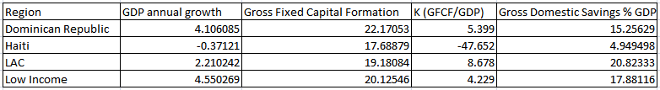

It is clear from our calculation of K that investment levels are extremely sensitive to a country’s GDP growth. We can also see from Figure 1.1 that investment levels in Haiti are right around the investment levels of the DR, LAC and Low income countries. The problem, therefore, must be inefficient investment. High levels of investment have no translated into economic growth. Haiti’s paradox of high investment levels accompanied by a contraction of per capita GDP can be explained by measurement problems within the national accounts. The Haitian Institute of Statistics (IHSI) is underfinanced and has weak institutional capacity and the availability of date is very limited and outdated. In addition to the shortcomings of the system of national accounts, the investment paradox can also be a result of under-estimation of GDP and overestimation of GDP
In addition to inefficient use of investment, there is an apparent disparity between gross fixed capital formation and domestic savings worth close to 15% of GDP. The World Development Index defines gross capital formation as:

“Gross fixed capital formation (formerly gross domestic fixed investment) includes land improvements (fences, ditches, drains, and so on); plant, machinery, and equipment purchases; and the construction of roads, railways, and the like, including schools, offices, hospitals, private residential dwellings, and commercial and industrial buildings. According to the 1993 SNA, net acquisitions of valuables are also considered capital formation.”

This disparity in savings and investment suggests that investment in the Haitian economy is not from within, but from abroad. Foreign direct investment over the period of 1980 to 2003 was approximately 26% of GDP and in the most recent record in 2005 FDI was 21% of GDP. More noteworthy is that Haiti’s total debt outstanding is US$ 1.4 billion and total debt as a percent of GDP is 34.1 percent. Haiti’s reliance on outside sources for aid, especially the United States, deepens Haiti’s debt and forsakes any improvements for future sustainability. Too much dependence will continue to undermine the capability of the Haitian government to address sustainable growth.

Figure 1.2
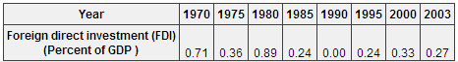
Source: Globalis

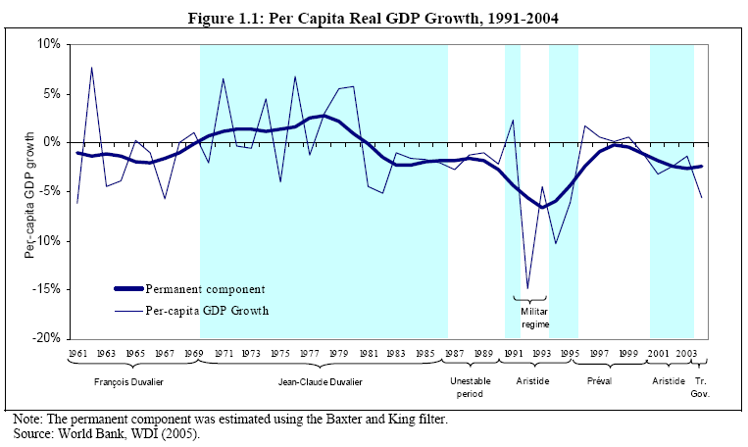

2-GAP:

The two-gap is the difference between available hard currency and actual sources of foreign exchange. Essentially, the two-gap is a good measurement for sustainability. If a country does well for one or two years, perhaps due to foreign aid, its good standing will not necessarily hold because of the strong affects that currency and foreign exchange have on the overall economy. The two-gap analysis involves the study of balance of payments, trade account balance, foreign reserves, and currency and liability balances. The balance of payments describes the sources of foreign exchange as it tracks the inflows into Haiti of currency from exports, asset sales, foreign investment, loans, and foreign aid. The opposite end of the balance of payments for Haiti involves the needs of foreign currency which include purchasing imports, repatriations of profits, and repayments of loans. The Haitian balance of payment in 2004 is considerably healthier than it has been in the last twenty years as a deficit of 1.16% of GDP, however this does not fully represent Haiti’s lagging balance of payment in the last twenty years as shown in table 1.1. Haiti’s trade account balance in 2004 was -29.31% of GDP. The trade account deficit indicates that imports were much higher than exports. In 2003 the trade deficit was evener higher at -32.12% of GDP, with imports at 46.6% of GDP and exports at only 16.2% of GDP. In 2007, Haiti’s exports were $554.8 million and its imports were a high $1.844 billion. Haiti’s overindulgence in exports eats away at the current account and causes a succession of other economic strains with many social implications. A result of Haiti importing more than half its food, local farmers struggle to sustain their businesses and their livestock and families impoverish.
Table 1.1 (As % GDP)
 |  |  |  |  | 1980 |  |  |  |  | 1983 | 1986 | 1989 | 1992 | 1995 | 1998 | 2001 | 2004
Current Acct. |  |  |  |  | -6.92 |  |  |  |  | -6.82 | -2.00 | -2.49 | .39 | -2.86 | .75 | -3.66 | -1.53
Financial Acct. |  |  |  |  | 5.20 |  |  |  |  | 5.59 | 1.53 | 2.39 | -1.24 | 3.26 | 4.94 | 2.29 | 1.42
CA and FA |  |  |  |  | -1.72 |  |  |  |  | -1.23 | -.47 | -.1 | -.85 | .4 | 5.69 | -1.37 | -.11
Net Errors and Omissions |  |  |  |  | -.85 |  |  |  |  | -.53 | .66 | -.42 | .50 | 4.14 | -4.7 | 1.23 | 1.27
Overall Balance |  |  |  |  | -2.57 |  |  |  |  | -1.76 | .19 | -.52 | -.35 | 4.54 | .99 | -.14 | 1.16
 |  |  |  |  |  |  |  |  | source: WDI

Haiti’s trade balance deficit leads to a lack of available foreign exchange. Massive trade deficits are most detrimental because they can cause currency declines, which in turn affect levels of imports, reserves and loans. Haiti had a fixed currency rate up until 1990, so that the Haitian currency, the gourde, was pegged against the US dollar. Even with a fixed currency rate, Haiti experienced sharp declines in total foreign reserves from 1985 to 1990 due to political turmoil. Duvalier’s struggling regime in the 1980’s led to his resignation, but Duvalier’s departure in 1986 was followed by successive failed elections and between 1986 and 1990, there were six different heads of state. Intense political instability deterred investment and inevitably Haiti’s low levels of foreign reserves triggered a currency crisis in 1991. Since these financial crises, Haiti has had a difficult time maintaining positive accounts without the help of foreign aid. While the currency rate has remained pretty constant in the last decade, they are volatile because of Haiti’s very negative net external position of -40.38, which is the ratio of liabilities to assets. Haiti’s estimated external debt to international financial institutions and foreign governments has grown from US$302 million in 1980 to US$1.4 billion today. Countries providing aid to Haiti will hold Haiti accountable, and essentially Haiti is selling its sovereignty by collecting increasing debts.

Haiti heavily relies on the outside world to compensate for its inefficient economy. The current account is pulled down by the trade deficit and should be pulled up by income and transfers. However, income has very little effect on the current account, as less than 1% of the GDP is affected by income, which describes Haiti’s inefficient workforce. Transfers, which include foreign aid and worker remittances, carry much of the weight in the current account. Worker remittances has consistently accounted for around 16% of GDP for the last decade and about 28% of Haiti’s GDP in 2004, while aid accounts for approximately 6% of GDP in the transfers. Worker remittances are so high because about one out of every eight Haitians presently lives outside the country’s borders. As a result, Haitians rely on other sources of income and thus has not been able to generate sufficient income to maintain the rhythm of food imports, leading to increased debt.
Despite Haiti’s large flow of remittances, the use of remittances remains overwhelmingly directed to consumption rather than investment or savings. As a result, the Haitian economy has become increasingly reliant on the money sent by the Haitian Diaspora living abroad when the focus should be on creating a more independent sustainable economy.
Another factor that has hurt the Haitian economy is the falling exchange rate for the Haitian gourde. Prior to 1991, Haiti had a fixed currency. Since then, the depreciation of the gourde to the dollar has grown. In 2004, the gourde was worth about $.026. Depreciation in a nation’s currency makes exports competitive and imports very expensive. Evident to the negative impact of depreciation on an economy is Haiti’s 1991 dollar depreciation rate of 39 percent. As a result, imports soared in less than one year from 20% of GDP to 34% of GDP. The trade imbalance was high and in turn the current account balance was even more negative. Exchange rates in Haiti are already very low and volatile to any changes international markets, therefore it is important for Haiti to increase its export industry while maintaining appropriate spending levels.

3-Gap

The future growth in Haiti depends on the 3-gap which is defined as the difference between available government revenues and required expenditures. The 3-gap is a good indication of the fiscal wellbeing of the country. During 2005 government expenditures were estimated to be US$600.8 million and revenues, about US$400 million resulting in a negative difference of US$200.8 million which is about 1.36% of GDP. The government relies heavily on international economic assistance for fiscal sustainability.The amount of money which the Haitian government spent was more than received in revenue. A massive budget deficit common in many third world and developing countries is the lack of self produced revenue, due to the fact that the only money which governments receive are taxes and foreign aid. Taxes can be an especially challenging obstacle since wealthy elite interest groups generally possess a great about of power and influence in Haiti. Also, poor people have too few assets to be taxed by the government; they would be unable to pay their requirement. Haiti has a moderate income tax rate and a high corporate tax rate. The top income tax rate is 30 percent, and the top corporate tax rate is 35 percent. Foreign aid to the Haitian government has led the government to become for expenditure focused since there is a constant influx of money. However, foreign aid also increases foreign debt. In 2005, Haiti received $515 million dollars in foreign aid and last year accumulated a $1.4 billion external debt. Curtailing the deficits will be difficult with the large amount of foreign aid constantly flowing into the country. The misallocation of public revenues for private use and the low government allocations for economic and social development have contributed directly to Haiti's extreme poverty.Military expenditures do not play a large role in the percentage of expenditures in Haiti. Haiti’s defense budget totaled an estimates US$26 million. Currently Haiti has a 5300-strong national police force, funded and trained by the US, formed in the place of its military which was disbanded in 1994 when democracy returned to the country. The amount of money which is spent equals 0.2% of GDP which is small enough that total military spending does not necessary needs to be reduced.

Total Factor Productivity
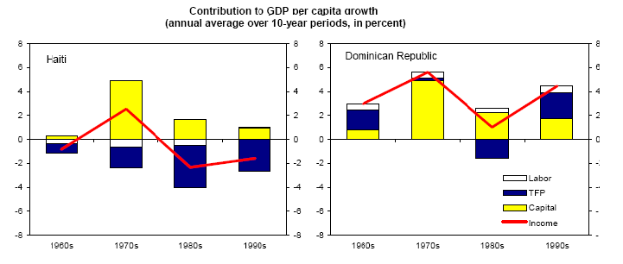
Economically, Haiti has experienced difficulty in the last four decades. Total Factor Productivity is an assessment of growth which measures the total output not caused by inputs or productivity and accounts for a majority of growth which occurs in a country. TFC is defined by the Cobb-Douglas production function Y= A x K^α x L^1- α. Total output equals a function of total factor productivity times capital input (K) and labor input (L).
TFP growth in Haiti has been negative for the last four decades while TFP growth in the Dominican Republic has only been negative for one out of the last three decades. Unlike the Dominican Republic, Haiti lacks both capital and labor which is necessary for growth in any type of economy.
Foreign Direct Investment has not been very dependable over the years. In 1999 FDI went from $30 million to $5 million in 2002. The instability of FDI makes it difficult for Haiti to know how much money foreign countries will be investing each year in order to create projects to attract the investment. Although FDI is criticized on many levels, it generally provides economic growth and poverty reduction by directing a large majority of profits back into the domestic economy.

International Ties
Since the 1990s Haiti has depended heavily on international aid from institutions such as the World Bank, International Monetary Fund (IMF), and Inter-American Development Bank (IADB). The dependence on foreign aid has supported an environment where Haiti has failed to develop many sectors of the economy on its own. In addition, the allocation of money is continuously questioned by international institutions as to whether or not it is going toward legitimate causes or into the personal funds of the elite majority.
Unskilled labor does not encourage the transfer of technology or the benefits of technology. Recently, in 2005, the United States permitted Haiti to have tariff-free access to US markets in order to stimulate the economy. Political instability has also played a huge role in the shrinking economy due to the fact that internal turmoil diverts focus from important aspects of the social and economic infrastructure of the country. Corrupt governments and elites also fail to implement economic policies which would benefit all citizens and the country as a whole.
Ties to the north in the import-export sector are very prominent yet also detrimental to the country. Northern countries such as the United States consume 80% of the exports from Haiti; Dominican Republic and Canada consume 7.6% and 3% of exports, respectively. This data reflects that Haiti is most dependent on the United States for exports which is dangerous if economic ties are severed between the two nations. Haiti exported $554.8 million f.o.b of products in 2007. The United States is also the lead importer of products into the country by supplying 46.5% of the imports to the country. The Netherlands Antilles with 11.9% and Brazil with 3.8% are a distant second. The influx of US products prevents the Haitian market from producing for their internal consumption because their products are inferior due to lack of technology and capital. Dependency theories would argue that Haiti is bound to agreements to the North with hefty strings attached. Haiti imported $1.844 billion f.o.b in 2007. The huge difference between the amount of products imported and exported is large. As a result, Haiti has problems with a balance of payments deficit, especially their current account balance of payments deficit. The current account deficit last year of -$184.8million puts Haiti in the category as a net debtor country which is investing more than it is saving. Therefore, Haiti depends on resources from other economies to meet domestic consumption and investment requirements. Haiti’s dependency on other countries and its lack of self-continues to inhibit growth in all sectors of the economy all the while building massive deficits to be paid of sometime in the future.
Intertwined with the economic issues is the problem of extreme and chronic unemployment. Around two thirds of the population is unemployed. Little access to jobs or job training hurts productivity and further postpones Haitian development. The labor force consists of about 3.6 million people out of 8.7 million inhabitants. The vast amount of unemployment leads to extreme poverty and little hope for sustainability. Poverty and the absence of job opportunities have driven many Haitians abroad in recent decades, mostly to the US and the Dominican Republic. Due to the fact that the per capita income in the DR is $1900 and in Haiti it is $9200, Haitian migration to the Dominican Republic has been large and filled with strife. Despite the Dominican Republic’s proximity, immigration is illegal and has caused strife and hostility between Haiti and its neighbor. Poor Haitians, however, are so determined to find work elsewhere because of limited opportunity in their own country that they fail to acknowledge the consequences of their migration.

Conclusion

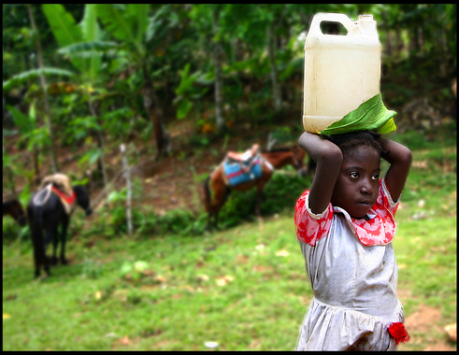
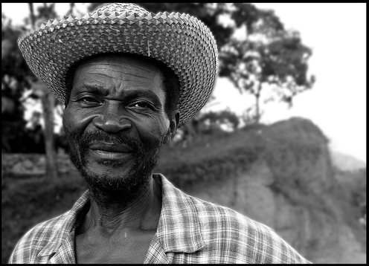
Poverty reduction and human development are intrinsic to our definition of development. Haiti is currently the poorest country in the western hemisphere; the country’s potential to reduce poverty and adequately provide a sustainable future for human development is undeniable. Currently, Haiti is in a detrimental cycle of extreme poverty which is aggregated by a corrupt government and an insufficient infrastructure. Through improvements in agriculture, government, and education the goals of development are within reach. In order to achieve economic growth, the economy must be diversified; especially, from their dependence on primary products and western markets. Also, subsistence agriculture must be subject to technological improvements in order for malnutrition and starvation issues to decrease. A transition from subsistence agriculture to commercial farming along with other income generating activity will help reduce rural poverty. Although many dilemmas such as political corruption and dependence on remittances and foreign aid cannot be solved in the short-run, the nation must begin to work toward long term-solutions.

Proposal Background
Agriculture is the largest sector of the Haitian economy, employing roughly two-thirds of the labor force but accounting for barely one-third of the GDP. Agriculture composes 28% of the economic sector while 66%, more than half, of the population is employed in the agricultural sector. These numbers indicate a lack of capital and efficiency. The lack of physical capital stems from the apparent lopsided investment amounts in agriculture when compared to other sectors of the economy. Despite two-thirds of the Haitian population living in rural areas only an estimated 20% of public investment was directed toward those areas. This systemic lack of investment has created an extremely poor infrastructure system, leaving many rural poor disconnected from markets.
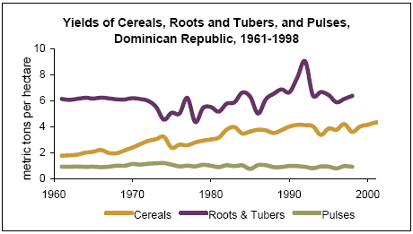
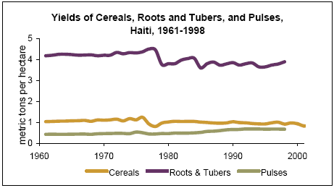

Corn, Beans, and Sorghum are Haiti’s three staple crops and are produced on 80% of the 1,341,497 hectares farmed in Haiti. Corn, cultivated on 47% of arable land, is far away and the most important crop to the Haitian people. Foodstuffs not used for subsistence that are sold in rural markets and along roadsides include mild Arabica coffee, Haiti's main cash crop. Haitian farmers sell it through a system of intermediaries, speculators, and merchant houses. Sugarcane is the second major cash crop, but since the late 1970s Haiti has become a net importer of sugar. Unfortunately, the decline of world reliance on primary product expectation has caused sugarcane to face a constantly shrinking market and barriers to trade. Primary products are not a dependable sector to rely strongly on in light of the fact that the demand for primary products such as sugarcane is decreasing due to the emergence of artificial substitutes. In addition, crop yields in Haiti are extremely low in comparison to the Dominican Republic and other Caribbean countries. This is indicative of poor planting and a lack of education in modern farming methods. Improving soil conditions and introducing high yield, high tolerance seeds will lead to substantially greater yields and more goods in Haitian markets, which in turn would raise income and standard of living and decrease Haiti’s reliance on imported food.

 | Haiti | Central America and Caribbean | World
Agricultural Production and Yields
Cereals, 1999-2001
Average production (000 metric tons) | 415 | 33,983 | 2,075,387
Per capita production (tons per person) | 51 | 196 | 343
Average crop yield (kg per ha) | 899 | 2,529 | 3,096
Agricultural Land
Total Cropland(000 ha), 1999 | 910 | 43,426 | 1,501,452
Arable & permanent cropland(%total) | 32.80% | 16% | 11.30%
Irrigated cropland(%total) | 8.20% | 19.10% | 18.30%
Agricultural Inputs
Average annual fertilizer use(0000 metric tons) | 9 | 2,815 | 141,360
Pesticide use, 1994-1996 (kg/ha cropland) | 23 | X | X
Percent of GDP from agricultural, 2000 | 28.40% | 6.10% | 5.00%

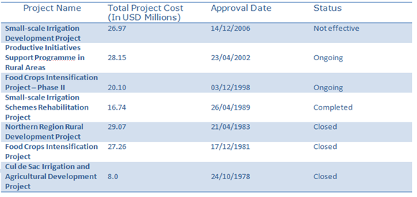
Since the election of President Rene Préval, the structural adjustment plan forced on Haiti by international financial institutions has resulted in an economic collapse across many sectors. Agriculture has particularly been hit hard. Agricultural advances have not occurred and environmental issues such as deforestation and erosion have reduced the amount of arable land. Although there are numerous agricultural development NGO’s and programs, rural farmers, especially in the northwest regions, lack adequate seeds, equipment, irrigation and training. The International Fund for Agricultural Development (IFAD) has allocated seven Projects totaling $156.29 million dollars towards the development of Haiti. $64.35 million of the project budgets were loans. As seen in these large expenditures below, the International community recognizes agriculture development in Haiti as a top priority.

Food Crisis
The global market, however distant most Haitians may seem from it, is making food completely unaffordable and unattainable. Haiti, a Caribbean island, relies heavily on imports to feed its population. Oil prices driven upwards from commodity speculation on Wall Street, ever increasing demand from heavy industry, expanding ethanol and bio-fuel interest in first world countries and stagnating production from the OPEC nations have wide ranging effects. Fertilizer, irrigation, and transportation have all become more expensive and along with the rise in price of basic ingredients such as corn, rice and wheat, food prices have been forced sky high. In addition, the 2007 Hurricane season destroyed most of Haiti’s crops and the subsequent flooding damaged food stocks. Heavy reliance on imported food opens Haiti to risk of global fluctuations in food prices, but when combined with low productivity and disasters affecting the food supply strained Haitians are pushed past the breaking point into starvation.
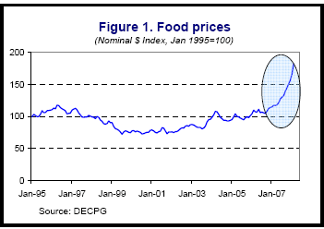
Last year, the food import bill of developing countries rose by 25 percent as food prices rose to levels not seen in a generation. Corn doubled in price over the last two years. Wheat reached its highest price in 28 years. Over the last few months food prices have been skyrocketing and Haiti has been hit hard with rising food prices since it imports most of its food. Since most people in the country live on one dollar or two dollars a day even a small increase in market food prices can be disastrous. Haitians have responded to the increases with violent street protests and riots. To date, three Haitians have died in the violent protests. The food crisis has also provoked many people to leave the country illegally. The director for the country's national migration office, Jeanne Bernard Pierre, said since the food crisis, her agency has received more repatriated Haitian boat people in a week than it used to receive in a month or more.
The Haitian Prime Minister, Jacques-Édouard Alexis, who has been blamed for handling the struggling economy poorly, was recently voted out of office. Mr. Préval, a former agronomist who is in his second term as president, met earlier in the day with food importers at the presidential palace and emerged to announce new measures that he said would knock the price of a 50-pound bag of rice from $51 to $43, a nearly 16 percent reduction. However, the plan to subsidize rice is only a temporary agreement between importers and the government which is not guaranteed to work. In the poorest country in the hemisphere, that discount could mean the difference between eating and going hungry for many families. One Haitian woman remarks that,
"Before, if you had a dollar twenty-five [cents], you could buy vegetables, some rice, 10 cents of charcoal and a little cooking oil," she said. "Right now, a little can of rice alone costs 65 cents, and it's not good rice at all. Oil is 25 cents. Charcoal is 25 cents. With a dollar twenty-five, you can't even make a plate of rice for one child."

Deforestation
Haiti’s other large obstacle is the impact of deforestation on agrarian endeavors. Haiti is 98% deforested. Deforestation has been occurring throughout the country at an alarming rate. In comparison, neighboring Dominican Republic holds well over 70% forest land. Haiti was once covered by a lush, tropical forest but by 1988 only about 2 percent of the country had tree cover. Deforestation is very detrimental because trees hold the top soil in place and absorb most of the rainfall water. The lack of ground cover causes higher rates of runoff, erosion, and sedimentation.

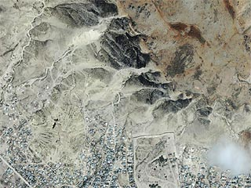
“An annual loss of 3 centimeters of top soil per year has caused a gradual decrease in agricultural production estimated at about 0.5-1.2%” - The World Bank
The reasons for uncontrolled deforestation are the logging businesses which pump revenue into the country and the use of wood for fuel and heating. Alternative energy importation from abroad is very expensive so people cut and gather wood for heating and cooking purposes. Currently, around 90% of people use wood to cook with everyday. Without an end to deforestation Haitians will not have adequate supplies of wood with which to cook their food. Unfortunately, most of Haiti's governments pay only lip service to reforestation. As in the case of other areas of Haitian life, the main impetus to act came from abroad. USAID's Agroforestry Outreach Program, Projè Pyebwa, was the country's major reforestation program in the 1980s. Peasants planted more than 25 million trees under Projè Pyebwa, but as many as seven trees were cut for each new tree planted.
An image of the mountain above the city of Gonaives. The barren slopes encroach into the city. (NASA - 2000)

The Role of Fonkoze and ORE
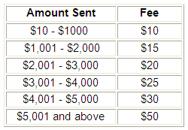
The first institution we wish to work with is Fonkoze. Fonkoze is the largest microfinance institution that offers a full range of financial-based services to the rural-based poor in Haiti. Established in 1994, Fonkoze currently has over 115,000 borrowers, 45,000 active borrowers, and 34 different branches which serve the rural poor. One of the many services which Fonkoze offers is money transfer services that allow Haitians overseas the opportunity to transfer funds to Haiti at a very low cost. Fonkoze charges a very reasonable transfer fare in the table 1.
Fonkoze does not only address the financial needs of the poor but it also strives to attack illiteracy and the lack of business skills among the poor. It is important that Fonkoze’s plans include addressing the social side of the humanitarian problems throughout Haiti because it shares with ORE similar goals of human advancement.
The remittances which flow through Fonkoze are mainly sent to the rural areas. A branch of Fonkoze is located in the city of Gonaïves so funds would flow directly into the area of interest for our development proposal. Another important aspect of Fonkoze which supports our development proposal is the presence of the organization in the United States. Fonkoze USA operates out of Washington D.C. and supports Haiti by raising donated funds, mobilizing investment funds for lending to Fonkoze, and increasing public awareness about Haiti in the United States. In addition to its D.C base Fonkoze has banking accounts with the Central Bank of New Jersey. The visibility of Fonkoze in the United States is important to attract donors by increasing the legitimacy of the organization for our target group of remittance matchers.
The second organization which we will be working with to achieve our development goals is ORE. The main goal in the Organization for the Rehabilitation of the Environment “is to increase profitable production of high-revenue fruit trees and cash crops, with improved plant materials and aggressive marketing, in order to replace subsistence farming”. The primary focus is improving land and the education of Haitians. ORE was established in 1985 by Sean Finnigan who saw the potential of Haiti’s land and people being neglected. ORE was formally in business when it was given a grant by the Canadian Embassy to produce 16,000 grafted fruit trees in Haiti. The initial program was a success and, ORE has continued to advocate and develop efficient Haitian agriculture practices. The ideals of agriculture sustainability within ORE exemplify our definition of development as well as our development goals. ORE’s work focuses on helping people in Haiti realize their economic potential while increasing income and thus self-sufficiency and standard of living. By utilizing the proposed partnership with Fonkoze, the funds which are directed to ORE will be used to teach people techniques and provide the tools in order to improve agricultural productivity. Also, the funds will initiate activism to prevent further deforestation and promote reforestation.

Remittances:
Money sent home from the Haitian Diaspora are referred to as remittances. According to Haiti’s Central Bank and World Bank statistics, it is recorded that Haitians send over one billion dollars a year, or more than a quarter of the country’s GDP. Since population data on foreign born individuals is hard to accurately account, many studies are based on estimates. One study in particular (Table 1) shows the population and the amount of total remittances based on minimum and maximum numbers in Canada, the US, and the Dominican Republic. Additionally, our 2-GAP analysis supports the recent trends that the majority of Haitian transfers come from remittances.
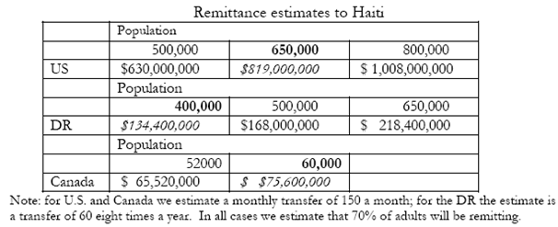

Remittances to Latin America and the Caribbean (LAC) reached $66.5 billion in 2007, an increase of 7 % over 2006. Migrant workers sent home one-third more than net Foreign Direct Investment (FDI) and more than ten times Official Development Assistance (ODA), making 2007 the fifth year in a row that remittance inflows topped the combined sum of FDI and ODA to the region. Typically, remittances are sent home $100 to $300 at a time and in many countries these monies are essential to the survival of millions of families living in poverty. Though the average size of a remittance is small, they not only play an important part in people’s daily lives but are particularly important for people during crisis.

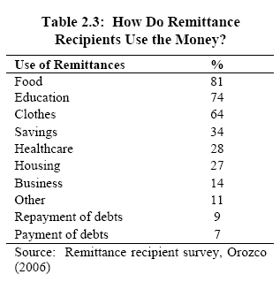

As indicated in Table 2.3 the majority of remittances are used for consumption of food and little is used for savings or business investment; the lack of savings is largely due to lack of financial guidance and know-how to invest.

Current Economic Market for Remittances:
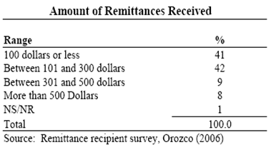
An increasing globalized world market continues to have a significant impact on the economy, environment and culture of individual countries. One important consequence of major global imbalances in development and an increasing demographic necessity for migration in Haiti is the growth of its remittance market. According to the Inter-Development Bank, remittances to LAC recently slowed from double-digit annual increases because the two largest recipients in the region departed significantly from past trends; Mexico grew only 1% in 2007 ($23.8 billion) and Brazil became the first to show an annual decrease of 4%. The combination of increased U.S immigration enforcement and slowing economy have lowered the ability of Mexican migrants to send money home, while the weakening dollar has lowered the value of migrants remittances sent to Brazil. Despite these decreases, remittances in the remainder of the LAC region experienced a tremendous 11% growth. With the exception of Brazil, the depreciation of the dollar has not yet had a major effect on remittances to the LAC. In the long-run, remittances remain a strong force in the LAC economy; the Pew Research Center for U.S Population Projections estimates that there will be a tripling of the size of the Latin American and Caribbean population in the United States, which is estimated to comprise 30% of the US population by 2050.
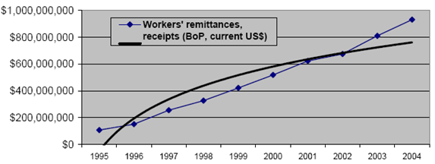
Aside from the large volume of remittance flow to Haiti, their relevance to the Haitian economy becomes apparent when compared to other economic indicators, such as GDP. In 2003, remittances made up approximately 30% of Haiti GDP compared to 8.7% five years earlier (Figure 6). Another important statistic to note is that remittance composition of GDP is higher than Haiti’s largest industry of agriculture, which makes up only 28% of GDP.

An issue for many remitters is the mode for transfer of monies abroad to their home country. Money transfers to LAC today are predominantly processed by licensed money transfer operators, such as Western Union, and informal transfer through network of friends and family with cash or money orders. As money transfers are being subjected to more intense scrutiny by regulators, the remittance industry has experienced a shift in remittances from informal to formal channels. Over the last three or four years other competitors such as banks, card-based operators and online wiring have emerged as players offering account-to-account transfers. The Multilateral Investment Fund (MIF), for example, has encouraged more service providers to enter the remittances market, particularly banks, credit unions and microfinance institutions focused on lower-income clients. Since 2000 the average cost for a $200 transfer to LAC has fallen from about 15 percent to 5 percent and thus families have kept billions of dollars that would have gone to fees and foreign exchange commissions, however, these fees still deter many remitters from using formal transfer methods.

Remittance senders in New York and use of company

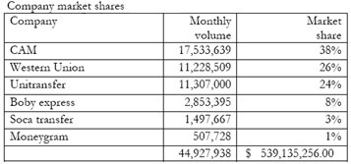
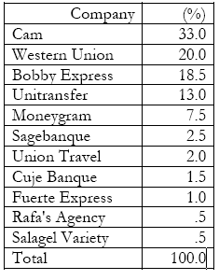
Source: Orozco 2006

The Inter-American Development Bank and the MIF are now seeking to bring more families who receive remittances into the formal financial system in order to expand their access to products and services that can help them build and protect assets, such as savings accounts, insurance, business loans and mortgages. The role of financial access in development is critical for Haiti. Diasporas and recipients have just recently realized the affordable banking opportunities, but have yet to work with one organization to maximize both personal and community funds.

In our economic, social and environmental development plan for rural agriculture we hope to reach two goals. First, we would like to create a microeconomic matching program for remittances in the North-Western Haitian region of Gonaïves. Second, we hope the funds raised will be used to restore, develop and maintain agriculture development in this devastated and impoverished area of Haiti.

Microeconomic Program for Remittances:
We propose the program of Remit and Match to the primary Haitian microfinance institution Fonkoze. Remit and Match aims to provide a means to access larger sources of funding to the rural Haitian sector by using Fonkoze’s financial services abroad and in Haiti. The premise of Remit and Match will be a partnership between Fonkoze and remitters and it will also act as a liaison for individual, government and corporate donations. Our mission is to use funds raised within Fonkoze for enterprise with Haiti’s Organization for the Rehabilitation of Environment, which would work to accelerate the alleviation of poverty and food crisis in our specified region. Our model for leveraging the large remittance market is to better integrate Haitian immigrants into the financial system as well as attract remittances and other funding towards investment pools for agriculture development.
One of the key indirect enablers of natural resources degradation in Haiti is the lack of sustainable financial resources to support both public and private interventions. At this point, it is crucial for Haiti to access immediate capital for agricultural development. We believe that with the size of the remittance market and the growing remittance services offered by banks worldwide we can leverage Haitian remittances to promote more favorable conditions for the rural poor. With the right marketing strategy, Remit and Match will target donors to match a percentage of remittances sent to Haiti, whereupon the remitter’s family will receive the full remittance and the matched donor money will go into a Rural Agriculture Fund (RAF) within Fonkoze’s funding accounts. As Haiti’s primary microfinance institution, Fonkoze occupies a unique position in the Haitian remittance market by providing banking services to communities that receive remittances. Partnering with Fonkoze will enable us to build upon its current existing infrastructure and experience with rural microenterprise by way of attracting more remitters and more funds. Essentially, by using marketing strategies, Remit and Match will provide more capital and remitter business for Fonkoze while Fonkoze will provide our program with the necessary financial and banking services. It is our purpose that the linkage between a remitter-leverage service and a microfinance institution will help facilitate the channeling of money flows into important investments such as rural agriculture.

The underutilization of banking services for international money transfers in rural Haiti is an issue Remit and Match would like to tackle. In order to do this, we propose the creation of an internet-based market for remitters. Our idea hails from the world’s first person-to-person micro-lending website known as Kiva.org, which empowers individuals to lend directly to entrepreneurs around the world. Whereas Kiva’s mission is to connect people through lending for the sake of alleviating poverty, Remit and Match’s mission is to connect donors with remitters so as to create a larger pool of funding for rural agriculture projects. Our development team has researched the current micro-level funding programs and we have found no other program like ours in Haiti. Unlike Microfinance, Remit and Match will not work with lenders and barrowers, but will rely solely on eleemosynary individuals and organizations. Essentially, our program will use an incentive-based strategy to attract loans to match remittances.
Logistics:
Our expectations for donor sponsorships are based on the similar incentives to give that the successful Heifer International Non-Profit works with—the aspect of selecting a more tangible gift, such as a flock of geese. The progress of projects funded through the RAF will be updated accordingly on our website so our donors can visualize the development to which their charities have gone. The basis of our website is to provide a medium for donors to view a remitter’s profile and family location. Our programs centers on the role of social brokering to bring together the different constituencies including Fonkoze, Fonkoze’s bank accounts with the City National Bank of NJ (CNBNJ), immigrants, donor s, and Haitian recipients. Therefore, depending upon where and what type of projects are planned in rural Haiti, a donor will choose to sponsor a remitter. Both the remitter and donor will have a profile and a Fonkoze bank account. Our job is to facilitate a matching agreement between the donor and remitter. For example, if a remitter is sending home $100 a month, the remitter’s matched money will pay Fonkoze’s small transfer fee ($10) and the Rural Agriculture Fund in one rural village will get $90 every month so long as the donor continues the sponsorship.

Incentives:

Donor:
-satisfaction of helping others
-“sponsoring” is more personal
-tax-deductible donations

Remitter:
-transfer fees are paid for
-family gets full remittance and nearby village will benefit from agriculture projects

Fonkoze:
-attract more funding for projects
- provide more financial advice for rural Haitians
-recipients will utilize more of Fonkoze’s micro-lending services

Haiti:
-increased agriculture development
-decreased reliance on food imports
-less rural-urban migration

We understand Remit and Match is an idealistic experiment. Therefore, it is in our best interest that we will start off with small monetary goals but with big agriculture planning goals.
Our program is different from remittance-supported programs such as ACCION and Migrant Hometown Association (HTAs) because it does more than provide decision making programs, financial services and charities to raise money. Moreover, Remit and Match is designed to promote community development through targeting remittance funds to a specific location and then matching those remittances to bring more capital to rural villages. In this way, we are helping the goals of the MIF, IDB and MFI’s to sway more remitters to use formal transfer methods rather than informal ones. Transfer operators like Western Union and CAM might lose business, but the goal of higher institutions and governments—for remitters and their families to use banking accounts to promote a better understanding and use of savings and investment in Haiti—will be reached. With the set of incentives we provide, our initials goals will be on target to produce an RAF fund for ORE to implement our agriculture programs within several months to one year.

Impact Scenario
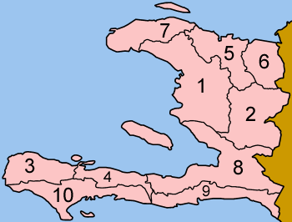
Our goals will start on the micro-level where we propose to work with one of Fonkoze’s larger branch in Gonaïves , which receives almost 10% of Haiti remittances. If Haiti is receiving over $1 billion annually in remittances, we expect that $100 million will be sent to the region near and around Gonaïves. Our goal for our first year is to match anywhere from 5-10% of remittances sent to Fonkoze in Gonaïves, which is equivalent to $5 to $10 million. The $5 to $10 million dollars would provide the initial funding for our RAF fund, which would form the primary funding for ORE’s agriculture development. Because the remittance market continues to grow and money is sent on a regular basis, our RAF fund will refill as remittances arrive and matched on a monthly basis. As shown in our table above, an additional incentive for donors to join our program is eligibility for tax-deductibles. The Rehabilitation of the Environment is a certified 501 (c) (3) public charity, which means that donors will save money by participating.

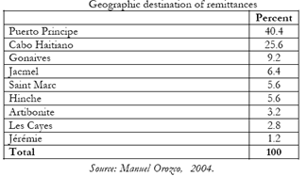
Gonaïves is in region 1 in the Arbonite district

Region of Focus: Gonaïves
With careful consideration, the northern city of Gonaïves was selected to be the starting location for our project with ORE and Fonkoze. We chose Gonaïves because it is a region with robust city infrastructure, granting easy access to markets and services while at the same time experiences high rural poverty and environmental damage. Though Gonaïves is just one of the many urban and rural areas that receive a consistent flow of remittances, we have chosen this area because of its strong potential for development. Gonaïves is a city of 200,000 people located on the northwest coast of Haiti. Importing seed and plants for farmers will not be a difficult obstacle because Gonaïves has a seaport and two main highways extending out of the city into the North and North West. Existing roads in the Gonaïves area will play a key role in our efforts, as reforesting Northern Haiti will require shipment of heavy material to the most damaged areas. Gonaïves was chosen not only for infrastructural conditions, but also because we saw that its extreme deforestation is preventing agriculture production. As a result of deforestation, soil has eroded and created geologically unstable conditions which threaten the homes and businesses. Revitalizing the Gonaïves region environmentally and implementing advanced cultivation methods will return the city to its former glory as a primary crop production center for all of Haiti.
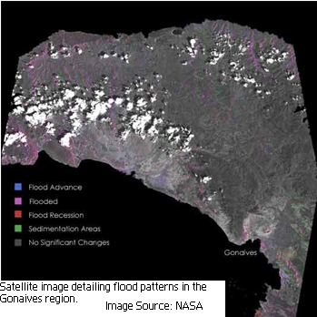
Haiti sits in the most active region of tropical storm activity in the Caribbean. On September 18th of 2004, Hurricane Jeanne hit Haiti’s North-western region. As a result, massive flooding and landslides devastated Gonaïves making this hurricane one of the worst natural disasters in Haiti’s history. Gonaïves was highly susceptible to extended flooding because the city sits in a geographic depression and the surrounding valley prevented any drainage of accumulated water. Mudslides destroyed the buildings and infrastructure of the city and caused 3,006 total deaths with 2,826 in Gonaïves. Official estimates of damage to the rural sector cited 70% of assets as damaged or destroyed. Despite all of these issues, Gonaïves has great potential for agriculture rehabilitation.
The immediate national and international response to the Jeanne disaster saved the city from complete destruction. There were relatively few riots and minor disturbances with armed gangs were quelled by Haitian and international security forces. The secure atmosphere allowed organizations to help many Haitian families. In the aftermath of the storm, the World Health Organization delivered 10,000 basic health kits to the area, the World Food Program distributed a total of 6,386 tons of food in and around Gonaïves, and USAID/OFDA airlifted 300 rolls of plastic sheeting along with 5,005 water containers to help those most affected. In addition to the large amount of supplies shipped in at the time of crisis, USAID continues to work in the Gonaïves area.
Although there are already NGOs working in the region to provide food and supplies, people are dependent on aid to survive. Our agricultural programs will use funds to provide people with the tools which allow them to be more self-sufficient and harvest their land with sustainable practices. Also, improving the soil would not only benefit Haitian farmers, but the city dwellers will be less vulnerable to catastrophic mudslides. Tree cover will help absorb water and prevent the kind of massive flooding to which deforested areas are prone. The northern Artibonite region holds great promise if developed quickly and expertly. Collaboration with ORE in identifying ideal seed types and high value plant varieties will maximize agricultural productivity for the once-fertile region.

Agriculture Goals for ORE
Examining the ecological damage in Haiti has led us to target four specific areas we believe require improvement and will lead to the greatest economic and social rewards. Haiti’s bare mountainsides and arid valleys must be rejuvenated. Though Haiti has excellent laws governing the conservation of trees, dwindling amount of forest land leaves little left to protect. First, we have identified Bamboo as a unique solution for the deforestation problem plaguing Haiti. Second, drip irrigation systems are ideal for small land plots and are easily developed and managed. Third, improving seed quality and availability will lead to greater crop yields and a movement away from subsistence farming towards commercial agriculture. Fourth, furthering ORE’s established market education program will raise optimism among Haitian farmers, increase income generation capabilities, and promote effective business relationships between producers, wholesalers and exporters.

Reforestation with Bamboo
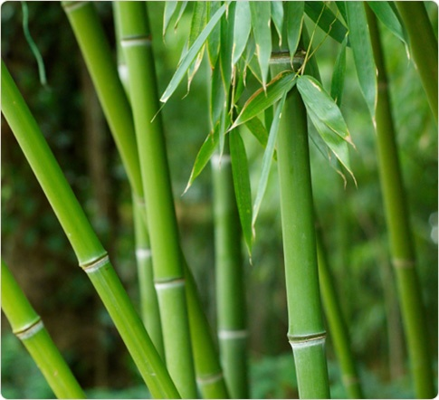
The effects of deforestation take a long time to reverse. Replanting trees will take years until they are large enough to be effective in preventing erosion and soil loss. However, Bamboo’s distinctive characteristics present an ideal solution for these problems. Bamboo grows the best in warm climates such as Haiti’s semi humid and humid zones, and it grows fast. Also, intricate roots systems grow underneath the shoots which lock in and retain soil. The purpose of the complex root system is that if a shoot is cut down or burned it will immediately grow again. The ability for the plant to constantly regenerate after being cut down makes it ideal for sources of renewable fuel. The plant can be used directly by the poor for construction, cooking utensils, boats, etc. There is also a high world demand for Bamboo and low levels of supply make the plant a sought after commodity on the global market.
Another positive benefit of Bamboo is the fact it does not require pesticide to flourish and can be grown on small plots of land. Pesticides, affordable to only a select few producers, can be very dangerous if they enter the ground water table or runoff into water sources used for consumption. With no need to purchase pesticide to grow Bamboo, little monetary investment is required from the Haitian farmer. A previous program initiated by USAID planted 200 Bamboo that were donated from Hawaii. Within four months, over 40,000 plants were grown and distributed around the country. Tall specimens of bamboo (15 - 25 feet tall) are sometimes available though always in short supply, cannot be shipped and cost from $250.00 to over $450.00. Therefore, for our purposes purchasing a fully grown bamboo would be ineffective. The most important part of a bamboo plant is not its height when you buy it as height can be a deceptive maturity indicator, as the most important part of the plant is the maturity of the rhizome stock. The rhizome stock is the living portion of the bamboo which grows underground. Most specimen-size plants (8 - 15' range) are priced from $120.00 to $180.00 on up based on size and species. The generic cost is $50 for a 5 gallon container. The most desirable option in respect to the acquisition of bamboo plants would be for organizations or donors to donate them.
Over the past 5 years, ORE has started a program to introduce and mass-propagate high quality bamboo cultivars suitable for building and handicrafts for the Haitian people. The program has quickly proved its worth as over 12,000 bamboo trees have grown from an initial stock of 150 plantings. An assortment of species is currently used by ORE in the southern area of Haiti. However, the most desirable species of Bamboo to introduce into northern Haiti is the Guadua angustofolia. This variety of Bamboo has been observed to have 21 cm daily growth. Within the first six months of growth the plant reaches a maximum height between 15 and 30 meters. The underground root system Bamboo grows in the superficial layer of the soil, located 20-50 centimeters below the surface, is the heart of the plant. Once properly cultivated, Guadua will provide a consistent and self replenishing supply to the Haitian people. Harvesting can begin six years after planting, though the environmentally beneficial effects are immediate. Tree cover is important for the ecosystem, and Guadua’s willingness to occupy disturbed areas makes this plant an ideal resource for the conservation of unstable soils. Though the Guadua variety reach their optimum development in the central region of the Andes thus restricting natural growth to Colombia, Ecuador and Venezuela, recent breakthroughs in bamboo cloning and engineering have produced species able to flourish in hardier conditions. Guadua is grown in groves, and educating farmers how to properly cultivate these groves for maximum productivity is important. The ideal mix in a Guadua grove is estimated to be 10% shoots, 30% young ones, and 60% mature trees with a density of 3000 to 8000 culms per hectare. A productive grove will yield 1,200 - 1,350 culms per hectare per year. Though many Haitians live on less than a hectare of land, even small groves can be productive and provide many benefits to farmers.

Drip Irrigation
Irrigation systems are another necessary tool for farmers to increase agricultural yields. Haiti’s farms require a type of irrigation system which conserves water due to the scarcity of water resources in the country. Drip irrigation is the solution to recurrent water scarcity. It is particularly useful in areas that have a low water supply. Because agriculture is practiced year-round, Haitian soils bear tremendous demands. Drip irrigation has the potential to enhance food productivity while preventing overexploitation of precious resources like soil and water. Efficient drip irrigation systems loose little or no water to runoff or evaporation since the tubes deliver the water directly to the root of the plant. Drip irrigation is the slow, even application of low pressure water to soil and plants using plastic tubing placed directly at the plants root zone. Crops irrigated by drip systems show water savings of up to 50 percent. The benefits drip irrigation includes higher crop yields, reduced labor costs, and efficient use of water. Drip irrigation systems cost approximately 500$ to 2000$ per acre which is relatively expensive but, the systems have low rates of failures and does not need to be replaced. Drip irrigation would be a very effective tool in rural Haiti to aid agricultural production.

Improving Seed Quality
Seed quality is another important issue to our development program. Currently, the majority of Haitian farmers are not educated in how to acquire high yield seeds nor do they understand the nuances of seed selection. Poor seed quality can prevent farmers from generating a productive crop. ORE is committed to providing high-quality seeds which are adapted to the adverse local conditions of many rural farms. Generally, farmers are forced to work in areas of low soil fertility, diseases and lack of irrigation. Many of the imported hybrid seeds provide goods harvests under good conditions but the conditions in Haiti require more durable seeds. ORE has set up a seed processing facility in Camp Perrin where we produce approximately three hundred tons of commercial seeds a year, using material from our ongoing seed research and improvement program.

Market Education
An essential part of our development goal is the education of the Haitian poor. ORE offers a unique, hands-on education program for farmers run by a dedicated staff. The programs help Haitian farmers focus on increasing productivity and marketing their crops. The courses include not only classroom lectures but, on-site training and assistance. The education programs also provide follow-up technical assistance programs. There are four separate courses offered: Propagation, Production, Post-Harvesting, and Marketing. Propagation teaches farmers staple crop seed production which includes learning how multiply and graft commercial seeds. The production course revolves around establishment and management of orchards. Finally, the post-harvest and marketing education teaches farmers how to harvest and store efficiently to be able to effectively sell their crops. Education is important to achieving a sustainable agricultural future by addressing the human side of agricultural productivity. No matter how much capital the farmers are given to work with, if their personal techniques are not conducive to maximizing efficiency then agricultural growth will not occur. Our development proposal supports the education programs which ORE provides.

Financing Our Development Proposal:

Remit and Match
In order to successfully run any non-profit organization or program there must be initial funding due to operating costs. We are bringing the program of Remit and Match to Fonkoze and ORE, therefore we expect to meet our own operating expenses efficiently and responsibly. We plan on raising funds for Remit and Match by applying for a partnership grant with the International Fund for Agricultural Development (IFAD), an agency affiliated with the United Nations. IFAD is currently accepting program proposals by May 2008 to partner with their Financing Facility for Remittances (FFR). The FFR is a US $13 million multi-donor facility whose mission is to enhance remittances as a development tool and its goals are to reduce poverty by leveraging remittances and migrant capital for development of rural areas in developing countries. More specifically, it aims to (i) reduce the transfer costs of remittances to rural areas; (ii) promote institutional partnerships; (iii) bank the ”unbanked” rural population; (iv) promote innovative remittance and financial services; and (v) further productive rural investment of migrants in their countries of origin. The objective of Remit and Match meet every aim listed by the FFR in addition to several others listed on their application. Another eligibility requirement is non-profit legal status, which includes an academic institution. As students and social entrepreneurs of Lehigh University we have the credibility and confidence that our program, Remit and Match, is qualified to receive grants from the Financing Facility for Remittances.
If selected to participate in FFR’s partnership, Remit and Match will be given a ceiling of $250,000 per project where the implementation period should not exceed 24 months. This money will be beyond sufficient for the creation of our website and initial marketing costs. If our operating costs exceed this amount, we will look for alternative ways to raise money.
Revenue
Contributions | 417,363
Program Services | $0
Investments | $0
Special Events | $0
Sales | $0
Other | $0
TOTAL REVENUE | $17,363
TOTAL EXPENDITURES | $17,229
Net Gain/Loss | $134

ORE:
The difference between revenues and expenditures for an organization allow potential investors to understand the wellbeing of the company. If the total amount of expenditures exceeds the total amount of revenues then the company is in poor shape. Last quarter, ORE experienced a positive net gain of $134 which proves the company, although the revenues are small, is financially stable enough to cover costs. An influx of capital will allow ORE to expand operations while focusing on the needs of Haitian farmers. The cash infusion is an incentive for ORE to partner with us and Fonkoze.

Revenues, ORE 2007

Proposal Conclusions
Haiti is the poorest country in the western Hemisphere. It is a country plagued by a corrupt government, decades of environmental abuse, an uneducated and unmotivated populace and a severe lack of investment in the economy. Our proposal identifies the agricultural sector of Haiti as having the most potential for growth and developmental impact. Raising income levels for the rural poor fits our ideological goals of advancing living standards in Haiti. Recent rises in global food prices and Haiti’s dependence on imports provided us with the impetus to utilize Haiti’s strong position in the remittance market to establish an efficient and sustainable production of food. As the rural economy grows and environmental problems are solved, Haiti will experience a social transformation. If our development proposal is accepted, we believe that it will have a multiplier effect by increasing standards in health, education and business. Until Haiti’s government can stabilize, we urge Fonkoze and ORE to join our mission in leveraging the remittance market to build a sustainable foundation for Haiti’s future.

Rapley p. 28
www.cia.gov/library/publications/-world-factbook/goes.he.html
http://www.infoplease.com/ipa/A0107612.html
http://www.giles.34sp.com/biographies/papadoc.html
World Bank, “Haiti: The Challenges of Poverty Reduction”, Report No. 17242-HA, August (1998)
https://www.cia.gov/library/publications/the-world-factbook
Seers, Dudley. "The Meaning of Development." Int Dev Rev (1969)
FAFO- Determination of a Poverty Line for Haiti 8
FAFO- Determination of a Poverty Line for Haiti 8
Egset, Willy. "A profile of poverty in Haiti." FAFO 2004
http://www.giles/34sp.com/biographies/papadoc.htm
IMF Working Paper: Growth in the Dominican Republic and Haiti: Why has the Grass Been Greener on One Side of Hispanola? ( Laura Jaramillo and Cemile Sancak 2007)
Transparency International. 2007 Corruption Perception Index. 2007. http://www.transparency.org/policy_research/surveys_indices/cpi/2007
Definition: Prevalence of child malnutrition (weight for age) is the percentage of children under five whose weight for age is more than two standard deviations below the median reference standard for their age as established by the World Health Organization. Figures are based on children under age three, four, and five years of age, depending on the country. Source: World Health Organization
http://devdata.worldbank.org/external/CPProfile.asp?SelectedCountry=HTI&CCODE=HTI&CNAME=Haiti&PTYPE=CP
World Bank, Haiti Social Analysis, 2006
World Bank, Haiti Social Analysis, 2006
IMF Working Paper- Growth in the Dominican Republic and Haiti
http://www.travelinghaiti.com/info/haiti-statistics.asp
http://www.britannica.com/eb/question-251961/5/density-sq-mi-Haiti
https://www.cia.gov/library/publication/the-world-factbook/geos/ha.html
International Fund for Agricultural Development (IFAD), “Sending Money Home” 2006.
Inter-American Dialogue commissioned by World Bank, “Understanding the Remittance Economy in Haiti”. March 2006.
World Bank
World Bank- Haiti Economic Memorandum
http://www.cmaj.ca/cgi/content/full/170/9/1379
http://www.cmaj.ca/cgi/content/full/170/9/1379
www.doctorswithoutborders.org
www.DirectRelief.com
www.grassrootsonline.org
4 www.Outreach-International.org
www.Outreach-International.org
WDI Country Statistics
World Bank – Haiti Economic Memorandum
https://www.cia.gov/library/publications/the-world-factbook/geos/dr.html
World Bank Haiti Economic Memorandum
World Bank- Haiti Economic Memorandum
WDI country statistics
World Bank Development Economics, Development Data Group (DECDG)
WDI
CIA World Factbook
IMF
WDI
WDI
WDI
http://www.ijdh.org/pdf/headline8-15-0b.pdf
https://www.cia.gov/library/publications/the-world-factbook/geos/ha.html
http://www.photius.com/countries/haiti/economy/haiti_economy_expenditures.html
http://www.ijdh.org/pdf/headline8-15-0b.pdf
http://dev.prenhall.com/divisions/hss/worldreference/HT/defense.html
http://economics.about.com/od/economicsglossary/g/tfp.htm
IMF Working Paper: Growth in the Dominican Republic and Haiti: Why has the Grass Been Greener on One Side of Hispanola? ( Laura Jaramillo and Cemile Sancak 2007)
http://ucatlas.ucsc.edu/fdi/fdi.html
http://www.usatoday.com/money/world/2004-02-26-haiticon_x.htm
www.usip.org (United States Institute of Peace Special Report)
Human Development Reports Data
www.investopedia.com
CIA- The World Factbook
https://www.cia.gov/library/publications/the-world-factbook/geos/ha.html
USAID Figures, 1995
http://www.britannica.com/eb/article-54468/Haiti
http://www.ifad.org/operations/projects/regions/PL/HT_all.htm
http://www.nytimes.com/2008/04/10/opinion/10thu1.html
http://www.nytimes.com/reuters/world/international-haiti-migrants.html?scp=3&sq=Haiti&st=nyt
http://www.nytimes.com/2008/04/13/world/americas/13haiti.html
http://ipsnews.net/news.asp?idnews=42011
http://www.haitiwebs.com/emagazine/content/view/275/155/lang,en/
http://www.haitiwebs.com/emagazine/content/view/275/155/lang,en/
http://www.haitiwebs.com/emagazine/content/view/275/155/lang,en/
http://www.haitiwebs.com/emagazine/content/view/275/155/lang,en/
http://www.fonkoze.org/
http://www.fonkoze.org/aboutfonkoze/history.htm
http://www.fonkoze.org/aboutfonkoze/fonkozeusa.htm
http://www.oreworld.org/background.htm
Inter-American Dialogue commissioned by World Bank, “Understanding the Remittance Economy in Haiti”. March 2006.
Inter-American Development Bank- Multilateral Investment Fund. Remittances 2007: “A Bend in the Road or a New Direction.”March 2008.
Inter-Development Bank- “Remittances 2007:A Bend in the Road or a New Direction” March 2008.
Inter-Development Bank- “Remittances 2007:A Bend in the Road or a New Direction” March 2008.
Inter-American Dialogue commissioned by World Bank, “Understanding the Remittance Economy in Haiti”. March 2006.
WDI 2006
http://www.iadb.org/mif/
http://www.iadb.org/mif/
RAF is a fund that would is in the name of ORE within Fonkoze
www.kiva.org
http://www.heifer.org/site/c.edJRKQNiFiG/b.204586/k.9430/Gift_Catalog.htm?msource=kw1844
ACCION remittances
http://www.guidestar.org/pqShowGsReport.do?partner=networkforgood&npoId=76445
http://www.unicef.org/infobycountry/haiti_28308.html
http://www.reliefweb.int/rw/rwb.nsf/AllDocsByUNID/50782bc421096dabc1256f2900599841
http://www.guaduabamboocostarica.com
http://www.haitiwebs.com/emagazine/content/view/297/155/lang,en/
http://www.haitiwebs.com/emagazine/content/view/297/155/lang,en/
http://www.oreworld.org/seed.htm
http://www.oreworld.org/seed.htm
http://www.ifad.org/ruralfinance/remittance/call.htm

