Answers to Assignment #5 (Varshneya)

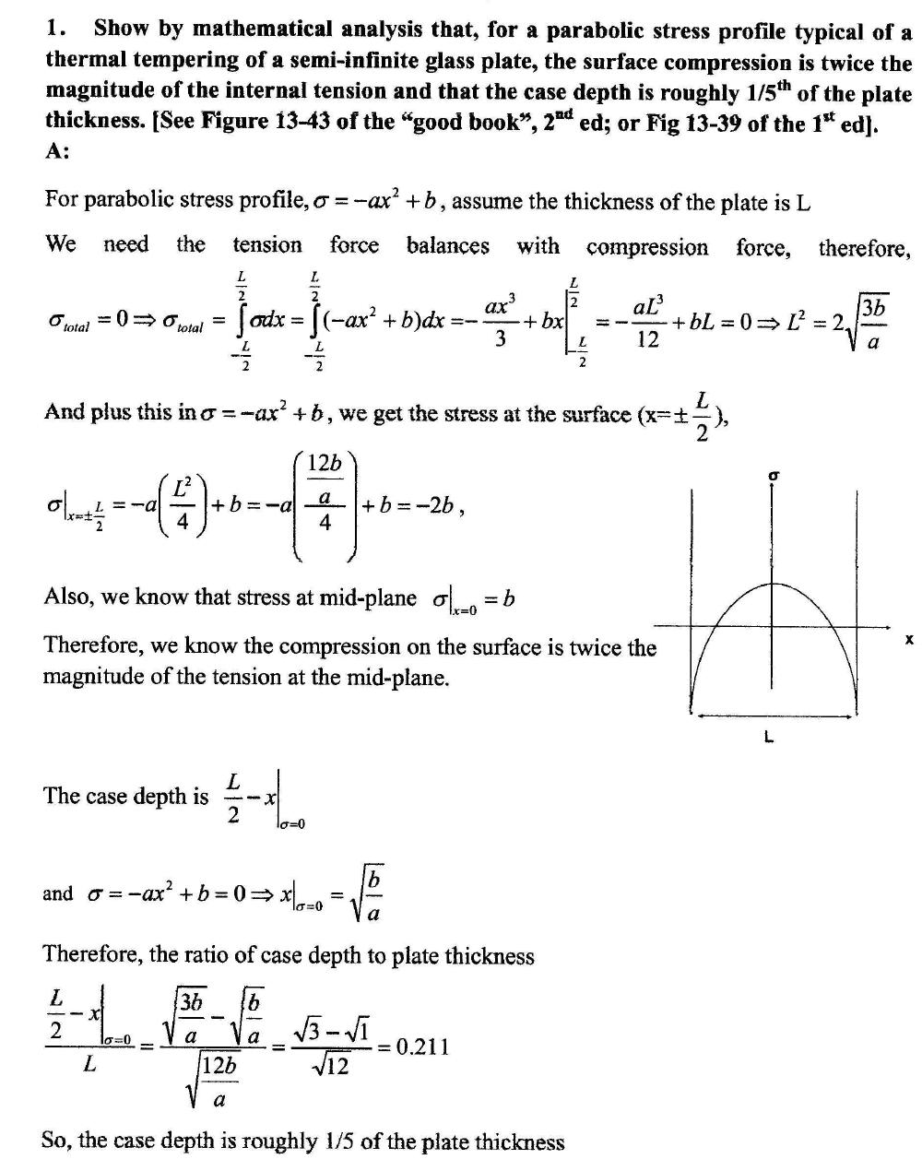

Question (2)
Very short question: Show using Figure 13-45 (2nd ed) OR Figure 13-41 (1st ed) that, even at the highest of the heat transfer coefficient, a 2 mm thick glass plate develops only about 10 MPa surface compression. [Comment: Hence, thin glass products can not be meaningfully strengthened by thermal means].

The answer to this question was not as simple as I thought!
The question really is, “What would be the ratio of the temperature differential between the mid-plane and the surface in a thinner plate to that obtainable in a thicker plate?”

You could have looked at Figure 13-44 and plotted the “degree of temper” vs plate thickness for the case of “natural cooling”. You would have found a near-enough straightline proportionality (passing thru 0,0). Hence, from 13-45, if a 6mm glass plate develops 2400 nm/cm of optical retardation at h = 0.0132 cal/cm2/sec then a 2mm plate would develop 1/3 of 2400, i.e. 800 nm/cm of retardation = 31.2 MPa center tension, i.e., about 65 MPa surface compression. [That is substantial and, of course, does not agree with my initial estimate of ~10 MPa].

The problem in the above argument, however, is that what applies to “natural cooling” does not apply to “forced cooling”!

Some help is obtained by looking at Kingery 2nd edition pages 838-839; equation (16.20). It shows that ΔT is proportional to φr_{m}² , where is the cooling rate and rm is the plate half-thickness. If you argue that you will maintain a constant cooling rate, then, the is a factor of 1/9 lower; i.e. the degree of temper will be 1/9th of 2400 nm/cm (= 10.4 MPa). The unfortunate problem in this argument is that, for a thinner plate, the cooling rate is likely much larger. (You could imagine that the heat transfer coefficient is maintained constant, hence, the cooling rate itself will be inversely related to r_{m}, which brings us to a ratio of 1 to 2 between the degree of temper developed and the plate thickness.

I have, therefore, accepted all reasonable thought. However, those of you who calculated the stress at 1mm away (2 mm overall thickness) from the mid-plane using the parabolic stress profile equation for a 6mm thick plate are simply wrong. In a 6mm plate, the stress at 1mm away from midplane would be tensile.

Question (3): Assume that a 6 mm plate of 15% Na₂O.8%CaO.1% MgO.2Al₂O₃.74%SiO₂ (wt%) glass is ion exchanged by immersion in molten KNO₃ at a temperature well below the strain point of glass. For simplicity, assume that the K⁺ ion concentration drops off linearly to zero starting from a 100% exchanged surface. Calculate the surface compression and the center tension when the penetration distance is (a) 20 microns and (b) 40 microns. Measured values of surface compression in typical commercial SLS glass are often around 500-600 MPa. Comment on the difference, if any. [Young’s modulus E = 70 GPa and Poisson’s ratio ν = 0.22. You will need to use the SciGlass CD attached to the inside of the goodbook’s back cover to calculate density of the parent and the K⁺-exchanged glasses. Kindly also note that equation 14.53 in the “new testament” should read σ in place of e. Equation is correctly given in the “old testament”.]

Answer: This actually turned out to be a pretty well-formed question. You should have taken the time to load SciGlass CD on your computer and learned to fool around with it.

So, after you load the Student version, click “Display” and the click “Calculator” in the display menu. The calculator window opens and you first click the “wt%” (because that is how the composition is given) and then input the various oxides and their percentages. In the property group draw-down menu, click “density” and the in “property” menu, click Molar volume. At this point, it is worth clicking “mol%” and you will find that the composition converts to mol% basis in a jiffy [note that mol% Na2O will be 14.57%]. Worth writing that mol% composition down somewhere. I used Gan Fuxi-74 method to calculate the density. In the “Unit” window, click cm3/mol. And then click “run” to give molar volume of the parent glass = 24.43 cc. Now, go to replace Na2O by K2O in the oxides window. You will need to input 14.57 as the mol% K2O content corresponding to 100% exchange on the surface. Click “Run” again, and you get the molar volume of the fully exchanged composition (at the surface) as 26.44 cc.

Hence, B = ΔV/[3V.ΔC] = (26.44 – 24.43)/(3*24.43*14.57) = 0.001875/mol% exchange.

Note the units as per mol% exchange. On the surface where C = 14.57 mol%, the BC term will simply give you 0.0273.

You could now assume that B is independent of C (i.e., there is no significant “mixed-alkali dependence) on molar volume, which is taught by authors including Dr. Steve Feller. The second term of Eq 14.53 is the center tension and can then be computed by integrating from the center (x =0) to x = +L (half-thickness = 3000 μm ) as [E/2(1-)L]* 2* 0.001875*[14.57*20 μm/2] = 8.16 MPa. The last expression in the square brackets is the area of the triangle for a 20 μm linear penetration depth. The surface compression is the first term of Eq 14.53 minus the center tension. Since the first term = [E/(1-)]* 0.001875*14.57] = -2.45 GPa. [I stuck a minus sign to denote compression.]
You can readily show that, for a 40 μm penetration distance, whereas the center tension roughly doubles, the surface compression does not decrease significantly.

The most important source of discrepancy with measured values is the assumption of perfect elastic expansion in the calculation of B. Lately, I have been trying to tell the world that the glass network expands elastically first and then deforms plastically which prevents the buildup of stresses (much like the case of an indentation on glass!).

