Neutron and X-ray Scattering Homework
Due Wednesday April 4 2007

Please do the work in this document and submit the work by attaching this to the assignment and pressing the submit button. That way I can assign a grade directly. Please rename the file n&X HomeworkXYZ.doc where XYZ are your initials Thanks.

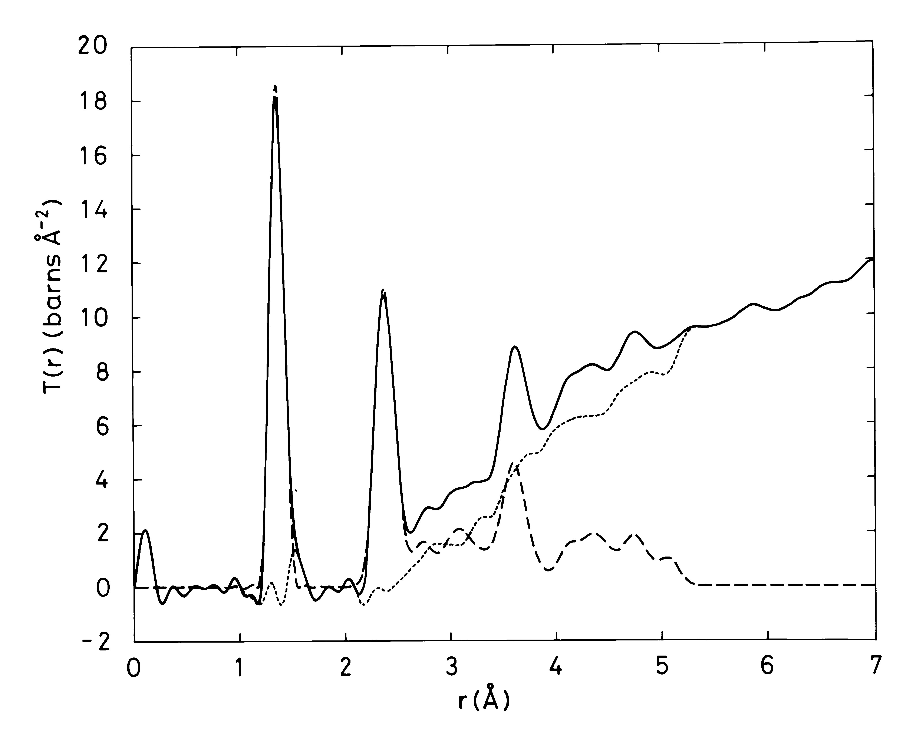
Above is a correlation function of boron oxide from Adrian Wright’s group. Use it to calculate all of the pair distances in the boroxol ring shown below the identify the peaks on the diagram above with arrows that correspond to the distances in the boroxol ring (black is boron and white is oxygen) Hint: remember the first peak can give you the B-O bond length.

2) Chaclogenide glasses tend to range from polymeric to network-like dependent on the average coordination number. Even in the network form though, they don’t obey Zachariasen’s rules and there are believed to be edge sharing GeS₄ tetrahedra in germanium sulfide containing glasses. Using the correlation function below from A.C. Hannon and B.G. Aitken to determine whether this is true or not. Now the glass in the correlation function is not just germanium sulfide so I will tell you that the bond length in pure germanium sulfide glass is 2.217Å because the first peak is actually a combination of first neighbor distances. I have included the diagram below which gives you a little trick for helping to calculate distances in

tetrahedra:
