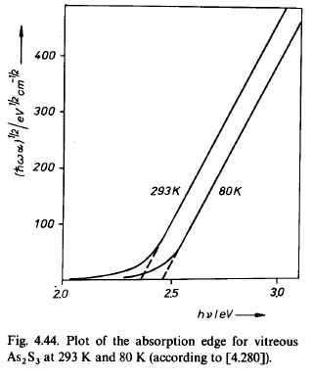
Bandgap vs Temp an Inquiry and an Exercise
This problem set was prepared by Bill Heffner. Thus, any questions or comments should be sent to wrh304@lehigh.edu . Submit your solution to Prof. Choi at: ykc310@lehigh.edu .
In lecture 6, slide 11 we examined the effect of temperature on the absorption edge and corresponding bandgap of vitreous As2S3. (Figure from Feltz, p 380). One student asked about the origin of this temperature dependence, so let us explore the question together through an exercise.
a) Estimate the temperature dependence of the bandgap (dE_{g}/dT ) for this material and compare it to that of the common III/V optoelectronic material GaAs (Kasap p 149 gives -4.5 x 10⁻⁴ eV/K for GaAs semiconductor or calculate your own using http://ecee.colorado.edu/~bart/book/eband5.htm ).

b) One explanation for the temperature dependence of the bandgap could be simply from the thermal expansion of the material and the resulting change in bandgap with increased atomic spacing. In this case the temperature dependence of the bandgap can be estimated from the dependence on lattice spacing (a) and the linear thermal expansion (α) using: dE_{g}/dT = a*dE_{g}/da * . Show how we obtain this equation (a short intuitive derivation only).

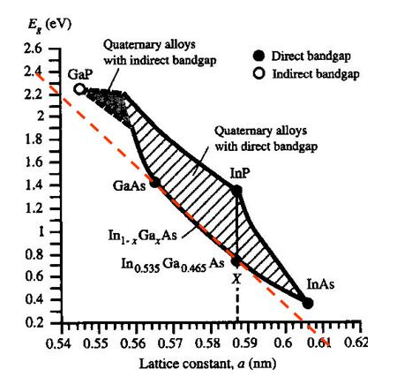
c) Optoelelctronic engineers design their devices using bandgap vs. lattice constant plots such as the one shown here (see Kasap, p 155). Use the plot to estimate the dE_{g}/da for GaAs. To do so just draw a straight line through GaAs, roughly parallel to the lower portion of the shaded region as an estimate as shown.

d) From the value of dE_{g}/da estimated above, calculate the estimated value of the dE_{g}/dT for GaAs. You will need the α value or an estimate of the same. (See e.g.,
http://www.ioffe.ru/SVA/NSM/Semicond/GaAs/thermal.html
How does your estimate compare to the dE_{g}/dT value for GaAs given in part a?

e) For the As2Se3 glass, Felty and Meyers (1967) give a linear thermal expansion value of 20.7 x 10-6 /K. Use this value and repeat the calculation of part d, using the same dE_{g}/da found for GaAs. How does this estimate of the dE_{g}/dT compare with that calculated in part a?

Note: S. A. Lourenco¸et. al. provide an analysis of this issue of origin of T dependence of the bandgap in III/V materials and in their introduction state “The temperature dependence of the band-gap energy, in special, can be explained by the sum of two distinct mechanisms: the electron-phonon interaction and the lattice thermal expansion. The main contribution to the temperature dependence of the band-gap energy is attributed to electron-phonon interactions.” Their overall conclusion is that “the thermal expansion contribution to GaAs, at room temperature, represents 21% of the total shift of the excitonic transition energy”.
S. A. Lourenco, et. al. Brazilian Journal of Physics, vol. 34, no. 2A, June, 2004. Thermal Expansion Contribution to the Temperature Dependence of Excitonic Transitions in GaAs and AlGaAs
available at: http://www.sbfisica.org.br/bjp/files/v34_517.pdf
For thermal expansion data on As2Se3 take a look at: E. J. FELTY and M. B. MYERS,
Journal of the American Ceramic Society, Volume 50, Issue 6, pages 335–336, June 1967, “Thermal Expansion of Arsenic-Selenium Glasses”.

