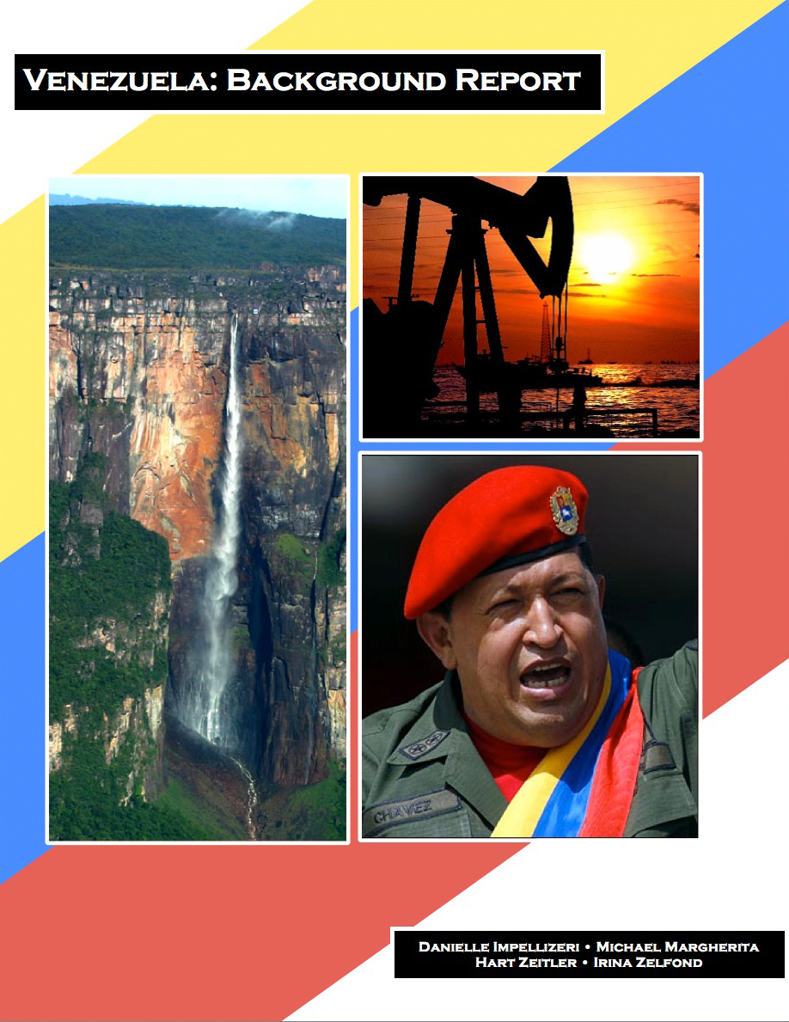
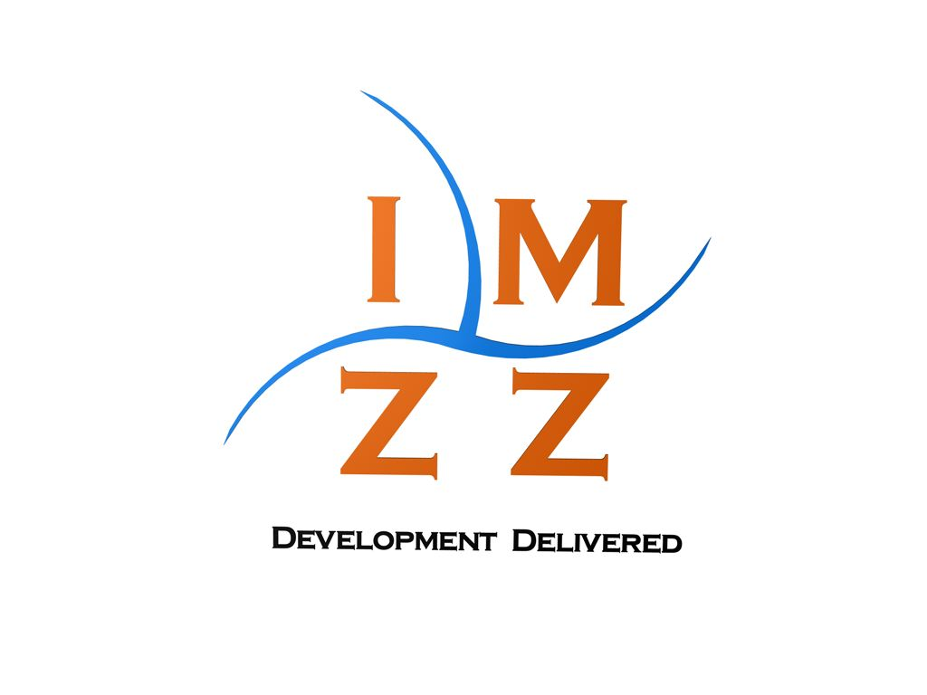
Policy Proposal
Table of Contents
Introduction Letter 4
Definition of Development 5
Education Background 6
Literacy Rates 6
Primary School Enrollment 9
Secondary School Enrollment 11
Progression and Completion of Education 13
Resource Devotion to Education 13
Identifying the Problem 16
Justification of Focus 19
Reasons for the Problem 22
Returns to Secondary Education 22
Quality of Secondary Education 25
Perception 26
Policy Proposal 28
Objectives 28
Improve Quality of Education 28
Increase Technical Training 29
Enhance Perception 30
Funding & Cost 32
Concluding Remarks 34
Appendix A 35

Introduction Letter
Honorable President Chávez,

Allow us to thank you for the opportunity to work in your beautiful country of Venezuela. Here at IMZZ Development, we are fully committed to helping Venezuela achieve its development goals. We are particularly excited by this opportunity, as we believe conditions within Venezuela are conducive to improving the lives of its citizens. We applaud you for making great strides in working towards a better future for your people, especially in the areas of basic literacy and infant mortality. We have noted your dedication to the Venezuelan people, and believe we can help push forward development within the nation for the benefit of all.

While analyzing Venezuela and the current opportunities for development, we have found that education improvements are the most promising. We would like to present you with a proposal to build upon the foundation you have already created in Venezuela regarding education. What follows is our proposal, and we ask that you take our suggestions into consideration, as we believe they will have a profound positive impact on your great nation. Thank you again for this opportunity, and we look forward towards working with you to create a brighter future for Venezuelans.

Sincerely,
Danielle Impellizeri
Michael Margherita
Hart Zeitler
Irina Zelfond
Founders, IMZZ Development

Definition of Development
Assessing the level of development of a nation requires a definition of development and metrics to quantify this definition. In a word, development is opportunity. Opportunity, however, is not a universal concept to be applied to every nation; rather, the core meaning of opportunity exists on a spectrum. To any given country we can assign one of three broad levels of development. Each of these levels is defined by different requisites that we believe enhance the opportunities available to a country’s citizens. It should be noted that ours is not a rigid structure; nations gradually move within and between the three levels of development. Furthermore, it is not necessary to completely fulfill the requirements of one level before progressing to the next; indeed, the process of development is quite fluid. As a final note, we maintain that these development processes must not be temporary or fleeting, but rather dynamic, self-sustaining, and continuous.
The first level, that of the least developed country, is to ensure that the basic needs of the population are met. It is the ability to move from a subsistence lifestyle to one that is both progressive and sustainable, a lifestyle in which an individual can look beyond the provision of the basic necessities of life towards a more expansive future. The second level, that of the moderately developed country, is to improve the quality and efficiency of the systems that function to provide those basic necessities. The third level, that of the developed country, is to ensure that the previous requisites of opportunity are available to every citizen. It is not enough that a simple majority has its basic needs met and is therefore exposed to increased opportunity. Instead, this level requires substantial efforts to deliver the benefits of development to everyone.
Opportunity, however, is an abstract concept, and thus extremely difficult to quantify. Of four indicators for encapsulating development (economic growth; economic growth coupled with social change; human development; and liberation) human development best reflects our definition. As such, we have determined that Venezuela currently resides somewhere between the first and second level of development. While many of the most basic needs of the population have been met, Venezuela has not yet achieved the possible maximum of quality and efficiency in terms of its internal systems, and most particularly of its educational system.

Education Background
Education is a prerequisite of opportunity. An uneducated or undereducated population cannot sustain development. The most effective measures of education within a population include literacy rates and primary and secondary school enrollment rates. The rates of progression and completion of education, as well as the amount of public expenditures directed toward education, are similarly significant in determining the state of a country’s educational system.

Literacy Rates
Literacy rates can be a useful indicator of human development; they illustrate how deeply education has penetrated society. If, for example, literacy rates are low across various dimensions (age, gender, class, race, etc.), we can assume that there is limited opportunity and most likely high inequality. The existence of high literacy rates can indicate a certain degree of development in education and allow us to evaluate the educational system overall. While high literacy rates do not necessarily signify that an educational system is effective, they are an essential starting point from which an educational system can progress.
Education at its most basic level has improved in Venezuela. As Figure 1 illustrates, literacy rates in Venezuela have increased across both the age group and gender dimensions over the period 1990 to 2007. The most impressive increase, 5.9%, occurred in the adult age group among females; the least impressive increase, 2.4%, occurred in the youth age group among females. The overall average rate of improvement in literacy across both the age group and gender dimensions over this period is 4.15%, which translates to an increase of roughly 0.23% per year.
Education at its most basic level has been relatively successful in Venezuela in comparison to similar countries, as illustrated in Figure 2. Venezuela’s literacy rates are slightly higher than both the regional and comparable country averages (see Appendix A).
Figure 1: Percentage of Literate Adults and Youth in Venezuela in 1990 and 2007

Figure 2: Percentage of Literate Adults and Youth in Venezuela, the region, and comparable nations in 2007

Primary School Enrollment
Primary school enrollment rates are an important indicator of development in that they represent a population’s access to the most basic foundations of comprehension and understanding.
Over the period 1999 to 2007, Venezuela experienced an initial surge in NER, followed by a period of relative stagnation. As shown in Table 1, primary school enrollment rates underwent significant change in Venezuela over the period 1999 to 2002, with each group (total, male, and female) experiencing a 7% increase in primary school enrollment. However, primary school enrollment rates underwent little to no change over the period 2002 to 2007, with the male group experiencing no change at all, and both the total and female groups experiencing a 1% decrease.
Venezuela’s performance in terms of primary school enrollment is relatively on par with that of similar countries. Figure 3 shows that primary school enrollment rates in Venezuela are high at 92%, though this rate is two percentage points less than the regional average of 94%. In terms of comparable nations, Venezuela, with a total primary school enrollment rate of 92%, is again two percentage points less than the average of 94%.

Table 1: Primary School Enrollment Rates in Venezuela in 1999, 2002, and 2007
Primary School Enrollment Rates |  | 1999 | 2002 | 2007
GER (%) | Total | 100 | 106 | 106
 | Male | 101 | 108 | 107
 | Female | 99 | 105 | 105
NER (%) | Total | 86 | 93 | 92
 | Male | 85 | 92 | 92
 | Female | 86 | 93 | 92

Figure 3: Primary School Enrollment Rates in Venezuela, the region, and comparable nations in 2007

Secondary School Enrollment
Secondary school enrollment rates are another important indicator of development in that they demonstrate a population’s access to an education that is focused on future opportunities, such as employment.
As shown by Figure 4 below, secondary school enrollment rates in Venezuela have shown steady improvement over the period 1999 to 2007. In almost every instance, Venezuela experienced an increase of ten or more percentage points. For example, from 1999 to 2002, total secondary school enrollment increased from 47% to 57%, and from 2002 to 2007, increased from 57% to 68%. However, it is important to note that, while these increases are to be commended, total secondary school enrollment remains fairly low at 68% as compared to total primary school enrollment at 92%. Figure 5 illustrates that the secondary school enrollment rate is slightly less than the regional average of 71%.
Figure 4: Secondary School Enrollment Rates in Venezuela in 1999, 2002, and 2007

Figure 5: Secondary School Enrollment Rates in Venezuela, the region, and comparable nations in 2007

Progression and Completion of Education
Statistics related to the progression and completion of education can serve to demonstrate the effectiveness of a country’s educational system. Table 2 provides information on the progression and completion of education in Venezuela in 2000 and 2008, unless otherwise noted. In Table 2, the International Standard Classification of Education measures school life expectancy as the expected duration of study for a typical student. Educational progression and completion in Venezuela is demonstrably strong, with 98% of students enrolling in the last grade of primary school in 2007. Furthermore, 95% of students made a successful transition from primary school to secondary school in 2007; this transition rate, however, decreased from a rate of 99% in 2000. At the same time, the percentage of students who repeat any grade in either primary or secondary school decreased significantly and school life expectancy increased from 10.5 years in 2000 to 14.2 years in 2008.
Table 2: Progression and Completion of Education in Venezuela in 2000 and 2008
Progression and Completion of Education | 2000 | 2008
Gross Intake Rate to Last Grade of Primary (%) | - | 98 (2007)
Percentage of Repeaters, Primary (%) | 7 | 3
Percentage of Repeaters, Secondary (%) | 10 | 3
Primary-to-Secondary Transition Rate (%) | 99 | 95 (2007)
School Life Expectancy ISCED 1-6 (Years) | 10.5 | 14.2

Resource Devotion to Education
Overall resource devotion to education can be helpful in understanding the degree to which a government is involved in the educational process. If, for example, a government spends a relatively high percentage of its GDP on education, and if those expenditures are reflected in high literacy and/or enrollment rates, it may be assumed that government spending on education is being used efficiently and appropriately. Table 3 below provides information on the resources devoted to education in Venezuela in 2007, including public expenditure on education and the distribution of public expenditure per level. It is important to note that public expenditure on secondary education is approximately half of public expenditure on primary education, 17% and 32% respectively. Furthermore, tertiary expenditure, at 43%, is significantly higher than both primary and secondary expenditure. Indeed, Seelke has argued that most Latin American governments have devoted a much larger percentage of their education budgets to funding primary schools and subsidizing public universities rather than secondary schools. It is entirely possible that this concentration of spending has influenced enrollment rates in Venezuela, and this disparity in spending may be an area in which Venezuela could seek to improve, i.e. redistributing funds more efficiently among the various levels of education.
Table 3: Resource Devotion to Education in Venezuela in 2007
Resource Devotion to Education | 2007
Public Expenditure on Education as % of GDP | 3.7
Distribution of Public Expenditure per Level (%)
Pre-Primary | 7
Primary | 32
Secondary | 17
Tertiary | 43
Unknown | 1

In order to comprehend the overall significance of Venezuela’s public expenditure on education as a percentage of GDP, we examine that same percentage in various countries throughout the Latin American and Caribbean region. As shown in Table 4 below, Venezuela devotes only 3.7% of its GDP to public expenditure on education, while Cuba devotes 13.3%, though Cuba is itself an exception to the general tendencies of the region. On average, and excluding Cuba due to its status as an outlier, countries in Latin America and the Caribbean devote 4.3% of GDP to public expenditure on education, slightly higher than Venezuela’s 3.7%.
Table 4: Public Expenditure on Education as % of GDP in the Region in 2007
Country | Public Expenditure on Education as % of GDP in 2007
Cuba | 13.3
St. Vincent and the Grenadines | 7.0
Barbados | 6.9
Guyana | 6.1
Jamaica | 5.5
Belize | 5.1
Aruba | 4.8
Costa Rica | 4.7
Colombia | 4.1
Dominica | 4.1
Venezuela | 3.7
Chile | 3.4
British Virgin Islands | 3.1
El Salvador | 3.0
Guatemala | 3.0
Peru | 2.5
Dominican Republic | 2.2

Identifying the Problem
We have identified low secondary education enrollment as the major problem that needs to be addressed in Venezuela. While Venezuela has successfully achieved a generally well educated population as exhibited by relatively high literacy rates and high primary education enrollment rates, we believe that secondary education enrollment rates are significantly lower than expected given the prevalence of primary education. Based on comparisons with countries that have similar GDP per capita levels, Venezuela lags behind in secondary education enrollment. Table 5 shows the countries with the closest GDP per capita levels to Venezuela’s and their respective average secondary education enrollment rates. Venezuela ranks the lowest among this rate in the time period observed.
Table 5: Secondary Education Enrollment Rates for Similar GDP per Capita Countries

Country | GDP per Capita  (2010 USD PPP) | Secondary Education Enrollment  (1998-2008 average)
Iran | 11,665 | 75.11%
Belarus | 12,260 | 86.40%
Bulgaria | 12,392 | 87.79%
Panama | 12,504 | 62.57%
Uruguay | 12,734 | 67.07%
Venezuela | 12,804 | 59.61%
Botswana | 13,391 | 60.68%
Turkey | 13,920 | 69.77%
Romania | 14,064 | 77.94%
Malaysia | 14,215 | 67.23%

As our vision of development is closely linked with opportunity, we believe focusing on increasing secondary education enrollment will have a strong positive impact on overall development in Venezuela. While primary education is a crucial element of society, it is with secondary education that a society can start to truly flourish and show indications of progress. Secondary education in its best form should prepare individuals for a life that brings value not only to themselves but also to society. In other words, secondary education has great positive externalities as individuals gain the ability to make a contribution to society after completing this level. By focusing on increasing enrollment rates of secondary education, Venezuela would be able to extend opportunity to more individuals.
In addition to the benefits widespread secondary education would bring to Venezuelan individuals, there are also general macroeconomic benefits it would bring to Venezuela. A 2008 joint study conducted by the International Institute for Applied Systems Analysis (IIASA) and the Vienna Institute of Demography (VID) emphasizes the significance of education in a country’s economic development. Specifically, successful secondary education can prove to generate the greatest results in terms of economic growth. With larger numbers of the population receiving secondary education, a country could expect to witness strong long-term economic growth, although it must be stated that investment in education alone is not a sufficient precondition for growth. Figure 6 displays four hypothetical educational attainment distributions (created by the IIASA and VID), and the respective GDP growth rates they yield. The height of the bars represents the GDP growth rates, and the proportional size of the segments within each bar represents the percentage of the population that attains a given education level. As can be observed, Scenario 3, which has roughly half the population with primary education and half with secondary, yields the highest growth rate.
Figure 6: Annual GDP Growth Rates According to Four Alternative Educational Attainment Distributions

From this we can conclude that providing universal primary and broad secondary education should be the first concern of a nation. After this is largely achieved, the nation should move to supplying tertiary education. With this approach, most segments of the population are reaping the benefits of education at a similar rate and little disparity among individuals can arise, all while the country can benefit from a high level of growth. Therefore, low secondary education enrollment hurts development in that not all are granted equal opportunities and that economic growth is hindered. In the following section, we will expound upon the importance of focusing on education for development.

Justification of Focus
In seeking to create more opportunities for the citizens of Venezuela, we believe that education is a subject that cannot be overlooked. Rather, education must be, and indeed has been, the primary focus of our analysis of the state of development of Venezuela.
There are numerous reasons for which it is imperative to focus on education in building the requisite foundations of growth and development. Anand and Sen, for instance, assert that “a general increase in educational levels, for example, will raise productivity and the ability to generate higher incomes, now and in the future.” Indeed, “better education leads not only to higher individual incomes but is also a necessary (although not always sufficient) precondition for long-term economic growth.” In fact, the Inter-American Development Bank argued in its 1997 report that, given contemporary trends, one additional year of schooling could raise annual growth rates by 1.5 percentage points. In turn, Wong has posited that education determines the relative global competitiveness of a country, and hence that a possible difference between the development of Asia and the development of Latin America can be traced to education. Furthermore, education also builds strong societies and polities, and is a “widely accepted humanitarian obligation and an internationally mandated human right.” Finally, education can assist in the reduction of long-standing inequalities among the citizens of a particular country. Reducing these inequalities will in turn “make Latin America an even more attractive setting for long-term investment.” The positive effects of education, therefore, are both short-term and long-term in nature, and if harnessed correctly, are capable of producing a species of growth and development that is self-sustaining.
It is important to note, however, that many of the social benefits of education do not manifest themselves until students have received ten or more years of education. This implies that secondary education is a crucial element of growth and development. A recent World Bank study found that secondary school enrollment rates in developing countries have been positively related to GDP levels in the past three decades. In addition, Hadden and London have concluded that the provision of secondary education, and especially the provision of secondary education for girls, can have substantially positive effects in less-developed countries. Their research demonstrates that secondary school enrollment and attendance have a noticeable effect on the overall reduction of fertility as well as both infant and childhood mortality. Indeed, Hadden and London observe that the effects of secondary education on these rates are greater than those of primary education. In a similar fashion, the International Institute for Applied Systems Analysis asserts that “investment in secondary education provides a clear boost to economic development, much more than can be achieved by universal primary education alone.” The IIASA maintains that in order to achieve growth and development, any program of universal primary education must be complemented by one of broad based secondary education. The World Bank goes even further and posits that secondary education is the cornerstone of educational systems in the 21st century. As part of its education initiative, the Inter-American Development Bank emphasizes the importance of school-to-work transition, and suggests that the difficulties faced by youths in Latin America in making this transition are the result of a gap between the skill set demanded by firms to fill job positions and the skill set provided by the educational system. Hence, reform of the educational system in order to close this gap would most likely involve a modification of the way in which “skills producers,” in this case secondary schools and training institutions, function so that students are more adequately prepared for employment post-education. Thus, it can be argued that secondary education directly contributes to the efficiency of a country’s work force, and consequently to that country’s levels of growth and development.
Over the past two decades, many Latin American countries have taken significant steps to improve their educational systems. However, education is still perhaps the most critical social issue facing countries in Latin America and the Caribbean. It is also the region’s most important catalyst for development. Therefore, we are confident that “systemic” reform of education, and of secondary education in particular, will provide the impetus necessary for Venezuela to enter into the second tier of development. In a much larger sense, we believe that broad based reform of education could enable the region as a whole to progress beyond its current state of development.

Reasons for the Problem
There are multiple possible reasons for low levels of secondary education enrollment. For example, in some instances low secondary education enrollment rates can be a function of the supply of education. In other words, access to the education is limited, whether it is physical access or financial access. In other instances, low secondary education enrollment rates are low due to the demand side. In such cases, education is available but individuals are choosing not to receive it, perhaps because they do not see the value or for other reasons.
We have done extensive research in an attempt to identify the reasons for why the rates of enrollment in secondary education are low in Venezuela. Although other reasons may exist, we have chosen to focus on the following dilemmas as we have recognized them to be the most crucial and they have the greatest potential to be reformed. First, the returns to secondary education are low. Second, the quality of secondary education is lower than required for development. And third, there is not a positive perception of education. For these reasons, among others, Venezuela’s secondary education enrollment rates are low.

Returns to Secondary Education
Individuals typically advance through the educational system because they see value in it. They recognize that the more education they receive, the better off they are financially. A rational individual reasons that the more time and effort he invests in himself by receiving an education, the better the payout in the end. Completion of primary education yields a salary X, completion of secondary education yields a salary Y (greater than X), and completion of tertiary education yields a salary Z (greater than Y). The further one progresses in the educational system, the greater the financial benefit should be (that is to say, each level of education should produce a greater financial gain than the preceding level). This is a logical movement as it creates incentives for individuals to progress further through education. However, this trend does not always turn out to be true.
In Venezuela, the average returns on secondary education are actually lower than the returns on primary education. In other words, the marginal benefit of one year of secondary education is lower than the marginal benefit of primary education. Figure 7 displays eight Latin American and Caribbean countries and the average returns of males based on attainment of various education levels. In half of these cases we observe a similar trend as is seen in Venezuela, while the other half show a steady increase in returns with increasing levels of education.
Figure 7: Average Returns of Male Wage Earners by Education Level
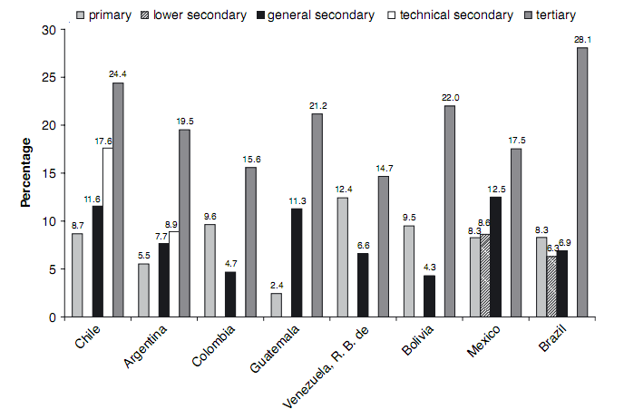
Returns on secondary education that are lower than returns on primary education can be detrimental to society. Individuals recognize tertiary education yields the greatest returns; however, tertiary education is not always a realistic option for everyone. Therefore, if they are left to choose between completing primary or secondary, and they perceive that primary education yields greater returns, they may be deterred from continuing their education. Society as a whole is left to deal with the consequences (such as slowed economic growth) of fewer people choosing to advance through the education system.
Furthermore, we observe that a technical secondary education can yield higher returns than a general secondary education, such as with the cases of Chile and Argentina from Figure 7. This is most likely due to the fact that after graduation from a technical institution, an individual is prepared to start a technical career which requires more training than general secondary education provides, and thus the wages earned are typically higher. Therefore, the secondary education enrollment rate could also be rather low as there is not enough access to technical secondary education in Venezuela. The most recent data shows that only 5.5% of those receiving secondary education in Venezuela obtained technical education, as compared to 24% in Chile and 35% in Argentina. Many may reason that if technical secondary education is not available, they will choose to not receive secondary education at all.

Quality of Secondary Education
The quality of education plays an integral role in preparing individuals for a fulfilling life. In Venezuela, unfortunately, the value of public education has deteriorated in the recent past. According to a study about the performance of the Fe y Alegría private school system in Venezuela, “average aptitude test scores for high school seniors have dropped from 21 to 6 in verbal and from 11 to 3 in math between 1987 and 2003.” In addition, the World Economic Forum ranked Venezuela 117th out of 133 countries in the quality of its education system. Poor quality education hurts the population as it does little to prepare individuals properly for opportunities afterwards.
A possible explanation for the poor quality of education is the proportion of trained teachers in secondary schools. Between 2005 and 2008, the percentage of trained teachers in secondary schools dropped from 83% to 80%. Teachers who are better trained in pedagogical skills as well as in the subject matter they are teaching are able to provide a better overall educational experience for students. The better the teachers, the more possibilities for students to complete their education and go on to live productive lives.

Perception
The perception of secondary education is strongly linked to the previous two issues of returns and quality, but it must still be addressed on its own. The value individuals assign to the educational system has a major impact on their decision on whether to enroll in school. No matter the reality of the situation, perceptions matter in that individual choices are often based on these perceptions. In Venezuela’s case, however, the perception does match the reality, as the returns on and the quality of secondary education are in fact low.
The overall perception of education in Venezuela is negative. Table 6 shows the results from opinion surveys conducted by Latinobarómetro, which confirm that Venezuelans have identified education as the critical problem they face in the country. Education was ranked as the most important problem, with the labor market coming in second. In this case, the labor market category included questions on low salaries, instability in the labor market, unemployment, and opportunities for the young.
Table 6: Survey Data on the Most Important Problem Facing Venezuela
Problem | 1998 | 2000
Education | 28.1% | 31.3%
Health | 8.1% | 2.2%
Labor market | 18.8% | 28.5%
Crime and drugs | 8.8% | 14.2%
Corruption | 14.3% | 5.0%
Poverty | 3.4% | 5.4%
Inflation | 9.0% | 5.4%
Political violence | 2.5% | 3.2%
Housing and environment | - | 3.1%
Other | 4.5% | 0.8%
Do not know | 0.5% | 1.0%

We view the labor market category as very closely connected with the education category as it addresses issues of opportunity after education. For the two years observed, 46.9% (1998) and 59.8% (2000) identified either education or the labor market as the most important problem. With such staggering numbers, we cannot deny the fact that these issues need to be resolved. Furthermore, the perception needs to change so that Venezuelans regain confidence in the education system and recognize the value in enrolling in school.

Policy Proposal

Objectives
Table 7 represents the quantifiable goals of our proposals, which we will expound upon in the following pages.
Table 7: Objectives
Goals | Current Status | 3 years hence
Trained Teachers | 80% | 100%
Technical secondary education as a percentage of total secondary education | 5.5% | 25%
Overall secondary enrollment | 68.4% | 80%

Improve Quality of Education
In order to boost the enrollment of secondary education, it is essential to improve the quality of the education provided. Currently, the quality of public education provided in Venezuela is poor and this deters many from completing secondary education. Therefore, the quality of education is a major obstacle to overcome in attempting to increase enrollment rates.
An effective way to improve the quality of education is to ensure that teachers are properly trained. This mainly involves developing teachers’ pedagogical techniques.
Once teachers expand their skill sets, they have the necessary tools to better prepare students for a more productive future. One of the leading institutions on education, Lehigh University, suggests five key areas for teacher development and we have embraced these five tenets as a guide for our proposed training program. These tenets are as follows:
- Practicing positive behavioral modification techniques;
- Creating new, rich, learning environments;
- Developing better learning programs for children who are at educational risk;
- Researching effective organizational leadership in urban and suburban schools;
- Understanding cultural identity and diversity.
While an individual benefits personally from an improved education (both intellectually and financially), there are also benefits for the rest of society. According to USAID, “improved educational quality is linked to strengthened human capacity that supports development across all sectors, especially improved health, more vibrant economic growth, more democratic governance, and improved environmental management.” Therefore, all benefit from an improvement in the quality of education, even those who are not directly receiving the education.
We estimate that it will take approximately three years from the date of implementation of the teacher training program for all teachers to be trained. This will lessen the financial burden on Venezuela by spreading out the cost over several years while also providing a chance to adapt the policy if necessary. We strongly believe investment in such a training program will have a strong positive impact on the quality of education as well as on the enrollment rate of secondary education.

Increase Technical Training
While low overall secondary education enrollment is the major issue facing Venezuela, technical secondary education enrollment is especially low and thus of key concern. By increasing opportunities for technical training, Venezuela could better prepare its young population for careers which would ensure sustainable national development. This would have direct benefits to the individuals themselves, as after receiving technical training they would be ready for a job that would pay a higher wage because of the specialized skills required. In addition, society would benefit from the provision of technical training because the industries these individuals would go into typically play a key role in the overall development and growth of a nation.
Technical training consists of many components that are not typically found in general education. Key elements of technical training include science and technology education and information technology skills, which focus on cognitive, social, and personality skills so as to develop the capacity for flexibility, problem-solving, creativity, initiative, and lifelong learning. Currently, Venezuela’s rate of enrollment for technical education is 5.5%, which we deem to be too low. We would like this value to grow to 25% over a period of three years. In order to achieve such growth, it will be necessary to train more teachers in a technical fashion. It will also be necessary to invest in materials that are needed to run a successful technical institution. We strongly believe such investment into technical secondary education will generate a higher enrollment rate of overall secondary education as individuals begin to realize the opportunities that are open to them with such a degree.

Enhance Perception
The improvements that our development proposal will produce will be mitigated if the general public’s perception of secondary education remains negative. People must be aware of the changes that have been made, as well as of the benefits these changes will have on their lives, in order for the development proposal to be fully effective. Thus, the final pillar of our policy proposal is a comprehensive information campaign concerning the ongoing changes.
There will be two main avenues through which information about the education changes will be disseminated. The first is through standard government channels. We believe this policy is of sufficient importance as to warrant attention from President Chávez. President Chávez should make an official speech announcing the programs, and subsequently continue promoting it whenever the opportunity arises. Key government officials will be expected to write editorials in the major newspapers explaining and promoting the plan. Also, once the plan is announced, government education officials will make themselves available to numerous media outlets to promote the programs. The goal is to get the media and press to run stories and air segments about the policy and the benefits it will provide. This will help more people understand the changes and how to take advantage of the new and improved education system.
Second, there will be a government-sponsored advertising campaign to promote enrollment in secondary education and enrollment in technical schools. While information from trusted news sources is better received by the general public, an advertising campaign will ensure that most of the population becomes aware of the new programs. This campaign will consist primarily of television and radio commercials, but there will also be some print advertising and outdoor advertising (billboards, etc.). The advertising campaign will be tailored regionally to emphasize various aspects of the improved system.
The campaign will last for the three-year duration of the policy implementation. There will be a large initial advertising blitz. There will always be an undertone of advertising going on, but it will become more intense as deadlines for enrollment approach. Government officials will promote the plan in the media and in the press as these deadlines approach. This final aspect of the policy proposal will serve to inform Venezuelans of the new and exciting educational opportunities available to them.

Funding & Cost
Any policy we propose needs to be grounded in Venezuela’s economic reality. We realize resources are scarce, and Venezuela has many areas that would benefit from a greater allocation of funds. As such, we have created two funding scenarios for our Figure 8: Venezuela’s GDP versus Oil Price projects, depending on government revenue. Venezuela’s ability to fund social programs is highly correlated to the price of oil, as Figure 8 illustrates. Our first funding scenario assumes that there will be no change in the current economic situation in Venezuela; that is to say, oil prices will not rise and generate additional funds. Our second funding scenario assumes oil prices rise, and Venezuela generates additional resources it can dedicate to education. The following tables estimate the costs for the various policies we are proposing. Given the dynamic nature of the marketing policy and the Venezuelan media, we feel uncomfortable estimating a cost for this specific proposal.
Table 8: Cost Estimates
Improving Quality of Education through Teacher Retraining
Total secondary education teachers in Venezuela | 217,516
Percent of teachers with training | 80%
Cost of training one teacher | $1,500
Upper Bound Cost: Assumes all teachers will be trained | $250,000,000
Lower Bound Cost: Assumes only untrained teachers will be trained | $70,000,000

Increase Emphasis on Technical Education
Current percent of technical secondary education | 5.5%
Desired percent of technical secondary education | 25%
Cost of training one technical teacher | $1,800
Upper Bound Training Cost: Assumes all technical teachers will be trained | $100,000,000
Lower Bound Training Cost: Assumes existing technical teachers will not be trained | $70,000,000
Additional cost of technical education per student as a percent increase over a normal student | 12%
Additional per-year cost of shifting technical education from 5.5% to 25% | $45,000,000

The costs displayed in Table 8 are rough estimates based on similar projects and policies in other Latin American countries. As we expect our proposals to take three years, the average cost per year will be, at most, 130 million dollars, and at least 80 million dollars. We have two funding scenarios to produce this money. The first scenario, in which oil does not produce the required revenue, calls for funds to be diverted from tertiary education. We feel the required funds are small enough (at most 130 million), and the resources currently devoted to tertiary education are large enough (over 3.5 billion dollars) to justify this redistribution. Also, attaining broad and effective secondary education is more important for development than tertiary education. The second scenario, in which oil does provide additional resources, calls for as much of the required cost as possible to come from this windfall. Any remaining financial need will be met with funds from tertiary education’s current allocation.

Concluding Remarks
In presenting to you our proposals, our primary objective has been to provide a compelling case that education policy changes will spur further development in Venezuela. We recognize Venezuela has made laudable progress within the realm of education, and we feel that these policy recommendations will build upon this success. We are honored that you have chosen IMZZ Development as a partner in future endeavors. We are confident in the proposals we have put forth, and we look forward to discussing them in detail with you and your advisors.
We would like to take this final opportunity to extend our sincerest gratitude for both your time and attention. It has been an exciting adventure here at IMZZ working on this project, and we hope to continue our relationship. Please feel free to contact our organization for any reason.

Appendix A
In order to more fully understand the relative position of Venezuela, we deemed it necessary to conduct a comparison with similar nations. The chosen nations were the five directly above and five directly below Venezuela on the World
Table 1: GDP per capita Comparison
Country | GDP per Capita, (PPP 2010 US $)
Iran | 11,665
Belarus | 12,260
Bulgaria | 12,392
Panama | 12,504
Uruguay | 12,734
Venezuela | 12,804
Botswana | 13,391
Turkey | 13,920
Montenegro | 13,950
Romania | 14,064
Malaysia | 14,215
United States | 46,715
Development Indicators list of countries ranked by GDP per capita (PPP, 2010 US Dollars). The island nation of Mauritius falls within the five-below/above rule, but we chose to exclude it and include Iran (six below Venezuela) instead, both because Mauritius’ population is only 1.2 million, and because Iran is more meaningful to people in terms of comparisons. For our purposes, Venezuela is included in the ‘Latin America and the Caribbean’ region for statistics provided by UNESCO. Table 1 illustrates the nations of comparable GDP per capita (PPP, 2010 US Dollars). We also chose to include the United States in the list because it provides an interesting perspective. The United States and its level of development are relatively ubiquitous concepts with which people can easily identify and make comparisons.

“Statistics, U. I. (2009)”. UNESCO Institute for Statistics: UIS Statistics in Brief: Education in Venezuela.. tinyurl.com/ye5tpb4
“Statistics, U. I. (2009)”. UNESCO Institute for Statistics: UIS Statistics in Brief: Education in Venezuela.. tinyurl.com/ye5tpb4
GER is the number of students enrolled in a given level of education, regardless of age, expressed as a percentage of the population in the theoretical age group for that level of education. Because this number involves the total number of students in a given grade, a higher number may, in fact, reflect poorly on the education system, as it implies students are not successfully advancing when they should be. If a country, for example, has 100 students eligible for grade 6 based on age, but has 120 students enrolled in grade 6, their GER would be 120. This means that roughly 20 students should be enrolled in a higher grade. NER is the number of students in the theoretical age group who are enrolled expressed as a percentage of the same population. GER numbers can be misleading, so we will focus on NER.
“Statistics, U. I. (2009)”. UNESCO Institute for Statistics: UIS Statistics in Brief: Education in Venezuela. 2/7/10. tinyurl.com/ye5tpb4
“Statistics, U. I. (2009)”. UNESCO Institute for Statistics: UIS Statistics in Brief: Education in Venezuela. 2/7/10. tinyurl.com/ye5tpb4
“Statistics, U. I. (2009)”. UNESCO Institute for Statistics: UIS Statistics in Brief: Education in Venezuela. 2/7/10. tinyurl.com/ye5tpb4
“Statistics, U. I. (2009)”. UNESCO Institute for Statistics: UIS Statistics in Brief: Education in Venezuela. 2/7/10. tinyurl.com/ye5tpb4
“Statistics, U. I. (2009)”. UNESCO Institute for Statistics: UIS Statistics in Brief: Education in Venezuela. 2/7/10. tinyurl.com/ye5tpb4
In this system, ISCED 1 refers to primary education, ISCED 2 to lower secondary education, ISCED 3 to upper secondary education, ISCED 4 to post-secondary non-tertiary education, ISCED 5 to the first stage of tertiary education, and ISCED 6 to the second stage of tertiary education.
“Statistics, U. I. (2009)”. UNESCO Institute for Statistics: UIS Statistics in Brief: Education in Venezuela. tinyurl.com/ye5tpb4
Seelke. “CRS Report for Congress: Overview of Education Issues and Programs in Latin America.” 2007
http://stats.uis.unesco.org/unesco/TableViewer/document.aspx?ReportId=125&IF_Language=eng& BR_ Fact=EEGDP&BR_Region=40520
“World Development Indicators.” The World Bank.
“Economic Growth in Developing Countries: Education Proves Key.” IIASA Policy Brief. August 2008.
Anand and Sen. “Human Development and Economic Sustainability.” 2000
IIASA. “Economic Growth in Developing Countries: Education Proves Key.” 2008
Birdsall. “Putting Education to Work in Latin America.” 1999
Wong. “Educación como factor de competitividad: experiencias comparadas entre Asia y América Latina.” 2008
Cohen et. Al. “Universal Basic and Secondary Education.” 2005
Vegas and Petrow. “Raising Student Learning in Latin America: The Challenge for the 21st Century.”
Birdsall. “Putting Education to Work in Latin America.” 1999
Cohen et. Al. “Universal Basic and Secondary Education.” 2005
Holsinger and Cowell. “Positioning secondary school education in developing countries.” 2000
Hadden and London. “Educating Girls in the Third World.” 1996
IIASA. “Economic Growth in Developing Countries: Education Proves Key.” 2008
World Bank. “Secondary Education.” <http://go.worldbank.org/HTKE9NIKF0> 2010
Inter-American Development Bank. “Education Initiative: School to Work Transition.” <http://www.iadb.org/ topics/education/EducationInitiative/index.cfm?language=EN&artid=6460> 2010
Seelke. “CRS Report for Congress: Overview of Education Issues and Programs in Latin America.” 2007
Inter-American Development Bank. “Reforming Primary and Secondary Education in Latin America and the Caribbean.” 2000
Di Gropello, Emanuela. “Meeting the Challenges of Secondary Education in Latin America and East Asia.” The World Bank. 2006.
Allcott, Hunt and Daniel Ortega. “The Performance of Decentralized School Systems: Evidence from Fe y Alegría in Venezuela.” March 2007.
“The Global Competitiveness Report.” World Economic Forum. 2009.
World Development Indicators. The World Bank.
Kaufman, Robert and Joan Nelson. Crucial Needs, Weak Incentives; Social Sector Reform, Democratization, and Globalization in Latin America. 2004.
“Education in Latin America and the Caribbean.” USAID.
Bedi Kanishka and J.K. Sharma. “Benchmarking the Quality of Secondary Education at the Micro Level and Policy Imperatives.” U21Global. November 2006.
All statistics come from WDI, with the exceptions of teacher training costs from magisamericas.org and the technical training cost, which comes from J.E. Gonzalez’s paper “The Per-Pupil Cost of Regular and Vocational Education Programs”
“Latin America and the Caribbean: List of Countries”. UIS Statistics 2/7/10. tinyurl.com/ya6tcla
World Bank’s World Development Indicators Database

