Nigeria:
The Persistence of Underdevelopment and Imperative for Change

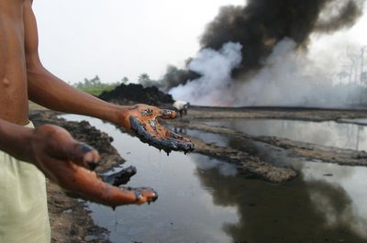
IR 322: Poverty and Development
Professor Bruce Moon
Lehigh University
Bethlehem, PA
Background Report: Nigeria

ABSTRACT: Nigeria is one of the wealthier nations in the world, yet the majority of its population is strikingly poor. This report seeks to address this issue by assessing the potential for development in Nigeria. While there are numerous obstructions to development, there are also many aspects of the country that make its prospects for development promising. This report uses this assessment to develop a proposal for a development plan focused on increasing the quality and availability of primary education in Nigeria.

Glen DeVillafranca
Nicholas Lancaster
Daniel Letts
Kate McCarthy
Diego Molina
Table of Contents

Introduction . . . . . . . . . . . . . . . . . . . . . . . . . . . . . . . . . . 5
Section 1: State of Nigeria . . . . . . . . . . . . . . . . . . . . . . . 6
A Thriving Economy . . . . . . . . . . . . . . . . . . . . . . . . . . . 7
The Real Problem – Poverty . . . . . . . . . . . . . . . . . . . . . . 12
Capital . . . . . . . . . . . . . . . . . . . . . . . . . . . . . . . . 12
Employment . . . . . . . . . . . . . . . . . . . . . . . . . . . . 14
Education . . . . . . . . . . . . . . . . . . . . . . . . . . . . . . 19
Health . . . . . . . . . . . . . . . . . . . . . . . . . . . . . . . 28
Inequity . . . . . . . . . . . . . . . . . . . . . . . . . . . . . . 32
Section 2: Cause - Why the Underdevopment? . . . . . . . . 38
Nigeria Since Independence . . . . . . . . . . . . . . . . . . . . . . 39
The Impact of Oil . . . . . . . . . . . . . . . . . . . . . . . . . . . . . 40
The Real Problem: Patron-Clientage . . . . . . . . . . . . . . . . . 45
Violence Prevents Development . . . . . . . . . . . . . . . . . . 49
Violence in the Delta . . . . . . . . . . . . . . . . . . . . . . . . 49
Violence from Ethnic Conflict . . . . . . . . . . . . . . . . . . . 52
Section 3: Constraints on Future Development . . . . . . . . 56
Consolidation of Influence . . . . . . . . . . . . . . . . . . . . . . . 57
Social Structures . . . . . . . . . . . . . . . . . . . . . . . . . . . . . 58
Political Structure . . . . . . . . . . . . . . . . . . . . . . . . . . . . . 59
Economic Structure . . . . . . . . . . . . . . . . . . . . . . . . . . . . 62
Section 4: Potential and Promise . . . . . . . . . . . . . . . . . . . 64
Fatalism – The Wrong Approach . . . . . . . . . . . . . . . . . . . . 65

Table of Contents

Why Nigeria . . . . . . . . . . . . . . . . . . . . . . . . . . . . . . . . 67
Economic and Fiscal Framework . . . . . . . . . . . . . . . . . . . . 68
System of Governance . . . . . . . . . . . . . . . . . . . . . . . . . . 68
Human Capital . . . . . . . . . . . . . . . . . . . . . . . . . . . . . . . 69
Young Population . . . . . . . . . . . . . . . . . . . . . . . . . . . . . 72
Section 5: How to Start the Change: A Proposal . .. . . . . . 76
Introduction

Nigeria is a nation characterized by both problems and potential. It has many detriments, including widespread poverty, severe income inequity, violence, and a weak, inefficient, and corrupt government; but it also has several advantages not shared by other underdeveloped nations, such as a strong economy supported by massive oil revenues, and an enormous, largely-untapped supply of labor. In this report, we outline the major impediments to development in Nigeria, the positive factors that could assist development, and finally, we propose a plan that will address what we have found to be the most pertinent and underlying cause of underdevelopment in Nigeria.
Before any assessment of development potential can be made, however, it is essential to first come to an understanding of what ‘development’ actually signifies. Development has long proven to be a contentious term. To many, development represents the growth of the economy of a particular country as measured by levels of income and consumption. We believe that this macroeconomic conceptualization of development misses the mark in several regards. As evidenced by the polar qualities of Nigeria’s economy and its people at large, and by the vast income disparities between the few rich and many poor, positive macroeconomic indicators do not guarantee the alleviation of poverty, let alone the improvement of domestic living conditions. Arrighi, Silver, and Brewer further prove through their study of convergences in industrialization and income levels that simply achieving a strong industrial sector does not guarantee the improvement of the human condition within a nation.
Instead, we believe that the term development must reflect the progress of a nation’s people over the progress of its economy: We define development as the increased opportunity and freedom to improve one’s life and to pursue ends according to one’s interests, preferences, and needs. Aristotle wisely noted, “Wealth is evidently not the good we are seeking; for it is merely useful and for the sake of something else” Hungry, sick, or persecuted people have their freedoms and opportunities constrained by the immediate necessity of survival. The success of the economy can only be valid measure of a nation’s progress once its people are freed of this condition of subsistence and can act according to their own desires. As we detail in the following section, positive macroeconomic indicators fail to reflect the condition of the Nigerian people due to the continued presence of this survival-based condition.

Section One
The State of Nigeria

A Thriving Economy
By classical, liberal standards Nigeria’s economy is thriving. Macroeconomic data suggests that recent years have been productive, promising times in Nigeria. While we will soon demonstrate that this is, in fact, not nearly the case for real people, this section will present some of the impressive economic statistics that have been reported of late. While the follow figures do present bright spots in Nigeria’s overall situation (certainly a falling GDP would not be a good thing) their juxtaposition with following sections on endemic problems (like poverty) brings the overall purpose of this paper into focus – why is this “growth” not reaching the people?
Figure 1 GDP (current US$)
When one measures economic performance they usually turn first to Gross Domestic Product (GDP). With regard to Nigeria, this is perhaps the most impressive figure of their entire economy. As Figure 1 shows, in recent years GDP has been growing at an increasing rate. Correspondingly, GDP per capita has also been increasing, and, as Figure 2 shows, income in Nigeria is not only higher than many of its neighbors, but has risen impressively faster. Such improvements in overall wealth of the country are significant and provide, at the most basic level, increased liquidity and capacity for the greater economy.
Figure 2 GDP per capita (current US$)
This growth is almost entirely a product of participation in international markets. Exports have largely been driving economic activity. As such, Nigeria has been maintaining a trade surplus (Figure 3). Increased trade has attracted substantial Foreign Direct Investment (FDI) and capital inflows as well. More economic activity in the country and a thriving export sector has afforded the government substantial revenue, resulting in a positive balance of payments since 1998.

Figure 3 Trade Balance
 | 2000 | 2005 | 2007 | 2008
Exports of goods and services (% of GDP) | 54 | 47 | 40 | 43
Imports of goods and services (% of GDP) | 32 | 31 | 30 | 30
Trade Balance (% of GDP) | (+)22 | (+)16 | (+)10 | (+)13

This spur in economic activity corresponds to the global rise in demand for oil – the dominating force in Nigeria’s economy. As Figure 4 illustrates, Nigeria has one of the largest reserves of oil in the worlds and is one of the largest exporters of primary energy products. The enormous demand for and high value of oil across the globe leaves the Nigerian economy quite comfortably supported, for the time being, by the massive capital inflows, FDI, and revenue streams that come from such a sector. Figure 4 also shows that much of Nigeria’s recent economic performance can actually be attributed to its oil sector. Later, we will discuss several, noneconomic ramifications of this.
Largely as a result of oil revenue, Nigeria does not suffer from the bottlenecks frequently plaguing the developing world. Savings gaps, for example, are usually quite problematic, leaving people without the available savings needed to invest.
Figure 4 Trade in Oil
Oil | bbl/day | Rank
Production | 2.169 million | 16th
Consumption | 286,000 | 45th
Exports | 2.327 million | 8th
Imports | 170,000 | 54th
Proven Reserves | 36.22 billion | 10th

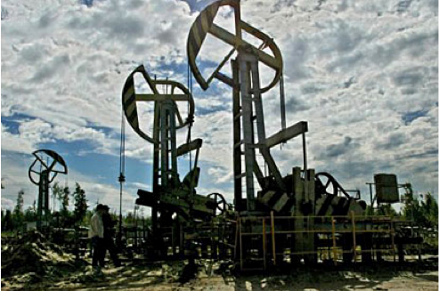Developing nations also usually suffer from currency bottlenecks. Without sufficient inflows, investing (and developing) becomes problematic, as foreign currency is not available to import required capital from other countries. Additionally, many governments in the global south lack the revenue needed for expenditures requisite for development (welfare programs, infrastructure projects, etc.). With the enormous revenues that come from being a large oil exporter, however, Nigeria does not suffer from any of these problems. On paper, at least, there is enough savings, consistent trade surpluses and positive balance of payments – again, almost solely due to oil revenue.
Picture 0 Source Emmanuel Dogbevi
Thus, through many macroeconomic indicators, the status of the Nigerian economy can be summed in two words – impressive and promising. No economist would call $1,400 wealthy, but with GDP growth rates as high as 10.6%, liberal economics would look at Nigeria not with an eye of concern, but with one of excitement. In fact Goldman Sachs, one of the largest investment firms in the world, has even crowned Nigeria as one of the “Next Eleven” rising economies. What the rest of our report will analyze, contemplate and explain is why then, despite such “progress” and “promise” are most of Nigerians still desperately poor, starving, undereducated, without healthcare and, more troublingly, not currently on course to see any of this change.
Nigeria is Rife With Poverty
Capital
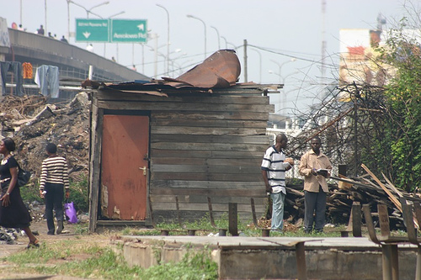
Nigeria is rife with poverty – a major impediment to development. Despite having Africa’s third-largest GDP, and regardless of successive efforts by the Nigerian government to alleviate poverty, the 2010 Global Monitoring Report by the United Nations Education, Scientific and Cultural Organization (UNESCO) revealed that about 92 percent of the Nigerian population survives on less than two dollars daily and about 71 percent survive on less than one dollar daily. Nigeria is now considered one of the poorest twenty countries in the world. These figures, when taken into consideration along with Nigeria’s lucrative oil industry, abundant mineral resources, and overall economic potential, are more than startling.
Picture 1 Source World Politics Review
GDP per capita, though not a holistically useful approach for measuring development, does indicate the vast discrepancies between highly developed countries, such as the United States, and what UNDP has classified as countries that have achieved “medium” development, such as Nigeria, Kenya, Ghana, and Uganda. In 2007, the difference between the GDP per capita of the United States and Nigeria was over USD 43,000. This figure is alarming as it testifies how far behind highly developed countries Nigeria is in terms of economic development. Still, measuring Nigeria’s level of development solely by GDP does not adequately represent the severity of Nigeria’s underdevelopment. Figure 5 below shows that the GDP per capita in Nigeria was actually higher than that of countries that ranked much higher on the Human Development Index than Nigeria.
Figure 5 HDI Compared to Income
Country | HDI Rank | GDP per capita (US$/PPP)
United States | 13 | 45,592
Kenya | 147 | 1,542
Ghana | 152 | 1,334
Uganda | 157 | 1,059
Nigeria | 158 | 1,969

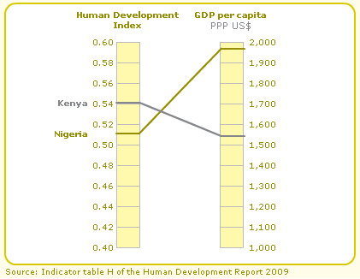
While Kenya’s GDP per capita is significantly lower than that of Nigeria, Nigeria is ranked eleven positions lower than Kenya according to the Human Development Index. The Human Development Index appropriately represents the severity of underdevelopment in Nigeria by evaluating GDP per capita, life expectancy, adult literacy and gross enrollment in education. As demonstrated by the Nigeria-Kenya example, measuring development through GDP per capita does not accurately represent a country’s real level of development
Picture 2 Source HDI

Employment
Poverty and unemployment are inextricably related. The problem, though, for one seeking to analyze the relation is first, what is employment? Is it a universal term or rather a conditional interpretation? Below we provide an answer with the hope of being able to explore the following themes: the size of the labor force, unemployment and the subsequent geographic inequality, unemployment across age groups, male/ female unemployment rates, the effect of education on employment, exogenous factors and their effect on employment, and unemployment as a corollary to size of population.
It is important to note that Nigeria’s definition of “unemployment” is roughly based upon the International Labor Organization’s (ILO) criterion. In other words, an individual must be without work and available for it. Most conventional definitions also include a third provision of “actively seeking work,” but even the ILO notes how this can be relaxed in countries with very limited options for employment. It is also essential to understand that self-employment, which is considered to be “at work,” is a fairly all-encompassing term consisting of people who, during the reference period, performed some work for profit or family gain, in cash or in kind.
Figure 6 National Unemployment Rates
Survey Period | Composite (%) | Urban (%) | Rural (%)
2003 | 14.8 | 17.1 | 13.8
2004 | 11.8 | 11 | 12.1
2005 | 11.9 | 10.1 | 12.6
2006 | 14.6 | 10 | 15.1
*2007 | 10.9 | 10 | 12.6

The problem when dealing with underdeveloped countries is that rarely does a sufficient supply of records exists to detail such a vital metric. The International Labour Organization’s Thirteenth International Conference of Labour Statisticians convened in 1982 to adopt their “Resolution Concerning Statistics of the Economically Active Population, Employment Unemployment and Underemployment.” It spelled out the need for countries around the world to develop a comprehensive system of statistics in order to provide a dependable base for those wishing to implement policy proposals.
As aforementioned, macroeconomic figures (such as GDP) do not provide any true insight into a country’s level of development. Simply put, they fail to reflect how the majority of the population is living. Likewise, unemployment rates on a national level do little to paint a meaningful portrayal of the hardships endured by Nigerians on an everyday basis. Yes, the national unemployment rate does infer that a great number of people are without work. However, it offers no further detail in regards to which age groups are affected the most, the difference in unemployment between rural and urban populations, or even where the majority of unemployed Nigerians live. These are basic statistics fundamental to any understanding of human development within Nigeria.
Picture 3 Source UNDP
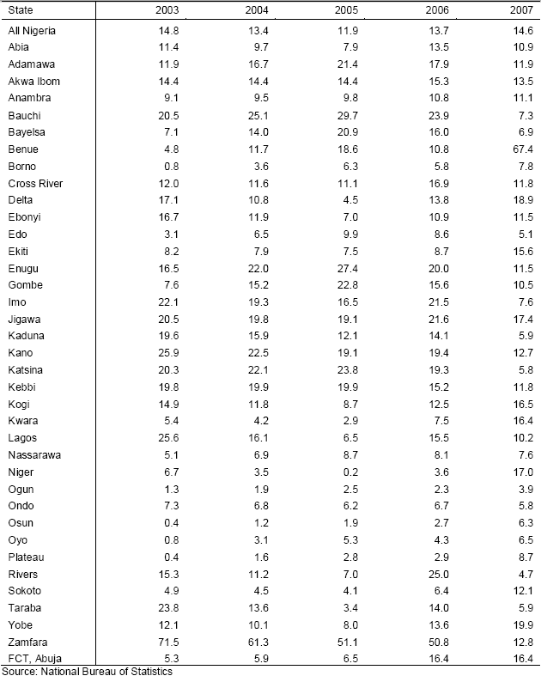
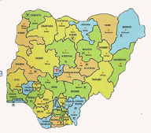
With a labor force of 46,113,831 in 2007, 10.9 percent translates into over 5 million unemployed. The data also reflects an important trend in the distributional elements of unemployment. While the urban rate has been consistently declining since a peak of 17.1 percent in 2003, rural unemployment and consequently composite Nigerian unemployment has been unpredictable to say the least.
Figure 7
Unemployment Rates by State
The data provided in Figure 7 demonstrates not only unemployment levels but also reiterates the issue of inequity prevalent in Nigeria. Picture 4, on the previous page, gives a geographic translation of this data.
What we can infer from this map and the other figures provided is that although pockets of above average and below average states do exist, positive instances lie in all regions of the country. In looking at the data on a state-by-state basis, we can appreciate the impact of distributional elements such as sector, geographic location and availability of natural resources. The central, agrarian state of Niger, for example, had an unemployment rate of 17 percent in 2007, while the oil-rich state of Bayelsa in the south had a much lower employment rate of 6.9 percent.
Lastly, we find it important to note that the two states at the heart of the Niger Delta, Bayelsa and Rivers, have experienced extreme variation in their unemployment rates. This is a reflection of the region’s dependency on oil exports sensitivity to fluctuations in world oil prices, and the high incidence of violent conflicts that disrupt productivity.
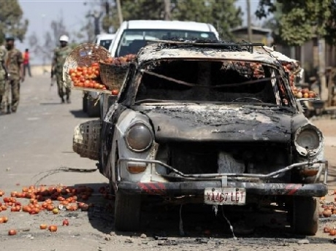
Education also directly affects levels of unemployment in the urban and rural sector. While in rural areas the majority of unemployment is seen amongst those with no schooling, urban areas tell a different tale. The best example of this is seen through Nigerians with post-secondary educations. In the rural sector, they account for only 3.6 percent of total unemployment while the urban sector accounts for a far greater 16.6 percent. At first glance this may appear surprising, but understanding the tendency of educated Nigerians to reside in or move to urban areas provides the understanding necessary to analyze such a statistic. Simply put, there are far more people with post-secondary educations in Nigeria’s urban districts than rural areas. With accessibility to more qualified jobs severely limited, at best, the dynamic becomes perfectly reasonable. The conclusion to be reached here is not that increased education has a negative impact on chances of employment but rather that employment for a particular skill level might be rather competitive, as presented above.
Picture 4 Source time.com

In a country as ethnically diverse as Nigeria, the archetypal definition used to characterize unemployment may be incompatible with various cultural norms amongst the peoples. With the assistance of the World Bank, however, the Nigerian government has been steadily increasing its capacity to gather key statistics throughout its states. Not only does this provide policy analysts with the ability to distinguish important trends in employment on the ever-important micro level, but also by allowing the government to conduct surveys and localized counts in each of its states, a more culturally relativistic picture is painted.
As noted by Seers, population affects development – so long as the workforce is growing at an accelerated rate it is almost impossible to relieve unemployment. According to the World Bank’s compilation of WDI’s (World Development Indicators), Nigeria’s population growth for 2008 was 2.23 percent. Although exceeding the world average in 2008 of 1.17 percent, a more appropriate comparison to other “developing” countries reveals it to be in the middle of the pack. An even more localized comparison (relative to Western African countries) depicts it as relatively small in terms of its growth rate.
Despite this, the problem remains that as the world’s eighth most populous country, Nigeria’s above average growth rate translates into a far greater amount of people are to be sustained. In fact, of the world’s ten most populous countries, Nigeria’s annual population growth rate is the highest, with only Pakistan coming close.
From the information gathered, although Nigeria’s situation appears to be improving, it is far from perfect. Volatility in worldwide oil prices, instability of urban businesses seeking to increase production, lack of electricity necessary for industrial practices, and inefficient agricultural practices throughout the country provide just some of the many explanations as to why there are so many without work. The effects of unemployment in Nigeria are paramount and widespread. It is a discriminatory force, affecting some more than others. Indeed, certain measures can be taken to repudiate its unequivocally adverse effects but, as is the case in Nigeria, many times the force is too big to stop (at least as a unitary actor).

Education
Education in Nigeria tells a story of extreme inequality. The government has engaged in an uphill battle to ameliorate the situation and make up for inequality, but the results have been less than optimal; there is still an enormous gap between education levels on rural and urban areas, between males and females, and between the rich and the poor. Corruption, especially during the military area, also hinders most efforts to improve the status quo. Even when the intents were legitimate the results were sub-optimal. Point-in-case, tertiary education in Nigeria has developed at the expense of primary schools. The ensuing section provides a closer look at the aforementioned points.
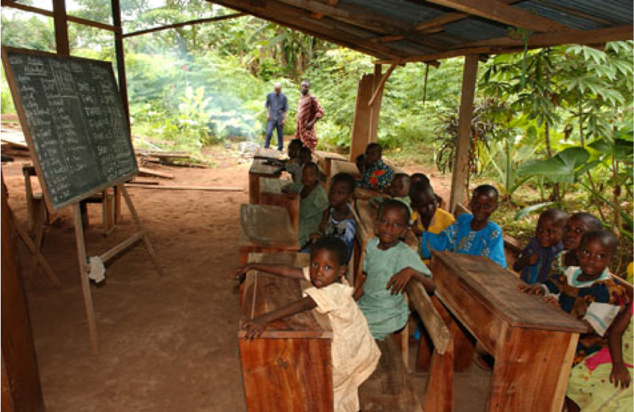Literacy presents a major obstacle to development in Nigeria; a literate population is critical to development beyond subsistence living. Much like its deceiving GDP per capita levels, literacy rates in Nigeria misrepresent education throughout the country. According to the Human Development Index, Nigeria’s adult literacy rate is 72 percent, ranking Nigeria 112 out of 182 countries whose literacy was calculated. Unfortunately this figure does not properly represent the overall education in Nigeria given that extraordinary inequity alters nationwide literacy rates. As seen in the figure below, rural Nigeria remains highly illiterate. With over half of the Nigerian population living in rural communities, it is evident that millions of Nigerians remain illiterate, preventing the country from obtaining true development.
Figure 7 bankstreet.wordpress.com

Figure 8 Adult Literacy Rates 2007
Category | Literacy Rate (%)
Male | 67.3
Female | 43.7
Urban | 70.9
Rural | 46.8
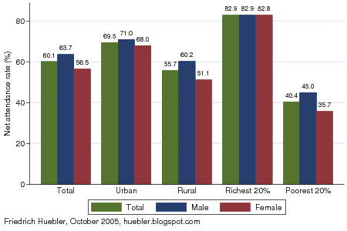
In conjunction with literacy, primary education is vital to successful development vis-à-vis focusing spending on basic education, as demonstrated by John Page in “The East Asian Miracle.” As observed in the figure below, primary education attendance is heavily dependent on income and residence. Survival (be it working or searching for food), especially in rural sectors of Nigeria, takes priority over education and thus much of the rural labor force is uneducated. Similarly, inequities in income distribution are reflected in primary education attendance. Nearly 83 percent of Nigeria’s most wealthy population attended primary education institutions (as of 2003) in comparison to merely 40 percent of the poorest Nigerian peoples; on average, 60.1 percent of children enrolled in primary schools (as reported by a 2003 Demographic and Health Survey). According to the same survey, 63.7 percent were male and 56.5 percent were female. Of the primary institutions that children attend, many are in a state of disrepair; there are about 2,014 primary schools in Nigeria with no buildings, having lectures held under trees. Primary education enrollment rates need to improve in order for the rising population to have access to a better future. Unfortunately higher rates will be hard to attain unless children are able to stop worrying about working and caring for their family, at the expense of their schooling.
Figure 9
Primary School Net Attendance Rates 2003
Secondary school enrollment rates in Nigeria provide a gloomy picture; the 2003 DHS (Demographic and Health Survey) survey indicates a total secondary school attendance of 35.1 percent, 37.5 percent for males and 32.6 being females. The data confirms the trend observed in primary education enrollment rates, where male presence is dominant.
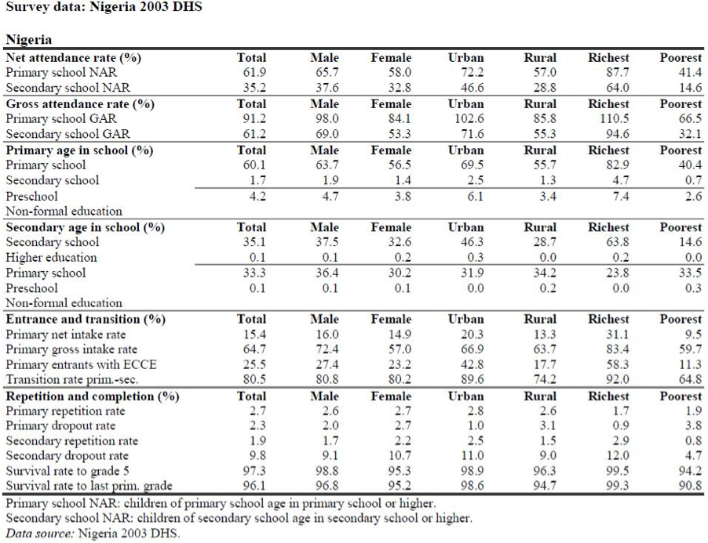
However, it is importance to note that female attendance in both primary and secondary schools was higher than that of their male counterparts for the richest group of Nigerians (.4 percent higher for primary and 2.4 percent higher for secondary education). These figures indicate the greater importance given to female education by the most affluent (and therefore most educated) Nigerians, magnified by their lack of necessity for females to care for their family or work.
Figure 10 DHS Survey Data
Figure 11 Gender Disparities in Education
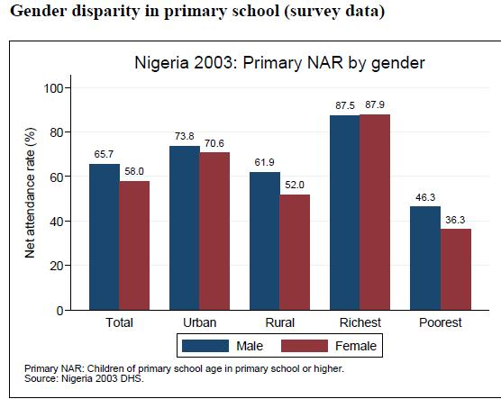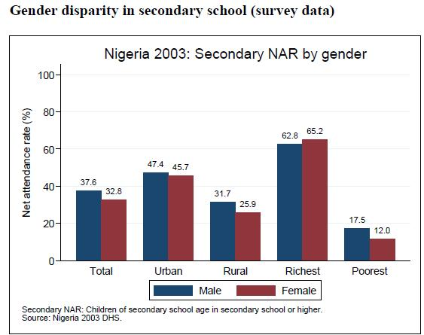
Secondary institutions in Nigeria can be divided into federal, state owned, and private sectors. Federal government schools are funded directly through the Ministry of Education and admission is based on an entry exam. Tuition fees are very low, ranging around $100, due to Federal government funding. As would de expected, state owned schools are funded by particular states and consequently run on a smaller budged. Despite the fact that education is supposed to be free of cost in most states, students are required to purchase books and uniforms costing around $200. Despite costing more than federal schools the quality of education is lower; they are often understaffed due to anomalies in staff salaries. Finally, private secondary schools are much more expensive, costing between $1,000 and $2,000. Due to their increased budget, classes are smaller, infrastructure is better, and teachers are better qualified.
Nigerian education is also plagued by a deficiency in the quality of teachers available. This problem is so that the government thought it necessary to express: “the falling standard of education in Nigeria is caused by ‘acute shortage of qualified teachers in the primary school level.’ Reportedly, about 23 percent of the over 400,000 teachers employed in the nation’s primary schools do not possess the Teachers’ Grade Two Certificate, even when…[it] is the minimum educational requirement one should possess to teach in the nation’s primary schools.”
Nigeria has not “articulated a development strategy linking knowledge to economic growth nor built up their capacity to do so…[As of 2003] Nigeria has only 15 scientists and engineers engaged in research and development per million persons. This compares with 168 in Brazil, 459 in china, 158 in India, and 4,103 in the United States.” The low number of scientists in Nigeria is an accurate reflection of the lack of enrollment in tertiary institutions. With regards to tertiary institutions there, too, are federal, state owned, and private universities. Subsequent analysis will explain the different hurdles that Nigerian universities have faced in the past and present.
The Nigerian government has often served as an obstacle to the expansion of education in the nation. During the times of military rule in Nigeria there was an evident neglect in tertiary education because of their aversion towards military rule. Furthermore, the implementation of some educational programs has been largely unsuccessful, serving “as conduits to transfer money to the corrupt political leaders and their cronies. For instance, the nation launched the Universal Primary Education (UPE) in 1976, but as noted, the program failed due to lack of fund necessitated by corruption.” Also, many of the loans provided by the World Bank during the 1990s (aimed for education) were utilized to buy unwarranted and expensive equipment that they were not able to set up or maintain. Military governments sought to interfere with university matters by “direct appointment of vice-chancellors, and in some cases, of military ‘sole administrators.’” Such practices diminished the autonomy previously enjoyed by universities; “incentives and rewards for research productivity, teaching excellence and associated innovation gradually disappeared. In consequence, research output dropped, educational quality declined, and management structures rigidified.”
The present tertiary education system in Nigeria is noticeably different, one of hope and opportunity for the development of human capital within the country. Boasting 48 federal and state universities and enrolling over 400,00 students, “the World Bank concluded that ‘more than any other country in Sub-Saharan Africa, the structures exist in Nigeria that could provide for a rational and effective development of university education.’” The enrollment ratio grew to 340 per 100,000 persons (the Asian average is 650 and 2,500 for South Africa).
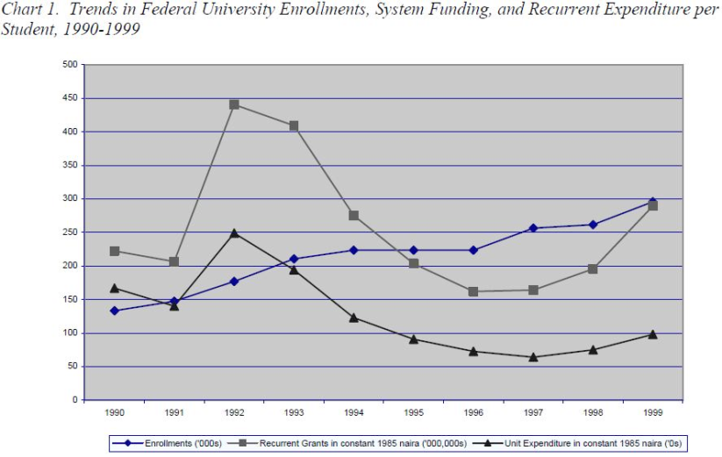
Alas, there has been a decline in the number of academic staff despite an increase in enrollment. “Long term brain drain, combined with insufficient output from national postgraduate programs in the face of rising enrollments, has left the federal university system with only 48% of its estimated staffing needs filled.” University expansion in Nigeria, although seemingly positive, has come largely at the expense of primary education; the government’s budget has been diverted from primary education and into university financial support. It does not take much examination to realize the negative connotation of these practices; a decrease in the quality of primary education will result in less people adequately prepared to enroll in secondary and consequently in tertiary education.

Despite the condition of education in Nigeria, the federal government’s budgetary allocation to education (as percentage of total federal government budget) was just 7 percent for 2001. Spending on education as percentage of GNP for Nigeria was merely 2.4 percent. Comparatively, that of Cote d’Ivoire was 5 percent, 4.4 percent for Ghana, and 7.9 percent for South Africa. Government accountability for their citizens (and for their prospects of development) needs to be emphasized in Nigeria. Bridging the gap between attendance rates in primary and secondary schools (60.1 percent and 35.1 percent, accordingly) will prove to be the only way of ensuring the success of future generations.
Figure 12 University Attendances

Health
Figure 13 Major Diseases
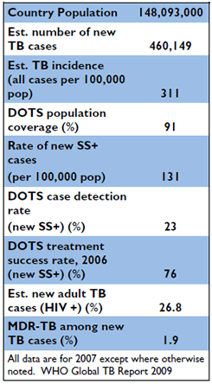
Life expectancy in Nigeria for 2009 was 46.96, ranked 216th out of 224 countries. Needless to say, there are several impediments that hinder the prospect of life within the country. Many diseases plague the nation, but despite having a decent number of facilities, the prohibitive cost of medicine, toppled with inefficient supply management of medicine severely affect the health of the Nigerian population.
Diseases in Nigeria pose a problem of paramount proportions. According to USAID, Nigeria is the fourth largest tuberculosis burden in the world. Fortunately, USAID, together with the World Health Organization (WHO) and the government of Nigeria have sought to implement Directly Observed Treatment Short-course (DOTS), the universally recommended strategy for tuberculosis control) since 2002. This has led to an increase in case detection from 38,626 in 2002 to 86,241 in 2006.
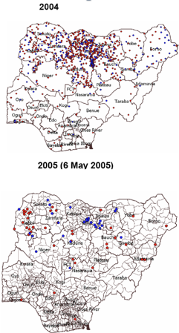
Polio also poses a huge problem in Nigeria as well. According to the World Health Organization, Nigeria was responsible for 63 percent of all of the poliovirus cases reported globally in 2004. This time, the problem is not rooted in the south but rather in the northwest; “6 states in the northwest – Kano, Kadanu, Sokoto, Zamfara, Kebbi, and Jigawa account for 73% of the total number of children paralyzed by polio [in Nigeria].”
Figure 14 Polio Incidents
Fortunately, as illustrated in Figure 15, there has been a decrease in the number of poliovirus cases since 2004. This has been the result of the control of the virus in the south and of a revamp in polio immunization in the north. However, a large polio outbreak in 2009 led to the emergence of 258 cases, compared to the 32 that surfaced in 2009.
Figure 15 Causes of Death
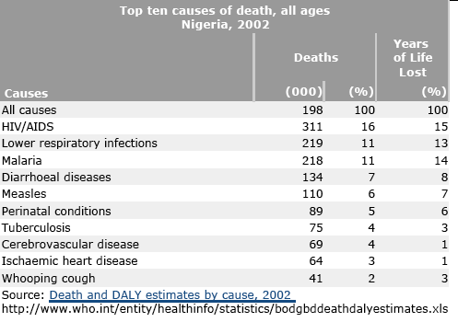
Unfortunately, polio is able to spread quickly through un-immunized children, and polio outbreaks in Nigeria have been linked to the emergence of polio in other African countries, previously unaffected by the virus.
A World Health Organization research initiative conducted in 2006-7 revealed that the price of medicines in Nigeria were exceptionally high in the private and public sectors. A closer look revealed a “wide variability in prices between states facilities and sectors.” Although the fluctuation of prices has improved since then, prices are still not optimal. In regard to accessibility to health facilities, Nigeria’s prospect is quite positive, where fewer than 2 percent of the populations needs to travel more than one hour to access any health facility, be it in the public or private sector. The main impediment to Nigerians is then the price of medicines and the percentage of the population with insurance coverage; 5 percentage of the households surveyed by the WHO report for the 2006-7 period. Supply management of medicines in Nigeria reveals (unfortunately, as expected) uncoordinated delivery leading to high prices. Additionally, due to lack of accountability, many medicines expire.
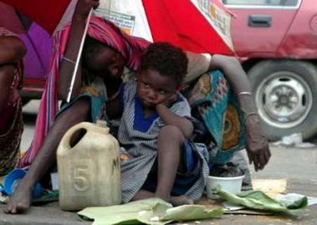
According to a UNICEF report, health expenditure as a share of total government expenditures in Nigeria was merely 3.4 percent for 2003-2005 (less than 1.2 percent of their GDP); the average health expenditure as a share of total government expenditures for West and Central African sates was 8.6 percent for that period.
Inequity
Picture 5 Source life.com
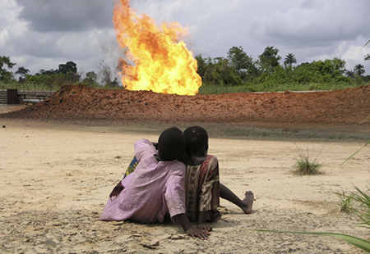
High levels of income disparity within a country hinder prospects for development. In Nigeria, high levels of inequality are observed through consumption trends, the urban/rural divide, the social class spread, and through different levels of education. Anand and Ravallion note that, “the importance of growth lies in the way that its benefits are distributed between people.” Concordantly, we believe that an unequal society prevents development by hindering social welfare. Social welfare entails providing society with the opportunity to expand their quality of life in a sustainable manner; when social welfare is absent, the majority of the population cannot free themselves from poverty and thus development is impossible. The ensuing section analyzes the corollaries of inequality; for the sources of inequality refer to the sections on oil and corruption
Picture 6 Source time.com
The most standard measurement of inequality is wealth distribution. While this is not the only way a country’s levels of equality can be understood, it is useful to analyze who has the wealth, where it is concentrated and how dramatic the differences are between the rich and poor.

Figure 16 Inequity Data
 | Nigeria | Rank | World Average
Gini Index | 42.9 | 91 of 141 | 40.87
Income Ratio of the richest 10% to the poorest 10% | 16.3 | 99 of 141 | 5.12
Consumption richest 10% | 02:32.4 | - | 2.5:32.04

The Gini Index is a summarized coefficient that helps to compare nations’ overall inequity on a macro level. For Nigeria, a Gini Index score of 42.9 shows a relatively high level of inequality in income, ranking them 91st in the world (out of the 141 ranked countries); this is significantly worse than other comparatively poorer countries in the region. It is not, however, extremely unequal as Nigeria’s figure is only about two points off the world average of 40.87.
Other, more specific data emphasize the levels of inequality. For example, Nigeria’s richest 10 percent of the population has an average consumption of over 16 times that of their poorest 10 percent. And with two percent of the population accounting for almost a third of the national consumption, Nigeria’s distributional indicators support the idea of a highly unequal Nigeria. As the figure below demonstrates, the richest fifth of the population accounts for over half of the durables owned by heads of households in Nigeria while the poorest fifth of the population holds only 3 percent.
Figure 17
Consumption by Quintile

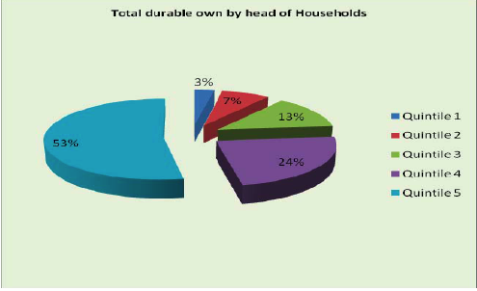
Inequality in Nigeria has created an urban-rural divide as well. Figure 20 shows that of those classified as living in the urban sector, only about 15 percent is in the lowest (first) quintile of income distribution, while one third of the rural sector is. Considering that most of Nigerian states are largely rural one can begin to appreciate the widespread effects of inequity.
Figure 18 Poverty by State
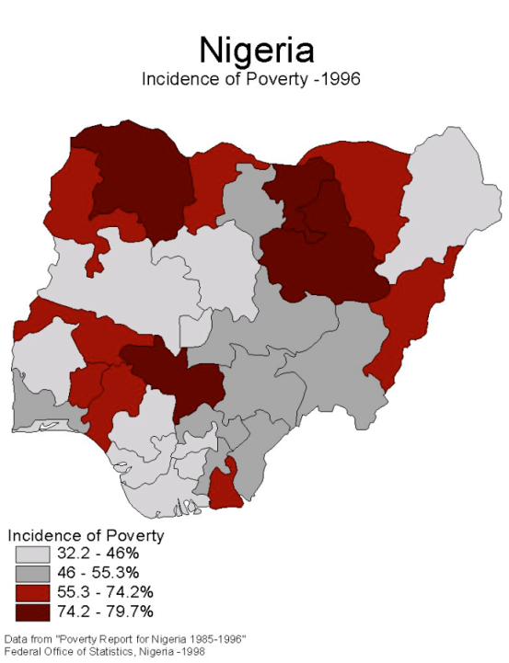
The transition from agrarian and rural societies to more urbanized ones is often an indicator of progress in the development process. While this often follows human development, a heavily rural demography can indicate that a population has not yet started to urbanize and thus has not met all of its human development needs
This form of inequality is extremely visible in Nigeria. As the figure below shows, the lowest wage earners, the first quintile, account for two and a half times the urban sector. Combined with the fact that many of the states in Nigeria are largely rural (see figure below) and one can gain some insight into the inequity in Nigeria.
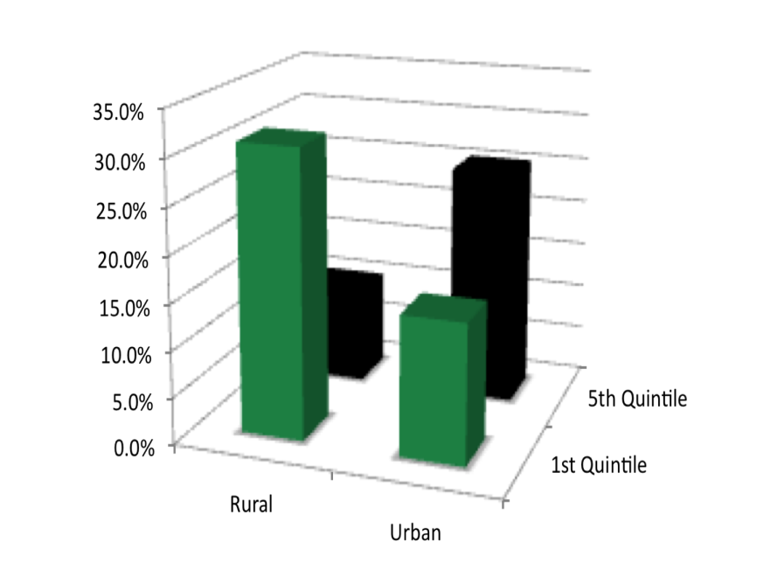
With a great deal of the wealth concentrated into urban areas and the majority of the poorest people living in the much greater rural ambit, analyzing the distribution of wealth in Nigeria by sector offers insight as to why Nigeria is less unequal and ultimately less developed. These “pockets of wealth” thus deprive the majority of the populous from the opportunity to prosper economically, characterized by a shortage of capital.
Figure 19
Rural-Urban Wealth Inequity

The distribution of the population along class and social lines also offers a great deal of insight into the disparity experienced in a country. Considering that half of the population is considered “lower class” and only 16.32 percent of their population qualifies as “upper-upper class” (see figure below), it becomes clear that there is a substantial amount of unevenness.
Furthermore, analyzing the distribution across classes can also offer into disparity in other areas. With regards to the aforementioned distribution across sectors, for example, and its implications for equality and development, the figure below demonstrates how class distribution, like quintile distribution, can be unequal by sector. Through this prism, only 10 percent of the rural sector qualifies as “upper-upper class” while nearly 60 percent of the rural sector falls under “lower class”.
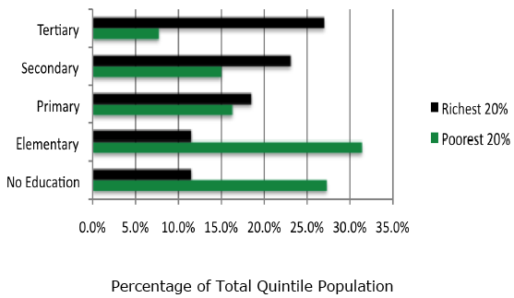
Accumulation of human capital is paramount to the attainability of different levels of development. In this manner, analyzing basic statistics on education and expenditures can be extremely telling with regard to surfacing of inequality. When qualified by quintile, for example, one can observe the relationship between income inequity and inequity in education. In the figure below, 27 percent of the poorest 20 percent of Nigerians (the first quintile) have no education while only 11 percent of the richest 20 percent of Nigerians have no education. It seems clear through these numbers, then, that there is a positive correlation between income inequity and educational inequity.
Figure 20 Inequity in Education
The sum of these statistics shows that the distribution of income in Nigeria is fairly unequal. This lack of equality is a major impediment to development in Nigeria. As Birdsall and Londono observe, “an unequal distribution of assets, especially of human capital, affects overall growth, and it effects income growth of the poor disproportionately… A better distribution of assets increases the incomes of the poor, reducing poverty directly.” Thus, any effort to achieve real development in Nigeria must also address the level of inequality.

Section Two
Causes – Why is Nigeria So Underdeveloped?

Why is Nigeria Not Developing?
There is sufficient empirical evidence that Nigeria’s economy is thriving yet, as we have ascertained, over 70 percent of Nigerians are currently living on less than one dollar per day. This paradox raises the question, how can this be? Liberal theorists would contend that growth of the macro economy is indicative of development. Alas, poverty persists despite the impressive growth in GDP discussed above. To understand why Nigeria is still rife with poverty we examine Nigeria’s arduous transition from colonial to civilian rule and the impact this transition had on civilian etiquette, as well as the conundrum its thriving oil industry poses to development. We conclude, that while Nigeria’s current status of underdevelopment is likely a product of a number of factors; the suffocation of the oil sector, entrenched patron-client system and frequency of internal conflicts bear most of the blame.

Nigeria’s Record as an Autonomous State
As an autonomous state, Nigeria has failed to conquer underdevelopment. Since obtaining its freedom from British Colonial rule on October 1, 1960, the Federal Republic of Nigeria has had great difficulty establishing a national government that adequately caters to the needs of its constituents. After the first two Nigerian republics failed to properly govern the ethnically diverse state, Nigeria was primarily ruled by the military for the remainder of the 21st century. Many coups were welcomed by the people of Nigeria as the military vowed to end venality and promote development. Unfortunately, such promises often went unfulfilled, sowing the seeds of Nigerian skepticism towards the state.
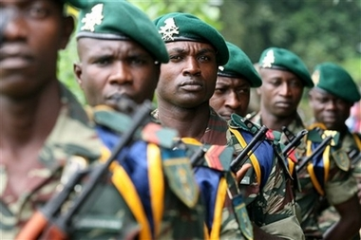
The persistence of underdevelopment throughout Nigeria’s history lies counterintuitive to a number of theories. The 1999 transition to a civilian ruled government proved that, contrary to the contentions of liberal economists like Seymour Lipset, democracy does not inherently foster development. Additionally, rather than the macroeconomic growth discussed above bringing development, inequity and poverty persisted. To understand why the status quo persisted we must examine the impact of Nigeria’s most lucrative oil industry.
Picture 7 willconnors.com

The Impact of the Oil Industry on Development
Endowed with what Jeffery Sachs describes as “the curse of natural resources,” Nigeria’s lucrative oil industry comes at an extraordinarily high cost to the people of Nigeria. In the Niger Delta, “within a 200-mile radius of the capital of Rivers State there is a higher concentration and larger reserves of sweet, easily refined crude oil than anywhere else in the world.” These vast reserves have attracted capital investment from abroad and, as a result, Nigeria is now the seventh largest oil exporter in the world. Unfortunately, the expansion and development of Nigeria’s oil industry has caused Nigeria to suffer from the economic phenomenon referred to as Dutch Disease. During the oil boom of the 1970s, the allure of profits from the oil industry fostered an enormous influx of petrodollars to the Nigerian economy. Smith contends that this influx “created an illusion of instant and seemingly unending prosperity,” and so is responsible for the subsequent decline of investment in agriculture and manufacturing. Thus, the economy of Nigeria has become drastically less diverse, wealth continues to be consolidated in the hands of few, and state and local government dependency on the federal government has intensified; each of these quandaries tremendously impedes development.
Figure 21 Oil Lead Growth

The domination of the Nigerian oil industry leaves the entire economy of Nigeria susceptible to collapse and consequently prevents growth and development. “The economic and the political viability of Nigeria have been largely supported by oil revenues.” For any state to have its viability dependent on the revenues of one industry, especially an industry where prices are so volatile, is cause for alarm. To demonstrate the severity of this plight we look to the effects of plummeting oil prices in the 1980s. “The slide of oil prices from about $40,00 USD in 1981 to less than $10.00 USD in 1986 led to massive balance-of-payments deficits,” which eventually necessitated creation and implementation of the Structural Adjustment Program under the International Monetary Fund (IMF). Yet over two decades later, while the agriculture and manufacturing sectors remain in stages of infancy the Nigerian economy is still extraordinarily dependent on revenues from oil. According to the World Bank, petroleum and petroleum products account for “45% of GDP, 95% of export earnings, and over 70% of total government revenue.” A healthy, stable economy is absolutely imperative to development; so long as Nigeria continues to rely almost solely on oil revenues sustainable development cannot occur. We examine the allocation of oil revenues to determine why the federal government would continue to practice such risky economic policies.
The means by which oil revenues are allocated perpetuates underdevelopment in Nigeria. We have established that the oil industry contributes an enormous seventy percent of all government revenues. In order to understand why Nigeria remains underdeveloped, it is equally as important to recognize the jurisdiction the federal government has over these revenues. The Allocation of Revenue Decree of 1992 determined that government revenues would be vertically dispersed by the Federal Ministry of Finance according to the following formula: 48.5 percent of total revenues would be allocated to the Federal Government, 24 percent to state governments, 20% to local governments and 7.5% to a “Special Fund,” a portion of which is used to finance development. Former Head of Public Relations at the Revenue Mobilisation Allocation and Fiscal Commission (RMAFC) Yushau Shuaib contends that in 2006, as a result of an Executive Order by President Obasanjo, revenue was vertically allocated according to the following formula: 53.69% to the Federal Government, 31.10% to state governments and 15.21% to local governments. Formulas aside, the more pressing issue is the fact that the Federal Ministry, a structure operated by the Federal Government, “collects, deducts from, and heads the committee doing the sharing of the revenue resources.” The Federal Ministry effectively acts as both judge and jury in revenue allocation. Though Nigeria is technically a democratic state, the fact that this system lacks both transparency as well as checks and balances directly contradicts democratic ideals. Accordingly, we conclude that, since the Federal Government hoards an exorbitant portion of the benefits of the oil industry, growth in Nigeria is an insufficient indicator of development.
Figure 22 Oil Prices and Corruption
Picture 8 Source George Osodi
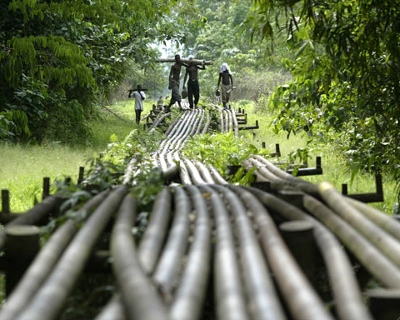
At the local level, the extraction of oil in the Niger Delta has costly, development-obstructing effects on the environment and citizens of Southwestern Nigeria. With few environmental regulations, toxins routinely pollute the water and soil of the Delta. For many citizens, survival has become increasingly arduous as, “farming and fishing have become impossible or extremely difficult…even drinking water has become scarce.” In addition, production of natural gas frequently results in gas flaring, due to lack of proper infrastructure. Gas flaring further affects the environment by causing acid rain, damaging vegetation and eating away the roofs of homes. These flares also have a tremendous impact on greenhouse emission and on the health of the people (due to the highly toxic gasses emitted from the flares). According to Friends of the Earth these toxic gasses have been found to lead to “respiratory illnesses, asthma, blood disorders, cancer, painful breathing and chronic bronchitis, among others.” The United Nations Development Programe describes the Niger Delta as suffering from “administrative neglect, crumbling social infrastructure and services, high unemployment, social deprivation, abject poverty, filth and squalor.” These conditions have bred hostility between the citizens of the Delta and the actors of the oil industry, as we will address later on. More importantly, these conditions demonstrate yet another reason why Nigeria, despite its growing economy, remains underdeveloped.

The Constraints of the Patron-Client System on Development
“When Nigerians talk about corruption, they refer not only to the abuse of state offices for some kind of private gain but also to a whole range of social behaviors in which various forms of morally questionable deception enable the achievement of wealth, power or prestige as well as much more mundane ambitions.”
Perhaps the greatest obstacle to sustainable development in Nigeria is the culture of corruption engrained in Nigerian society. In its 2000 Global Corruption Report Transparency International ranked Nigeria the most corrupt country in the world. Historically, the people of Nigeria have had very few reasons to believe that the actions of their government will directly improve their lives. From colonial rule to military dictatorship and now what is promulgated as “democracy,” the people of Nigeria have yet to come by any substantial reason to put their faith in their leadership. As a result, Nigerians have come to honor the principles of reciprocity, kinship and loyalty in order to protect themselves and those closest to them. These ideals foster a patron-client system that permeates all levels of society. Though the people of Nigeria may accept patron-client relations as the norm, this does not mean that this practice is without consequences; such consequences unequivocally have dramatic ramifications for development prospects. The degree to which endemic corruption exists in Nigeria fosters and perpetuates fraudulent institutions and behavior from all levels of society, thus preventing the transpiration of legitimate, sustainable development.
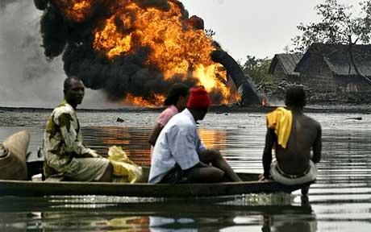
When Lord John Dalberg-Acton famously said, “power corrupts; absolute power corrupts absolutely,” he might well have been talking about the ruling class of Nigeria. The current state of underdevelopment is largely attributable to the overwhelming control elites have over the political, economic and social systems of Nigeria. Radical theory stipulates that, without the existence of a true “middle class” it is less than likely that the state will adequately reflect the interests of its constituents. Mirroring this assertion, Planning School proponents Wilber and Jameson contend that elitist ruling classes are fully aware that, “if social and economic development comes, their power, status and way of life will be threatened.” Therefore it is in the interest of Nigerian elites to continue to promote patron-client relations so as to keep the Nigerian populous in a position of inferiority. In what Jean-Francios Bayart describes as “the reciprocal assimilation of elites,” politicians and oil officials regularly, “loot the state in mutually beneficial bargains that unify government and business elites while perpetuating Nigeria’s dramatic inequalities.” Again, inequity allows for the preservation of the status quo and prevents any permanent development; this analysis provides an explanation as to why, despite its promises, the federal government has yet to enact policies that allocate the resources necessary to stimulate development.
Picture 9 Source Associated Press
Similarly, states and local governments use their power to allocate funds distributed by the federal government to promote patron-client relations. Nigeria’s federal system dictates that the central government must allocate large sums of money to state and local governments every month. Local government officials not only receive handsome incomes but also have the ability to distribute funds as they see fit. Therefore, local elections tend to be fierce competitions for power surrounded by corruption in the form of election rigging, bribery, extortion and violence. In addition to revenue distribution, state and local governments exercise their power to award contracts in order to reap the benefits of reciprocity. Nearly all jobs in Nigeria, from construction to oil refining, are awarded through contracts, typically from the government. The acquisition of contracts is nearly synonymous with the promise of wealth and thus, “illustrates the ways in which local moralities intersect with state politics to create and reproduce a political economy grounded in patron-clientism.”
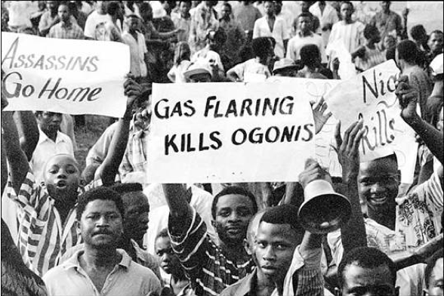Nigeria’s present state of underdevelopment is largely due to the actions of the federal government, however grassroots patron-client relations do little to stop this cycle. Throughout Nigeria, the patron-client system “permeates nearly every facet of public life, and many facets of private life.” As aforementioned, Nigeria is a society based around principles of reciprocity, kinship and loyalty. Though these ideals typically connote moral soundness, the behavior required to uphold these values often makes the line between justifiable and corrupt behavior indistinguishable. Smith discusses the paradox of bribing a family friend to vouch for his niece so she could attend a Nigerian university. Theoretically bribery of any kind is corrupt behavior yet, in a society where cultural ties determine whether one is admitted to a university, paying a fee to receive an education seems to be morally justified. As we have demonstrated, actions in the name of patron-client reciprocity, from the morally ambiguous to the blatantly fraudulent, perpetuate rampant inequity and thus hamstring Nigerian development.
Picture 9 Source University of Michegan

The Impact of Violence on Development
Another serious impediment to development involves the complicated social aspects of an ethnically and religiously diverse nation. Armed conflict and religious extremism have created an inhospitable environment for development in many parts of Nigeria. Whether by perpetuating the conditions that emphasize survival over freedom, or by restricting important developmental prerequisites such as education, it is clear that these geopolitical qualities have been restricting the progress of development in Nigeria. The three main issues in these regards are the oil-sparked violence in the Niger Delta, the religious and ethnically based violence in Central Nigeria, and the extreme Islamic laws of Northern Nigeria.

Violence in the Delta
The conflict in Nigeria’s oil rich Niger Delta is largely a result of the inequitable distribution of wealth and associated with the nation’s enormous oil industry. Despite the steady growth of the oil industry since Nigerian independence, benefits have been slow to trickle down to the majority of the population. While the oil industry has provided some highly skilled Nigerians with well-paid jobs, the majority of the Delta population has become poorer since the 1960s. Additionally, the extremely inefficient method by which oil is produced in the Delta has created many forms of oil-generated environmental pollution evident throughout the region. Farming and fishing have become impossible or extremely difficult, and drinking water has become increasingly scarce. There is strong reason to believe that malnourishment and disease have increased due to the production of oil in this region. Disaffected communities have attempted to organize against the oil industry, but protests and activism have been regularly met with military repression, sometimes ending in the loss of life. In several cases military forces have been summoned and assisted by oil companies.
In retaliation, various gangs of militant youths have formed to destroy oil infrastructure, shut down oil plants, and kidnap workers. Incidences of kidnapping and infrastructure sabotage increased greatly throughout the 1990s. Taking advantage of the lawlessness of the region, gangs have also “robbed banks, burned police stations and murdered police officers in the streets.”
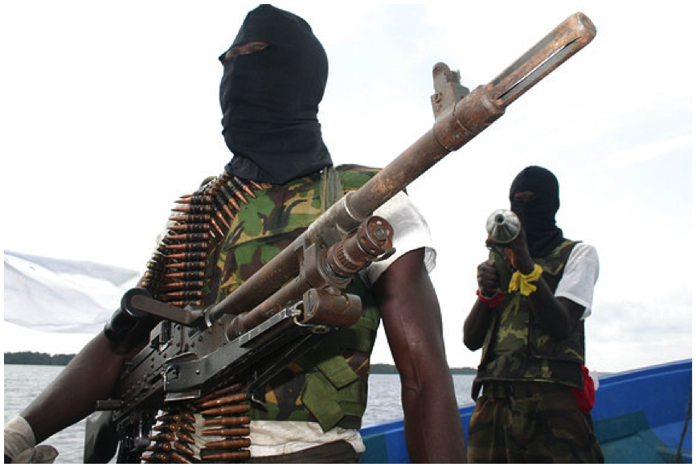Since then, larger and better-organized anti-oil groups have formed that have been willing to take on not only oil companies but the Nigerian government itself. The Niger Delta People’s Volunteer Force (NDPVF), and the Movement for the Emancipation of the Niger River Delta (MEND), two such organizations, have been responsible for a number of larger-scale incidences, such as a 2005 storming of an oil production plant by over 100 armed militants, and a 2006 attack on an Italian petroleum company that resulted in the death of nine employees. Additionally, oil production in the Niger Delta has caused inter-ethnic violence over control of land and the wealth associated with it. Conflicts between the Ijaw and Itsekiri tribes have resulted in numerous deaths and several halts in regional oil production.
Picture 9 Source novite.com
Picture 10 Source novite.com
The violence that has spawned out of the oil industry has also transformed into politically motivated killings. According to a report issued by the Human Rights Watch, the large revenues enjoyed by the governments of oil-producing states have been put to work sponsoring violence and insecurity on behalf of ruling party politicians. The report details an incident following the 2007 national elections:
During a six-week period beginning July 1, escalating gang violence saw several dozen people killed and scores more wounded in Port Harcourt’s streets. Many victims were ordinary Nigerians who were either caught in the crossfire between rival gangs or deliberately shot by gang members. People were killed as they got off buses, sat drinking at local cafes, or tried to flee as gunfire erupted around them. In one case, a young girl and her parents were shot dead as they returned from an all-night church service. In another, seven people including a bread seller and truck driver were shot dead on their way to work. In addition to violence in Port Harcourt itself, gang violence spread to other Rivers State communities. In the worst-affected communities like Ogbogoro, cult gangs carried out a reign of terror that included murder, rape, and other violent crimes.
This was no random explosion of violence. The bloodshed was a widely predicted aftershock of Nigeria’s rigged and violent April 2007 nationwide elections. Most of the gangs involved in the July and August fighting gained experience and power as the hired guns of Rivers State politicians, who used them to rig elections and intimidate political opponents. The clashes between the groups primarily represented a violent competition for access to illegal patronage doled out by public officials in the state government.

Many politicians in the Niger Delta have grown rich exploiting the large amount of revenue flowing through state governments, and have enlisted the help of the already-formed gangs to make sure that they stay in power. These politicians are rarely, if ever, brought up on corruption charges, a fact that has enraged the local populace. Due to the ability of those in power to suppress popular opinion through targeted gang-related violence, however, there is little that local communities can do.

Violence as a Result of Ethnic Disparities
Violence, however, is not limited to the Niger Delta. Religious and ethnic violence has become widespread as a result of a culture clash between Muslim and Christian tribes. Religion in Nigeria is split right down the middle: the North is predominately Muslim, and the South is predominately Christian. The violence that has occurred has been in towns of high Christian-Muslim integration, along the country’s religious fault line in Central Nigeria. Causes of the violence can be traced back to a recent radicalization of Islam in the North. While Islam has been a part of Northern Nigeria for over a millennium, its radicalization is a much newer occurrence. The first state institution of Sharia law dates back only to 1999, and is indicative of a larger trend towards extremism in the North. Several states have followed the Taliban’s example in Afghanistan by implementing draconian punishments for what could be considered trivial offenses, such as public stoning for adultery, amputation for theft, and even beatings for women who commit the crime of wearing pants. The result has been a severe polarization of society. According to a report issued in 2002 by the Freedom House's Center for Religious Freedom more than 6000 deaths had been attributed to conflicts caused by the new laws. These conflicts have been an ongoing occurrence, and are just as prevalent today as ten years ago. Most recently a slaughter of almost 500 Christians, including women and children, occurred in March of this year in retaliation for a January massacre of Muslims that left 300 dead.
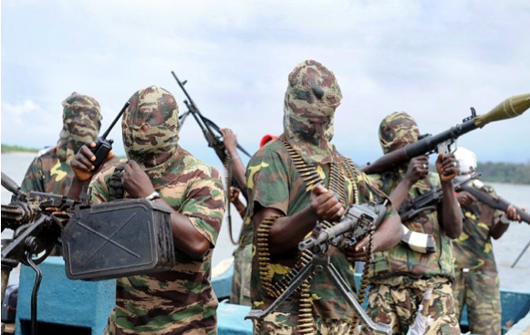 The religious extremism that helped spark this conflict is a problem in and of itself, however. In addition to Christian-Muslim violence, many fear that the ongoing radicalization of Islam in Nigeria will evolve into terrorism. One scholar notes that “there is a struggle going on for the minds of the Muslim population in [Nigeria,] one that is tied up in the economic conditions and political turmoil in that country over the past several years.” This struggle has left Muslim Nigerians feeling alienated by their government, and many now view the government with a deep-seated suspicion that it is acting against their interests. This sentiment has been partly manipulated by religious clerics. For example, some preached that the polio vaccines distributed in 2004 by the Nigerian government were a Western plot to sterilize Muslims. The combination of religious extremism and an inimical opinion of government create a perfect breeding ground for terrorism. Militant groups such as Boko Haram, shown above, (translated: Western Education is Sin) and Al Sunna Wal Jamma, (Followers of Mohammed's Teachings ) have rapidly gained support in the past few years and have occasionally clashed with Nigerian security forces. And while there is no current indication that foreign terrorist organizations have taken hold in Nigeria, many see “the potential for linkages between terrorist groups and Nigeria’s already well developed criminal and drug trafficking groups [as] a worrisome prospect.”
Picture 10 (Boko Haram) Source neorepublica.com
The destabilizing effects that extremism and violence throughout Nigeria have had on development are profound. In the North, the culture of radical Islam runs contrary to the innovative and progressive culture of development. In our Definition of Development, we stated that education was the key to development progress. When the main form of education is radical Islamic teachings that deny well-proven scientific theories in favor of scripture verses, little actual education is present. Sharia law prohibits many of the activities that one might view as essential to development, such as having opinions that conflict with scripture, or women opening businesses. When one’s ability to pursue ends according to their interests, values, and needs is constricted so severely, development is almost impossible to achieve.
The ongoing violence in both Central Nigeria and the Niger Delta also creates a crippling constraint on development. As Jakob Kellenberger of the Red Cross notes, “This violence destroys lives, perpetuates poverty and undermines development.” It increases the risk of investments and increases the cost of government security, a particularly troublesome problem considering Nigeria’s status as a net debtor. It causes citizens of the Nigeria to become prisoners of the violence around them; they are therefore not free to pursue their interests and preferences, focused on survival instead of development.

Section Three
Constraints on Future Development
Constraints on Future Development
As far back as most can remember Nigeria has not really changed. Socially, politically and economically Nigeria has largely been at a status quo for most of the past half century. Despite advantages rare in the third world (resources, land, a large population, etc), changes in policy, leadership and economic ideology have failed to bring Nigeria out of underdevelopment. In the future, many constraints remain that might keep this promising country stuck in the global south.

Consolidation of Influence
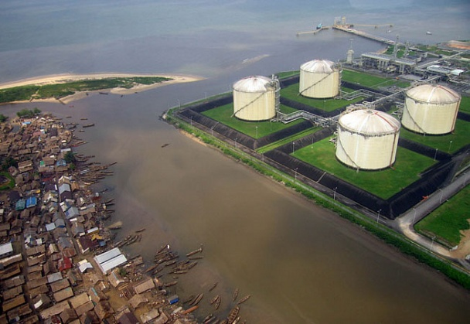
The fundamental constraint to development prospects in the future is the resistance that would be brought by the most influential individuals. As development naturally requires changes, reorientation and redistribution (of both wealth and power), those currently benefiting, currently making money and currently in control will have no incentive to promote it. This is an imposing constraint to development in the future.
Picture 11 Source vanityfair.com
The consolidation of power and wealth is easily witnessed. The above sections on inequity and poverty present a wealth of impressive and clear data to this effect.

Social Structures
A variety of influences perpetuate this consolidation, which in turn, perpetuates the status quo of underdevelopment. Perhaps the most deeply rooted and most constraining of these influences is the social structure of Nigeria.
As discussed above, Nigerian society promotes the patron-client system. It is perceived as “part of doing business” and the terrible ramifications that result from it seem to be widely underappreciated. Such indifference not only makes irradiating corruption more difficult, it contributes to its metastasizing throughout the country.
As corruption seeps into the pours of Nigerian society, without contest, future development becomes all the more challenging and all the more imperative. Patron-client systems disrupt development initiatives in both the short and long term. In the short term, resources are often diverted away from those they were intended to help, making start-up extremely difficult. Fewer development plans will be attempted if their likelihood of actually being instituted is suspect.
Long-term viability is critically important to any development enterprise and the patron-client system compromises the longevity of any project. In the long-run development must be sustainable. There must be confidence in sources of revenue, distribution of resources and in the general success of any endeavor. In a society entrenched in corruption, however, this confidence is rare, and rightly so.
Thus, the acceptance of patron-client system in Nigerian society must be overcome for development to be truly effective. The problem, and the true constraint posed by this system, is its firm foundation in Nigerian culture. Without a proper civic education and real awareness of the endemic and crippling problems that come from corruption, Nigeria will never be able to grow, develop, or come close to meeting its true potential.

Political Structures
The instability, illegitimacy and overall weakness of Nigerian governments since independence in 1960 have been as pervasive and as constraining to development as corruption. The result has been a dependence on grass roots and individual level development plans instituted outside of the state. Alas, the political environment in Nigeria is a constraint on development in three ways: absent good governance a lack of stability will drive away assistance, an ineffective government lacks the capacity to promote development through the public sector (i.e. welfare, market regulation, trade policy, etc.), and it forces more challenging and less effective grass roots development plans.
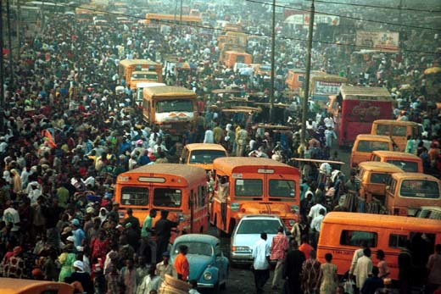
In a fluid, powerful state, one accepted as legitimate and representative of its polity, development through the public sector is a possibility. For these states, sound policies are likely to be implemented and likely to be effective. Management of the economy and welfare systems is a realistic function of the state and has the potential to help meet peoples’ basic needs and afford them greater freedoms and opportunities.
For a state like Nigeria, one prone to coups and military rule, famous for corruption and inefficiency, and without popular legitimacy, the state lacks such opulence. This is because effecting change from the public sector requires a respected and powerful government. If a food distribution system, for example, cannot get food to the poor because of corrupt and poorly planned mechanisms, the state is not only failing to alleviate poverty, but actually making development more difficult.
Picture 12 cas1.elis.ugent.be/avrug/illmil/lagos.htm
This instability is an enormous deterrent for potential developers. The global south is large and diverse and there are many other countries in need of assistance. The lack of accountability rampant in Nigeria is an enormous constraint on future development because it could drive potential donors, investors, NGOs and other developers away, leading them to attempt to develop other countries where their investment would get a more guaranteed, albeit lower, return – leaving the promise and potential of Nigeria unrealized and the desperate needs of its people unmet.
Weakness in the public sector, without dramatic change, will constrain development in many other ways. Welfare systems, for example, can be one of the most efficient and promising mechanisms to meet the basic needs of a large populous. As stated in the What is Development? section above meeting such needs is an essential step to long-term, sustainable development.
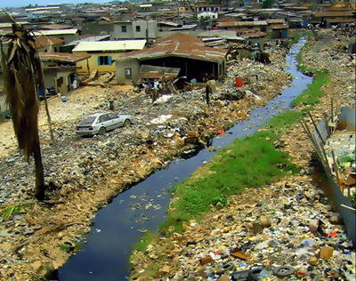
A poorly functioning government is also a potential constraint on government on the macro level. Management of economies, markets, and trade relations can be of significant importance to developing nations. For Nigeria, a well functioning government could provide much needed management of the oil sector. Policies to promote domestic markets, diversified exports and thus, a reduced dependence on the oil sector would be extremely impactful accents to other development policies. While this function of the state is not primary, and might not offer the initial promise of welfare plans in alleviating poverty, such functions of government can greatly still have important benefits, especially in later stages of development.
The absence of such public sector lead development has forced the emergence of extra-governmental development initiatives. Mostly in the form of Non-Governmental Organizations, aid is forced to micro-level projects because traditional public sector routes are corrupt, instable and unreliable.
Picture 13 Source Earth Institute: Columbia University
This contributes to the constraining effect of a weak state because grass roots development is much less effective. Despite the multitude of NGOs across Nigeria, little change is yet to be shown. This is because resources applied to public lead development plans have a much higher payoff for simple economies of scale reason. Each NGO enterprise requires its own administration, fund raising, information gathering, etc. – while a government-sponsored initiative, if properly and effectively implemented, can operate under a larger, more streamlined institution.
Thus, on top of promoting corruption, the political environment of Nigeria poses a constraint on development by making the implementation of any development strategy more difficult and slower to pay-off. This is because without good government, state-planned development is ineffective if not detrimental, and smaller, extra-governmental development enterprises are pursued out of necessity.

Economic Structures
As in the past, the economic environment in Nigeria could also be a constraint in the future. While this is for a number of reasons, most can be traced back to the consolidation of power discussed above and its ramification.
The lack of a middle class, for example, is a substantial impediment to development in the future. In the inequity section above it is indisputable that there is a serious distribution problem in Nigeria. For the economy, this means that local, domestic markets are weak. Since most resources have been allocated to the more profitable oil sector, other sectors have been slow to develop. As a result, a middle class and all of its benefits have never emerged.
Economically, the presence of a working middle class has enormous pay offs socially and developmentally. A working class leads to a middle class and thus, civil society. Such civil societies naturally forge stronger, more representative governments. As discussed above, the benefits from a strong political system for development are vast and would be critically important to future development. Their absence, in turn, will be an important constraint to bear in mind.
Dependence on oil will also be a serious constraint on growth in the future. As the above comments on oil explain, mineral export-lead growth systems such as Nigeria’s are inherently unstable, susceptible to fluctuations in global oil prices and prone to corruption. They perpetuate many of the problems already inherent in a country by eliminating the need for accountability. In Nigeria, oil is the primary source of government revenue. This effectively eliminates the necessity of the taxpayer to the state, covering up problems and perpetuating the status quo – perpetuating underdevelopment.

On the path to future development Nigeria has many obstacles in sight. Ranging from deeply entrenched social structures to political instability, finding a way for Nigeria to develop seems a daunting proposition. These problems, however systemic, however imposing, are not unbreakable. The follow sections will explain why action should be taken now to free the enormous potential that is currently being caged in Nigeria.

Potential and Promise
Section Four
Potential and Promise
Though the picture we have painted thus far seems dark and grim, the prospect for development is not impossible. In fact, Nigeria has several characteristics that are conducive to development. In this section, we detail the promising aspects of Nigeria’s economy, government, and people.

Fatalism – The Wrong Approach
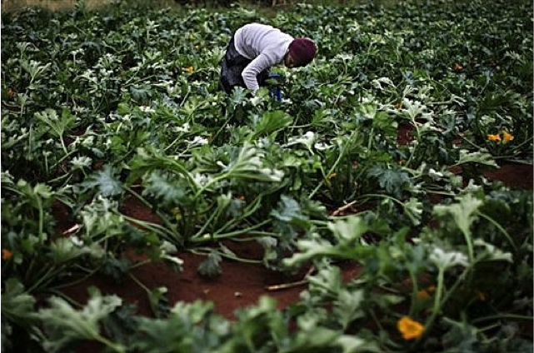Similar to the negative connotation given to many of the troubles affecting Nigeria, the fatalist sentiment generally expressed towards Nigeria by many in the “developed” world leads to erroneous assumption that development is impossible. Bosah Ebo argues that, “News media have shaped the [Western] image of Africa as a most unpleasant part of the world, where coups and earthquakes are staples of life.” This attitude has by and large come to represent the perception uninformed outsiders hold of the African continent as a whole and likewise had a marked effect on how Nigeria is regarded.
Picture 13 Source: International Land Coalition
Although these views under-appreciate much of the promise found throughout Nigeria, they are also understandable. Images of the pain-ridden faces and bloated stomachs of malnourished infants leave a far more lasting impression than graphs, statistics, charts or indexes. However, with the constant understanding that Nigeria still faces a considerable challenge in overcoming the many problems afflicting its people, it is significantly more important to appreciate positive trends within the country.
Regrettably, even scholars fluent in the complexities that have come to represent Nigerian society often choose to focus on the more disheartening aspects of their past and present situation. As Jeffrey Herbst bluntly claims, “…Nigeria is simply too big and too important in West Africa for the world to ignore not only its disastrous record but also the fact that there is no reason to believe that it will improve in the future”. In defense of this fatalist assertion, Herbst cites mostly the incessant failure of the state to enact meaningful initiatives in support of the people. While we offer no challenge to this contention of extraordinary government inefficiencies, we take issue with the seeming condemnation expressed of Nigeria.
The problem with Herbst’s assessment is that it approaches the situation from a far too “top-down” perspective. As we have maintained, the failure of the Nigerian state and its unassailable linkage to the patron-client system is the greatest impediment to its people pursuing ends according to their own interests, preferences, and needs. Rather than subscribe to fatalist notion of inevitable failure, we find many key elements within Nigerian society to promise real potential to change this situation – potential rare in the third world.

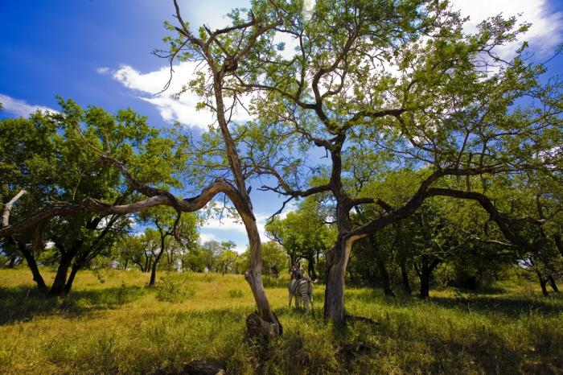
Why Nigeria?
Picture 14 Source puretravel.com
As further stated by Herbst, continuing decline will, “threaten not only Nigeria itself but the entire West African region.” With approximately one-fifth of sub-Saharan Africa’s population residing in Nigeria and its status as one of the world’s “Next Eleven” large economies, the importance of promoting real change and achieving real development in a country with such far-reaching influence is indisputable. Such considerations, along with those positive elements unique to Nigerian society, make it an especially gainful cause.
In discussing Nigeria’s encouraging potential, it is important to include a variety of data. Through the remainder of this section, we will explain the more broadly-based gauges and why they are vital indicators in understanding Nigeria’s development potential, gradually transitioning to those more likely to produce tangible change.
Economic and Fiscal Framework
As stated above, Nigeria’s economy can be an enormous asset in the future. Its lack of bottlenecks symptomatic of the global south makes investment and development more viable. Though fiscal stability is largely supported by oil, its high value and demand in international markets provides Nigeria with liquidity and subsequent autonomy many other developing nations lack.
Though much of this revenue and economic growth fails to meet everyday people, is presence must still be counted a huge potential benefit the country holds. With this rare advantage, development could break the never-ending cycle of waste, greed, and inefficiency.

System of Governance
As previously stated, the Nigerian state has long been criticized for its seemingly innate corruption, as well its inability to help Nigerians to the level they deserve. It is, however, important to note the government already has an infrastructure in place that, at a basic level, has the potential to one day administer such a vibrant country efficiently.
The 1979 Constitution was composed of a Federal Charter designed to insure ethnic equality through means such as requiring the Cabinet to consist of a representative from each state (Bozeman 328). Subsequent constitutional conventions have resulted in the adoption of newer versions, but the main tenets to it have remained intact. These include various measures that offer great hope for the future of development including the continual stressing of state autonomy and religious freedom. In 1996, the number of states in Nigeria was increased to 36 with one territory, Abuja, much like the capital of the United States. This division of power helps to alleviate some of the ethnic tensions present in the first two Republics and though it has far from solved the problem, provides a sound foundation for future generations of Nigerians to assume.

Human Capital
Human capital is a critical factor when calculating the development potential of a nation. Human capital is primary because without it, any development plan, even if perfectly instituted, will be unsustainable. The populous must have its basic needs met and be capable of instituting, maintaining, and promoting development on its own if development is to be a long-term and successful endeavor. Bruce Moon emphasizes this point: “the maintenance of minimal standards of living is a prerequisite for economic growth, political growth, political development, social evolution, cultural adaptation, and spiritual fulfillment. Basic human needs are, in short, basic.”

For Nigeria, it is clear that their level of human capital both offers enormous potential and requires enormous improvements to be a valuable resource for the Nigerian economy. Its current status can be summarized in a few words: large, growing, unhealthy, and lacking in skill.
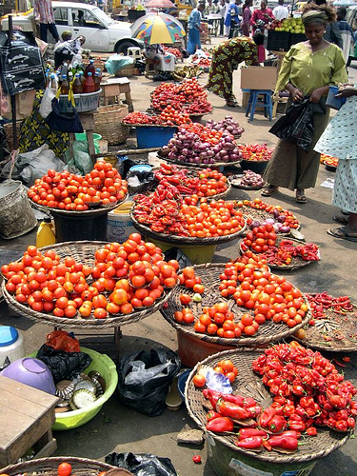
As Seers notes, population has a significant effect development in both positive and negative ways. According to the World Bank’s compilation of WDIs, Nigeria’s population growth for 2008 was 2.23 percent. Although exceeding the world average in 2008 of 1.17 percent, a more appropriate comparison to other “developing” countries reveals it to be in the middle of the pack. An even more localized comparison to Western African countries depicts it as relatively small in terms of its growth rate.
Picture 15 Alun John
Despite this, the possibility remains that as the world’s eighth most populous country, Nigeria’s above average growth rate has the capability to translate into a powerful labor force evocative of the country’s great potential as a whole. In fact, of the world’s ten most populous countries, Nigeria’s annual population growth rate is the highest, with only Pakistan coming close. This includes other “developing” countries such as Indonesia, Bangladesh, and China.
Figure 23 Population Growth Rates
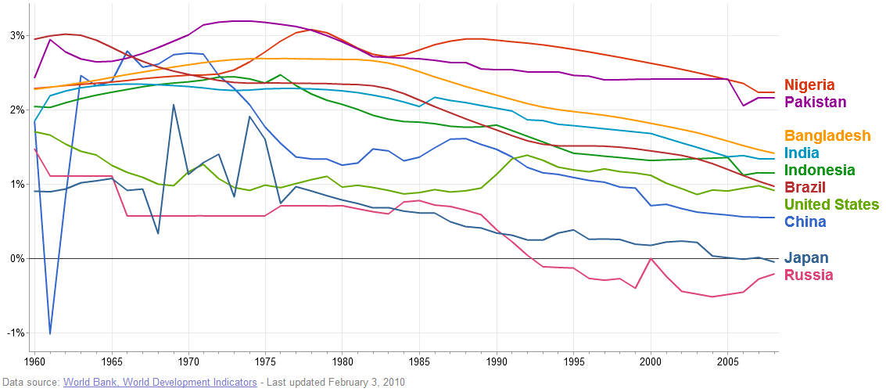
It is important to note, however, that without the ability to employ such a large work force, rampant unemployment can actually simply exacerbate the problems already in place. Furthering Nigeria’s potential are some bright spots in the country’s general business environment. The report shows that Nigeria performed in the top half of all nations in three fields: employing workers (37), protecting investors (57), and getting credit (87). These are all key indicators for development and are extremely pivotal in regards to doing business in any country. While they might not outweigh some of the more glaring problems presented above, future development would do well to make use of these strengths.
While these increases in population and improvements in education (albeit insufficient to date) do offer a potentially exploitable and valuable resource, the prevalence of disease and lack of accessible and effective healthcare enormously depreciates the value of the labor force for the Nigerian economy.
With improvements in disease prevention and available healthcare, (potentially as a consequence of better education) as well as continued course in improving skill levels, Nigeria’s large and growing labor force could be an extremely valuable resource in the future.

Young Population
Nigeria is a country dominated in terms of population by an abundance of young men and women. While acknowledging the youth bulge theory advocated by critics such as Gary Fuller (1995) and Gunnar Heinsohn (2003) which argues an overly young male population can result in increasing instability amongst a country, we take a different approach to the topic.
Using the model of Iran, where 70% of the people are under the age of thirty, we apply the overall optimistic feeling expressed towards future developments in this Middle Eastern country to our own example in West Africa. Granted, there are fundamental differences between the two such as the Iranian state’s religiosity and the Nigerian state’s “secularity,” but the general feeling of discontent amongst the two countries’ youth population is similar.

Figure 24 Population Age Distributions

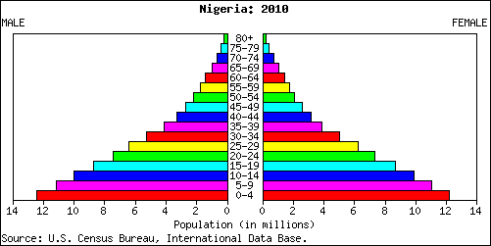

The Iranian model showcases the power education can have over a people. A pillar to the Islamic Revolution, increased accessibility to education has opened the minds to what many now perceive to be rampant injustice. “In response to the Islamic Republic’s slogan of ‘Higher Education for the Masses’, universities have been built all over Iran. The Republic’s successful education policies have entirely created the well-educated and politicized children of the Revolution …they have been the first to express their dissatisfaction…” (Alavi 138).
In a country with a life expectancy of just 47 years, Nigerians must recognize the need to enact some type of change. Yet the persistence of the patron-client system, and the depredation it has had on society, has left many Nigerians disillusioned to the notion it could ever change. This falls directly in line with the point we have made of such identity politics being the main impediment to a person being able to develop according to their own interests, ideas, and preferences.
Picture 16 Source bet.com
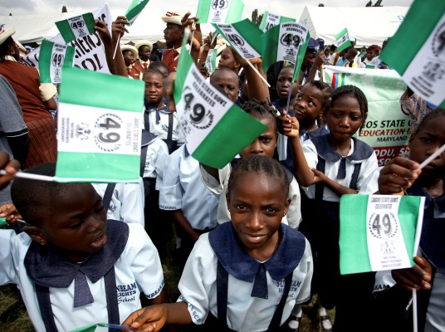
With the thought already in mind that their lives could and should be better off, furthering the ability of Nigerians to access education, and with it the ability to form their own opinions on the state of Nigerian affairs, will surely have a marked effect on the future potential of development. Like the Iranian case, where the youth of today have lived their entire lives after the Islamic Revolution, there are a growing amount of young Nigerians growing up in age devoid of the military dictatorships of old. A report published in 2009 by Dr. AA Adeogun reports that, “In 1999, when the Military returned the country to democratic rule, the second coming of private universities commenced. The outgoing military regime announced the approval of some private universities. The approval of these private universities is predicated on the fact that Nigeria as a nation has a youthful population that is yearning for education at the tertiary level.”Sharing a somewhat new understanding of society, the desire to learn, and increasingly encouraging strides as seen in the table below, Nigerians display the potential to satisfy one of their most basic needs while also providing the knowledge and skills necessary to further develop.
Picture 17 Source bet.com
Figure 25 Education Potential
 | 1990 | 2000 | 2004 | 2005 | 2007 | 2015 (MDGs) | Progress Towards Target
Net Enrolment | 68 | 95 | 81.1 | 84.6 | 89.6 | 100 | Good
Pupils Starting Grade 1 who reach Grade 5 | 67 | 97 | 84 | 74 | 74 | 100 | Good
Primary Six Completion Rate | 58 | 76.7 | 82 | 69.2 | 6  7.5 | 100 | Fair

Proposal
Section Five
A Development Proposal

In this report, we have illustrated the variety and depth of underdevelopment in Nigeria. While there is no single solution to all of problems in Nigeria, we believe that increasing the quality and availability of education is an essential requirement of development. While focusing on education may not directly affect the problems of entrenched corruption and an exploitative global oil industry, we feel that it is the best, most practical way to improve the lives of poor Nigerians. We hope to work alongside the many existing NGOs already on the ground in Nigeria to help attract more students to the classrooms and keep them in school.
One of the greatest problems observed with regards to education is the decreased enrollment in primary schools from one year to the next. By the time children are done with their primary education there has been a steady decrease in continuity. By the time secondary school comes about, there has been a drop in enrollment rates from 60.1 percent in primary education to 35.1 percent for secondary schools.
Given the present figures and trends in primary and secondary enrollment we wish to address and consequently breach the gap between primary and secondary education enrollment. The problem, as we view it, is not incompetent students as “over 50% of the head teachers sampled say that above 80% of their pupils gain admission into secondary school. The rest responded that 60 – 79% of their pupils gain admissions (26.9%) while for 4.5% of the head teachers, less than 59% of their pupils gain admissions,” but a lack of incentive to attend school.
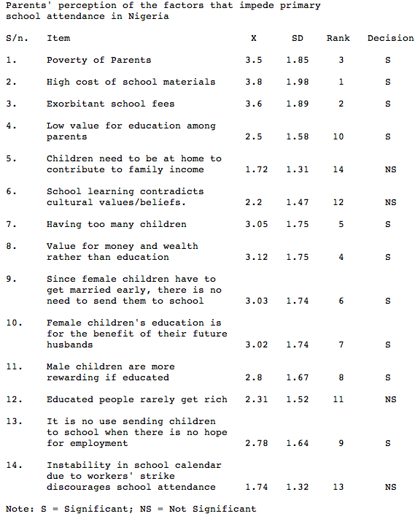
Figure 26 provides an account of the factors that impede primary school attendance in Nigeria as perceived by parents. It is reasonable to assume that these conditions will hold true (and perhaps be exacerbated) for secondary education given that parents indicated the “value for money and wealth rather than education” as the fourth most important decision for impedance to primary school attendance. Thus, secondary education would be perceived to them as even less important than their primary counterpart. The survey also ilustrates that poverty (of the individuals and of the government) is one of the major encumbrances to school enrollment.
Figure 26
Reasons for Not Attending School
Keeping these findings in consideration, certain provisions should be made to expand education. For example, providing completely free-of-charge education (for the poor only), not having to pay for materials (or subsidizing them by local production), and modifying the current value system to emphasize the importance of education over money and wealth.
Our goal with a proposal will be to increase the attendance and retention of schools already doing a good job. This would be one of the most effective ways for us to promote development because through a relatively small-scale initiative we could see great outcomes.
One idea to this end would be to establishing a farm within the school, tendered by the students and the teachers. The purpose of this farm would be multifaceted; to teach students the importance of self-sustainable and ecologically friendly agricultural practices, to provide the students with free-of-cost meals during school time, and to sell surplus food in a shop at the school to provide revenues to subsidize the cost of school materials.
The result would be a school that could not only offer an enormous incentive for students to attend, but one that was helping to sustain itself. Such a school would have increased attendance, increased matriculation, better learning (as well nourished students will develop faster) and more effectively contribute to making the changes needed in Nigeria.
Mimicking the efforts of Marie Da Silva in her school in Malawi, we wish to provide children with the opportunity to have an education. As Da Silva said, “ It does not take a Bill Gates to make a difference in the world.” All you need is drive and a desire to help others.
Bibliography of Figures
Figure 1: World Bank, World Development Indicators
Figure 2: World Bank, World Development Indicators
Figure 3: World Bank, World Development Indicators
Figure 4: CIA World Factbook
Figure 5: United Nations Development Program, Human Development Report
Figure 6: Nigerian Bureau of Statistics
Figure 7: Nigerian Bureau of Statistics
Figure 8: World Bank, World Development Indicators
Figure 9: Friedrich Huebler, huebler.blogspot.com
Figure 10: Nigerian Bureau of Statistics: Demographic and Health Survey
Figure 11: United Nations International Children’s Fund
Figure 12: Nigerian Bureau of Statistics
Figure 13: World Health Organization, Global TB Report
Figure 14: World Health Organization
Figure 15: World Health Organization, Death and DALY Estimates
Figure 16: UNDP, Human Development Report
Figure 17: Nigerian Bureau of Statistics
Figure 18: World Resources Institute
Figure 19: Nigerian Bureau of Statistics
Figure 20: Nigerian Bureau of Statistics
Figure 21: World Bank, World Development Indicators (GDP), OPEC (Oil Prices)
Figure 22: Transparency International (CPI), OPEC (Oil Prices)
Figure 23: World Bank, World Development Indicators
Figure 24: U.S. Census Bureau, International Data Base
Figure 25: United Nations Development Program, Millenium Development Goals
Figure 26: Journal of Instructional Psychology, Obiunu Jude “The Dilema of Prmary School Attendance in Nigeria
Ncl208

Aristotle, Nicomachean Ethics, Ch. 5
- World Development Indicators, The World Bank
- World Development Indicators, The World Bank
- Net FDI increased from 1.14 billion to 2.01 (current US$) from 2000 to 2005 - Source: World Development Indicators, The World Bank
- World Development Indicators, The World Bank
- The World Fact Book, CIA
- International Monetary Fund
- A savings gap is also known as the One-Gap. It is the difference between savings levels and the required level of investment to support development. Without enough savings, individuals cannot invest in the capital needed to increase productivity and develop.
- Also know as the Two-Gap.
- The difference between government revenue and the amount of revenue requisite to promote develop is also known as the Three-Gap.
- Goldman Sachs Investment Bank, ""The Next Eleven"," Goldman Sachs, 2007.
- “UNESCO on Poverty in Nigeria.” The Daily Champion. 2010. AllAfrica.com. 8 February 2010. http://allafrica.com/stories/201001280540.html
“medium developmet” is defined by UNDP as having an HDI between .5 and .75
- “Human Development Report: Nigeria.” United Nations Development Programme. 2009. http://hdrstats.undp.org/en/countries/country_fact_sheets/cty_fs_NGA.html
- “In situations where the conventional means of seeking work are of limited relevance, where the labour market is largely unorganised or of limited scope, where labour absorption is, at the time, inadequate or where the labour force is largely self-employed, the standard definition of unemployment given in subparagraph (1) above may be applied by relaxing the criterion of seeking work.” (ILO)
- The ILO, and likewise Nigerian, definitions of employment consider gainful paid and self employment to consist of: “‘at work’: persons who during the reference period performed some work for [profit or salary/family gain], in cash or in kind.” (ILO)
- Resolution concerning statistics of the economically active population, employment, unemployment and underemployment, adopted by the Thirteenth International Conference of Labour Statisticians” 1982. http://www.ilo.org/wcmsp5/groups/public/---dgreports/---integration/--- - stat/documents/normativeinstrument/wcms_087481.pdf
- “World Development Indicators 2009.” The World Bank. 2010.http://web.worldbank.org/WBSITE/EXTERNAL/DATASTATISTICS/0,,contentMDK:21725423~pagePK:6413315 0~piPK:64133175~theSitePK:239419,00.html
- Annual Abstract of Statistics.” Nigerian National Bureau of Statistics. 2007. - http://www.nigerianstat.gov.ng/nbsapps/annual_report.htm - * 2007 data is an estimate
- For additional information on the relation between education and income (corollary to education) see “Inequity”
- “Annual Abstract of Statistics.” Nigerian National Bureau of Statistics. 2007. http://www.nigerianstat.gov.ng/nbsapps/annual_report.htm
- Seers, Dudley. “The Meaning of Development.” Revista Brasileira de Economia. 24:3. 1970.
- After talking with a group of Nigerians (Collins Emoja among them), we discovered that literacy rates, as observed by them, were much lower (although a number was hard to quantify).
- Page, John. “The East Asian Miracle: Building a Basis for Growth.” Finance & Development. 1 March 1994.
- "Education statistics: Nigeria." Child Info. UNICEF, n.d. Web. 9 Apr 2010. <http://www.childinfo.org/files/WCAR_Nigeria.pdf>.
- Ibid.
- "Nigeria: Education Profile." United States Diplomatic Mission to Nigeria. U.S. Department of State, n.d. Web. 9 Apr 2010. <http://nigeria.usembassy.gov/nigeria_education_profile.html>.
- ibid.
- Dike, Victor. "The state of education in Nigeria and the health of the nation." African Economic Analysis (2002): n. pag. Web. 7 Apr 2010. <http://www.africaeconomicanalysis.org/articles/gen/education10204234737htm.html>.
- Saint , William, Teresa A. Hartnett, and Erich Strassner. "Higher Education in Nigeria: A Status Report ." Boston College. N.p., 2003. Web. 9 Apr 2010. <http://www.bc.edu/bc_org/avp/soe/cihe/inhea/profiles/he_nigeria_status.pdf>.
- Dike, Victor. "The state of education in Nigeria and the health of the nation." African Economic Analysis (2002): n. pag. Web. 7 Apr 2010. <http://www.africaeconomicanalysis.org/articles/gen/education10204234737htm.html>.
- ibid.
- Saint , William, Teresa A. Hartnett, and Erich Strassner. "Higher Education in Nigeria: A Status Report ." Boston College. N.p., 2003. Web. 9 Apr 2010. <http://www.bc.edu/bc_org/avp/soe/cihe/inhea/profiles/he_nigeria_status.pdf>.
- ibid.
- Saint , William, Teresa A. Hartnett, and Erich Strassner. "Higher Education in Nigeria: A Status Report ." Boston College. N.p., 2003. Web. 9 Apr 2010. <http://www.bc.edu/bc_org/avp/soe/cihe/inhea/profiles/he_nigeria_status.pdf>.
- World Bank, 1993.
- World Bank, 1993.
- Saint , William, Teresa A. Hartnett, and Erich Strassner. "Higher Education in Nigeria: A Status Report ." Boston College. N.p., 2003. Web. 9 Apr 2010. <http://www.bc.edu/bc_org/avp/soe/cihe/inhea/profiles/he_nigeria_status.pdf>.
- HINCHLIFFE 2002; UNESCO 2000
- "Life Expectancy at Birth." CIA World Factbook n. pag. Web. 7 Apr 2010. <https://www.cia.gov/library/publications/the-worldfactbook/rankorder/2102rank.html?countryName=Nigeria&countryCode=ni&regionCode=af&rank=216#ni>.
- "Polio Eradication in Nigeria." World Health Organization. N.p., n.d. Web. 31 Mar 2010. <http://www.who.int/countries/nga/mediacentre/backgrounders/2005/polio_backgrounder_060505.pdf>.
- "Technical Cooperation for Sustainable Development." WHO. World Health Organiaztion, n.d. Web. 7 Apr 2010. <http://www.who.int/countries/nga/reports/who_2007_annual_report.pdf>.
- "Technical Cooperation for Sustainable Development." WHO. World Health Organiaztion, n.d. Web. 7 Apr 2010. <http://www.who.int/countries/nga/reports/who_2007_annual_report.pdf>.
- "Fiscal Space & Public Expenditure on the Social Sectors." UNICEF, Feb 2009. Web. 7 Apr 2010. <http://www.unicef.org/wcaro/wcaro_08_UNICEF_OPM_briefing_paper__Fiscal_Space.pdf>.
- Anand and Revallion. “Human Development in Poor Countries: On the Role of Private Incomes and Public Services. The Journal of Economic Perspectives. 7:1. 1993. 133-50.
* The ratio of X: Y here gives the percentage of the population (X) that holds a percentage of the wealth (Y)
- The Gini Coefficient measures the difference of inequality of income or wealth. Through a number of inputs it calculates a line (the Lorenz curve) and measures the area between that line and a line of perfect equality (45˚).
- The Gini Index must be used with caution. Some criticize it for measuring nominal (rather than PPP) income, being distorted by large areas, not accounting for magnitude of differences, and failing to acknowledge lifetime income. All these factors might also affect a country’s level of inequality
- “Human Development Report: Nigeria.” United Nations Development Programme. 2009. http://hdrstats.undp.org/en/countries/country_fact_sheets/cty_fs_NGA.html
- Quintile distributions define the population in fifths based on ordering of wealth. Thus, the first quintile is the 20% of the population with the least amount of wealth and the fifth quintile is the richest fifth of the population.
- Birdsall, N. and J.L. Londono. 1997. “Asset Inequality Matters: An Assessment of the World Bank’s Approach to Poverty Reduction,” American Economic Review 87: 32-37.
“The Curse of Oil Still Stalks Nigeria Delta” The Curvse of Oil Still Stalks Nigeria Delta. (2010, March 29). Retrieved April 7, 2010, from The Independent: http://www.independent.co.uk/news/world/africa/the-curse-of-oil-still-stalks-nigeria-delta-1930001.html
Nigeria. (2010, April 1). Retrieved April 4, 2010, from CIA World Factbook: https://www.cia.gov/library/publications/the-world-factbook/geos/ni.html
Dutch Disease refers to the economic phenomenon that explains the correlation between increasing exploitation of natural resources and the decline of the manufacturing sector.
Smith, D. (2007). A Culture of Corruption. Princeton, NJ: Princeton University Press. Pg. 64
Ikein, A. a.-A. (1998). Oil and Fiscal Federalism in Nigeria. Brookfield, VT: Ashfield Publishing.
Ikein, A. a.-A. (1998). Oil and Fiscal Federalism in Nigeria. Brookfield, VT: Ashfield Publishing.
Secretary General World Trade Organization, "Trade Policy Review: Nigeria," World Trade Organization, April 2010 <http://docsonline.wto.org/GEN_highLightParent.asp?qu=%28+%40meta%5FTitle+Nigeria%29+and+%28+%28+%40meta%5FSymbol+WT%FCTPR%FCS%FC%2A+%29+or+%28+%40meta%5FSymbol+WT%FCTPR%FCG%FC%2A+%29%29&doc=D%3A%2FDDFDOCUMENTS%2FT%2FWT%2FTPR%2FS147%2D0%2EDOC%2EHTM&curdoc=6&popTitle=WT%2FTPR%2FS%2F147>.
Akweme, Alex. “Federalism and Public Finance in Nigeria.” January 2002. http://www.nigerdeltacongress.com/farticles/federalism_and_public_finance_in.htm. April 8, 2010. This formula was adopted by the Constitution of 1999.
Shuaib, Yushau. “Understanding the Revenue Allocation Formula”
Ekwueme, A. (2002, January). Federalism and public finance in Nigeria. Retrieved April 7, 2010, from Niger Delta Congress: http://www.nigerdeltacongress.com/farticles/federalism_and_public_finance_in.htm
- Shah, Anup. "Nigeria and Oil." Global Issues. N.p., 03 Jul 2004. Web. 2 Apr 2010. <http://www.globalissues.org/article/86/nigeria-and-oil>.
- "Fact Sheet: Harmful Gas Flaring in Nigeria." Friends of the Earth. N.p., Nov 2008. Web. 2 Apr 2010. <http://www.foe.org/pdf/GasFlaringNigeria_FS.pdf>.
OIL INDUSTRY HAS BROUGHT POVERTY AND POLLUTION TO NIGER DELTA. (2009, June 30). Retrieved April 9, 2010, from Amnesty International: http://www.amnesty.org/en/news-and-updates/news/oil-industry-has-brought-poverty-and-pollution-to-niger-delta-20090630
Smith, D. (2007). A Culture of Corruption. Princeton, NJ: Princeton University Press. Pg. 5
Nigeria Tops Corruption Chart. (2000, January 13). Retrieved April 3, 2010, from BBC News: http://news.bbc.co.uk/2/hi/africa/923570.stm
The extent to which democracy actually exists in Nigeria will be discussed later in the report.
Smith, D. (2007). A Culture of Corruption. Princeton, NJ: Princeton University Press.
Jameson, W. a. Pradigms of Economic Development and Beyond.
Smith, D. (2007). A Culture of Corruption. Princeton, NJ: Princeton University Press. Pg. 64
Smith, D. (2007). A Culture of Corruption. Princeton, NJ: Princeton University Press. Pg 112
Smith, D. (2007). A Culture of Corruption. Princeton, NJ: Princeton University Press. Pg. 42
Oil For Nothing: Multinational Corporations, Environmental Destruction, Death and Impunity in the Niger Delta. Essential Action, 2000. http://www.essentialaction.org/shell/Final_Report.pdf
- Mathiason, Nick. “Shell in Court Over Alleged Role in Nigeria Executions.”
- “ Nigeria: Niger Delta Gang Violence Goes Unpunished.” 2008. Human Rights Watch. http://www.hrw.org/en/news/2008/03/20/nigeria-niger-delta-gang-violence-goes-unpunished
- “Niger Delta. 2006. GlobalSecurity.org. http://www.globalsecurity.org/military/world/war/nigeria-2.htm
- “Politics as War: The Human Rights Impact and Causes of Post-Election Violence in Rivers State, Nigeria.” Human Rights Watch. Volume 20, No.3 (A). 2008.
Politics as War: The Human Rights Impact and Causes of Post-Election Violence in Rivers State, Nigeria.” Human Rights Watch. Volume 20, No.3 (A). 2008.
- Marshall, Paul. “Radical Islam in Nigeria.” The Weekly Standard. April 15, 2002: The Talibanization of West Africa. http://www.weeklystandard.com/Content/Public/Articles/000/000/001/099tvutr.asp
- Nossiter, Adam. “Toll From Religious and Ethnic Violence in Nigeria Rises to 500.” New York Times. March 8 2010. A4. http://www.nytimes.com/2010/03/09/world/africa/09nigeria.html
- Lyman, Princeton N. “The Terrorist Threat in Africa.” 1 April 2004. Testimony Before the House Committee on International Relations. http://www.cfr.org/publication/6912/terrorist_threat_in_africa.html
- Lyman, Princeton N. “The Terrorist Threat in Africa.” 1 April 2004. Testimony Before the House Committee on International Relations. http://www.cfr.org/publication/6912/terrorist_threat_in_africa.html
- Kellenberger, Jakob. “Armed Violence and Development.” 2006. International Community of the Red Cross. http://www.icrc.org/web/eng/siteeng0.nsf/html/small-arms-statement-070606
Sachs, Jeffery. "Diagnostic Economics." Print.
Hawk, Beverly G. Africa's Media Image. New York: Praeger, 1992. Print.
Herbst, Jeffrey. "Is Nigeria a Viable State?" The Washington Quarterly, 1996. Web. 6 Apr. 2010. <http://galenet.galegroup.com/servlet/BioRC?srchtp=advanced&c=1&ste=28&tbst=asrch&tab=8&n=10&bConts=8&ADN=A18499201&docNum=A18499201&locID=ugnid>
"Chapter 1: Basic Human Needs," Bruce E. Moon, The Political Economy of Basic Human Needs (Cornell University Press, 1991).
Seers, Dudley. “The Meaning of Development.” Revista Brasileira de Economia. 24:3. 1970.
Note: It should be noted that Nigeria’s definition of “unemployment” is roughly based upon the ILO’s own criterion. In other words, an individual must be without work and available for it. Most conventional definitions also include a third provision of “actively seeking work,” but even the ILO notes how this can be relaxed in countries with very limited options for employment. It is also essential to understand that self-employment, which is considered to be “at work,” is a fairly all-encompassing term consisting of people who, during the reference period, performed some work for profit or family gain, in cash or in kind.
“‘Doing Business’ Nigeria.” Ease of Doing Business Report. World Trade Organization n.d. Web 1 Apr 2010. >.
Alavi, Nasrin. We Are Iran. Brooklyn NY: Soft Skull, 2005. Print.
Adeogun, Dr. A. A., Dr. S. T. Subair, and Mr. G. I. Osifila. "Deregulation of University Education in Nigeria: Problems and Prospects." Florida Journal of Educational Administration & Policy 3.1 (Winter 2009). Web.
http://hdr.undp.org/en/reports/nationalreports/africa/nigeria/Nigeria_2008-09.pdf Human Development Report, Nigeria 2008-2009
"EDUCATION SECTOR STATUS REPORT." Planipolis. UNESCO, n.d. Web. 10 Apr 2010. <http://planipolis.iiep.unesco.org/upload/Nigeria/Nigeria%20Ed%20Sector%20Status%20May%202003.pdf>.
"NIGERIA EDUCATION SECTOR DIAGNOSIS ." Planipolis. UNESCO, n.d. Web. 10 Apr 2010. <http://planipolis.iiep.unesco.org/upload/Nigeria/Nigeria%20Education%20Sector%20Diagnosis.pdf>.
Many children in school do not get the chance to eat from the time they have breakfast to the time that they go home for dinner; many of them do not even have the resources to have breakfast.
CNN Hero, established the Jacaranda Foundation, the first completely free-of-cost school in Malawi
A School for Hope: Educating AIDS Orphans, 30 March, 2010.

