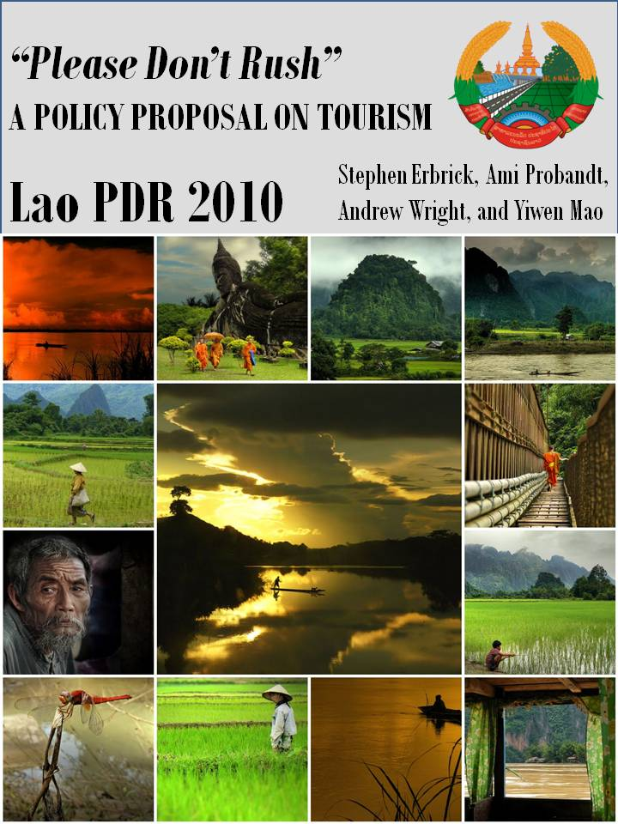
Table of Contents
Introduction Letter 3
Definition of Development 4
Why Laos? 4
Why Tourism? 6
Tourism Attractions in Laos 7
Current State of Tourism 11
Human Development in Tourism 13
Current Status of Ecotourism 14
Definition and Benefits of Ecotourism 14
Current Development of Ecotourism in Laos 15
Current Challenges in Tourism 17
Conclusion 18
Policy Proposal 19
Why are Standards Necessary? 19
The PDR Accreditation System and Its Implementation 21
Sample Standards for Eco-tourism 22
Sample Standards for Pro-poor Tourism 25
Strategies for Implementing Pro-poor Tourism 27
Areas of Concern 28
PDR Accreditation System Budget 29
Further Developmental Effects 31
Conclusion 32
Appendix 33
Works Cited 38

Introduction Letter
Honorable Prime Minister Bouphavanh:
We are addressing you today on behalf of the Special Project Group of the National Tourism Authority of Laos. A new era for the Laotian tourism sector has begun. In the last few years, we have seen significant and rapid growth in the tourism sector. Tourism has become a primary force in bringing prosperity to our cities and villages. As civil servants representing the Laotian citizenry, we feel it is our duty to make better use of tourism as a means of improvement for the lives of our people. Therefore, we humbly present to you our proposal entitled “Please Don’t Rush” (PDR) which is an accreditation system aimed at promoting a sustainable and dynamic tourism sector.
Laos is blessed with rich natural and cultural resources which afford us a competitive advantage in tourism over our neighbors. Foreign tourists come to our country seeking untouched natural beauty and an authentic cultural experience. Because of our country’s magnificent landscape and unique culture, ecotourism in Laos has become world-renowned. Tourism has become a major source of foreign income, generated numerous employment opportunities, and will create spillover effects in other sectors such as education or healthcare. It has changed and will continue to change the lives of countless Laotian citizens.
However, the tourism sector faces several constraints which will hinder its future success. These restrictions include inadequate government standards and regulations, a shortage of business management skills, insufficient advertising, and underdeveloped infrastructure. Our proposal will overcome these challenges through government support and free market operations.
The PDR Accreditation System includes two sets of standards: one for ecotourism and one for pro-poor tourism. We believe these two facets are closely interconnected as pro-poor tourism provides a base for growth in ecotourism, and ecotourism ensures sustainable pro-poor development. By combining these two separate orientations into one proposal, we will help to enable Laotians to have the capacity to pursue their valued lives and will facilitate Laos’s long-term prosperity.
Honorable Prime Minister Bouphavanh, we believe that our proposal under your insightful leadership will bring great progress and open a new chapter of development in the great history of the People’s Democratic Republic of Lao and the Lao People's Revolutionary Party.

-The Special Project Committee
National Tourism Authority
Vientiane
April, 2010

Definition of Development
Without a working definition of what it means to be developed, it will be difficult for our policy proposal to address Laos’s numerous developmental needs and then secondly try to mitigate them. To us, freedoms are not only the primary ends of development; they are also among its principle means. PPT strategies like those proposed in this report promote freedoms like increased opportunities for economic growth, enhanced wellbeing, and improved decision making power for Laos’s rural poor. If implemented correctly, pro-poor tourism can mitigate major unfreedoms that restrain impoverished Laotians from being all that they can do or be. Thus, we see pro-poor tourism as a tool for helping people to transcend their current situation. Our definition of development urges us to focus not only on the accumulation of material wealth, but also on important social and political indicators as well. Although our definition of development is derived from Sen, this does not mean that our policy proposal is entirely focused on providing basic human needs for Laos’s rural poor. Instead, our PPT policy proposal will strive to reinforce these basic human needs while simultaneously expanding the rural population’s ability to access advanced economic, social, and political opportunities.

Why Laos?
Although Laos is one of few remaining Communist states in the world and is also one of the poorest countries in South East Asia, it has overcome numerous difficulties and has established itself as one of the most dynamic and rapidly developing nations in the region. Bucking years of war and isolation, the government of Laos has since introduced itself to the world as one of the most environmentally pristine and culturally unique places in the world to visit. Laos has shown great potential, sustaining average growth rates of over 5% per year. But, however impressive this progress may sound, it is sustained by massive hydroelectric dams and harvesting natural resources. Furthermore, these sectors do not provide substantial benefits for most rural Laotians. Therefore, our policy proposal will reverse this trend by promoting sustainable development that does not exploit Laos’s pristine natural resources or under utilize its human capital. Through proper use of Laos’s resources, we will be able to propose a development plan which benefits all Laotians. This section will briefly describe the current state of Laos’s economy and society.

The economy of Laos has been growing quite rapidly, but it is still weak and underdeveloped. As previously stated, the country is one of the poorest in the world with a GDP per capita of about $2,100. For comparative purposes, the average citizen in Thailand generates $8,100 per year and the average American produces over $46,000 per year. From these statistics, you can see that Laos is in dire need of economic development.
Laos is a mountainous and landlocked country. Therefore, opportunities in agriculture and manufacturing are minimal. The majority of agricultural goods are produced using non-sustainable methods such as the Swidden method which involves massive deforestation. Additionally, the mountainous landscape restricts arable land to 8% of Laos’s total land area. The lack of sea ports gives the neighboring countries of Cambodia, Vietnam, and Thailand major advantages in the export of manufacturing products.
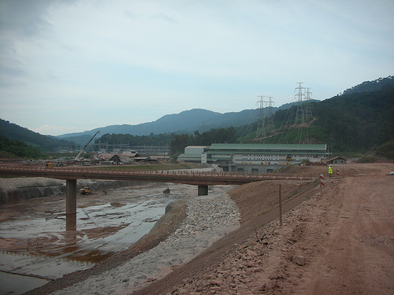
Development of the hydropower industry is a source of major ecological and societal damage. Dams in rivers will disrupt the fragile balance of nature and may displace people living near the dam as they are no longer able to farm in the new environment. Therefore, we have decided not to further develop Laos’s large hydropower industry.
Laos’s financial situation is stable. Tourism has been a source of much needed foreign currency and has created a trade surplus in services and thus balances the country’s trade deficit in goods. As you can see from the chart below, tourism revenues have been increasing over the past 17 years, but we still see opportunities for further improvements.

Although the GoL prefers Lao businesses as developers and investors in the tourism industry, FDI from 2006-2008 in the tourism industry totaled 120 million USD. These investments have been increasing since the 1990’s, indicating a strong international interest in investing in the tourism industry due to large potential returns from this growing industry.
In addition to a stable external balance, the government’s budget deficit is also relatively stable and manageable. The government could sustain a period of slightly larger deficits to finance developments in tourism if necessary, although deficits are not desirable if other sources of funding exist.
Socially speaking, the wellbeing of most Laotians has improved over the past ten years. Infant mortality rates have fallen and average life expectancies have risen, indicating overall improvements in healthcare. The number of literate primary school graduates has also increased. However, improvements in the sectors of healthcare and education are still possible; there is still much room for improvement. Additionally, Laos’s workforce is currently underdeveloped. This uneducated and underemployed human capital is a resource which could be improved and utilized in all industries.

Although Laos has made much economic and social progress, numerous unfreedoms are still present in Laos which prevent the average Laotian from securing the opportunity to be able to choose his or her path to the future. We have determined that developments in other sectors other than tourism are not sustainable given the current state of the economy, society, and environment in Laos. Developments in the agriculture or manufacturing sectors will not provide an efficient and competitive growth source for Laos, improvements in hydropower generation are harmful to the environment and citizens, and the country does not have access to the massive amount of funds necessary to develop its education and healthcare sectors independent of outside sourcing. Therefore, we believe that the best development option for Laos is through its embryonic tourism sector. Through tourism, Laos will be able to achieve rapid growth which will benefit all citizens. The following section will describe the current condition of the tourism industry in Laos.

Why Tourism?
Tourism, coupled with hydropower, has served as the major source of foreign income for Laos. Due to numerous ecological and societal concerns, we have decided not to further develop Laos’s large hydropower industry. However, the potential benefits of tourism are currently not fully realized in Laos. Laos is blessed with rich natural and cultural resources that are suitable for tourism development. This rapidly growing and profitable sector has not received as much attention from the GoL as it requires for complete development. Although the sector is still underdeveloped, a very basic infrastructure is currently in place. Therefore, it will be easier for the government and private industry to further develop this sector versus another sector which is relatively undeveloped. Also, tourism provides self-sustaining revenues for the upkeep of public property such as temples and roads. These revenues would come mainly from the purchase of visas which are required for most citizens entering the country, and fees from granting accreditation status to businesses.
We recognize that tourism is a sector that can be developed and can become a source of growth for Laotians. We believe this industry can be further developed for less cost and added benefit than other sectors such as education or healthcare since a rudimentary infrastructure already exists. Also, the developments made in this industry will have spillover effects for other areas of society. Thus, there will be both direct and indirect benefits from tourism. Direct benefits include increasing employment opportunities and revenues for local businesses. Indirect effects will occur in other sectors such as education and healthcare because tourists will demand educated staff on tours and in hotels and access to safe drinking water, food, etc. Additionally, revenues generated from tourism will have a multiplier effect on this industry and the country as a whole since citizens and the government will be able to use the generated revenues to increase consumption and improve standards of living. Eventually the revenues from the tourism industry will be shared among the many different sub-sectors of the industry such as lodging, restaurants, transport, and micro-businesses which focus on selling souvenirs.
Aside from generating government revenue, income for citizens, employment, and various spillover effects, tourism will help Laos to earn revenues in foreign currency. This inflow of capital will increase the foreign reserves of the country, allow for future repayment of foreign debts, and could additionally be used to purchase foreign goods.
Other non-economic benefits can be achieved by increasing the reach of the tourism industry. These include increased capacity building through the training of locals in tourism services, opportunities for Laotians to come in contact with other cultures, and improved access to services and infrastructure. Pro-poor tourism can also help to distribute income to rural areas which would assist Laos in its efforts to eliminate its massive urban bias. An eco-friendly and culturally-friendly focus will help Laos work toward preserving its natural landscape and tradition.

Tourism Attractions in Laos
Why would a tourist want to travel to Laos? Laos boasts many pristine natural, traditional cultural and inspiring historical attractions. This section will describe the main things to do and places to see in Laos.
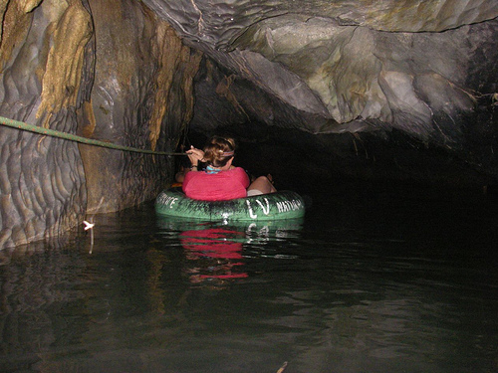
Caves
Laos boasts some of the most extensive limestone cave networks in Asia. One of the best, Konglor Cave, can be found in Laos’s central Khammouane province. What makes this cave superior is the fact that one can ride a small boat through the over six mile network of caves. Not far away, determined trekkers can discover the Tham Pa Fa cave where 229 Buddha idols were discovered in 2004. Many of these caves served as a base for Laos’s revolutionary forces during the Vietnam War.
Treks
Adventurous tourists can explore Laos’s steep mountains, tropical forests, and remote villages on foot with a local guide. Laos’s unparalleled waterfalls, caves, and wildlife are usually best investigated this way. The local guides have an intimate knowledge of Laos’s flora and fauna and will make the trip to Laos much more interesting.
Rivers
One of the best ways to see Laos is by river. Traversing the entirety of Laos, the Mekong River is an excellent way to pass through dense jungles, ravines, and sometimes even through extensive limestone cave systems. Depending on the level of adventure sought, Laos’s rivers can provide the adventurous a wild ride or the more sedate traveler a much mellower experience. Between October and March, Laos’s rivers have Class I and II (on a scale of five) rapids. But during the monsoon season between July and October, even mellow rivers turn to whitewater, creating a Class V rafting experience. Even the most seasoned of kayakers will find plenty of challenges. Unlike neighboring countries, one can ride Lao’s river networks for days on end. But more importantly, Laos’s rivers often go where its roads do not and provide visitors a rare opportunity to see undeveloped rainforest where few people have ever been before.
Local Handicrafts
Textiles, silver, wood products, and baskets are the most popular handicrafts produced in Laos. Like neighboring Cambodia, Laos is best known for producing home-spun silk and cotton. More specifically, Lao weavers are most notably known for their complex patterns based on traditional folk lore. While visiting Luang Prabang, do not miss the night market in the center of town where these goods can be purchased cheaply. Lao sarongs and hill tribe bags are a popular souvenir to bring home. Although the majority of shops have fixed prices, bartering is still advisable for most items.
Food and Drink
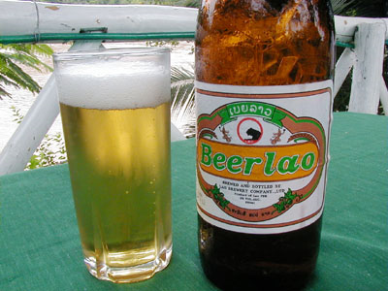
Laotian food is typically a blend of flavors from Thai, Vietnamese, and Chinese dishes. Some French restaurants, which are reminiscent of the colonial era, are still popular among rich tourists and the diplomatic community and are mostly located in larger cities. The French meals are usually more expensive and not authentic, so most tourists who desire to really experience Laos buy directly from food venders in the market. Traditional Lao food is very spicy, but most venders will reduce the kick for westerners. Fish sauce, which is used in curries, is made from anchovies and is typically used to flavor dishes.
National Foods
• Sticky rice - This rice is a staple crop in Laos. The GoL is currently implementing a plan to make the country self-sufficient in sticky rice production.
• Pho - This dish is a white rice noodle soup. It is usually served with beef and or pork although vegetarian versions are available.
• Laap - This minced meat, fish, or vegetable dish is tossed in lime juice, garlic, onions, powdered rice, and chilies to give it a uniquely Laotian flavor. It is usually always accompanied by sticky rice.
• Tam maal hung - This dish is a Lao-style papaya salad.
• Khai phaan - This popular weed from the Mekong River is a Luang Prabang specialty.
National Drinks
• Lao lao - This drink is a popular rice whisky. There are two brands available to give consumers a chance to choose which they like best.
• Beer Lao - This drink may as well be the national drink. It is produced locally, and almost everyone in the country drinks Beer Lao as there are no age restrictions on consumption.
Nightlife

In Vientiane, there are several discos that host local Lao bands. But in most other cities and towns, one will have to seek out a large hotel for nightlife. In general, Laos’s nightlife is laid-back. Most evenings in Laos involve a Beer Lao and an early night.

Vientiane Attractions (Laos’s northern capital, located on the Mekong River)
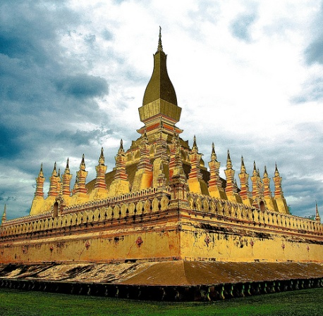
Unlike Hanoi or Bangkok, Vientiane is a sleepy escape from modernity. In Laos’s small capital, temples and other religious sites blend seamlessly with the city and most sites are reachable by foot. For example, Laos’s That Luang monument, the symbol that replaced the hammer and sickle on the country’s seal, was built in the 16th century and is Laos’s most sacred Buddhist shrine. Each terrace of the monument is gilded in pure gold and features different designs representative of Buddhist doctrine. Another important temple, Wat Sisaket is considered by many to be the most interesting Laotian temple. Inside Wat Sisaket, over six thousand miniature Buddhist inscriptions from the 18th century rest on shelves. In the center of Vientiane, one can see the Patuxai (literally Gate of Triumph). Built between 1962 and 1968, this monument commemorates those who fought for independence against the French in the first Indochina War. Rather ironically, the arch looks a lot like the Arc de Triomphe in Paris. But upon closer inspection, the architecture and design is decidedly Laotian because it boasts four rather than two archways. While in Vientiane, it is worth visiting the Laos National Museum which documents the struggles against the French and the rise of the current regime. The Laos national Museum is an interesting way to become acquainted with Laotian culture, archaeology, history, and politics before exploring beyond downtown Vientiane.

Luang Prabang Attractions (North-central Laos)

Located roughly 265 miles north of Vientiane, Luang Prabang is one of the best sites to visit in South East Asia. Until 1975 and the subsequent Communist takeover, Luang Prabang was the royal capital of the Lan Xang, or the land of a million elephants. Luang Prabang is a World Heritage Site and is one of the best cultural centers to visit in Laos because of its numerous temples blended with European influenced architecture. A visit to Luang Prabang is not complete if one does not watch or take part in the morning food procession completed by the saffron clad monks of the local temples. During the food procession, monks from the various temples move from house to house collecting their alms. Interacting with the monks is a unique way to immerse oneself in Buddhist culture, although women should be warned not to touch the monks.
Overall, Luang Prabang is not unique compared to other popular destinations in Northern Thailand, but unlike the former, Luang Prabang is the last place in South East Asia that has maintained its original heritage and atmosphere. Unlike the other popular sites, Luang Prabang remains unsoiled by tourists and has not yet been transformed into a maze of shops and stalls.
Although Luang Prabang has fewer temples than other destinations like Bangkok or Chiang Mai in Thailand, Luang Prabang’s art is not even comparable. The most visited temples in Luang Prabang include Wat Xiang Thong, the authentic former royal temple complete with colorful mosaics that display some of the best art in Asia and Wat Sene and Wat Mai, the next two temples worth visiting, both boast gold gilded walls and other ornate decorations.

Bokeo Attractions (Northwestern Laos)

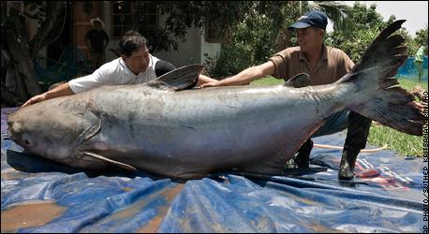
Moving beyond Luang Prabang to the northwestern corner of Laos, one can observe several interesting sites besides temples and markets. The region of Huay Xai offers several interesting villages where traditional lifestyles are still maintained. Within a half-days hike, one can observe Hmong people that are even more conservative than those found in Thailand. It is suggested that travelers visit the village chief (phuu nyai baan) before interacting with villagers. The most prominent hill-tribe village in Laos is Ban Nam Sang. An hour outside of Hyay Xai via tuk-tuk, the village boasts a large and very rare tribal population. These villagers are so traditional that it is recommended that foreigners do not bring gifts like sweets, clothing, or pharmaceuticals because it is feared that these interactions may threaten their traditional ways. However it is acceptable for visitors to make monetary donations to the village chief so that the money can be pooled to build a village school. Huay Xai is also a major fishing destination for those seeking the phla beuk, a.k.a. – the giant catfish. The phla beuk is the world’s largest fish and can grow up to several meters long and can weigh over 650 pounds. Although the numbers of wild phla beuk has dwindled in recent years, the allure of the fish attracts many to the Mekong River during mid-April and May.
The most enigmatic of Laos’s attractions is the Plain of Jars. Extending across the Xieng Khouang plateau, almost 90 sites boast these megalithic jars. The jars are found in clusters, ranging from one to upwards of several hundred in close proximity to one another. Steeped in mystery, the scientific and local community has yet to reach a general consensus for how and why the jars originated. Some locals believe that the jars were built to store Lao rice wine or water 2,000 years ago for thirsty travelers, but that is just speculation. Other local legends purport that a local race of giants used to inhabit the area. Regardless of how the jars came about, Xieng Khouang plateau remains pocked with jars that weigh upwards of 1,200 pounds each. Although the Plain of Jars is not yet a world heritage site, it remains Laos’s weirdest must see destination.

Chamapsak Attractions (Southwestern Laos)

One of the easiest to visit provinces in Laos, Chamapsak supports a population of around 50,000 in Southern Laos. Bordering Thailand and Cambodia, the province’s capital city of Paske rests at the banks of the Mekong and is quickly becoming a top site for trade and tourism.
Wat Phou is an important part of the larger Champasak province. Located in Southern Laos, Wat Phou is nestled amongst a diverse cultural landscape and picturesque natural beauty. This 1,500 year old Khmer ruin is the second United Nations World Heritage Site in Laos. By itself, the temple is not worth the 45 minute flight South from Vientiane, but coupled with the solitude and the beauty of the natural landscape, Wat Phou becomes a must see destination. The waterfalls, azure blue skies, and endless stars make Wat Phou worth traveling beyond Laos’s sleepy cities to see this small compound of temples.
Although Laos is a landlocked country, the region of Si Phan Don does have several thousand Islands worth visiting. Some four thousand islands dot the river, creating a surreal landscape of water decorated by floating lush green clumps of vegetation. Best reached via the Mekong River, Si Phan Don is the spot to find a guesthouse along the river and relax. Besides sitting beside the banks of the Mekong with a beer in hand, the other reason for visiting Si Phan Do is to see on the Khone Falls, one of the largest waterfalls in South East Asia.
Conclusion
The descriptions of the above natural and cultural attractions will certainly make tourists want to visit Laos. By preserving the natural wonders and culture of the country, Laos will ensure that tourists will keep coming to the country for many years into the future.

Current State of Tourism
Laos’s tourism industry is currently underdeveloped. We see many potential improvements which could be made to improve its efficiency and quality, but first, we must understand the current state of the tourism industry in Laos. This section will provide a brief background on the recent developments and current situation in this sector.
ASEAN leaders have signed an agreement aimed at fostering cooperation of tourism between the ASEAN countries to strengthen the industry and increase productive competition between the countries. The ASEAN development bank plans to contribute funds to promote tourism especially in impoverished countries. The Mekong sub-region in which Laos is located will receive funding for a tourism website, advertising, workshops and seminars. These seminars will be used to provide training to workers who will then be able to promote tourism through marketing, using their skills acquired from the seminar.
ASEAN’s tourism policy allows each participating country to have an independent policy on development of tourism. However, Lao’s tourism industry is supported both technically and financially by neighboring countries and international organizations such as the Asian Development Bank, World Bank, and the European Union, we suspect that these organizations have some control over spending of contributed funds.
Realizing the potential benefits of supporting the tourism industry, the GoL declared implementation and promotion of cultural, natural, and historical tourism to be one of its top priorities. The GoL has dedicated efforts in improving the tourism industry through infrastructure developments and improvements in the visa system. Through its efforts in developing infrastructure, especially road linkages, between different tourist areas, the GoL can help to promote increased tourism in areas which were previously unreachable. Recent infrastructure improvements have included roads to the Kuang Si waterfall and Kang Lor cave. Improvements in the major road “Number 13”, which is a north/south corridor, have also been made. Additionally, in April 2010, the GoL and World Bank signed an agreement for about US $28 million for the repair of roads. If these funds are used correctly, the GoL could increase tourist revenues flowing to smaller towns by focusing on creating road systems to connect tourists to these smaller attractions. In addition to roads, Laos has been making improvements to its airport facilities which will help travelers from outside Southeast Asia to reach the country.
The second major government improvement to tourism is through its visa laws. Currently, all tourists from outside ASEAN countries or Japan must get visas to visit the country. Tourists can receive visas from thirteen checkpoints located along Laos’s borders. These visas are valid for thirty days as opposed to fifteen as they were in the past. This increase in length of visas will encourage longer stays. However, tourists can still only renew their visas two times to stay a total of about three months before having to cross the border and then come back into Laos. This restriction is one which tourists may seem as a negative aspect to Laos. Additionally, international checkpoints lack proper management and supervision by the government. Service fees at different points vary due to employees skimming the excess fees for themselves. This problem is one not unique to the tourism industry. It could be solved through more government oversight or provision of incentives to keep the workers at these sites from conning tourists into paying more than is necessary to obtain a visa.
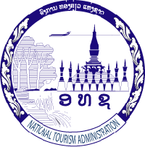
Because of the growing scope of the tourism industry, the GoL created the National Tourism Authority (NTA) which is chaired by the prime minister. Its function is to oversee tourism operations in the country. Its budget has been increasing rapidly over the past twenty years due to increased tourist revenue and demand in the tourism industry. Many provinces have NTA offices which are used to raise awareness of tourism, the benefits of involvement in the sector, and resources available to Laotians interested in being engaged in the industry. However, this organization is underfunded; personnel lack training and sufficient number of workers and are therefore often not capable of responding to the current demand. This gap means that tourism at the provincial and district levels remain underdeveloped. Because planning and development resources of different communities are not well integrated, tourism tends to grow fastest in larger towns where more resources are available. Also, due to lack of funding and government assistance, tourism sites themselves which are located in rural areas have not been improved or up-graded to attract tourists.
The GoL gives preferential treatment to businesses owned by Lao nationals. This advantage would be extremely helpful to Laotians interested in the tourism industry; however, the national assembly has adopted tourism laws which permit foreign countries to invest in tourism sectors. Despite part of the tourism industry being owned by foreigners, between private and public tourism businesses, tourism directly employs 300,000 Laotians. Additionally, indirect employment opportunities reach many more citizens.
Since 1990, Laos has seen a 27% increase in number of tourists per year. For 2010, the GoL expects over two million tourists to visit Laos. For comparative purposes, this figure is close to number of tourists that visited Cambodia last year. Revenues during this period have also increased from 2,250,000 to 113,898,000 USD. The average international tourist stays in the country for about 4.5 days and the average cross-border tourist stays for about 8 days. Laos hopes to increase average tourist stays to 11 days by 2020 and increase the number of tourists to 3 million per year. By increasing length of stay and number of tourists, the GoL expects that the revenues will increase to 370 million US dollars. Through advertising, the GoL could better reach the North American market which currently represents only about 6% of all tourists in Laos. By increasing the number of tourists from this continent, the GoL could easily reach its goal of 3 million tourists.
By increasing information about each tourist site, tourists can better plan their stay. Specifically, there are 257 cultural sites, 570 natural sites, and 162 historic sites as designated by the NTA. Some examples include the Hoprakeo (Emeral Budha) temple in Vientaine, archeological objects archive in Sethapura, Standing Stone in Houphanh, and Khone waterfall in Champassak. Other activities in Laos involve viewing traditional customs and festivals. These activities include boat racing, fire rocket festival, and wedding ceremony rituals. They present the opportunity for tourists to view authentic Laotian culture. Eco tourism, which will be discussed in the next section, has also become increasingly popular with tourists.

Human Development in Tourism
Because there are few educational institutions centered on providing professional training targeted on tourism, staff in the tourism sector have limited knowledge of basic skills. The NTA has set up a training center, but the NTA training only covers basic level skills which do not meet standards expected by tourists. The GoL is currently looking to accelerate short course training of trainers in hotel and tourism related fields such as business administration, guest service, and foreign language knowledge, and is seeking assistance from neighboring countries and international organizations to construct hotel and tourism vocational training centers. The GoL also hopes to collaborate with the ministry of education to update curriculum on tourism. To achieve this goal, they must provide training materials such as computers and overhead projectors. If this goal is achieved, the program would better the lives of countless Laotians, as the training for the tourism sector would provide them with options they may have never thought possible.
Additionally, a focus on pro-poor tourism will aim to enhance the linkages between tourism business and poor people. The goal of pro-poor tourism is to directly increase the benefits which can be realized by the impoverished citizens of Laos. Tourism’s contribution to poverty reduction will involve participation of poor people in the tourism industry which will provide them with quality jobs and a steady income source. The poor can be employed as producers of food for the growing tourism sector which will provide a source of demand, operators of micro tourism businesses which will create products that can be sold to tourists, and in industries such as infrastructure construction the goal of which is to increase opportunities for expanding tourism. They could also be employed directly in tourism through employment in hotels, restaurants, and as tour guides. Through expansion of local businesses with commitments to employ local people, entrepreneurial opportunities for locals, and development of collective community income through tourist revenues collected from fees on communal sites, the community will greatly benefit from the tourist revenues. However, if the fees and opportunities are repatriated or given to the central government, the local community will not benefit as much from the tourist activity.

Current Status of Ecotourism
Tourists come to Laos to experience its rich cultural, natural heritage, and breath-taking scenery. The fact that the Laotian society is less influenced by industrialization and modernization than other countries in the region provides the country with a “comparative advantage” which makes it a more attractive travel destination than its neighbors for tourists seeking an experience of untouched natural beauty. Natural and cultural based tourism, which are the base sectors for ecotourism, accounted for 46% of total foreign tourist income. Therefore, it is crucial for Laos to preserve this industry. Ecotourism serves the purpose of preserving the natural landscape as it enables a sustainable growth in the tourism sector. The income from this growth can then be used to stimulate growth and development in the whole society.

Definition and Benefits of Ecotourism
Ecotourism refers to responsible travel to fragile, pristine, and usually protected areas. The promotion of ecotourism usually serves multiple purposes, such as educating the traveler, providing funds for conservation, benefiting the economic development of local communities, and fostering respect for different cultures. The founding principle of ecotourism is to ensure that future generations will have access to the same natural and cultural heritage relatively untouched by human intervention as the current generation does.
In Laos, ecotourism is defined as “tourism activity in rural and protected areas that minimizes negative impacts on societal and ecological resources and is directed towards the conservation of natural and cultural resources, rural socio-economic development and visitor understanding of, and appreciation for, the places they are visiting.” Therefore, ecotourism development in Laos will not only emphasize the theme of “environmental friendliness,” but also help reduce poverty, assist in livelihood improvement, fund forest biodiversity conservation, empower local residents, and promote traditional culture. Ecotourism will lead to long term sustainable development as summarized in Laos’s vision for ecotourism according to National Travel Authority (NTA).
"Laos will become a world renowned destination specializing in forms of sustainable tourism that, through partnership and cooperation, benefits natural and cultural heritage conservation and local socio-economic development, and spreads knowledge of Laos' unique cultural heritage around the world."- The National Travel Authority
With this vision in mind, a successful ecotourism in Laos should strive to include the following tasks:
- Decrease the negative impacts of tourism on local environment and culture.
- Increase awareness in the importance of ethnic groups and biological diversity.
- Preserve and promote traditional culture.
- Encourage responsible business practices, which cooperate closely with local authorities and the local people to support poverty alleviation and deliver conservation benefits.
- Extend local employment opportunities.
- Provide a source of income to conserve, sustain and manage the Lao protected area network and cultural heritage sites.
- Maximize the benefits for the Lao national economy, especially local businesses and people living in and around the protected areas.
- Ensure that tourism does not exceed the country's social and economic limits as determined by researchers working in conjunction with local residents.
- Promote local architectural styles that have been developed in harmony with Lao culture and environment, and that use local materials, minimize energy consumption and conserve local plants and wildlife.
Generally, ecotourism will utilize the available tourism resources to assist in the social and economic development of Laotian citizens, especially rural villagers who otherwise would have had only limited access to free market commodities or social support services. Ecotourism is able to push the national development well beyond the scope of economic growth. Therefore, it is a practical and effective means to empower local Laotians to the pursuit of their valued lives.

Current Development of Ecotourism in Laos
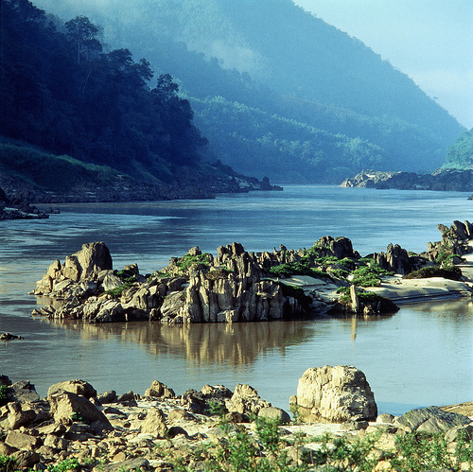
The government of Laos has realized the importance of ecotourism and its potential benefits to the development of the whole country. In recent years, much has been done to promote ecotourism which has gained much popularity within the country.
Due to its unique geography, culture, and history, Laos has attracted thousands of tourists to rural remote areas, especially to areas where there are pristine forest, caves, rivers, and ethnic villages. A network of 20 National Protected Areas (NPA) has been set up to better capitalize on these resources. These protected areas cover nearly 14% of the country and have been recognized as one of the best designed NPA systems in the world. These NPAs, often located in remote areas, offer a wide range of ecotourism attractions centering on three themes: natural attractions, cultural attractions, and historical attractions. Popular activities for ecotourism include, but are not limited to, trekking, climbing, birding, cycling, and camping, and visiting ethnic villages, caves, rivers, wildlife, handicrafts, waterfalls, etc.
The government of Laos has realized the potential benefits that ecotourism will bring to the country and has determined to take actions to further development in the sector. It has identified its “5 Key Objectives” and “10 Year Goals” in ecotourism, as listed in the following.
5 Key Objectives:
  - Strengthen institutional arrangements for planning and managing ecotourism growth.
  - Support training, capacity building and the promotion of good practice.
  - Support environmental protection and nature conservation.
  - Provide socio-economic development and cultural heritage protection for host communities.
  - Develop ecotourism research and information.
10 Year Goals:
  - Strengthen national and provincial capacity and expertise in the ecotourism sector,
  - Coordinate and where necessary, guide and regulate the development of ecotourism to ensure it adheres to guiding principles
  - Support local communities and the private sectors by ensuring they are given sufficient freedom and assistance to develop
Here is a list of the major eco-tourism projects and some brief information.
The LNTA-ADB Mekong Tourism Development Project is being implemented with the financial assistance from the Asian Development Bank and partnership from Vietnam and Cambodia. Currently the GoL is developing 20 new community-based ecotourism products in Luang Namtha, Luang Prabang Khammouane, and Champassak provinces. These projects hope to promote cultural and environmental protection, construct tourism-related infrastructure, strengthen local stakeholders' management capacity, the role of women and ethnic minorities in the tourism industry, and intensifying public and private sector efforts at marketing and promoting Lao ecotourism products.
The UNESCO-LNTA Nam Ha Ecotourism Project was first launched in 1999 and is primarily supported by the Government of New Zealand. This project is the first and longest running community-based and the most well known ecotourism program in Laos. It focuses on strengthening the conservation-ecotourism linkages in the Nam Ha area, stimulating private sector investment in ecotourism, increasing the skills and capacity of tourism managers in Luang Namtha, and creating district and provincial tourism management plans to ensure sustainability and equitable distribution of tourism's benefits. The Nam Ha Project’s success was well recognized worldwide as it was awarded the 2001 United Nations Development Award and a British Airways Tourism for Tomorrow Award in 2002.
The CUSO Community Based Ecotourism Development in Attapeu Province project works with the Provincial Tourism Authority to develop various ecotourism initiatives in the region. The project consists of home stay programs, eco-trekking with local guides in Xepian National Protected Areas, and village visits to ethnic Lavae, Taliang, Oy and Alak tribes. The main point of this project is to create jobs, capacity building, and eco-cultural conservation through the use of sustainable ecotourism strategies.
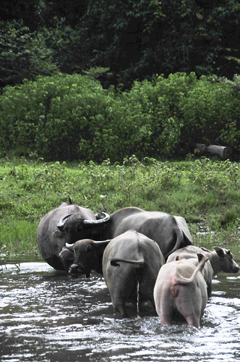
The SNV-Lao National Ecotourism Advisory Program aims to deliver advice on policy, strategy, management, and product development issues to a range of clients from the national, regional, and provincial levels. Advisees include the Lao National Tourism Administration, the Ministry of Agriculture and Forestry's Division of Forestry Resources, the Mekong Tourism Development Project, etc.
The EU Ecotourism Program in Vieng Phoukha program focuses on poverty alleviation and job creation by training local guides and villagers to develop and operate ecotourism products that sustainably utilize and protect the area's unique cultural and natural heritage.
This is only a sample of the many projects in tourism currently under way in Laos. Despite many efforts by both the government and NGOs, the ecotourism industry is still underdeveloped, and its full potential is unrealized. Part of the reason for the underdevelopment is that this industry is subject to the same challenges and constraints that the tourism sector as a whole faces. These constraints will be discussed in the next section.

Current Challenges in Tourism
The largest constraints specific to the tourism industry are poor management of businesses and outdated regulations. Businessmen lack business skills like customer service etiquette and family businesses often evade taxes. Government standards for food and water safety are virtually non-existent. Together, these detriments make Laos’s tourism industry less attractive. Ecotourism faces an especially difficult situation with respect to standards. Currently, standards across provinces differ widely and are not government regulated. For ecotourism, this lack of standards means that businesses can claim to be eco-friendly, however, in practice, is unfriendly to the environment.
Another impediment is competition from other Southeast Asian countries. On one hand, Laos could increase its tourism standards by charging higher prices. Yet, the drawback is that foreign tourists may not think Laos is worth the extra money and thus turn away from the country. On the other hand, focusing on low price strategy leads to inadequate investment in quality and services, which will not attract tourists either. Additionally, Laos’s limited infrastructure, lack of skilled entrepreneurs, weak government safety policies, underdeveloped tourist sites, and a lack of advertising also harm Laos’s tourism industry.
Other potential challenges to successful development of the tourism industry include an uneducated workforce, the tendency toward inefficient uses of capital for expenditures and investments in both public and private industries, and the communist political system. However, we believe that we can overcome these obstacles through our policy proposal which will aim to improve all sectors of the Laotian society and economy.

Conclusion
The tourism sector has been rapidly growing over the past twenty years, providing large potential revenues for the government. However, neither government policies nor human capital resources have kept up with the changing industry. Weak organizational structure and personnel system, especially at the provincial level harms development in the tourism industry. If these limitations can be surpassed, Laos will be able to fully realize its potential in tourism.

Policy Proposal
Our policy proposal will focus on creating a sustainable tourism industry which will further the long term development progress in Laos. We hope to foster this industry through an accreditation system and governmental subsidies, which will create a safe and sustainable tourism environment in the country. We will begin this section by discussing the importance of standards in the tourism sector. Then, we will unveil the proposed accreditation system and its implementation plans. After that, we will outline some sample standards for eco- and pro-poor tourism that the accreditation system should incorporate. Recommended strategies for implementing pro-poor tourism will follow. In addition, we will address areas of concern for this proposed system. A budget for our project will be provided. Finally, we will describe future development effects of this proposal.

Why are Standards Necessary?
In recent years, tourism has become a major source of foreign capital for Laos. Laos is blessed with rich natural, cultural, and historical resources that have become an attractive destination in Southeast Asia for tourists who seek untouched natural beauty and an authentic cultural experience. Particularly, the idea of ecotourism has gained much popularity within the country and has become one of the “competitive advantages” of Laos in the global market. Several ecotourism projects supported by the Laotian government and the international institutions, such as the LNTA-ADB Mekong Tourism Development Project and the UNESCO-LNTA Nam Ha Ecotourism Project have proven to be successful and have been well recognized globally as effective means of stimulating sustainable development and poverty eradication.
However, there are many constraints within the Laotian tourism sector which will greatly hinder future growth. These constraints include a lack of official standards within the industry, shortage of business management skills, limited infrastructure, and vulnerability to competition from other Southeast Asian countries. Therefore, we are proposing an accreditation program entitled “Please Don’t Rush” (PDR). The overarching goal of this accreditation system is to steer the Laotian tourism sector towards an eco-friendly and pro-poor direction which will not only reduce poverty through empowerment of local residents but also ensure sustainability of growth in tourism through preservation of natural and cultural heritage. The philosophy of our proposal is to ensure that the Laotian people will be able to pursue their valued lives and achieve prosperity in the long term.
The accreditation system will have two facets: ecotourism and pro-poor tourism. We firmly believe that these two features are strongly interdependent. Without ecology, any efforts for pro-poor development will be short-lived as there will be few attractions for tourists. Without a pro-poor focus, ecotourism will lack the support from the masses; any authority or state proposing overriding ecotourism without emphasis on pro-poor tourism objectives will lose support. Thus, ecotourism and pro-poor tourism work well together. For example, as most of the ecotourism sites in Laos are located in remote areas where local residents are impoverished, ecotourism cannot succeed without the active participation and cooperation of the local people. The project’s pro-poor orientation will motivate local residents to seek self-sustaining ways of earning incomes.
We decided to propose an accreditation system as we believe it would create incentives for businesses to pursue eco-friendly and pro-poor tourism without much interference from the government. The authority’s role will mainly be on the macro level, such as designing a set of standards, conducting inspections and evaluations, and monitoring compliance with long term strategies. Our project will identify specific areas on which we recommend the GoL should focus. During Phase I of the project, the GoL will research and set specific standards for accreditation. How the businesses reach these benchmarks should not be enforced by the government because it will allow firms to generate creative solutions as each firm will have a different situation and unique constraints. Therefore, the government cannot efficiently create solutions to each business’s specific problems. Additionally, through our study of the Three Gap in Laos, we found that government revenue is not sufficient. Furthermore, the allocation and distribution of government revenue is not efficient. Thus, we believe an accreditation system that involves minimal government participation will be more practical than other forms of government intervention to align the interests of this sector with those of the general public. In addition, the accreditation system will work well with the market system that the Laotian government has recently promoted. Finally, providing accreditation status to businesses will let tourists know that these businesses are legitimate. In turn, these businesses can help to promote a progressive image for the country.
This accreditation system will allow individual businesses to gain the advantage of an industry standard and a pathway to nationally recognized qualifications. They will also obtain sophisticated management advice from the NTA, guidance for employee trainings, and benchmarks for performance evaluation. Furthermore, being accredited by the authority will create positive publicity for the businesses. Accredited businesses will be more appealing to foreign visitors, have good public relations with local residents, and be able to attract the top talents in the industry. Lastly, businesses striving to be eco-friendly and pro-poor oriented will be eligible to apply for certain governmental subsidies. In general, accredited business will have more growth potential in the future.
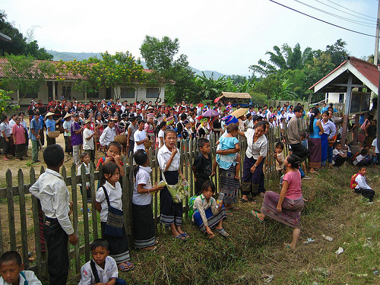
To tourists, an accreditation system will provide them with a standard for the services and goods that they purchase during their visits. Uncertainty and ignorance can create unnecessary worries which will affect the quality of travel. With a government approved accreditation system, tourists can make more informed and wiser choices about their trips and greatly mitigate travel risks, such as health and food quality issues. As a result, tourists will have a more pleasant experience in Laos and the likelihood of visiting to the country again will increase.
To local communities, this accreditation system will inspire businesses to make long-term-oriented decisions because they must focus on maintaining their accreditation from year to year. Employment opportunities in local businesses will be created as the government provides incentives to use local products and labor. Communities will also be afforded technology, education, and credit to start new businesses. Furthermore, infrastructure and social services will become more widely available as the GoL must provide these services to support the tourism industry. Thus, the poor will have access to many benefits that are not accessible under the status quot.

The PDR Accreditation System and Its Implementation
The PDR Accreditation System will include two sets of standards, ecotourism and pro-poor tourism. All businesses within the tourism sector are eligible to be accredited under either or both standards. Upon receipt of an application and fee, the PDR Accreditation Committee of the NTA will review the application and will conduct an unannounced on-site inspection. A sample accreditation and evaluation form can be found in Exhibit One of the Appendix. This committee will be composed of full time inspectors who are independent of the businesses within the industry. Once certified, the business will receive a plaque of recognition, pictured below, which they can hang in the entry of their business and advertisements. Once accredited, the business is responsible for paying annual membership fees, maintaining the standards it has achieved, and attending the NTA authorized training programs. The PDR Accreditation Committee will also conduct annual inspections and evaluations to make sure that the businesses stay committed to the code of conduct. Furthermore, the committee will operate a “whistleblower” system in which employees and customers can contact the NTA and report any behavior that is in violation of the standards. At the same time, an arbitration committee will be created to resolve disputes.
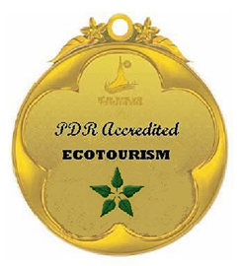
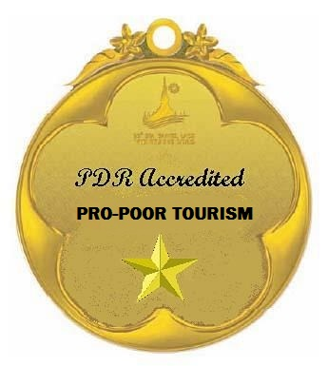
The proposal will be implemented in two stages. The First Stage will last three years. The major objective of this stage will be constructing a feasible accreditation system. The NTA will seek opinions and suggestions from various sources like relevant academics and industry experts before implementing the standards. The NTA will also establish and staff the PDR Accreditation Committee. The application and assessment procedures will be defined, and the “whistleblower” system and an appeal mechanism will be organized within the aforementioned time frame.
Most importantly, the NTA and the Accreditation Committee must inform businesses of the standards and benefits of complying with the standards as well as the rights and responsibilities associated with compliance. The government can accomplish this task through providing information on its website and distributing pamphlets. Below is a list of the major phases for the First Stage.
Phase I: Develop adequate and appropriate standards for each industry within the tourism sector.
Phase II: Establish the PDR Accreditation Committee and identify its responsibilities, organizational structure, and code of conduct. Furthermore, the GoL must Staff and train the Committee.
Phase III: Define the application and assessment procedures and set up a “whistleblower” system and an alternative dispute resolution mechanism.
Phase IV: Inform businesses of the standards and application procedures as well as the benefits of complying with the standards and ensure proper interpretation of their rights and responsibilities.
The Second Stage will involve actual implementation of the accreditation system. At this point, the NTA and the Committee will accept applications and conduct inspections and evaluations. At the same time, the authority will provide marketing and publicity for all accredited businesses. Advertising will consist primarily of a website that lists all member businesses and informative packets. The NTA and the Committee will also design education programs, distribute training materials, and host seminars to invest in long term human capital for the industry. A sample publicity brochure for PDR Accreditation Program to local businesses can be found in Exhibit Two of the Appendix. The major phases for the Second Stage are summarized as below:
Phase I: Accept applications and start to conduct inspections and evaluations.
Phase II: Sponsor marketing and publicity for accredited businesses.
Phase III: Invest in long-term human capital by designing education programs, distributing training materials, and hosting seminars.
In addition, throughout the implementation of the accreditation system, the Committee needs to consistently request feedback from businesses, tourists, and local communities. Necessary adjustments need to be made and problems need to be addressed properly and promptly. Most importantly, the Committee and the NTA have to take initiatives to ensure transparency and even-handed treatment of applicants and members. Furthermore, the authority should closely monitor changes in the sector and be open to new ideas and solutions of new rising environmental issues.

Sample Standards for Eco-tourism
The determination of standards is the most important task in the planning stage. We recommend that the GoL contact diverse sources for suggestions and opinions. The NTA should organize conferences, seminars, panel discussions, and feasibility studies to benefit from all interested parties, such as representatives from academy, industry, and customer groups, etc., to decide on the standards and criteria for the accreditation system. In this proposal, we are including sample standards for eco- and pro-poor tourism that the actual system should make an attempt to address with the hope that these samples will become a guide for the accreditation system.
All members of the PDR Association must recognize that they have an obligation to protect the natural resources that they are blessed with if they are to maintain growth in the tourism sector into the future. The goal of ecotourism is to ensure that future generations will be able to enjoy the same natural beauty that the current generation is enjoying. In addition, preserving the natural environment will attract more foreign visitors to Laos and increase the aggregate as well as individual incomes in Laos. Therefore, tourism businesses which have the most direct contact with the natural resources should take on the responsibilities to employ environmentally friendly standards. We have devised a set of guidelines that will be used by the government to certify ecotourism businesses in an endeavor to promote ecotourism in Laos.
- Management: The company needs to make environmental awareness one of its top priorities. Adequate education and training aimed at ensuring that staff understands its roles and responsibilities for sustaining an eco-friendly tourism should be provided to employees. The company should adapt social responsibility as one of the criteria for performance evaluation. Customers should be informed about green policies and asked about feedback on green actions. In addition, the company should monitor resource use and prepare reports on corporate social responsibilities.
Only through a top-down approach will the idea of ecotourism be fully implemented and enforced in the operations of tourism businesses. Thus, standards for evaluating the commitment to ecologically friendly tourism on the management level become crucial. Only when the management team has emphasized the importance of ecology and provided incentives for its employees to act ecologically will actual green actions become the norm.
- Planning: The company needs to identify and monitor the negative environmental impacts caused, or potentially caused, by its activity in a given period. The company must design specific plans to reduce the negative impacts. The company has to participate actively and continuously in environmental improvement programs in surrounding areas or other regions of the country.
Planning defines the strategic direction of any business operation. Standards in this aspect will ensure businesses incorporate environmental concerns into their short term and long term goal setting procedures. It is important for businesses to identify the negative impacts of their activities on environment. Only when they are aware of those problems will they take initiatives to seek solutions. At the same time, participating in community or national programs will enable businesses to pool intelligence and resources together so that they can collaborate on initiatives.
- Energy: Facilities and venues of the company should be built with the idea of reducing energy consumption. The company must use energy-efficient appliances, low energy lighting, and efficient heating, cooling and hot water systems. The company should also be active in seeking renewable energy choices.
Natural resource exploitation threatens to taint Laos’s natural ecosystem. Massive use of nonrenewable energy will threaten the sustainability of not only the tourism sector but also the entire Laotian economy. Emission of greenhouse gases will cause serious pollution that will harm the health of local people as well as make the country a less attractive country to foreign visitors. Therefore, businesses should seek ways to reduce energy consumption and rely more on renewable energy sources. In order to achieve this goal, business models need to be redesigned and standards changed.
- Water: Businesses should install water efficient showers, faucets, and toilets. Washing machines and dishwashers should be operated in a fashion that conserves water. Rainwater should be creatively utilized. The company should commit itself to environmentally friendly cleaning products and methods that do not contain chlorine or phosphates. Ecological waste water treatments should be implemented.
Water is one of the most crucial natural resources for human beings. Without safe and clean water, it would be impossible for people to live. Water quality closely ties the standards of living of local residents with tourism as tourists must use the same water source as local villagers. Thus, standards for responsible use of water are extremely necessary.
- Purchasing: Businesses should conduct supplier screening and only buy from ecologically responsible suppliers. Efforts should be made to favor products made from recycled materials. Sustainable sources of timber should be used as building supplies. Local, organic, and vegetarian food should be provided. Local crafts and traditional techniques should be appreciated.
Implementing environmentally friendly purchasing policies is an effective way to vertically integrate the idea of ecology in the supply chain. By promising only to purchase from responsible suppliers, businesses will use their bargaining power to persuade more people to become environmentally conscious. By purchasing local crafts and organic food, businesses will provide motivation to suppliers to use ecological methods of production and to reduce industrialization which can harm ecosystems. Especially, considering 80% of the work force in Laos is currently employed in agriculture, buying locally will provide employment opportunities and income sources for many residents.
- Waste: Companies should use reusable or recyclable packaging and buying in bulk should be encouraged. Garden, kitchen, and hazardous household waste must be disposed of properly. Reusable electronic equipment should be promoted and proper recycling and disposal should be ensured. The company should reduce usage of printers and toner cartridges. Recycling options should be provided to the customers.
Proper disposal of waste is also critical to protecting the natural environment. Improper treatment of hazardous waste will deteriorate the water and soil condition in the country. This will not only harm the health of local residents and foreign tourists, but it will also negatively impact the already low productivity of Laotian agriculture. As the tourism sector expands, more people will visit remote areas of Laos, especially National Protected Areas. Therefore, the need for a code of conduct regarding waste disposal is especially important because more people produce more waste.
- Innovation: Companies should encourage innovations in the ways of operating eco-friendly tourism.
New environmental issues rise all the time, and innovative solutions are always needed. Relying on old methods to solve new problems can prove to be ineffective and wasteful. Thus, there must be an incentive for businesses to actively and continuously seek creative means of pursuing ecological standards. Making innovation a priority in the PDR Accreditation plan can help motivate businesses to keep up with the changing times.

Sample Standards for Pro-poor Tourism
All members of the PDR Association must recognize that they have an obligation to respect the Lao people’s unique way of life. All businesses must understand that they have the power to positively or negatively impact traditional Lao lifestyles. In the past, unrestricted tourism in Laos has hurt the indigenous population despite the economic benefits. Therefore, all businesses should try to promote responsible business. We have devised a set of guidelines that will be used by the government to set standards which will be used to certify businesses in an endeavor to promote pro-poor tourism in Laos.

- Job Creation and Education: Companies must commit to employing and training local people at fair wages.

Although Laos has a relatively low unemployment rate, over 80% of its population engages in subsistence agriculture. By hiring indigenous Laotians, businesses can improve the indigenous population’s relative weak educational and vocational skill base through training programs and a job that involves more than just farming. By developing their human capital, businesses can empower the local population to achieve additional employment opportunities. Through increased educational provisions in the tourism sector, Laos will also see increases in education provided other sectors.

- Small Enterprise Development: Companies must make a commitment to developing complementary industries through technical support, marketing support, and access to credit.

By developing complementary industries, businesses can generate positive externalities. For example, by providing credit to burgeoning industries or small handcraft producers, businesses can help small business gain a foothold in an economy where credit is scarce. In turn, these new enterprises can hire more local workers and thus the cycle expands.

- Local Economic Linkages: The company must make a commitment to sourcing food, goods, and services locally.

By buying locally, businesses ensure that jobs and money stay local. Supporting local business provides support for the jobs they offer. Aside from economic considerations, Laos’s local goods are often unique and cannot be produced anywhere else in the world. Thus buying local goods maintains Laos’s distinct culture and lifestyle. Also, buying locally is ecologically friendly, as discussed in the previous section. However, most importantly, buying locally creates a sense of community. Local business are employed by local residents, therefore buying local goods increases social capital and creates social stability.

- Generation of Community Income: Companies must make a commitment to entering into equal opportunity relationships with local community members and are recommended to donate to community projects.

If businesses commit to equality and fair terms of employment, indigenous populations will support the companies’ endeavors and will cooperate in promoting Laotian tourism. Tourism in Laos is dependent on a strong relationship between businesses and the indigenous population. This symbiotic relationship is important because many tourists want to experience life in a Laotian village without fear of violence or theft. But most importantly, a social climate of strife is not conducive to attracting foreign tourists that are wary of ethnic conflict or protests.

- Sharing Services: Companies must allow local people to access any service, infrastructure, or telecommunications available to tourists.

By allowing all Laotians to utilize any service created by businesses, Laotians will have better access to important centers like markets, hospitals, and schools. If actualized, Lao people will be able to look beyond their narrow hilltop and can travel freely to better markets, better hospitals, and better schools. In doing so, economic and social indicators will improve greatly without much added expenditure from the GoL.

- Access to Natural Resources: Companies must ensure that indigenous populations are not displaced or are deprived of natural resources like water.

If local populations are displaced or deprived of access to natural resources, Lao people are deprived of their basic human needs. Since our project is meant to support the development of poor people, using resources at the expense of the indigenous population is counterproductive.

- Promoting Culture and Minimizing Negative Cultural Impacts: Companies must promote cultural traditions in a respectful manner so that the Lao people’s traditional ways are not exploited for the benefit of foreign tourists. Companies should actively participate in charities and organizations that protect and promote Laos’s special cultural heritage. Additionally, they should provide comprehensive information on natural and cultural heritage to its customers and employees.

A sense of awareness for the protection and promotion of Laos’s natural and cultural heritage should be planted in the daily operations of every business. Businesses should encourage employees to embrace tradition as foreign tourists will not be able to enjoy the culture of Laos if local villagers are not willing to pass the traditions on to future generations. What separates Laos from other popular destinations in the region like Thailand and Cambodia is the fact that its unique culture has largely been left unperturbed. Compared to other popular Buddhist temples like Angkor Wat, Laos’s temples pale in comparison. Most of Laos’s temples are in poor disrepair or are not authentic; however Laos’s indigenous culture is largely untouched and has not yet been overly westernized. Therefore Laos’s businesses must protect local cultures and traditions in order to attract foreign tourists that are seeking an authentic indigenous experience that tainted countries like Cambodia and Thailand cannot provide.

Strategies for Implementing Pro-poor Tourism
In essence, PPT aims to create linkages between tourism enterprises, residents, government officials, and entrepreneurs. The linkages vary significantly depending on the unique constraints and situation of the involved actors. For example, a tourism company that is interested in developing a tour that visits a remote highland village might work jointly with a village chief. By emphasizing joint planning and cooperation, the tour company creates new initiatives for the entire village. There is no single means for implementing PPT practice is Laos. The way that these practices are implemented by business will vary considerably depending on their unique constraints and situations.

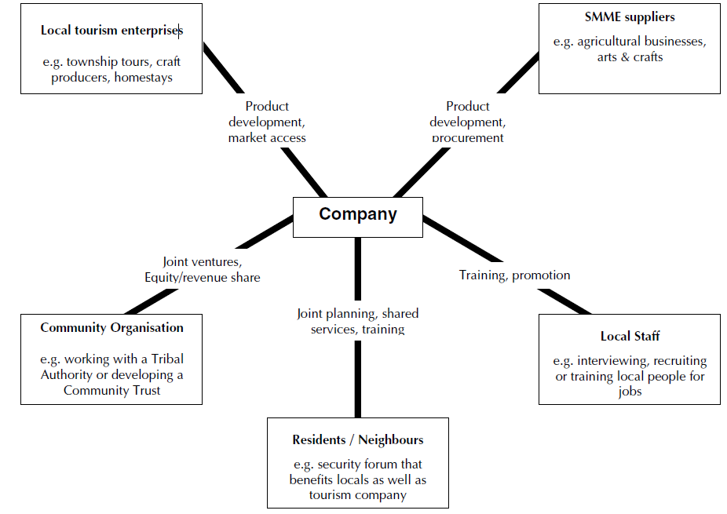

Expanded Business Opportunities
Trekking companies that utilize the trail networks along Laos’s remote villages will often purchase goods and food produced by the population. To expand business opportunities, Lao villagers should produce local handicrafts and agriculture that can sold to these tourists. In some instances, it might be necessary to introduce microcredit to these villagers to finance their business plans. If credit is not available, then it is recommended that villagers perform cultural shows and demonstrations that require little or no investment. Furthermore, employment is generated in these remote regions by introducing tours that boast toilet facilities, campsites, and potable water. This will tremendously reduce disease and diarrhea for the local communities. Increased and permanent employment opportunities are later provided by the trekking tours that require local guides or aids. Local villagers could also create and maintain trails paths for businesses at a small fee. These are just a few examples; the table below explores other means of implementing PPT in Laos.
Increased Economic Benefits | Enhance Non-financial  Livelihood Impacts | Enhance Participation &  Partnership
- Expand local employment,  wages: - commitments to  local jobs, training of local  people.  - Expand local enterprise  opportunities – including  those that provide services  to tourism operations  (food suppliers) & those  that sell to tourists (craft  producers, handicrafts,  guides etc.)  - Develop collective income  sources – fees, revenue  shares, equity dividends, etc. | - Capacity building, training  - Mitigate environmental  impacts.  - Address competing use of  natural resources.  - Improve social and  cultural impacts.  - Increase local access to  infrastructure & services  provided for tourists –  roads, communications,  healthcare, transport. | - Create a more supportive  policy/planning  framework that enables  participation by the poor.  - Increase participation of  the poor in decision making  by government &  the private sector.  - Build pro-poor  partnerships with the  private sector.  - Increase flow of  information &  communication between  stakeholders to lay the  foundation

Figure: Strategies for implementing PPT
The core aim of PPT is to increase opportunities for the poor instead of expanding the sector. Pro-poor tourism is a broad approach that involves numerous actors at the government and village level. There is no one path for implementing the aforementioned strategies; effective PPT consists of transforming these aggregate strategies into concrete actions. Proponents of PPT contend that compared to other operations like microfinance, PPT is much more effective at reducing poverty because tourism delivers consumers to the product thus creating better opportunities for the rural poor of Laos. Given the diverse nature of tourism, peasants, women, and other marginalized peoples have increased opportunities to participate or engage in informal sectors like selling opiates. Although the potential for positive growth is high, several challenges constrain PPT in Laos. These constraints will be explored in the next section.

Areas of Concern
This accreditation system is based on the assumption that all parties involved have good faith and are not dishonest or corrupt. We find that most Laotian officials are responsible and act in the general interest of society. However, as in any other country, some government officials are dishonest and fail to carry out their duties. The GoL needs to realize that corruption will be detrimental to this accreditation system and the future development of the country. Corruption will harm the image of the country and make Laos a less attractive travel destination for investment. It could also divert resources from pro-poor programs effectively harming Laotian citizens. It will also undermine efforts to sustain ecology which are necessary to create a sustainable ecotourism sector. Therefore, actions to avoid and eliminate corruption in public services sectors--especially in tourism-- have become a requisite for development.
Due to the nature of PDR Accreditation System, possible corruption is most likely to occur in the inspection and evaluation process. Thus, the independence of inspectors is crucial. The Committee should conduct thorough pre-employment background checks to ensure that the recruits do not have conflicts of interest. Additionally, the inspectors should be paid above the average wage paid by other sectors so as to reduce their incentive to accept bribes. In addition, there should be a rotation of roles within the Committee periodically so that no individual will stay in one industry or one job function long enough to seek illegal benefits from his or her power. We also recommend that the Committee be externally audited by a foreign consulting firm or other organizations that are experts in the field of tourism.
To increase the transparency of the accreditation system and the tourism sector, a “whistleblower” system should be established. Additionally, the government’s website for accredited businesses should provide a copy of the industry’s standards and codes of conduct for the general public. This site should also host a form to file complaints against accredited businesses which violate these standards. Tourists, employees, and local residents must have the ability to report any behavior of the members that is in violation with the standards directly to the Committee as the Committee cannot constantly monitor all businesses. The Committee should impose a serious penalty, such as a fine or removal of membership, on those businesses which fail to comply with membership standards.
Additionally, in order to ensure justice and fairness in the inspection and evaluation process, an appeal mechanism should be established through which applicants and members can seek a third party or independent arbiter for disputes. This measure will ensure that neither the Committee nor the authority will manipulate its power in an unethical manner which may undermine the independence of businesses or be seen as an unfair attempt to control businesses practices.
These mechanisms will help reduce the possibility of corruption within the accreditation system. However, we also acknowledge that the mechanisms are not perfect and much more must be learned from trial and error in the field.

PDR Accreditation System Budget
The following is an outline of our projected expenses and revenues for Year One of our Project Proposal. Salaries for staff will comprise the majority of expenses. In the appendix, we have included a spreadsheet outlining our budget in more detail.
We will pay the existing NTA staffers their wages plus a small cost of living increase. In the first year, we will need to hire two highly respected Laotians to run the training program for the tourism inspectors. They will demand higher salaries relative to the general Laotian public, but we feel that hiring the best available talent to train our inspectors will have high returns in the future. We will also pay our inspectors well above the average Laotian’s income to help reduce the temptation and necessity of corruption and bribes. We will pay them a base salary of $3,000 or 26.4 million kip per year as well as a $15 per diem for every day they spend on the road inspecting attractions. We anticipate them traveling about half of the year, or 150 business days, so the inspectors’ total compensation will come out to about $5,250 USD or almost 20 million kip per year. This wage is 250% greater than the average Laotian farmers’ earnings, and it will permit our inspectors to be unbiased observers and advisors who will not be tempted to accept bribes in order to care for their families or support their opium addiction.
We will also require a website to be designed and maintained by a third-party to both increase awareness of our program for Laotians interested in becoming inspectors or tour guides and businesses which desire to become accredited as well as a resource for foreign tourist looking for information regarding tourism in Laos.
We have a number of one-time expenditures in our first year that include the purchase of cars and mopeds for inspectors, computers for staff, and other necessities in order to implement our policy. We have decided to pay the small premium to buy hybrid and Flex Fuel SUVs and mopeds as these vehicles will represent our long-term eco-friendly goals. Another large one-time expense is the purchase of twenty ITS eXact Micro 7+ Standard Photometer Kits, pictured to the right, which will be used by our inspectors to measure the water quality of the eco-lodges.
We will begin funding our advertising campaign in Year One. We will outsource most of the work to an advertising firm to begin developing a campaign to promote the natural beauty and wonder of Laos. No ads will air in Year One, but the $200,000 will provide the research and groundwork necessary to develop a successful marketing strategy for ecotourism in Laos.
Our revenues will come from two sources: member businesses and from tourists entering the country. First, we will charge a one-time initiation fee of $75 per attraction to pay for an inspector to certify the site. Second, there will be a yearly membership fee of $25 per attraction to help pay for the maintenance and recertification processes needed to ensure that members continue to follow our guidelines and regulations for ecotourism.
Our largest revenues will come directly from the tourist. Currently, only citizens of ASEAN countries can enter Laos without a visa. Every other traveler must pay a charge between $20 for Chinese tourists and $42 for Canadians. We will increase visa fees by $1.50 USD for every nation that must carry a visa. Currently, only 20% of Laotian tourists come from outside the ASEAN, but out of a projected two million annual visitors, 400,000 of these visitors are attracted to Laos from outside the ASEAN region which will give us the opportunity to generate $600,000 in additional revenue to cover all of our operating costs.
Withstanding any major unforeseen costs, this leaves us with a $40,885 surplus for the Fiscal Year One. We will use part of the excess revenues to improve social services and then will put the rest into a low-risk portfolio and roll the money over into our advertising budget for Years Two and Three.
Our proposed program aims to be self-sufficient and not rely on taxpayer’s money to sustain its operations. Yet, a huge side benefit of this program is increased tax revenue from the tourism sector, which the Laotian government can use towards improving social services. Further development effects of our program will be discussed in the next section.

Further Developmental Effects
According to our forecast, the GoL will be able to realize a surplus of $40,885 during the PDR Accreditation Program’s first year of implementation. Revenues will come from the collection of membership fees from participating businesses and the increase in visa prices for foreign tourists. In subsequent years of the program, the amount of surplus is expected to increase as the program will not encounter many of the one-time set up expenditures during the first year, which totaled over $100,000. The surplus from the program as well as increased tax revenue from the tourism sector will be used for various purposes in both the tourism and other sectors, such as social services. Through addressing social services, we can create spillover effects from tourism which will help achieve the ultimate goal of furthering development and eradicating poverty in Laos. This section will outline the possible uses for and benefits from the effects of this proposal.
Through examination of Laos’s three-gap, we found that public expenditures in agriculture, education, healthcare, and transportation networks are insufficient. For example, the average Laotian teacher earns only $36 per month and has few teaching materials such as books. This meager salary and lack of necessary materials could be supplemented through the additional revenues which the government receives from tourism. Higher pay to teachers would encourage educated people to start careers in the field, and a greater quantity of teaching resources would certainly enable teachers to provide high quality education. The benefits of educated teachers and standard teaching supplies are immeasurable benefits. After graduating, these students would have a strong foundation to start a career in the tourism industry or elsewhere if they so choose. This career can lead them on the path to their desired life.
The additional government revenues from tourism can stimulate improvements in education, agriculture, transportation networks, and healthcare. With additional revenues, the GoL would have the necessary funding to complete projects which would create access to cities, teach farmers more efficient and eco-friendly farming methods, or provide affordable, high-quality access to healthcare to the rural poor.
As part of our commitment to sustainable and eco-friendly development, the revenues could be used to support National Protected Areas in Laos. These areas include sites such as caves, waterfalls, and forests. By using revenues for the preservation of these natural wonders, we will ensure the preservation of Laos’s comparative advantage in ecotourism as well as the environment as a whole.
Within the PDR project itself, additional revenues will be used to provide subsidies to businesses which have a demonstrated intention of becoming certified pro-poor or eco-friendly. These businesses will be evaluated based on progress toward their goals. Preferential treatment will be given to businesses which have the greatest financial difficulties with reaching the certification goal. Subsidies to businesses striving to be pro-poor conscious and eco-friendly are necessary due to the extraordinary costs associated with these goals. A pro-poor focus will require businesses to hire local workers who have likely not had necessary training for the job. The company will then have to provide training and education to that worker so that he can be a productive part of the business. An eco-friendly focus may require even more funding because being ecologically conscious requires a business to incur many additional costs such as purchasing a water filtration system versus using bottled water. We believe spending money in the aforementioned areas will create a positive feedback loop. Therefore, the government should use additional tourism revenues to support businesses which are struggling to achieve the accreditation standards.
Any additional revenues which have not been used to fund education, healthcare, transportation networks, or efficient agriculture should be saved and used to build an advertising budget for the PDR Accreditation Program. Currently, only 20% of visitors to Laos come from outside the ASEAN and Japan areas. Advertising in Europe and the Americas could draw many more tourists to Laos.
In conclusion, additional revenues from the tourism sector in Laos could have far-reaching effects for the entirety of Laos. Additional funds could be used in education, healthcare, transportation networks, or efficient agriculture. By funding these sectors, the GoL could improve the lives of countless Laotians and enable them to pursue their valued lives in a long and sustainable way.

Conclusion
Since 1986, Laos has experienced steady and rapid development. The economy has seen high growth rates, the financial situation of the country is stable, and social indicators have improved. Although Laos is still a communist state, the Laotian government is determined to open up the country for international investors and to promote the free market. Despite of all these positive changes, there are still numerous unfreedoms within the country that prevent the Laotian people from fully achieving their lifelong goals. Constraints on development include unfavorable topography, an inefficient agriculture sector, underdeveloped human capital, insufficient government revenues, and inefficient use of capital.
After assessing the constraints and potentials, we decided to focus on growth in tourism sector as a means towards our ultimate development goal because it enables rural Laotians to have freedom of opportunities to live their desired lives. Laos is blessed with rich natural and cultural resources that are unique and serve as a “competitive advantage” over neighboring countries. Tourists come to the country to seek untouched natural beauty and an authentic culture experience. Particularly, Laotian ecotourism has gained much popularity in the international tourism market.
Therefore, we proposed a policy program entitled “Please Don’t Rush” (PDR), which is a national accreditation system that aims to steer the Laotian tourism sector towards in an eco-friendly and pro-poor direction. This system will not only reduce poverty through empowerment of local residents but also ensure sustainable growth in tourism through the preservation of natural and cultural heritage. Through government provision of incentives and guidance, this accreditation system combines the benefits of both free market operations and central planning since it will not only stimulate economic growth but also generate multiplier effect to other sectors, especially social services. Increased revenue from the tourism sector can then be invested in education, healthcare, and infrastructure, leading to further development. It is our hope that, with this proposal, the Laotian people will be able to achieve prosperity in the long term.

Appendix
Exhibit One: Sample Accreditation and Evaluation Form
Exhibit Two (a): Sample Publicity Brochures for PDR Accreditation Program
Exhibit Two (b): Sample Publicity Brochures for PDR Accreditation Program
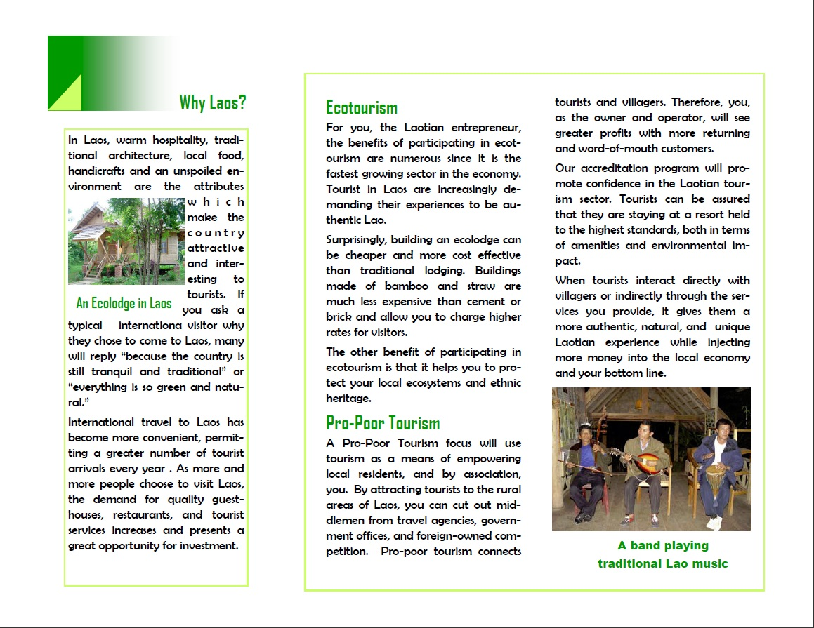

Works Cited
Ecotourism in Laos - Ecotourism Laos. GMS Sustainable Tourism Development Project. Web. 30 Apr. 2010. <http://ecotourismlaos.com>.
Grover, Amar. "Namha Ecotourism Project." UNESCO Bangkok. UNESCO, July 2008. Web. 30 Apr. 2010. <http://www.unescobkk.org/culture/our-projects/sustainable-cultural-tourism-and-ecotourism/namha-ecotourism-project/>.
"LAO: Greater Mekong Subregion Sustainable Tourism Development Project." Asian Development Bank. Web. 30 Apr. 2010. <http://pid.adb.org/pid/LoanView.htm?projNo=38015&seqNo=02&typeCd=2&projType=GRNT>.
Lao PDR. Lao National Tourism Administration. Current Situation of Tourism. Oct. 2007. Web. 30 Apr. 2010. <http://www.sri.cmu.ac.th/online/news23/Ambassador%20Vang%20Rattanavong.pdf>.
Lao PDR Tourism Strategy 2006-2020. Rep. Lao National Tourism Administration, 2006. Web. 30 Apr. 2010. <http://www.latalaos.org/doc/Strategy2006.pdf>.
"Laos Hotels & Travel Guide - Laos Information." Hotels & Tours in Cambodia, Vietnam, Laos, Thailand, Myanmar (Burma), Yunnan. Asia Web Direct. Web. 30 Apr. 2010. <http://www.visit-mekong.com/laos/>.
"Laos NGO Resources." Nonprofitexpert.com. Web. 30 Apr. 2010. <http://www.nonprofitexpert.com/countries/laos.htm>.
Maclaren, Fergus. A Strategic Overview of Ecotourism Accreditation and Certification:. Rep. The International Ecotourism Society. Web. 30 Apr. 2010. <http://www.world-tourism.org/sustainable/IYE/Regional_Activites/Brazil/cases/TIES.htm>.
NZAID Lao PDR Strategy. Rep. NZAID. Web. 30 Apr. 2010. <http://www.nzaid.govt.nz/library/docs/nzaid-lao-pdr-strategy.pdf>.
"Practical Strategies for Pro-poor Tourism." Pro Poor Tourism. Web. 30 Apr. 2010. <http://www.propoortourism.org.uk/index.html>.
Schipani, Steven. DESIGNING AND OPERATING AN ECOLODGE IN THE LAO PDR. Lao National Tourism Administration- Asian Development Bank. Web. 30 Apr. 2010. <http://www.ecotourismlaos.com/directory/publications/designing_and_operating_an_ecolodge_in_the_lao_pdr_english.pdf>.
Scripts, More Dhtml. "Revealed Comparative Advantage (RCA) Of: R.D.P. LAO." International Trade Centre. 2001. Web. 30 Apr. 2010. <http://www.intracen.org>.
Sopheareak, Kong, and Horth Vanny. Tourism Statistics Report 2009. Rep. Ministry of Tourism. Web. 30 Apr. 2010. <http://www.tourismcambodia.com/ftp/Cambodia_Tourism_Statistics_2009.pdf>.
"Sustainable Travel : Ecotourism Certification." TouristTravel.com. Web. 30 Apr. 2010. <http://www.touristtravel.com/ecotourism_certification.htm>.
"Tourism of Cambodia, 1st Edition." Tourism Cambodia. Web. 30 Apr. 2010. <http://tourismcambodia.com>.
"What Is Ecotourism." Ecotourism Australia. Web. 30 Apr. 2010. <http://www.ecotourism.org.au/>.

GDP per capita growth from 2000-2008 measured as PPP with respect to US dollars
Measured as PPP to US dollars in 2009
Market exchange, 2000 US dollars
http://www.ecotourismlaos.com/directory/publications/lao_nta_ecotourism_strategy.pdf
http://www.ecotourismlaos.com/laoecotourism.htm
http://www.ecotourismlaos.com/protected_areas.htm
http://www.ecotourismlaos.com/directory/publications/lao_nta_ecotourism_strategy.pdf
http://www.laostravel.biz/ecotourismprojects.htm
http://pid.adb.org/pid/LoanView.htm?projNo=38015&seqNo=02&typeCd=2&projType=GRNT
http://www.unescobkk.org/culture/our-projects/sustainable-cultural-tourism-and-ecotourism/namha-ecotourism-project/

