Haiti Background Report

2008
Anthony Diaz, Ashley Trapp, Annie Feldman
Lehigh University
2/18/2008

Table of Contents
Introduction
What is Development? 2
Values Foundation 2
Theoretical Foundation 2
Political Instability in Haiti 4
Our Definition 4
Comparisons 5
How unequal is Haiti today? 6
Where did inequality come from? 8
The Human side of Haitian Development 10
Geography and Agriculture 12
Key Areas of Development 13
Food and Imports 13
Infrastructure 14
Education: 15
1-GAP: 18
2-GAP: 22
3-Gap 27
Conclusion 32

Introduction
The purpose of this paper is to provide a comprehensive assessment of Haiti’s economic and social progress since the mid 20th century. This assessment will show that the country has failed to progress economically, as evidenced most clearly by stagnation in the real Gross Domestic Product and continued high unemployment. Haiti’s acute social ills, which complete the picture of a country that is experiencing minute development will be illustrated by political instability, low literacy rates, lack of basic yet essential infrastructure, a spreading HIV problem, infant mortality, poverty and hunger.

What is Development?

Values Foundation

Human development and improved quality of life is crucial in our definition of the nation’s development due to a moral foundation that all people have the natural born right to live a healthy and meaningful life. Without a genuine sense of well-being and self-respect, Haiti’s people will have little motivation to create new opportunities and improve their lives. Economic development should not be the singular goal but the necessary path to other avenues of social development and progress.

Theoretical Foundation

The theoretical foundations in our definition of development include theories of development such as modernization theory, dependency theory, world systems theory, and state theory. Although each theory possesses its own set of different and sometimes conflicting underlying values, each plays a role in determining what development does and does not include. Modernization theory emphasizes that modernization can be achieved through emulating the previously followed paths to development by established developed nations. Haiti cannot develop by simply emulating any developed western nation due to the fact that Haiti has its own unique history, geography, culture, and problems. In order to develop, Haiti must devise a specific plan to address all aspects of its distinctive needs. The relative prosperity of the Dominican Republic motivates the emulation of the neighboring country. The stark comparison only highlights the weaknesses in Haiti. Dependency theory explains that as long as the Third World is linked to the north they could never break free of their dependence and poverty. Consequently, Haiti depends on the United States for 80% of its exports and 46.5% of its imports. The perpetual link to western countries began as early as 1697 when Haiti became a colony of France and dependent on French economy, policy, and rulers; Haiti did not gain independence until1804. World Systems theory describes how periphery countries such as Haiti are exploited through the semi-periphery by the core. The inequality in Haiti which emerges from the unequal distribution of labor and exchange is caused by a concentration of wealth in the global North. Haiti must find a unique development plan which can allow the country to act as a self-sustaining system, one which is benefited by outward relations, not hindered by them. Finally, State Theory supports the fact that Haiti’s political instability must be eradicated in order for the country to provide an atmosphere for sustainable economic growth. After the tumultuous dictatorship of Francois ‘Papa Doc’ Duvalier ended in the early 1970s, the government switched hands multiple times before Jean-Bertrand Aristide was elected president in 1990. Consequently, small economic elite has supported a ‘predatory state’ that has made only negligible investments in human resources and basic infrastructure.

Political Instability in Haiti

One of the main concerns which could prevent the adoption of a given development policy or could undermine the success of a new policy is the level of government corruption combined with social hostility. In the late 1800s and early 1900s there were twenty two regimes changes which occurred through violent coups. The constant government replacements make it impossible to have sustainable policies through regime changes. Even if a developmental policy is adopted by a particular administration, there is a very high probability that if a coup occurs the new government will throw out all previously existing policies. The large amount of violence which accompanies coups prevents the people from having faith in their government and, consequently, their government’s policies. The violence causes citizens to feel unsafe in their own country causing them tentative in playing an active role in government due the lack of transparency. Also, Haiti is considered one of the most corrupt nations in the world which brings into question how funds for developmental projects would be handled by the government. The level of corruption discourages all types of investment which is imperative for growth of the financial sector which is crucial in achieving sustainability.
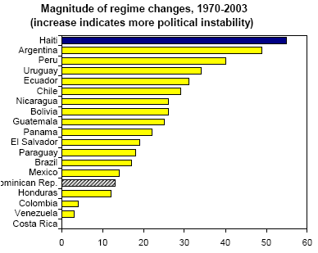

Haiti’s political instability and regime changes have hindered economic growth by causing the government to be incapable of implementing policies or even lasting long enough to devise economic policies. The amount of regime changes in Haiti over the last few decades were the greatest number in Latin America and South America; Argentina trailed Haiti’s number of regime changes slightly with 50 compared to Haiti’s 66 regime changes.

Our Definition

Development requires an amalgamation of economic growth and social transformation. Over the last half century Haiti failed to achieve consistent growth rates, make any real gains in political stability and respond to the dire health and poverty issues plaguing the country or improve literacy rates. Development should include sustained macro and micro economic levels to develop current economic growth trends such as Gross Domestic Product and Gross Domestic Product per capita.
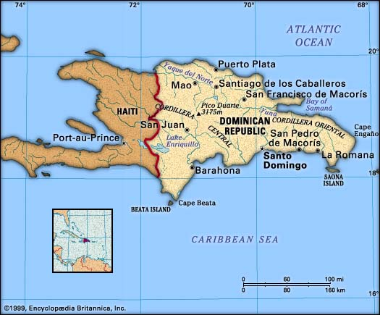
In order for Haiti to develop, widespread income inequality and a persistent urban bias must be addressed. Under our definition, true development will only begin occur when all members of a society experience an increased standard of living. Therefore, a singular focus on economics which ignores social development is not a complete development plan. Investment in all levels of education, public health programs, and sound infrastructure are essential to an improved country when combined with economic growth. The definition of development evolves from the underlying principles of the two foundations, values and theory, which provide the framework for a complete development plan.

Comparisons

Throughout our paper we will use the Dominican Republic, Haiti’s only neighbor on the island of Hispaniola, as a reference of comparable study. Despite sharing the same basic geographic characteristics and similar history, Haiti and the Dominican Republic have a very peculiar, unexplained growth divergence. The Dominican Republic is radically more developed than Haiti in a number of ways. The Dominican Republic has consistently outperformed Haiti in terms of structural policies and lasting political stability. Our development plans hopes to improve Haiti’s circumstances and put it on the same, if not better, path toward development as its neighbor.

How unequal is Haiti today?

Haiti’s colonial past reflects the current structure of society today. Haiti is currently the poorest country in the Western Hemisphere, with 80% of the population living under the $1 US dollar a day poverty line and 54% in abject poverty. The Haitian population is divided into three distinct classes: the elite “neo-Duvalierist” faction of former military officers, warlords and politicians, a small middle class with neo-liberal tendencies, and a majority of socially democratic poor. Economic inequality between classes in Haiti today is high compared to other countries in the Caribbean. It is a truism, according to Seers, that poverty will be eliminated more rapidly if any given rate of economic growth is accompanied by a declining concentration of incomes. The commonly used measure of inequality is the Gini coefficient, which ranges from 0 to 1. A low Gini coefficient indicates more equal income distribution, while a high Gini coefficient indicates more unequal distribution. According to the UNDP-sponsored FAFO institute Haiti’s overall Gini coefficient in 1999/2000 was .509. This puts inequality well above that of Europe and North America, where Ginis are in the range from 0.25 to 0.35.

While income inequality is an important indicator of a country’s development, it is also a relative measure of poverty that has its drawbacks. In Haiti’s case the Gini coefficients reveal that its income inequality is high compared to others countries such as the Dominican Republic; however, the Gini coefficient does not take into account how each specific country deals with income inequality. For example, if a government provides food stamps to the poor, the Gini coefficient excludes that source of income in its measuring parameters but will include a government subsidy. An advantage of the Gini coefficient is information it provides on income trends within a country. In Haiti, the Gini coefficients of rural and urban areas reveal that the pattern of inequality is changing by region. While total inequality is constant, the Port-au-Prince area is experiencing increasing inequality (.416 to .586) and rural inequality has decreased (.489 to .449). While poverty in Haiti is high relative to other countries, it appears to have decreased within the country. The percentage below the poverty line was 59 in 1986/1987 and 48 in 1999/2000.

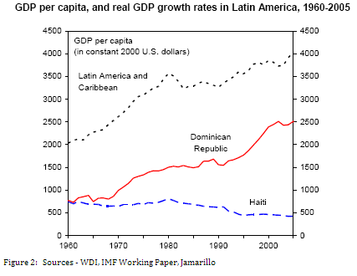
In 2006, the economy only had a 2.5% rate of growth which is not sufficient to achieve substantial future growth. Ownership of wealth has become concentrated in a small percentage of the population. By 2002, the richest four percent of the population controlled sixty-six percent of the country’s assets. Haiti’s government institutions remain weak and depend on external assistance to reform programs ranging from the economy to the education system. Most Haitian institutions lack the appropriately educated and technically skilled human resources to operate modern systems for government programs. One result is the mismanagement of financial assistance by international donors. Corruption is a major problem in all aspects of Haiti which is detrimental to the financial sector because investors are hesitant to supply capital into the country. Within our definition of development, we will attack the core problems within the economy, which is to fix the infrastructure, alleviate the hunger pains of labor workers, and improve the ability of Haitians to attain stable jobs. The GDP (ppp) in 2007 was $15.82 billion which is almost four times less than the GDP (ppp) of neighboring Dominican Republic which was $84.5 in 2007. Though on a historical decline, the growth rate grew in 2007 to 3.5% due to the help of macroeconomic programs of the IMF. It is not certain, however, that the growth rate will continue to improve in the future without help from Bretton Woods institutions. The GDP per capita (ppp) in Haiti in 2007 was $1,900 compared to the Dominican Republic GDP per capita (ppp) of $9,200. In comparison to the Dominican Republic, Haitians are living well below the means. Although it’s a good indication of Haiti’s economic progress, it fails to report on issues such as infant mortality rate and illiteracy that are important to our definition of development. Though GDP is used extensively in quantifying economic growth and industrial output, it cannot be used synonymously with the word ‘development’. Any measure of raw economic output misses the human side of national development.

Where did inequality come from?

Haiti gained independence from France in 1804, yet two centuries later the island’s colonial past is still extremely visible and influential. French colonists imported massive numbers of African slaves to work the sugar plantations bringing wealth to a small, white elite and entrenching socioeconomic inequality deep into the psychological fabric of Haiti. Constant intervention by foreign powers in Haiti’s internal affairs has proved disastrous over the years, leaving a mix of broken policies, factionalism and corruption. Ill fated interventions of the global North have stripped away faith in the government of Haiti. However poor the interventions on the North’s part were, domestically the government’s negative effects far exceed it. Between the years of 1844 and 1915, Haiti was lead by twenty-two different leaders, each of whom generally lost power due to disastrous coups. After a twenty year occupation by the American military, Francois ‘Papa Doc’ Duvalier declared himself president for life in 1957. Papa Doc’s fascist dictatorship was marked by corruption and rises in inequality. The dictator stole money from the people to build elaborate compounds for himself and pocketed loans from foreign government into personal bank accounts. After Papa Doc died and his son, Jean-Claude Duvalier took power and Haiti consequently experienced harsh economic conditions caused by the US recession in the early 80s. The economic poor economic climate causes social unrest throughout the country and the dictator was forced to flee the country.
In comparison to the rest of Latin American, Haiti has experienced the most regime changes between 1970 and 2003. The amount of regime changes represents the lack of stability—an important aspect in government required to foster any degree of economic growth. In general, the fewer regime changes a country experiences, the higher the growth rates. In contrast, the Dominican Republic has experienced about five times fewer regime changes and has experienced higher levels of growth than Haiti.
Transparency International’s Corruption Perception Index, which measures the level of corruption perceived by businessmen and country analysts, ranks Haiti as the fourth most corrupted nation in the world with a 1.6 out of ten, with zero being viewed as the most corrupt. With such a discouraging level of corruption in Haiti and the inevitable cynicism of investors, any long term solutions involving Haiti’s dependence on foreign investment for finances would be unlikely. Therefore an improvement in the CPI rating’s quantitative categories should be a goal in the development strategy of Haiti. To achieve this goal, Haiti must make strides in combating stability problems including rampant criminal gang violence, corruption within the police department, and drug trafficking.

The Human side of Haitian Development

Particularly striking is Haiti’s losing battle with hunger, with a child malnutrition rate of 17.2% among 7.9 million. In order to develop physically and intellectually to the greatest potential, proper nutrition is vital. Growing up hungry stunts the human growth potential idealized in our vision of development. Malnutrition is a serious disadvantage in terms of economic growth, affecting the ability of the poor to work and improve their living environment. Alleviating the pains of hunger is not only a conscionable moral ideal but it also has a direct impact on productivity. Village improvements such as irrigation projects and road repairs are not on the government’s agenda because of the constant search for food. Though outside help from the World Food Program is considerable in Haiti, internal changes must be made to alleviate hunger and recognize the severity of a generation starved.

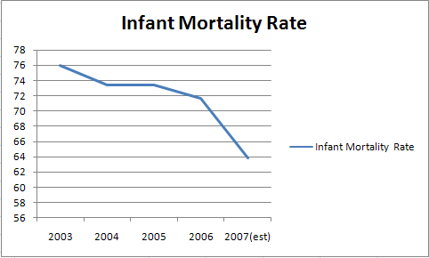
Hunger itself is not the only serious health problem in Haiti. Infant mortality rates are high in comparison to similar GDP related countries at 63.83 deaths for every 1,000 live births. Despite this high number, it’s more promising when compared to sky high rates in early 2000. Nonetheless, infant mortality in Haiti is comparatively high compared to a Latin American and Caribbean average of 28 per 1,000. Further reduction of the IMR requires heavy amounts of basic improvements made, specifically in the rural area. Chief among these improvements is access to safe water. Only 7.9% of Haitians living in rural areas access safe water, a disproportional amount to an even lower 28% in metropolitan areas. The government’s lack of investment in rural areas is apparent. Fortunately assistance by NGO’s and foreign aid programs has been high in the past twenty years. Road building and the construction of drinking wells and water filtration systems have given hope to many. Improving the lives of the poor in Haiti by providing water and food, the most natural and basic of needs is a key component in the social development of Haiti.

Geography and Agriculture

Geography and population measures play a vital role in shaping a country’s growth performance. According to the International Monetary Fund some of the determinants of geography include the quality of natural resources, productivity of land, the public health environment and the extent to which a country can become integrated with world markets. As mentioned before, one important implication of geography and climate is a country’s access to clean water. In Haiti, 54 percent of the population is without sustainable access to an improved water sources, compared to 14 percent in the Dominican Republic. This measure, however, is not independent of influences by the government’s allocations of resources. Haiti is the second most densely populated country in the western hemisphere with a population density of 797.4 per sq. mile in 2005. Although high population density is favorable for economic development in coastal regions with good access to trade, this high quantity does not bode well for Haiti’s limited number of trading partners and lagging economy. It was estimated by the Population Reference Bureau that 36 percent of the population lived in urban areas in 2001. According to the United Nations, the urban population growth rate for 2000–2005 was 3.4 percent while the rural population growth rate for those years was close to one percent. Population movement may be a result of a demise of an agrarian economy or simply an urban bias. Regardless of its source, this is an important trend that our assessment of Haiti’s development would like to explore further.
The majority of Haitians depends on the agricultural sector which includes subsistence farming and primary products such as sugarcane. Unfortunately, the decline of reliance on primary product expectation has caused sugarcane to face a constantly shrinking market and barriers to trade. Primary products are not a dependable sector to rely strongly on in light of the fact that the demand for primary products such as sugarcane is decreasing due to the emergence of artificial substitutes. Also, uncontrollable factors such as a famine or drought can ruin an entire season. Agriculture composes 28% of the economic sector while 66%, more than half, of the population is employed in the agricultural sector. These numbers indicate a lack of capital and efficiency. Haiti’s main primary products are coffee, mangoes, sugarcane, rice, corn, sorghum, and wood. Industry is relatively more efficient than agriculture; it comprises 20% of GDP and employs 9% of the labor force. However, most of the industry is export-oriented and does little to improve the internal welfare and consumption throughout Haiti. The main industries include sugar refining, flour milling, textiles, cement, light assembly based on imported parts. The service industry comprises 52% of the GDP while only employing 25% of the labor force. Clearly, industry is more efficient than agricultural production.

Key Areas of Development

Food and Imports
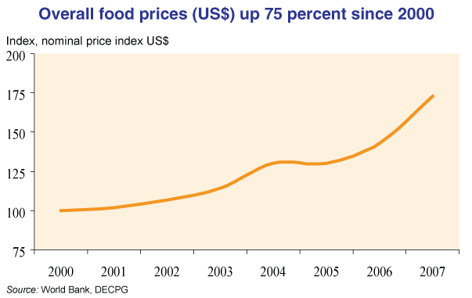
With the majority of Haitians living on or below the poverty line any upset in routine threatens lives and can further plunge the country into turmoil. Haitians, as well as all the world’s poor, make do with what they are blessed with having, yet certain things are completely out of their control. The global market, however distant most Haitians may seem from it, is making food completely unaffordable and unattainable. Haiti, a Caribbean island, relies on imports heavily to feed its population. Oil prices driven upwards because of fertilizer, irrigation and transportation demands, along with basic ingredients such as corn and wheat becoming more expensive, and an increasing global demand for bio-fuels all force food prices sky high. In addition, the 2007 Hurricane season destroyed most of Haiti’s crops and the subsequent flooding damaged food stocks. Heavy reliance on imported food opens Haiti to risk of fluctuations in food prices, placing Haitians in an even more precarious spot than they already are.

Infrastructure
Many studies find that infrastructure improvement drives economic growth (Calderón and Servén, 2004) as well as poverty reduction. However, Haiti has one of the worst infrastructures in the modern world. Use the graph below to compare Haiti with other Latin American countries and Sub-Sahara Africa and it is easy to see the massive divide. Haiti is cursed with an unstable environment, detrimental to even the smallest infrastructure projects. Constant hurricanes and tropical storms cause massive erosion, landslides, weaken top soil and cause pot holes. A dismal 5% of roads are listed as in “good” condition.
Access to water is an extreme problem, especially for the rural population. Though only 11% of households are piped to a reliable water source, virtually none of these houses are owned by Haiti’s poorest. Lack of potable water facilitates the already destructive health problems. Also, less than half the population has access to improved sanitation facilities. Consequently, potable water and clean sanitation facilities go hand in hand; lack of clean sanitation facilities pollutes the water supply. Electricity use is minimal throughout the country due to the fact that only 36kwh (kilowatt hours) of electricity are used per capita in a year. In sub-Saharan Africa people use 457kwh of power a year which is more than ten times the amount of power which is used in Haiti. The poor infrastructure of roads, water sanitation, and electricity use prevents Haiti from developing.
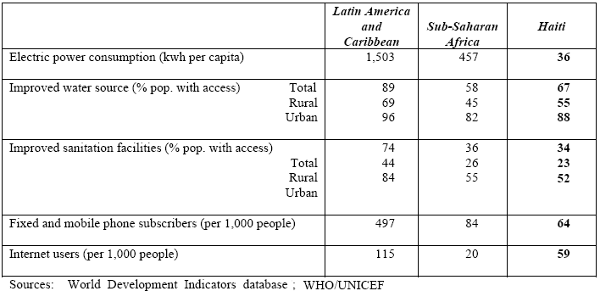

Education
Education is a crucial condition for growth that brings more than just skilled labor to an economy. Education also has beneficial impacts on nutrition, health, and empowerment of girls and poverty. It offers hope that children will help families break out of the vicious cycle of poverty. Access to education in Haiti has declined in recent years and disparities between urban and rural enrollment have worsened. The major deterrent that prevents enrollment is the cost of education. Despite continuous economic problems, there has been progress in school attainment. This is due to the fact that ninety-two percent of schools in Haiti are operated by a diverse group of private actors who have stepped in to “fill this gap” in the education sector. Figure 2.13 shows the attainment profile—percentages of students reaching each grade level by income group in two years. The profile shows progress at nearly all points. For example, while only 40 percent of 15-19 years old had completed 3rd grade in 1994-1995, that figure jumped to 56 percent in 2001. While there seems to be an increase in school attainment, this does not suggest that the quality of education has improved. Since investment in school is coming from private funds, there is little data that shows increased in learning and literacy.
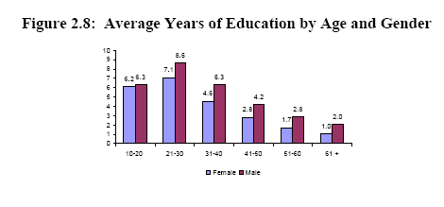

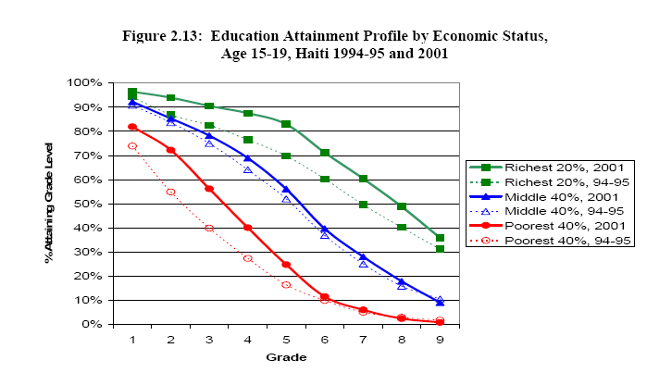

Another aspect of education we can look at is the returns from education in terms of wage earnings. The small role of wage earnings is apparent in Table 2.1, which shows the breakdown of household income where only 20 percent of income comes from wages. Such low incomes indicate that education is not producing much skill to contribute to the average household income.
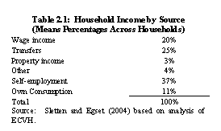

Healthcare
Healthcare in Haiti is in a state of crisis. Only about 60% of Haiti's 8 million residents have access to any form of health care services, according to the Pan American Health Organization (PAHO). The public healthcare system in the country is currently failing and has proved to be unable to handle the needs of the people. A 2003 Red Cross study indicates there is fewer than 1 hospital bed for every 1000 patients throughout Haiti and 209 surgical beds for the 6 million people living outside Port-au-Prince. The lack of health care does not only jeopardize people’s lives but promotes the spread of infectious diseases. The lack of sanitation also increases the risk of food and waterborne diseases such as Hepatitis A and E, typhoid fever, and bacterial and protozoal diarrhea. Also, poor sanitation and hygiene, coupled with inadequate nutrition, have contributed to a high incidence of physical challenges, ranging from congenital deformities and amputations to stroke-related paralysis and head and spinal cord injuries.
Another huge health issue is the prevalence of HIV/AIDS. Haiti has one of the highest rates of HIV/AIDS infection outside of Africa; an estimated 250,000 are living with the disease, according to WHO. The prevalence of the AIDS is a major obstacle because it diminishes the work force and creates a large portion of the population which has extensive medical needs. In order for the country to develop the people must have access to decent healthcare and health education.

Political Instability

One of the main constraints which could prevent the adoption of a given development policy or could undermine the success of a new policy is the level of government corruption combined with social hostility. In the late 1800s and early 1900s there were twenty two regimes changes which occurred through violent coups. The constant government replacements make it impossible to have sustainable policies through regime changes. Even if a developmental policy is adopted by a particular administration, there is a very high probability that if a coup occurs the new government will throw out all previously existing policies. The large amount of violence which accompanies coups prevents the people from having faith in their government and, consequently, their government’s policies. The violence causes citizens to feel unsafe in their own country which makes them tentative in playing an active role in government due the lack of transparency. Also, Haiti is considered one of the most corrupt nations in the world which brings into question how funds for developmental projects would be handled by the government. The level of corruption discourages all types of investment which is imperative for growth of the financial sector which is crucial in achieving sustainability. Another obstacle is the lack of a cohesive police force because it makes it difficult for there to be any law enforcement. There are extremely high levels of drug trafficking which goes through the country due to the levels of corruption and kickbacks which officials receive for ignoring the contraband traveling in and out of the borders. Police are necessary to prevent crime which will reduce the number of gangs and gang related deaths.

NGOs Currently in Operation

Non-governmental organizations are a necessary tool for development in third world countries which are attempting to achieve sustainable growth. NGOs are organizations created by private entrepreneurs which lack government funding and participation. Haiti has a wide range of NGOs which operate within the borders of the country and participate in a variety of operations which benefit the country. In order for Haiti to achieve sustainability, NGOs need to utilize their resources and funds to eliminate situations of dependency and give people the opportunity to live productive lives.
Currently, there are a wide variety of NGOs which operate in Haiti that address the health, education, agriculture, and political problems throughout the nation. Doctors without Borders is an emergency medical relief association which operates in countries in crisis. The organization provides emergency medical services, sanitation services, vaccines, and AIDS education. The services which Doctors without Borders provides are necessary for the prevention of disease through medications and sanitation. In order for health to improve, organizations like Doctors without Borders need to promote health education and provide health services which are not available in the hospitals. Other organizations provide more general services. For example, Direct Relief provide wholesale medical supplies to Haiti; it has given around 60 million dollars worth of medical supplies to date.
Other organizations such as Grassroots International address human rights issues and defend the land of the indigenous people. The organization protects human rights to land, water, and food. Organizations which encourage subsistence agriculture are very important in Haiti due to the high amount of malnutrition and, the fact that the country imports a large majority of its food from abroad. Outreach International is another NGO which deals with the social side of development issues and helps people develop skills which will allow them to be productive in society. Also, the organization has a civil branch which teaches people to build local governance and move away from the corruption tendencies inherent in many aspects of the Haitian government. In addition, Outreach International offers education programs which work with over 100 schools and 12,000 students annually to help children develop themselves so that they can break out of the cycle of poverty. We believe that when children learn to read and write, and gain skills in problem solving and community building, they will be better equipped as adults to transform their communities. NGOs are a crucial aspect in our development plan. Working with NGOs to expand the scope of projects to specifically address Haiti’s unique needs will be beneficial to the potential growth of the country.

Economy

1-GAP:

As a complement to social and political development goals, we will use GDP indicators to produce a better understanding of Haiti’s micro and macroeconomic policies. Though we stress that the key to Haiti’s development is the improvement of education, health and social standards, Haiti’s economic growth rates can contribute significantly to the attainment of overall human welfare. By looking at Haiti’s economic trends and utilizing economic models, we will establish realistic economic targets for Haiti.
In 2006 the Haitian economy recorded positive GDP growth of 2.5% for the second year running. Output growth of 2.5% in 2006 allowed for an increase in per capita GDP of 0.7%. Though Haiti has recently achieved positive growth rates, between 1961-2000 Haiti’s real income per-capita fell by an average percent per year. Indeed, Haiti’s economic performance has been one of the worst in Latin America and the Caribbean (LAC) region and similar to that observed in the worst performing sub-Saharan African countries. In order to pull Haiti out of its long-term economic slump it is important that we analyze what is preventing growth, which can be seen through GAP analysis.
The most fundamental developmental obstacle for poor countries is the inadequate supply of investment. The relationship between growth rate and investment is often overlooked but it is crucial in our determination of savings and investment levels. One solution to the ‘gap’ between investment and savings is given in the Harrod-Domar equation, which indentifies the gap between the savings available and the level of investment required to achieve any given growth target. While most development models are familiar with the Solow Growth Theory, which takes into account land, labor and efficiency factors, the Harrod-Domar equation derives a simple, yet very informative relationship between GDP growth and investment level.

Source: WDI

The Harrod-Domer equations says that the change in GDP is equal to 1/K * I where K is the capital-output ratio and I is the investment level. This model is especially important because we can set the target growth rate for Haiti to the Dominican Republic’s 2007 growth rate of 7.2%. Typically the standard capital-output ratio is 5, however because Haiti’s economic performance is unique we will use average growths rates and investment levels to determine the more accurate capital-output ratio specific to Haiti.
Currently, Haiti’s average annual growth in GDP from 1980 to 2003 is in total -.37%. Given this negative growth rate, it is difficult to draw an accurate depiction of investment using the Harrod-Domer model. In figure 1.1 we see a the capital-ouput ratio calculated for Haiti from 1980-2003 would be -47.652 due to a two-decade long period of negative growth rates. If Haiti is to use the Dominican Republic’s 2007 GDP growth of 7.2% as a target rate, then according to the Harrod-Domer equation, the appropriate level of investment would be 7.2% * -47.652. This very high negative number is strikingly illogical since a country cannot have a negative investment rate. For Haiti’s case, it is therefore appropriate to use another method of analysis of the one-gap other than the Harrod-Domer model.

Figure 1.1: Harrod-Domer Components taken from 1980-2003
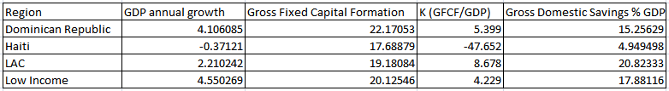

It is clear from our calculation of K that investment levels are extremely sensitive to a country’s GDP growth. We can also see from Figure 1.1 that investment levels in Haiti are right around the investment levels of the DR, LAC and Low income countries. The problem, therefore, must be inefficient investment. High levels of investment have no translated into economic growth. Haiti’s paradox of high investment levels accompanied by a contraction of per capita GDP can be explained by measurement problems within the national accounts. The Haitian Institute of Statistics (IHSI) is underfinanced and has weak institutional capacity and the availability of date is very limited and outdated. In addition to the shortcomings of the system of national accounts, the investment paradox can also be a result of under-estimation of GDP and overestimation of GDP
In addition to inefficient use of investment, there lies an apparent disparity between gross fixed capital formation and domestic savings worth nearly 15% of GDP. The World Development Index defines gross capital formation as:
“Gross fixed capital formation (formerly gross domestic fixed investment) includes land improvements (fences, ditches, drains, and so on); plant, machinery, and equipment purchases; and the construction of roads, railways, and the like, including schools, offices, hospitals, private residential dwellings, and commercial and industrial buildings. According to the 1993 SNA, net acquisitions of valuables are also considered capital formation.”

This disparity in savings and investment suggests that investment in the Haitian economy is not from within, but from abroad. Foreign direct investment over the period of 1980 to 2003 was approximately 26% of GDP and in the most recent record in 2005 FDI was 21% of GDP. More noteworthy is that Haiti’s total debt outstanding is US$ 1.4 billion and total debt as a percent of GDP is 34.1 percent. Haiti’s reliance on outside sources for aid, especially the United States, deepens Haiti’s debt and forsakes any improvements for future sustainability. Too much dependence will continue to undermine the capability of the Haitian government to address sustainable growth.

Figure 1.2
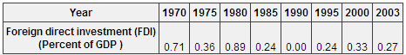
Source: Globalis

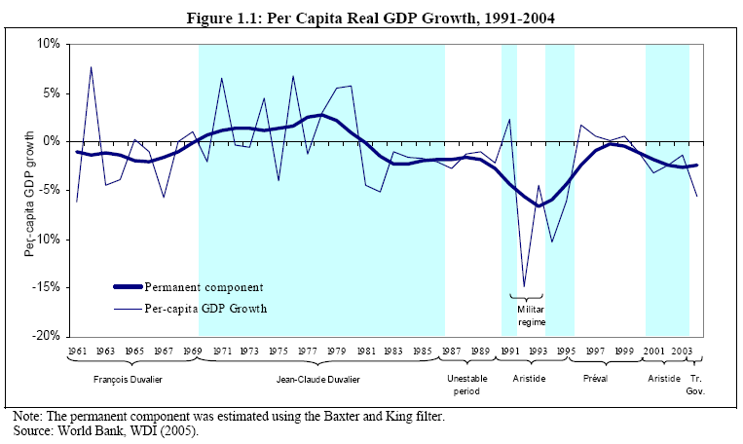

2-GAP:

The two-gap is the difference between available hard currency and actual sources of foreign exchange. Essentially, the two-gap is a good measurement for sustainability. If a country does well for one or two years, perhaps due to foreign aid, its good standing will not necessarily hold because of the strong affects that currency and foreign exchange have on the overall economy. The two-gap analysis involves the study of balance of payments, trade account balance, foreign reserves, and currency and liability balances. The balance of payments describes the sources of foreign exchange as it tracks the inflows into Haiti of currency from exports, asset sales, foreign investment, loans, and foreign aid. The opposite end of the balance of payments for Haiti involves the needs of foreign currency which include purchasing imports, repatriations of profits, and repayments of loans. The Haitian balance of payment in 2004 is considerably healthier than it has been in the last twenty years as a deficit of 1.16% of GDP, however this does not fully represent Haiti’s lagging balance of payment in the last twenty years as shown in table 1.1. Haiti’s trade account balance in 2004 was -29.31% of GDP. The trade account deficit indicates that imports were much higher than exports. In 2003 the trade deficit was evener higher at -32.12% of GDP, with imports at 46.6% of GDP and exports at only 16.2% of GDP. In 2007, Haiti’s exports were $554.8 million and its imports were a high $1.844 billion. Haiti’s overindulgence in exports eats away at the current account and causes a succession of other economic strains with many social implications. A result of Haiti importing more than half its food, local farmers struggle to sustain their businesses and their livestock and families impoverish.
Table 1.1 (As % GDP)
 |  |  |  |  | 1980 |  |  |  |  | 1983 | 1986 | 1989 | 1992 | 1995 | 1998 | 2001 | 2004
Current Acct. |  |  |  |  | -6.92 |  |  |  |  | -6.82 | -2.00 | -2.49 | .39 | -2.86 | .75 | -3.66 | -1.53
Financial Acct. |  |  |  |  | 5.20 |  |  |  |  | 5.59 | 1.53 | 2.39 | -1.24 | 3.26 | 4.94 | 2.29 | 1.42
CA and FA |  |  |  |  | -1.72 |  |  |  |  | -1.23 | -.47 | -.1 | -.85 | .4 | 5.69 | -1.37 | -.11
Net Errors and Omissions |  |  |  |  | -.85 |  |  |  |  | -.53 | .66 | -.42 | .50 | 4.14 | -4.7 | 1.23 | 1.27
Overall Balance |  |  |  |  | -2.57 |  |  |  |  | -1.76 | .19 | -.52 | -.35 | 4.54 | .99 | -.14 | 1.16
 |  |  |  |  |  |  |  |  | source: WDI

Haiti’s trade balance deficit leads to a lack of available foreign exchange. Massive trade deficits are most detrimental because they can cause currency declines, which in turn affect levels of imports, reserves and loans. Haiti had a fixed currency rate up until 1990, so that the Haitian currency, the gourde, was pegged against the US dollar. Even with a fixed currency rate, Haiti experienced sharp declines in total foreign reserves from 1985 to 1990 due to political turmoil. Duvalier’s struggling regime in the 1980’s led to his resignation, but Duvalier’s departure in 1986 was followed by successive failed elections and between 1986 and 1990, there were six different heads of state. Intense political instability deterred investment and inevitably Haiti’s low levels of foreign reserves triggered a currency crisis in 1991. Since these financial crises, Haiti has had a difficult time maintaining positive accounts without the help of foreign aid. While the currency rate has remained pretty constant in the last decade, they are volatile because of Haiti’s very negative net external position of -40.38, which is the ratio of liabilities to assets. Haiti’s estimated external debt to international financial institutions and foreign governments has grown from US$302 million in 1980 to US$1.4 billion today. Countries providing aid to Haiti will hold Haiti accountable, and essentially Haiti is selling its sovereignty by collecting increasing debts.
Haiti heavily relies on the outside world to compensate for its inefficient economy. The current account is pulled down by the trade deficit and should be pulled up by income and transfers. However, income has very little effect on the current account, as less than 1% of the GDP is affected by income, which describes Haiti’s inefficient workforce. Transfers, which include foreign aid and worker remittances, carry much of the weight in the current account. Worker remittances has consistently accounted for around 16% of GDP for the last decade and about 28% of Haiti’s GDP in 2004, while aid accounts for approximately 6% of GDP in the transfers. Worker remittances are so high because about one out of every eight Haitians presently lives outside the country’s borders. As a result, Haitians rely on other sources of income and thus has not been able to generate sufficient income to maintain the rhythm of food imports, leading to increased debt.
Despite Haiti’s large flow of remittances, the use of remittances remains overwhelmingly directed to consumption rather than investment or savings. As a result, the Haitian economy has become increasingly reliant on the money sent by the Haitian Diaspora living abroad when the focus should be on creating a more independent sustainable economy.

Another factor that has hurt the Haitian economy is the falling exchange rate for the Haitian gourde. Prior to 1991, Haiti had a fixed currency. Since then, the depreciation of the gourde to the dollar has grown. In 2004, the gourde was worth about $.026. Depreciation in a nation’s currency makes exports competitive and imports very expensive. Evident to the negative impact of depreciation on an economy is Haiti’s 1991 dollar depreciation rate of 39 percent. As a result, imports soared in less than one year from 20% of GDP to 34% of GDP. The trade imbalance was high and in turn the current account balance was even more negative. Exchange rates in Haiti are already very low and volatile to any changes international markets, therefore it is important for Haiti to increase its export industry while maintaining appropriate spending levels.

3-Gap
The future growth in Haiti depends on the 3-gap which is defined as the difference between available government revenues and required expenditures. The 3-gap is a good indication of the fiscal wellbeing of the country. During 2005 government expenditures were estimated to be US$600.8 million and revenues, about US$400 million resulting in a negative difference of US$200.8 million which is about 1.36% of GDP. The government relies heavily on international economic assistance for fiscal sustainability.The amount of money which the Haitian government spent was more than received in revenue. A massive budget deficit common in many third world and developing countries is the lack of self produced revenue, due to the fact that the only money which governments receive are taxes and foreign aid. Taxes can be an especially challenging obstacle since wealthy elite interest groups generally possess a great about of power and influence in Haiti. Also, poor people have too few assets to be taxed by the government; they would be unable to pay their requirement. Haiti has a moderate income tax rate and a high corporate tax rate. The top income tax rate is 30 percent, and the top corporate tax rate is 35 percent. Foreign aid to the Haitian government has led the government to become for expenditure focused since there is a constant influx of money. However, foreign aid also increases foreign debt. In 2005, Haiti received $515 million dollars in foreign aid and last year accumulated a $1.4 billion external debt. Curtailing the deficits will be difficult with the large amount of foreign aid constantly flowing into the country. The misallocation of public revenues for private use and the low government allocations for economic and social development have contributed directly to Haiti's extreme poverty.Military expenditures do not play a large role in the percentage of expenditures in Haiti. Haiti’s defense budget totaled an estimates US$26 million. Currently Haiti has a 5300-strong national police force, funded and trained by the US, formed in the place of its military which was disbanded in 1994 when democracy returned to the country. The amount of money which is spent equals 0.2% of GDP which is small enough that total military spending does not necessary needs to be reduced.

Economically, Haiti has experienced difficulty in the last four decades. Total Factor Productivity is an assessment of growth which measures the total output not caused by inputs or productivity and accounts for a majority of growth which occurs in a country. TFC is defined by the Cobb-Douglas production function Y= A x K^α x L^1- α. Total output equals a function of total factor productivity times capital input (K) and labor input (L).
TFP growth in Haiti has been negative for the last four decades while TFP growth in the Dominican Republic has only been negative for one out of the last three decades. Unlike the Dominican Republic, Haiti lacks both capital and labor which is necessary for growth in any type of economy. 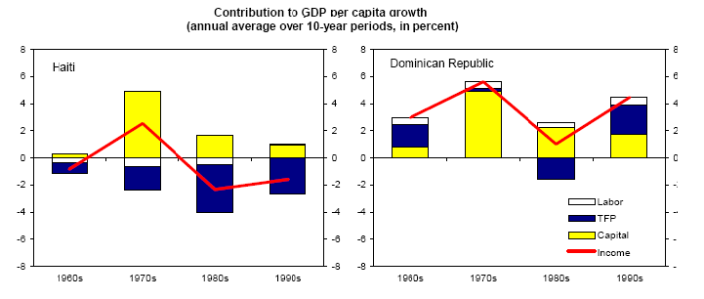
Foreign Direct Investment has not been very dependable over the years. In 1999 FDI went from $30 million to $5 million in 2002. The instability of FDI makes it difficult for Haiti to know how much money foreign countries will be investing each year in order to create projects to attract the investment. Although FDI is criticized on many levels, it generally provides economic growth and poverty reduction by directing a large majority of profits back into the domestic economy.
Since the 1990s Haiti has depended heavily on international aid from institutions such as the World Bank, International Monetary Fund (IMF), and Inter-American Development Bank (IADB). The dependence on foreign aid has supported an environment where Haiti has failed to develop many sectors of the economy on its own. In addition, the allocation of money is continuously questioned by international institutions as to whether or not it is going toward legitimate causes or into the personal funds of the elite majority.
Unskilled labor does not encourage the transfer of technology or the benefits of technology. Recently, in 2005, the United States permitted Haiti to have tariff-free access to US markets in order to stimulate the economy. Political instability has also played a huge role in the shrinking economy due to the fact that internal turmoil diverts focus from important aspects of the social and economic infrastructure of the country. Corrupt governments and elites also fail to implement economic policies which would benefit all citizens and the country as a whole.

Ties to the north in the import-export sector are very prominent yet also detrimental to the country. Northern countries such as the United States consume 80% of the exports from Haiti; Dominican Republic and Canada consume 7.6% and 3% of exports, respectively. This data reflects that Haiti is most dependent on the United States for exports which is dangerous if economic ties are severed between the two nations. Haiti exported $554.8 million f.o.b of products in 2007. The United States is also the lead importer of products into the country by supplying 46.5% of the imports to the country. The Netherlands Antilles with 11.9% and Brazil with 3.8% are a distant second. The influx of US products prevents the Haitian market from producing for their internal consumption because their products are inferior due to lack of technology and capital. Dependency theories would argue that Haiti is bound to agreements to the North with hefty strings attached. Haiti imported $1.844 billion f.o.b in 2007. The huge difference between the amount of products imported and exported is large. As a result, Haiti has problems with a balance of payments deficit, especially their current account balance of payments deficit. The current account deficit last year of -$184.8million puts Haiti in the category as a net debtor country which is investing more than it is saving. Therefore, Haiti depends on resources from other economies to meet domestic consumption and investment requirements. Haiti’s dependency on other countries and its lack of self-continues to inhibit growth in all sectors of the economy all the while building massive deficits to be paid of sometime in the future.
Intertwined with the economic issues is the problem of extreme and chronic unemployment. Around two thirds of the population is unemployed. Little access to jobs or job training hurts productivity and further postpones Haitian development. The labor force consists of about 3.6 million people out of 8.7 million inhabitants. The vast amount of unemployment leads to extreme poverty and little hope for sustainability. Poverty and the absence of job opportunities have driven many Haitians abroad in recent decades, mostly to the US and the Dominican Republic. Due to the fact that the per capita income in the DR is $1900 and in Haiti it is $9200, Haitian migration to the Dominican Republic has been large and filled with strife. Despite the Dominican Republic’s proximity, immigration is illegal and has caused strife and hostility between Haiti and its neighbor. Poor Haitians, however, are so determined to find work elsewhere because of limited opportunity in their own country that they fail to acknowledge the consequences of their migration.

Conclusion

Poverty reduction and human development are intrinsic to our definition of development. Haiti is currently the poorest country in the western hemisphere; the country’s potential to reduce poverty and adequately provide a sustainable future for human development is undeniable. Currently, Haiti is in a detrimental cycle of extreme poverty which is aggregated by a corrupt government and an insufficient infrastructure. Through improvements in agriculture, government, and education the goals of development are within reach. In order to achieve economic growth, the economy must be diversified; especially, from their dependence on primary products and western markets. Also, subsistence agriculture must be subject to technological improvements in order for malnutrition and starvation issues to decrease. Although many dilemmas such as political corruption and dependence on remittances and foreign aid cannot be solved in the short-run, the nation must begin to work toward long term-solutions.

Rapley p. 28
www.cia.gov/library/publications/-world-factbook/goes.he.html
http://www.infoplease.com/ipa/A0107612.html
http://www.giles.34sp.com/biographies/papadoc.html
World Bank, “Haiti: The Challenges of Poverty Reduction”, Report No. 17242-HA, August (1998)
https://www.cia.gov/library/publications/the-world-factbook
Seers, Dudley. "The Meaning of Development." Int Dev Rev (1969)
FAFO- Determination of a Poverty Line for Haiti 8
FAFO- Determination of a Poverty Line for Haiti 8
Egset, Willy. "A profile of poverty in Haiti." FAFO 2004
http://www.giles/34sp.com/biographies/papadoc.htm
IMF Working Paper: Growth in the Dominican Republic and Haiti: Why has the Grass Been Greener on One Side of Hispanola? ( Laura Jaramillo and Cemile Sancak 2007)
Transparency International. 2007 Corruption Perception Index. 2007. http://www.transparency.org/policy_research/surveys_indices/cpi/2007
Definition: Prevalence of child malnutrition (weight for age) is the percentage of children under five whose weight for age is more than two standard deviations below the median reference standard for their age as established by the World Health Organization. Figures are based on children under age three, four, and five years of age, depending on the country. Source: World Health Organization
http://devdata.worldbank.org/external/CPProfile.asp?SelectedCountry=HTI&CCODE=HTI&CNAME=Haiti&PTYPE=CP
World Bank, Haiti Social Analysis, 2006
World Bank, Haiti Social Analysis, 2006
IMF Working Paper- Growth in the Dominican Republic and Haiti
http://www.travelinghaiti.com/info/haiti-statistics.asp
http://www.britannica.com/eb/question-251961/5/density-sq-mi-Haiti
https://www.cia.gov/library/publication/the-world-factbook/geos/ha.html
World Bank
World Bank- Haiti Economic Memorandum
http://www.cmaj.ca/cgi/content/full/170/9/1379
http://www.cmaj.ca/cgi/content/full/170/9/1379
www.doctorswithoutborders.org
www.DirectRelief.com
www.grassrootsonline.org
4 www.Outreach-International.org
www.Outreach-International.org
WDI Country Statistics
World Bank – Haiti Economic Memorandum
https://www.cia.gov/library/publications/the-world-factbook/geos/dr.html
World Bank Haiti Economic Memorandum
World Bank- Haiti Economic Memorandum
WDI country statistics
World Bank Development Economics, Development Data Group (DECDG)
WDI
CIA World Factbook
IMF
WDI
WDI
WDI
http://www.ijdh.org/pdf/headline8-15-0b.pdf
https://www.cia.gov/library/publications/the-world-factbook/geos/ha.html
http://www.photius.com/countries/haiti/economy/haiti_economy_expenditures.html
http://www.ijdh.org/pdf/headline8-15-0b.pdf
http://dev.prenhall.com/divisions/hss/worldreference/HT/defense.html
http://economics.about.com/od/economicsglossary/g/tfp.htm
IMF Working Paper: Growth in the Dominican Republic and Haiti: Why has the Grass Been Greener on One Side of Hispanola? ( Laura Jaramillo and Cemile Sancak 2007)
http://ucatlas.ucsc.edu/fdi/fdi.html
http://www.usatoday.com/money/world/2004-02-26-haiticon_x.htm
www.usip.org (United States Institute of Peace Special Report)
Human Development Reports Data
www.investopedia.com
CIA- The World Factbook

