IDEA
Interactive Distance Education Applications
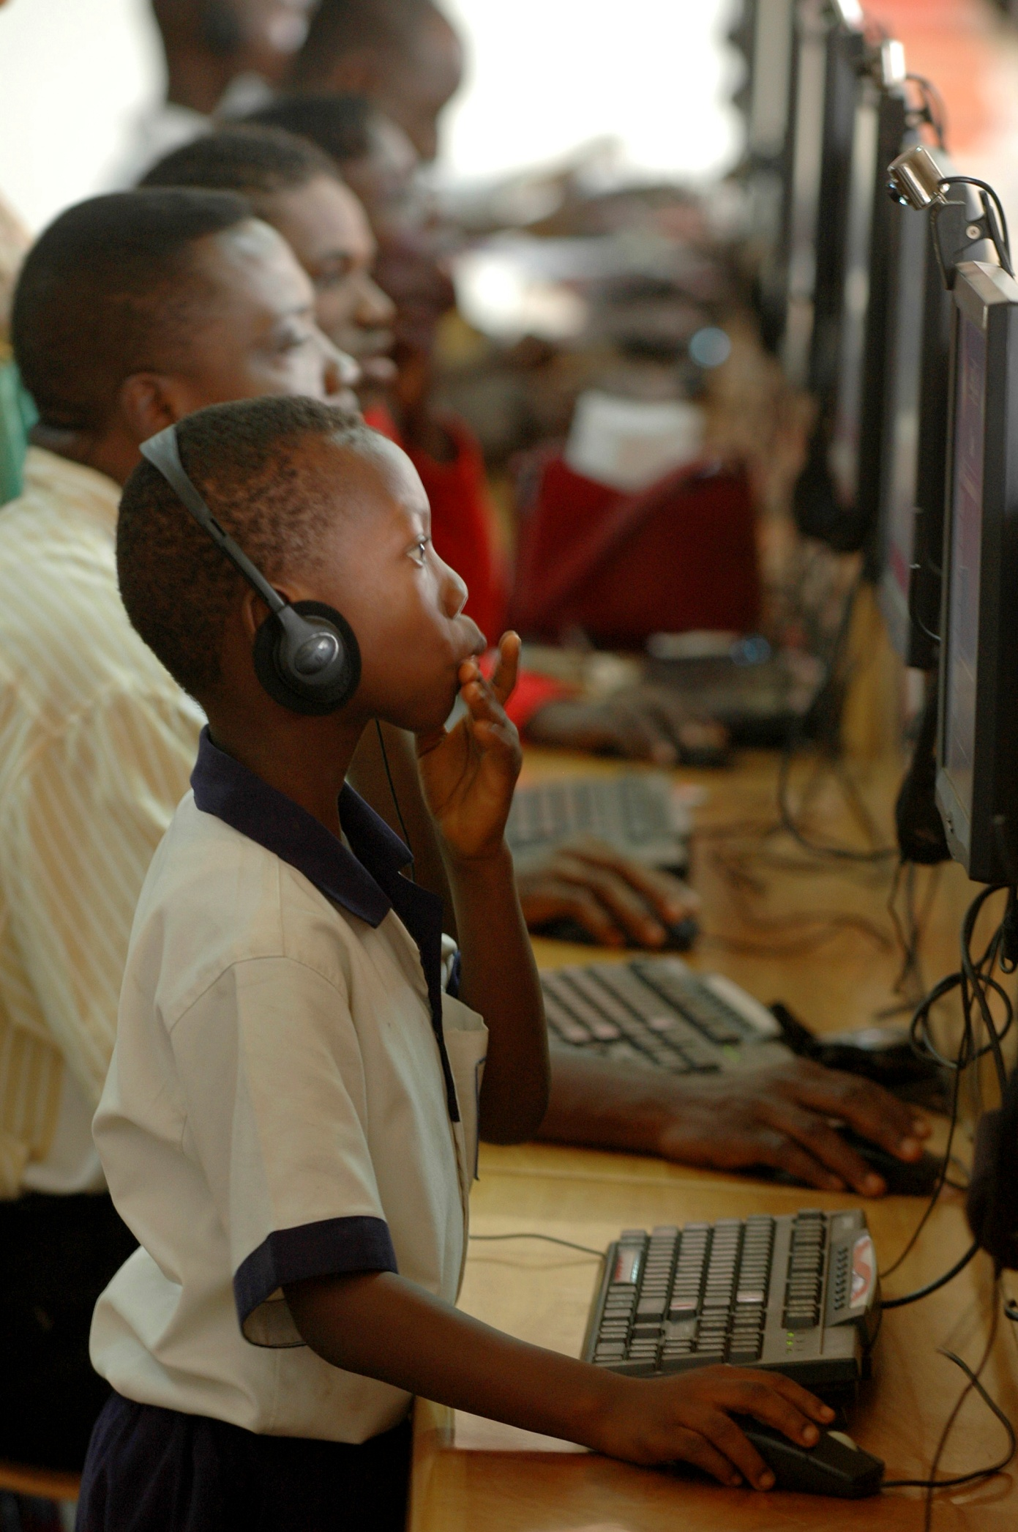
A Proposal for Ghanaian Development

Tommy Dewick
Ashley Ozery
Kara Werner
Table of Contents
Introduction 2
Definition of Development 2
A Brief Background of Ghana 3
Economy 3
Education 4
School Enrollment Rates 5
Completion of Education 8
Literacy Rates 10
Gender Equality 11
Quality of Teachers 12
Resource Devotion to Education 14
Infrastructure 16
Internet Usage 16
Roads 18
Electricity 19
Our Proposal 20
Bringing Technology to Rural Ghana 21
Information and Communication Technologies 21
Our Partners 23
Inveneo 23
OOG voor Ghana 24
oneVillage Foundation 26
I.D.E.A. Interactive Distance Education Applications 26
Step 1: Preparation 27
Choosing a location: 27
Choosing a school: 28
Step Two: Prepare the Computers 29
Step Three: Education and Training 31
Step Four: Implementation into the Curriculum 33
Budget 34
Conclusion 36
Bibliography 37

Introduction
When one reads about the condition of West Africa, news is very rarely good. Côte d’Ivoire is perennially in chaos, Liberia is considered by many to be the most impoverished country in the world, and the injustices of the diamond mines in Sierra Leone is infamous. It is astounding that, amongst this misery, there is one country that has the potential to break out of this cycle of despair and join the ranks of developing countries. That country is Ghana.

Definition of Development
To further discuss the current state of Ghana and its potential for the future, it is useful to consider our definition of development. U Thant, the third Secretary General of the United Nations, summarized development as economic growth plus social change. We have chosen to adopt this definition of development. Development is an interrelationship between economic and noneconomic elements of society. Economic growth is defined as the increase in GDP or other measures of aggregate income. Economic growth can be driven by improvements in domestic savings, trade balance, and international investment position, to name a few. Social change, the second component of our definition, refers to the alteration of the social order of a society. This can be completed by changing human development indicators. Many theorists will look exclusively at economic growth or human development (e.g. Amartya Sen) as individual factors in assessing development. We found that both factors were important in the definition as they are not exclusive. Our proposal first addresses social change, in bringing new technology to rural Ghana, and addresses economic growth second, in supporting industry and creating new employment opportunities by increasing education. While the story of much of West Africa may be one of misery, the story of Ghana is one of potential.

A Brief Background of Ghana

Economy
Before examining Ghana’s development potential, it useful to consider its general wealth as a frame of reference. The most commonly used measure of wealth is Gross Domestic Product (GDP), defined as the sum of value added by all resident producers in a country plus any product taxes (less subsidies) not included in the valuation of output. More simply, it is the final value of all goods and services produced within a country. Figure 1 graphs Ghana’s GDP from 1999-2009 against six of its neighboring countries. Ghana has grown at a faster rate than any other country except Nigeria. Its exceptional rate of growth is one reason why it is comparatively more developed than many other countries in West Africa.

Figure 1

Education
- Dudley Seers once said, “higher educational levels are ends in themselves, but education is also a means.” Education is critical for poverty reduction and development. Ghana has made substantial progress in recent years with its education program, but there is still significant room for improvement and this is an area Ghana should prioritize. Ghana has been successful in meeting high-developed country standards for gender parity in primary enrollment, but has gender issues as education moves past secondary education and has low enrollment rates in all areas. Ghana’s education system is poor because government financing in education is too low. Government financing fell from 6.4% of GDP in 1976 to 1.4% in 1983. Even though the government started to put initiatives into place to improve the system a few years later, Ghana had already fallen behind most of the world in education statistics.
- Ghana has many potential sources for development in education. Its Ministry of Education has put numerous initiatives in place in recent years to improve both access and quality of education. One of its main priorities at this time is to complete the UN’s Millennium Development Goal of universal primary education by 2015. One of the greatest problems associated with large increases in enrollment rates is that quality of teachers and content tend to decrease at the same time.

School Enrollment Rates
- Ghana has steadily increased the percentage of its population that has completed primary education, but many improvements can still be made. The net enrollment ratio of students in primary education improved from 63 percent in 2000 to 77 percent in 2008. Figure 2 shows that Ghana is comparable to the average net enrollment for developing Sub-Saharan African countries. This growth in education statistics provides hope that Ghana is taking initiative to improve; however, Ghana still falls short of providing almost a fourth of its population with a basic education.
- Figure 2

As increasing numbers of students are introduced to primary school, the student:teacher ratio is declining. Due to this lack of increasing numbers of trained teachers, the quality of education is rapidly declining. The average class size in Ghana is currently approximately 40 students, reaching as high as 55 students in some of the poorer regions. It is not uncommon to see classes with over 50 students, and while classes with over 70 students are rare, they do exist. Other issues in the Ghanaian education sphere complicate this further: outdated syllabi and/or textbooks, teachers’ failure to complete the syllabi, lack of teacher training, difficulty of subject matter or instruction, teacher absenteeism, students of different learning levels, and lack of materials/resources.

- Ghana has also steadily improved its secondary net enrollment rate over the past decade, from 33.8% in 2000 to 47.4% in 2007. Again, its rates are higher than its neighbors’ standards, but still much lower than the world average. While it is important to note that Ghana has made improvements, total secondary school enrollment remains moderately low at 47.4% as compared to total primary school enrollment at 77%. This is similar for all countries shown below (Figure 3), showing that this is not only a problem in Ghana, but worldwide. Primary and secondary education is tuition-free and mandatory in Ghana. The Ghanaian government passed the Free and Compulsory Universal Basic Education (FCUBE) Initiative in 1996. The percentages are still very far below 100% enrollment because of a lack of teachers and other resources. One reason for this is because the education system is highly centralized and the government cannot feed enough money into the system in order to afford everything necessary.

- Figure 3

Completion of Education
- Ghana’s educational system’s effectiveness can be displayed through statistical data. The primary completion rate is the percentage of students that complete their last year of primary school. Primary completion rates have also increased from 69.5% in 2000 to 75.9% in 2007 (Figure 4). Ghana has been steadily improving its education standards, but must enact many more changes.

- Figure 4

In terms of secondary completion, another problem unrelated to leaving school because a student does not want to attend anymore takes place. At the end of Junior Secondary School, students take the Basic Education Certificate Examination (BECE) in order to place them into a Senior Secondary School. Over 280,000 Ghanaian students take the test and there are only 70,000 spots. The test covers the following compulsory subjects: English, Social Studies, Religious and Moral Education, Mathematics, General Science, Agriculture, and Pre-Technical Skills. This can prevent students in the secondary level from completing the second part of secondary education.

Literacy Rates
- Over the past decade, Ghanaian literacy rates have increased across both age and gender dimensions. Ghana’s literacy rate (as measured by all adults fifteen and up) improved from 58% in 2000 to 66% in 2008. This is around a 1% increase per year. Figure 5 shows how Ghana compares to its surrounding states. Ghana’s rates are very average in comparison to the rest of Sub-Saharan Africa. This reaffirms that Ghana still needs to work on improving its performance in literacy rates. The official language of instruction throughout Ghana is English. Students sometimes study in one of the local languages for the first three years, but English becomes the medium of instruction thereafter. All textbooks and materials are generally in English. Since literacy rates and access to education coincide with one another, it is important for the Ministry of Education to continue to work to improve primary completion rates so students have a chance to start learning English in the classroom.

- Figure 5

Gender Equality
- In regards to gender equality in education, the World Bank measures it using a ratio of female to male enrollment. In 2008, the ratio was 99% for primary enrollment, 89% for secondary enrollment, and 54% for tertiary enrollment. It is important to note that many more men are attending college than women. As of 2007, only 6% of the Ghanaian college-aged population was enrolled in tertiary education, another problematic issue of Ghana’s development of education. Figure 6 compares Ghana to other Sub-Saharan African countries in terms of gender parity in primary education. According to the blue highlighted section of GER Gender Parity Index, Ghana has achieved gender parity in 2008, but is not near to the dotted UPS line, referring to 95% net enrollment. Ghana is ahead of most of Sub-Saharan Africa in terms of gender parity, but has improvements to make in net enrollment.

- Figure 6
- 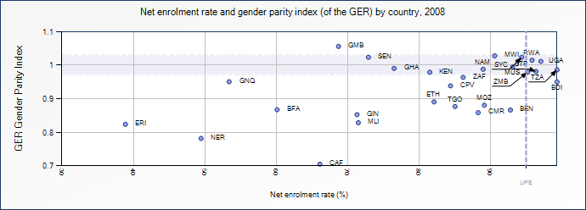

- The one statistic that is most troubling from the World Bank is that the percentage of trained teachers in primary education that have received the minimum amount of teacher training required for the country has decreased in recent years. It was 69% in 2000 and in 2008, fell to 49%. This is something that Ghana could improve upon to better their education process.

Quality of Teachers
- Ghana must improve the quality of its teachers, and this is a tremendous source for potential development. The issue of providing a quality education to students is directly related to the quality of teachers in the educational system. Teachers who do not undergo training are substantially less likely to provide a quality education for their students. The Ministry of Education has made it their goal to have teachers at the primary school level at least have a Diploma. This consists of attending a three-year Teacher Training College. The percentage of trained teachers has increased in the kindergarten level in recent years, but decreased in both primary and secondary education (Figure 7). This trend can be partially explained by the increases in the national enrollment rates.

- Figure 7

- A National Commission on Teacher Education set up by the Ministry of Education has the following concerns, “Teacher Training Colleges are inefficient in producing effective teachers since the trainees and tutors have so little exposure to actual schools and classrooms, and academic content is taught and tested above practical teaching methods.” Supervision of teachers and their curriculum is also very weak and ineffective within Ghana. Most teachers are not monitored and end up teaching what they choose, regardless of the syllabi. There are also issues with teachers being late or not even showing up at all, resulting in low teacher-pupil interaction hours. Standards need to be created in order to keep teachers to a high level of excellence and promote a quality education.

Resource Devotion to Education
- Resource devotion to education is a key source of development for Ghana. Public expenditure on education needs to reflect what the current needs of the country are in order to create substantial improvement. Public expenditure on education was 5.4% of GDP in 2005. More money was spent on the area of secondary education than primary education, even though secondary education has considerably lower enrollment rates. Also, 18% of expenditures were spent on tertiary education when only 6% of Ghana’s population makes it this far in schooling. When comparing to other countries in the Sub-Saharan African region, Ghana devotes a higher percentage of its GDP to education than its neighbors, but not substantially more (Figures 8, 9).

- Figure 8
- Resource Devotion to Education | - 2005
- Public Expenditure on Education as % of GDP | - 5.4
- Distribution of Public Expenditure per Level (%)
- Pre-Primary | - 4.8
- Primary | - 34.4
- Secondary | - 37.4
- Tertiary | - 18

- Figure 9
- Country | - Public Expenditure on Education as % of GDP in 2005
- Ghana | - 5.4
- Benin | - 4.1
- Burkina Faso | - 4.5
- Côte d’Ivoire | - 4.3
- Togo | - 3.4
- South Africa | - 5.4

- Since 2001, Ghana has created a special fund for education called the Ghana Education Trust Fund. This takes 2.5% of the Value Added Tax and funds approximately 10% of all education spending in the country. At this time, almost 90% of the money goes to higher education, another issue with too much money being funneled into higher-level education. Another problem regarding the education budget concerns the Public Sector Wage Bill. This bill includes all salaries and benefits paid to government officials, nurses, and teachers, and is becoming a growing portion of Ghana’s GDP. The government claims that this is because they are trying to attract the top talent for teachers, but the amount of trained teachers has been decreasing over this time. Ghana needs to work towards being able to train their teachers, while finding an appropriate pay that does not take up a growing portion of GDP. Policies to work towards providing a quality education and developing a budget focused more on primary education are two means of development that Ghana should work towards in the future.

Infrastructure
Infrastructure has an enormous effect on the state, as it can then affect business, both in the manufacturing and agricultural sectors. As infrastructure (and as a result, the state) develops, access to healthcare and education improves, sanitation becomes more accessible and advanced, public transportation options arise, and the state becomes more connected, both domestically and internationally.

Internet Usage
Internet availability and usage is an important part of infrastructure. It can assist business, educate users, and is a vital way of connecting with the global system. In developed countries such as the US, almost all citizens use the Internet. Ghana falls short in this department.
- Figure 10 describes Internet users as people with access to the worldwide network, measured per 100 people. The world average is 23.9, yet Ghana is only 4.3, falling even behind the rest of Sub-Saharan Africa. The majority of users are in the capital, Accra, with Internet use in rural areas almost totally absent. In the workforce, over 53.1% of companies do not provide Internet access to their employees. Companies frequently only have one email address and point of access. Employees stand in line and wait their turn to use the Internet, causing a lag in productivity in the workforce. Businesses are less efficient as a result. Due to the prohibitive costs of Internet subscription and computers, cyber cafes are the most popular choice. Again, this favors urban areas and is unhelpful for the majority of Ghana.

Figure 10

Ghana is behind the world technologically, but it is catching up. As it develops its infrastructure, industry will boom, agricultural activities will become more profitable, and Ghana will have a greater presence in the international system.

Roads
- In addition to virtual connections, infrastructure also refers to tangible ones. 14.9% of Ghana’s roads are considered paved, well below the world average and the most developed states’. As of 2000, the world considered 39% of its roads paved. Ghana is only slightly ahead of the Sub-Saharan African region. This lack of quality roads has serious implications for manufacturing sectors and exports. One only has to look at a road map to see where the major routes are. The red lines on the map below (Figure 11) indicate roads; the light grey lines indicate railways. Most are near urban hubs and ports. These transportation challenges make it very difficult for investors to see rural Ghana, and therefore may discourage investment in these sectors.

Figure 11
- 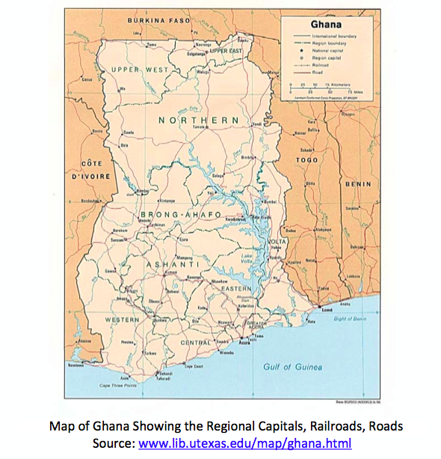

Electricity
- Electricity consumption is exceptionally low in Ghana, in stride with the rest of Sub-Saharan Africa. It is approximately ¼ lower than the world average. Figure 12 measures consumption in kWh per capita as “the production of power plants and combined heat and power plants less transmission, distribution, and transformation losses and own use by heat and power plants.”

- Figure 12

Our Proposal
After identifying education and technology as the two sectors with the greatest potential for development, we decided to direct this focus where it would make the biggest impact. Resources are more commonly distributed in urban, populated areas, yet these are not always the areas with the greatest need. One such deprived area is the Ajumako district in the Central Region of Ghana. In Ajumako, the economically active people desert the village in favor of cities and towns, and the permanent residents are traditional peasant farmers engaged in subsistence farming. Gender discrimination is practiced and encouraged, and occupational segregation is enforced through formal education and in employment.
- While there are many problems in this area, and assuredly in the country as a whole, they extend beyond the scope of our capabilities. We have determined our impact can best be felt as a grassroots project, designed with the interests of rural Ghanaians in mind. Too frequently projects are not catered to the people’s specific needs and failure is imminent. Our intention is to improve the lives of people, and to start we must design the proposal with respect to their culture and lifestyle.

Bringing Technology to Rural Ghana

Information and Communication Technologies
The majority of Ghanaians live in rural and remote communities that lack basic access to information and communication technologies (ICT), such as computing and Internet access. Access to these technologies can improve their lives in simple yet profound ways. ICTs can provide better economic opportunities by creating market access to those who formerly had none. There are many professions that require computer skills, and this requirement is becoming more and more common. If a Ghanaian student wishes to earn a high salary, computer skills are vital. Some of these careers include Information Technology (a rapidly growing field), government positions, tourism, graphic design, banking, and engineering. These are all professions that could greatly benefit Ghana as a whole. By bringing ICTs to Ghana, we intend to offer a better future for its children through higher quality education. This is the area we intend to prioritize.
The biggest issues we identified in the education sector are lack of technology and supplementary resources, lack of training, and outdated materials. In bringing ICTs to rural Ghana, we will tackle all of these issues. There is a stark lack of technology in rural classrooms. There are many reasons for this, mainly expense. Initial cost is a nonissue for Ghanaian schools if an organization provides the resources. Once a school takes the first step, such as owning several computers, there is great potential for the future. Complementary technology such as printers, projectors, and learning programs can all enhance the educational process. Access to the Internet multiplies this potential indefinitely. Students learn and reinforce vital skills, such as literacy, language competency, and typing ability through use of computers. These are necessary to succeed in many occupations.
- The second large obstacle to bringing technology to schools in rural Ghana is lack of information and training. We will use our development background to select products which will enhance the educational experience with as few impediments as possible. By designing this project with rural Ghana in mind, we will make this process considerably easier for our target school. Once the technology has been selected, we will partner with different organizations to bring training and lesson plans to the school.

Our Partners
In order for any development project to be successful, cooperation among various organizations is vital. For this project, we will collaborate with three partners.

Inveneo
Inveneo is a San Francisco-based nonprofit social enterprise that provides communication technology tools, training, and ongoing support to information communication technology partners in developing countries. Inveneo has experience in Ghana and understands the unique challenges of introducing technology to a developing country. One of the biggest challenges in determining the type of ICT installation to undertake is calculating the ongoing costs of running the systems. This is particularly important when grid power is either unreliable or non-existent, as is the case for much of rural Ghana. In these situations, the cheapest initial systems may not be the least expensive solution over time. While the initial cost of the computers is something to take into consideration, the ongoing cost of the power and peripheral equipment required to power the computers is a bigger issue. Over five years, this cost is often 10-12 times the cost of the equipment itself. For this reason, we chose against using donated computers and technology. While the initial cost may be low or even free, the long-term costs are much higher. Donated computers often run unprotected software, as well. The combination of unreliable and expensive power, rampant viruses, and inexperienced users often makes these labs inoperable. We intend our impact to be sustainable, and so using outdated technology, even if free of charge, is not something we will consider.
Inveneo technology is designed for the developing world, and so it tackles many issues other technology cannot. The biggest benefit is the very low power consumption. The units’ peak at 18 watts of power, meaning they can be powered by solar or other alternative power sources. In a world where fuel and power is extremely expensive, this is a crucial fact. Climate was also taken into account during design, and Inveneo computers are more durable in hot, humid, and/or dusty environments. This decreases maintenance time and costs while increasing the lifetime of the technology, contributing to a sustainable future. Despite all of these unique considerations, Inveneo technology has easily replaceable components in case of breakage or loss. This is extremely important, as often when equipment must be replaced, the component is unavailable or too costly (foreign brands).

OOG voor Ghana
OOG voor Ghana is a Dutch NGO with a mission in educational support. OOG voor Ghana offers ICT education, advice on distance education implementation, and provides supplementary educational resources. OOG voor Ghana produces several educational resources, mainly on their website or in CD-ROM format. Some of the subjects covered by the expansive content include computer science, teacher training, mathematics, education, science, toys and games, children’s books, and anti-violence materials. Where there is no Internet connection available, OOG voor Ghana provides CDs with Internet content to schools. This can include e-books, lesson plans, encyclopedias/dictionaries, short stories, computer software, typing programs, computer games and more. These CDs are designed for students aged 8-15 years. At first glance, the inclusion of computer games seems out of place, but it is an often-overlooked necessity. Computer games mask the learning process by making it fun for students. Students will become adept at typing and using the mouse while completing puzzles and challenges. This is a form of positive reinforcement to keep students interested in new technology. These CDs are offered for $5, but in cases where the money is unavailable, OOG voor Ghana offers the CD for free.
- Another excellent resource from OOG voor Ghana is their ICT lesson plans and distance education lessons. They offer two years of ICT lesson plans, catering to various skill levels and exposure. These have already been used successfully in multiple schools, including the Bisco School located in Tamle. The distance education lessons are useful in introducing IT to students who have had no former access to computers in the past. They are useful for anyone new to computing. In this way, OOG voor Ghana provides educational resources for both teachers and students, who require a different approach.

oneVillage Foundation
Our third partner is the oneVillage Foundation (OVF), a Ghanaian organization. OneVillage is devoted to increasing collaboration and access to ICT in communities lacking resources, facilitating local content creation, and building bridges among digital and physical communities globally. Originally born with the mission of using ICT to improve the way we address the AIDS pandemic in Africa, OVF realized its true mission was bringing people together to counter the “digital divide.” OVF supports the idea that ICTs can create strong positive change, and that sustainability is one of the most important factors for success. We decided it was important to work with a Ghanaian NGO for multiple reasons. First, they are local, and being so, understand the local traditions and culture in ways no foreigner could. This is necessary to obtain the trust of those whom we are trying to aid. Second, after we exit Ghana, OVF will remain nearby. This will greatly assist sustainability. OVF coordinates workshops periodically to promote ICT and Sustainability Initiatives and continues its involvement long after the initial project.

I.D.E.A. Interactive Distance Education Applications
We believe that the best way to overcome the challenges faced by Ghana is through bringing distance-learning technology to a school in Ghana in order to supplement the education of its students. The main benefit to this is that it helps compensate for the usually subpar quality of education that is provided in Ghanaian schools. Since many Ghanaian teachers are poorly trained, if they are trained at all, having virtual lessons put together by competition educators will provide some means of a failsafe to ensure that students will be able to keep up with the curriculum. In addition, given the widespread problem of teacher absences, computers would ensure that students would never have to miss a lesson. The final benefit is the experience students would gain from using technology, which would help prepare better for jobs later in life in an increasing technology-centric world.

Step 1: Preparation

Choosing a location:
For logistical reasons we chose the Ghanaian village of Afranse as the site to implement our technology. This is because another NGO with whom we have several contacts , SEAD Ghana, has significant experience in the area. SEAD is focusing on expanding agricultural productivity though conservative agriculture education, which will coincide nicely with our efforts to utilize distance education technologies in the classroom. Working with this NGO will provide us with two benefits. The first is that it would allow us to share contacts and other resources. SEAD has relationships with many influential community leaders, which means what we will have an easier time generating support for our project in Afranse than in another village. SEAD has a great deal of community trust and working with them would lend our project some local legitimacy. We would also have logistical information, such as transportation details available to us, which would help with the long term implementing of our project.
In addition, using Afranse as a site allows us to tap into firsthand research from SEAD’s reconnaissance trips to the village. Data on Ghanaian villages is extremely hard to find so the benefit of on the ground information is immense. By partnering with SEAD, we were able to learn a great deal about the quality of education and state of technological utilization. Furthermore, these accounts suggest the perfect school for our project.

Choosing a school:
We decided to use the Kofi Annan Trade School as the site for our project. This school was only established in 2005 and is thus a prime candidate for experimental learning techniques. With 165 students total and up to 75 students in a class, the school could definitely benefit from more personal technologies to compensate for less teacher-student interactions. SEAD Ghana has also informed us that textbooks are very outdated. Considering the cost of replacing books, computer technology would allow students to update their knowledge at a lesser cost. Another benefit of the school is that it is geared towards leadership and higher-skilled professions. Students in this kind of school would certainly be able to benefit from increased computer experience.
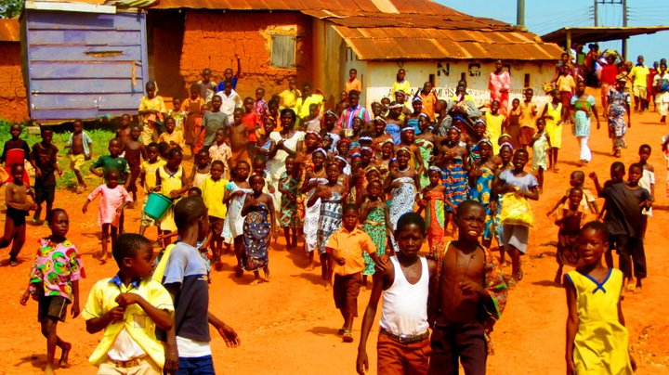

Another benefit that comes with using the Kofi Annan Trade School is the fact that it has an electrical grid on site, which would make powering the computers feasible. Many other rural communities in Ghana do not have this luxury and attempting to bring ICT technologies there would entail many more difficulties than we are able to solve at this moment. In fact, access to electrical grids was listed as one of the primary reasons why more ICT technologies presently do not exist in Ghana.

Step Two: Prepare the Computers
The first step of all is to bring the computers to the school of choice and figure out the appropriate location for them. There are 165 students currently at the Kofi Annan Trade School, so we figured it would be good to start with 3 computers, having approximately 50 students to each one. The location of these computers is dependent upon a visit to the school. We need to see the structure of how the school is set up in order to decide which location is best. One option we would consider is to place the computers in different classrooms, so that they are able to supplement the learning there. The best option would probably be to put all three computers in a similar location because this would probably be easiest for the set-up of the technology. We would look for either an empty room, or adding the computers into a room that is quiet and does not have many people present at various times of the day. The rooms that the computers are in need to be very secure to prevent any burglaries or damages to the computers. There should be metal, locking doors and bars on all windows.
We will be using the Inveneo High-Efficiency Computing Station for our computers. The reason we chose this is because it is a computer system designed for usage in rural and off-grid locations where electrical supplies are limited or unreliable. Electricity is a big problem in Ghana and this will ensure that we can get the computers to go to the most needed areas of Ghana, the rural communities. The technology behind these computers is described in detail in the section on Inveneo. The one benefit of the technology not discussed is that it is has multi-user viewing. Since we are only providing a computer for every 50 students, this makes it possible for multiple students to learn on the same computer at the same time. We decided to use this technology over second-hand computers because “free” computers draw lots of power and end up being a more expensive option in the end.
We also need to buy tables and chairs to place in the room with the computers. We plan to purchase locally available parts, as they are usually cheaper and require little transportation fees. This is included in our attached budget. Another necessary component is virus protection software. These softwares often cost very little money and can prevent viruses from being written to any system files. Another protection method that needs to be implemented is surge protection and voltage stabilization. Again, this equipment is relatively inexpensive and is available in most places. It is crucial to prevent damage to the computers.
By using Inveneo as a partner in the process, they should be able to help us through all the issues during installation. They know the exact technology that is necessary to have a fully working system. Based on previous case examples, Inveneo provides a critical support system based on the technical specifications and insight given. They follow through on deadlines and provided significant moral support.

Step Three: Education and Training
Once a site has been selected, the next step is to educate all those that are involved on how to use the computers. This includes teachers, students, and any volunteers in the community. Many of these students have probably never used a computer before and they need to have general computer training in order for this addition to be helpful. This is extremely important in order to promote short-term success and long-term sustainability.
First, it is necessary for us as a partner of Inveneo, to be trained in the technology so we can train the community. We plan to use the Inveneo Certified ICT Partner program, which has already been used by Inveneo in many of its past projects. It is sponsored by USAID, Washington State University, and Cisco. The training starts out with a one-week training that covers applied theory, problem solving, and other technology solutions. Next, this is followed by another week of a more applied training where the partner participates in the actual solution deployment. We will be trained in IT networking, long distance wireless networking, Linux/Open Source desktop and network management, VoIP system design, and IT power solutions. This way, we not only have Inveneo to help us through our first deployment, but after this training, we will be certified to implement this technology at other schools in the future. It is important to include in the training process information about proper equipment care. Users should be taught the basics about how to keep the equipment in good working condition. We also want to establish modes of communication (phone, email, standard mail) between the school and ourselves so that if any problems, questions, or concerns arise in the future, the school will be able to contact at us at any time. This will not only support the success of the program, but will also promote a long-term relationship between the community and ourselves.
Once the students and teachers have been educated in the use of the computers, it is necessary to show them how this new technology will be used to improve the quality of their education. We plan to implement an already created program by OOG, a Dutch company that produces free educational content for students in both primary and secondary schools. It is important for the educators at the school to go through all the educational resources on their own in order to make sure that they understand all the information that is being presented to the students. This way, they will be able to answer any questions that the students may have throughout the learning process. The company also has a computer literacy educational program that could be used to supplement the training that is provided by Inveneo. The curriculum on the computer is very user friendly and should not need training before the students can start using the software.
After training the students and teachers, it would be helpful to involve the rest of the community in the new addition of computers into the school. With the lack of technology in Ghana, it would be helpful to allow the entire community to get a chance to understand how this technology is applicable to their children’s education. There could be some hesitation in the community regarding the use of technology as a teaching method over having an actual teacher present. We think it is important to convey that the adoption of these additional teaching methods could have the potential to greatly improve the quality of education provided and could help their children succeed better in their academics. We could hold a seminar for interested parents and community members to portray this information. If the school wants, Kofi Annan could offer night classes for people in the community to use the computers to learn the technology or even use the same software as the students if some adults are illiterate. This would not be provided by I.D.E.A., but would be an added benefit to the community of these technologies, especially at a time in which students are not using them.

Step Four: Implementation into the Curriculum
The last step of the process is to make sure the OOG software is correctly implemented into the curriculum at the school. Working with teachers at the school, it is necessary to get access to their current curriculum and look through the OOG software options. The teachers, with our help, should coordinate their lesson plans with the software to make sure that they coincide with one another. It is optimal to get each student on the computer at least once a week in order to promote a constant usage of the given technology. There are 165 students in this school, 3 computers, and they attend school for 5 hours per day, 5 days a week. This means that there are 75 hours per week for computer usage. If two students are on the computer for 60 of the hours and three students are on the computer for 15 of the hours, then this would work out that each student could get access on the computer at least once a week. Because of the technology mentioned before, it is possible for multiple students to use the computers at a time since each can see the screen easily.
Not all lesson plans on OOG need to be used; the subjects that are tested on by the Basic Education Certificate Examination should be given the highest priority as this is what Ghanaian children are tested on by the government and decides whether they can move on to the next level of their education. In Ghana’s average classroom, mathematics and English are given over 40% of the instructional time. Yet, in the BECE, these subjects are only 28% of the material. This software will be able to give the students more access to learning the other subjects on the examinations.
In order to promote long-term sustainability, it is necessary to review the curriculum each year and make sure that OOG is still applicable to the school’s teachings. If not, there are many other academic computer softwares that could be used to teach students; our organization can recommend these to the schools at that time. One of the benefits of using OOG is that they will take any e-books that are available on the Internet and put them on CDs for schools that do not have Internet access (like Kofi Annan).

Budget
Throughout the formation of our project, we kept in mind the availability of monetary resources, trying to cut down on costs as much as possible at all times. By doing so, we put together a plan that is economically feasible and should be appealing to our prospective investors. Our project initial cost over five years is $5100. We have not been able to get in contact with Inveneo, so the budget that we are using is created by websites that we have found with information about their services. The problem with this data is that these labs have twenty plus computers in them and we needed to reduce these numbers to our smaller, initial proposal. Also, we decided to only provide transportation to Ghana for one. Since Ashley and Kara are graduating, we figured it would be most likely that Tommy would be the only one able to attend.
GOODS | COSTS
3 Computers | $1800
Furniture (3 Tables, 7 Chairs) | $300
Technical Support | $750
Power Equipment | $850
Transportation to Ghana for One | $1400
Initial Estimate | $5100

The picture below shows what we are able to save by using the Inveneo system instead of donated or new computers. We chose to use the generator as the type of technology we use to bring in the computers. The reason for this choice is that solar energy was too expensive and the AC grid only allows the computers to be turned on every other day. We thought that the generator option was a good compromise between the two. The picture below shows how over five years of time, the benefits outweigh the initial costs of a more expensive technology.
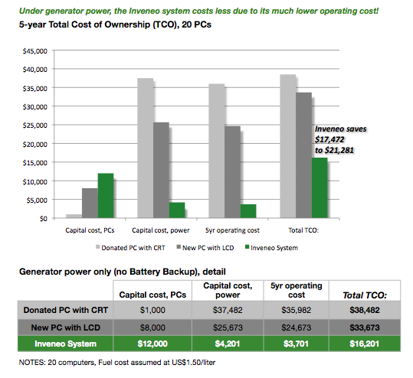

Conclusion
Introducing Information and Communications Technology to rural Ghana will have an enormous impact. ICTs create new opportunities and supplement existing education. Access to resources in the future, especially the Internet, could radically improve lives. For development in Ghana to truly succeed, projects must be created with Ghanaian people in mind. Introducing ICTs to a secondary school in rural Ghana will have beneficial short and long-term effects.
In the short term, a population of students and teachers will be introduced to new technology. Their typing and technological skills will improve, making them more marketable in other professions. Access to educational supplements will enhance their experience and cause them to excel beyond previous levels. Potential access to the Internet will provide students a wealth of information not available anywhere else. Long-term effects include increased opportunity for employment, especially skilled labor. We hope that students continue their interest in ICTs long after graduation and take these skills with them wherever they go in life. By partnering with other organizations, we will ensure a smooth installation and training process for the school.

Information and Communications Technology is the key to improved education and employment opportunities for Ghanaian students. Even just one computer can help students cross the digital divide and build the skills for the life they deserve. The potential is there, the time to act is now.

Bibliography
"Accomplishments." oneVillage Foundation. oneVillage Foundation, n.d. Web. 4 May
2011. <http://www.onevillagefoundation.org/accomplishments>.

- Ahiabenu, Kwami. “Ghana: Rapid growth in Internet use despite cost constraints.” Africa News Agency (Sept. 2001): n. pag. Afrol. Web. 22 Feb. 2011.
- <http://www.afrol.com/‌News2001/‌gha003_internet_growth.htm>.

- Akyaempong, Kwame. "Teacher Training in Ghana- Does It Count?" Centre for
International Education, Mar. 2003. Web. 19 Mar. 2011. <http://ageconsearch.umn.edu/bitstream/12867/1/er03049b.pdf>.

"Annan Centre to train economically challenged kids." Ghana News Agency (July 2002):
n. pag. Modern Ghana. Web. 4 May 2011.
<http://www.modernghana.com/news/23867/1/annan-centre-totraineconomicallychallenged-kids.html>.

"Connecting Those Who Need It Most." Inveneo. Inveneo, 2009. Web. 4 May 2011.
<http://www.inveneo.org/?q=mission>.

"The Educational System of Ghana." Embassy of the United States. USA, n.d. Web. 4
May 2011. <http://ghana.usembassy.gov/education-of-ghana.html>.

- Goulet, Denis. ""Development"...or Liberation?" International Development Review 13.3
- (1971): 544. Print.

"ICT in education - Lesson-plans and Distance education lessons." OOG voor Ghana.
OOG voor Ghana, 16 Nov. 2006. Web. 4 May 2011.
<http://www.oogvoorghana.org/ukindex.htm>.

Mereku, K. D., et al. Opportunity to Learn: English and Mathematics in Ghanaian
Primary Schools. Equip 123. BECAS, 27 June 2005. Web. 4 May 2011.
<http://www.equip123.net/docs/e2-OTL.pdf>.

- Ministry of Education, Science and Sports [MoESS] (2008). Education Sector Report.
Accra: MoESS.

SEAD Preliminary Site Assessment Field Notes

- Seers, Dudley (1969). The Meaning of Development. International Development Review
6(4), 6 14.

- Sen, A (2000). A Decade of Human Development. Journal of Human Development 1(1),
17 23.

- "Statistics in Brief." UNESCO Institute for Statistics. UNESCO. Web. 15 Feb. 2011.
- <http://stats.uis.unesco.org/unesco/TableViewer/document.aspx?ReportId=134F_Lan>

“The Introduction of ICT into the Ghanaian Educational Curriculum; Successes, Failures, and the Way Forward.” Ginks.com. July 2009. Web 4 May 2011
<www.ginks.org/CMSPages/GetBizFormFile.aspx?filename=240f9e58>

Goulet, Denis. ""Development"...or Liberation?" International Development Review 13.3 (1971): 544. Print.
Sen, A (2000). A Decade of Human Development. Journal of Human Development 1(1), 17-23.
- Seers, Dudley (1969). The Meaning of Development. International Development Review 6(4), - 6-14.
- Information for neighboring countries could not be found as far back as the 1970s-early 1980s
- Akyaempong, Kwame. "Teacher Training in Ghana- Does It Count?" Centre for International - Education, Mar. 2003. Web. 19 Mar. 2011. <http://ageconsearch.umn.edu/bitstream/12867/1/er03049b.pdf>.
- World Development Indicators- Primary Net Enrollment Rate
Mereku, K. D., et al. Opportunity to Learn: English and Mathematics in Ghanaian Primary Schools. Equip 123. BECAS, 27 June 2005. Web. 4 May 2011. - <http://www.equip123.net/docs/e2-OTL.pdf>.
- World Development Indicators- Secondary Net Enrollment Rate
- It is calculated by taking the total number of students that are enrolled in the last grade of primary school, minus the number of people repeating the grade, divided by the total number of children that are of age to graduate.
- World Development Indicators- Primary Completion Rate
"The Educational System of Ghana." Embassy of the United States. USA, n.d. Web. 4 May 2011. <http://ghana.usembassy.gov/education-of-ghana.html>.
- World Development Indicators-Literacy Rate
- Ministry of Education, Science and Sports [MoESS] (2008). Education Sector Report. Accra: MoESS.
- UNESCO Institute for Statistics
- World Development Indicators- % of Trained Teachers in Primary Education
- Akyaempong, Kwame. "Teacher Training in Ghana- Does It Count?" Centre for International Education, Mar. 2003. Web. 19 Mar. 2011. <http://ageconsearch.umn.edu/bitstream/12867/1/er03049b.pdf>.
- Akyaempong, Kwame. "Teacher Training in Ghana- Does It Count?" Centre for International Education, Mar. 2003. Web. 19 Mar. 2011. <http://ageconsearch.umn.edu/bitstream/12867/1/er03049b.pdf>.
- Ministry of Education, Science and Sports [MoESS] (2008). Education Sector Report. Accra: MoESS.
- Ahiabenu, Kwami. “Ghana: Rapid growth in Internet use despite cost constraints.” Africa News Agency (Sept. 2001): n. pag. Afrol. Web. 22 Feb. 2011. - <http://www.afrol.com/‌News2001/‌gha003_internet_growth.htm>.
- World Development Indicators – Electric Power Consumption (kWh per capita)
"Annan Centre to train economically challenged kids." Ghana News Agency (July 2002): n. pag. Modern Ghana. Web. 4 May 2011.
"Connecting Those Who Need It Most." Inveneo. Inveneo, 2009. Web. 4 May 2011.
“The Introduction of ICT into the Ghanaian Educational Curriculum; Successes, Failures, and the Way Forward.” Ginks.com. July 2009. Web 4 May 2011
5-year Total Cost of Operation (TCO) is the cumulative cost from installation throughout the first 5 years of a facility's operation, and it includes these factors: - Original capital cost of computers - Original capital cost of power equipment, including generator, wiring, protection devices, batteries, chargers, inverters, solar panels, mounting, labor etc. - Ongoing monthly operating costs, such as maintenance, generator fuel, or (for AC grid source) power company charges per KW/Hr. http://www.inveneo.org/poweradvantage
"ICT in education - Lesson-plans and Distance education lessons." OOG voor Ghana. OOG voor Ghana, 16 Nov. 2006. Web. 4 May 2011. <http://www.oogvoorghana.org/ukindex.htm>.
"Accomplishments." oneVillage Foundation. oneVillage Foundation, n.d. Web. 4 May 2011. <http://www.onevillagefoundation.org/accomplishments>.
SEAD Preliminary Site Assessment Field Notes
“Annan Centre to Train Economically Challenged Kids” Modern Ghana. Web 5 May
“The Introduction of ICT into the Ghanaian Educational Curriculum”
Inveneo
Mereku, K. D., et al. Opportunity to Learn: English and Mathematics in Ghanaian Primary Schools. Equip 123. BECAS, 27 June 2005. Web. 4 May 2011. <http://www.equip123.net/docs/e2-OTL.pdf>.
OOG voor Ghana
http://www.inveneo.org/download/Cheapest_TCO_With_Inveneo.pdf
Referenced from Caroline Kusi- student that attends Lehigh from Ghana
This includes: generator, wiring, protection devices, batteries, chargers, inverters, solar panels, mounting, labor etc.

