CAMBODIA:
(Preăh Réachéa Anachâk Kâmpŭchea)
An Assessment of Development Potential
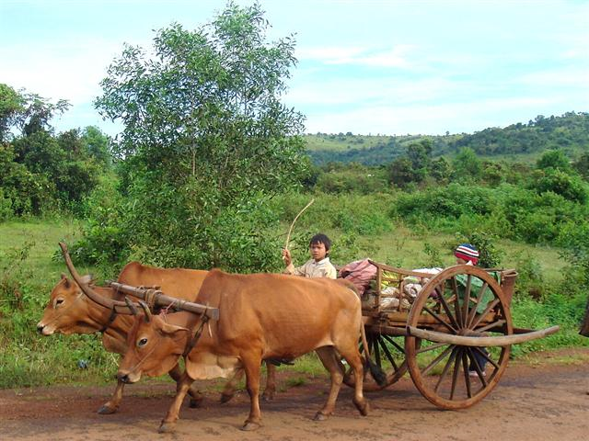
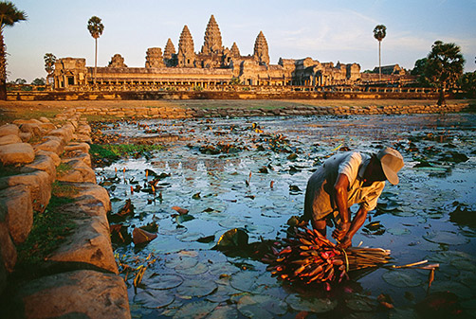
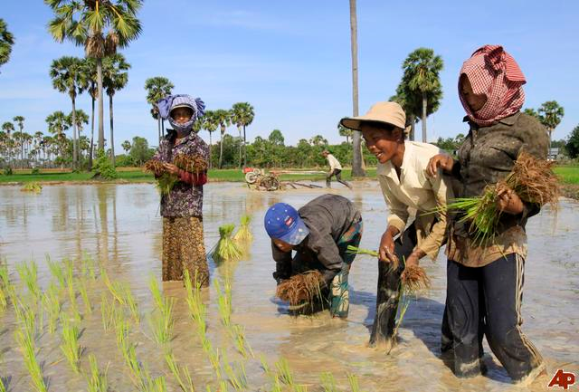
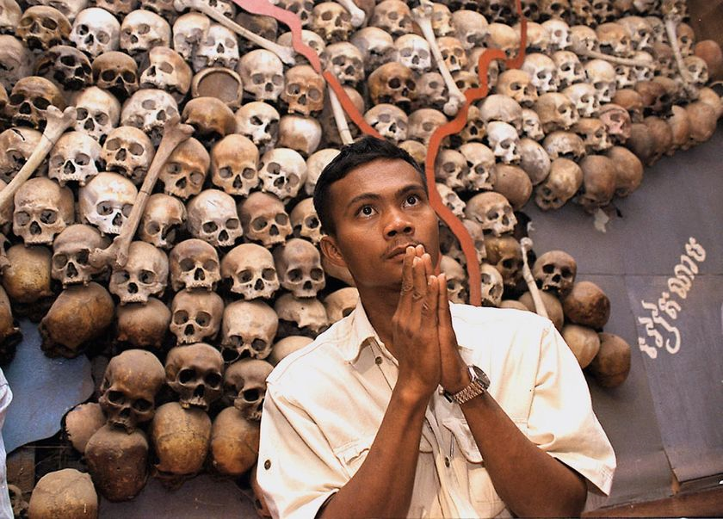
Lauren Collins Kara Gustafson
Annie Hong Busra Ozturk

IR 322
Professor Moon

Table of Contents

- Introduction 3
  - Historical Context: Khmer Rouge 3
  - Theoretical Foundations of Development 6
  - Towards Development 8
- Measuring Development 9
  - Political Development 9
  - Economic Measures 13
  - Education 20
  - Health 26
- What is Cambodia’s Development Potential? 34
  - Project Proposal 35
- Appendix 36
  - 1-Gap Analysis 36
  - 2-Gap Analysis 39
  - 3-Gap Analysis 44
- Works Cited 48

Introduction
As a resident of the United States, you can expect to live to the age of 78. Throughout your lifetime, you have access to opportunities unavailable in other parts of the world. You have the freedom to pursue an education, a family, and a career. You can vote. Whichever path you choose, you come into this world expecting to live a long, full life.
Imagine you were not born in the US, but somewhere in East Asia, where the life expectancy is 72. Subtract six years off of your life.
Suppose you were born in Southeast Asia. You have just lost another three years.
Now, imagine you were born in Cambodia. Subtract nine more years from your life. In your expected 60 years, you will live on an average of $2 per day. Most likely you will live in a rural community, with little or no opportunity to pursue work outside of subsistence farming. Chances are you will not reach secondary school. You are not entitled to subsidized food or health care, and have little say in petitioning the government to improve your situation. Overall, you will have a very low standard of living. How did you get here?
In this report, we will describe Cambodia’s current state of development and recent progress, diagnose why it still remains among the world’s poorest nations, and highlight the greatest priorities in alleviating poverty. We will then lay out a development proposal to improve maternal health in Cambodia through increasing the availability of trained midwives to rural villagers.

Historical Context: Khmer Rouge
Understanding Cambodia’s current state is only possible by considering its historical context. There are many ways to explain Cambodia’s current dismal state: low-lying corruption, poor economic planning, a lack of transparency in the government, and so forth. Although all of these explanations have truth to them, one cannot begin to analyze Cambodia’s predicament without an understanding of the devastation wrought by Pol Pot (pictured below) and the Khmer Rouge. In fact, the majority of development concerns surrounding Cambodia stem from the Khmer Rouge’s removal of the country’s foundation: the economy, education, healthcare, and social-cultural systems.
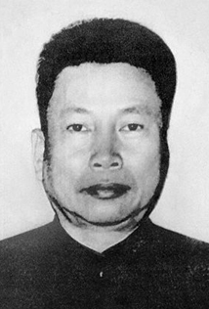
Recalling accounts of her childhood under the Khmer Rouge, Loung Ung, a former Phnom Penh resident, describes how the economic policies of the new revolution first came to her attention:
“I have to go to the toilet,” I tell Ma urgently after dinner.
“You have to go in the woods.”
“But where?”
“Anywhere you can find. Wait I’ll get you some toilet paper.” Ma goes away and comes back with a bunch of paper sheets in her hand. My eyes widen in disbelief,
“Ma! It’s money. I can’t use money!”
“Use it, it is of no use to us anymore,” she replies, pushing the crisp sheets into my hand.
(Kiernan, 2002)

Born to a successful farming family with royal connections, Saloth Sar (who would later adopt the name Pol Pot) came to age in a time where Vietnam’s influences on Cambodia were quite substantial and communist ideology was rampant. Pol Pot and his closest companions, who were educated in Paris, desired to establish a government, to be known as Democratic Kampuchea, in Cambodia that would emphasize the country’s independence and a return to “true” Khmer origins: peasantry. To transition the monarchy of Norodom Sihanouk to Democratic Kampuchea, “all cities were evacuated, hospitals cleared, schools closed, factories emptied, money abolished, monasteries shut, libraries scattered” (Kiernan). For years, freedom of movement, of the press, of worship, organization, and discussion was completely erased from Cambodians. The family structure, of vital importance to Khmer culture, was destroyed. Parents were separated from their children, who were taught to distrust and spy on their parents. Human communication and interdependence completely disappeared.
As Ben Kiernan, author of The Pol Pot Regime explains, “A whole nation was kidnapped and besieged from within.” Cambodia was sealed off with the closing of borders, foreign embassies, and press agencies. Radios, newspapers, and all other forms of communication were seized and immediately destroyed. The speaking of foreign languages was strictly forbidden. As Kiernan writes, “[People] quickly learned that any display of knowledge or skill, if “contaminated” by foreign influence (as in normal twentieth-century societies), was folly in Democratic Kampuchea” (Kiernan). Those who were educated or showed signs of being educated (i.e. wearing glasses) were often executed, for only peasants were desired by the regime. The consequences of these actions still remain in Cambodia today, where there are few teachers, health professionals, entrepreneurs, or senior monks.
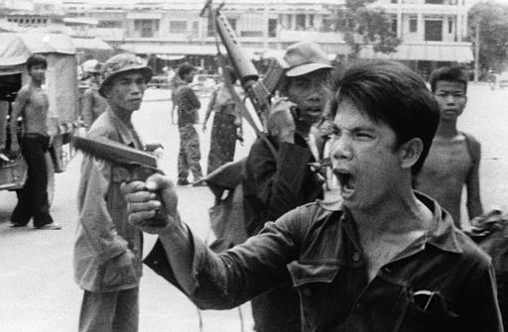
Two groups of Cambodians, old and new people were pinned against each other, making it nearly impossible for Khmers to trust one another. Old people were Khmer Rouge cadres and peasants, with new people being former urban residents. The regime’s motto for the “new” people was, “To keep you is no gain, to lose you is no loss.” Minorities, which included Cham Muslims, Chinese, and Vietnamese were either expelled from the country or executed. With the cities deserted, rural Cambodia was transformed into a prison camp state. Millions of Cambodians were forced into hard labor in rice fields, with long hours and barely anything to eat. The worker’s forced efforts successfully transformed the Cambodian countryside: replacing tiny dikes and irrigation systems, removing walls of earth to make straight canals, and establishing paddies, creating hectares of rice land.
In the end, over 1.7 million Cambodians would die in the four years Democratic Kampuchea ruled. In 1979, Vietnamese forces invaded Cambodia after a failed pre-emptive attack on their country, ordered by Pol Pot. The Khmer Rouge was ousted and replaced by the original king, Norodom Sihanouk. The Khmer Rouge remained largely intact, despite being a government in exile, and for years after their official fall the rebel group made multiple attempts to rule from the outskirts of Cambodia.
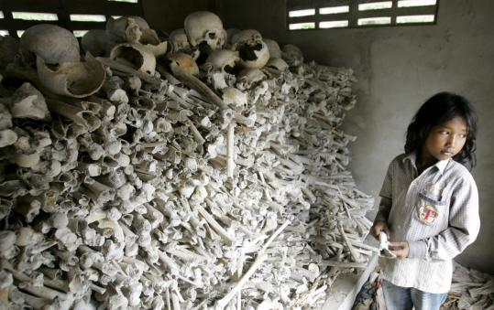
Although Pol Pot died in 1998, the tremendous effects of the Khmer Rouge are still felt throughout Cambodia today. The massive destruction, murder, and feelings of mistrust the Khmer Rouge enacted have prevented the state from developing alongside of its neighbors. Despite enduring genocide and political instability for years, today Cambodia has managed to become a peaceful and stable nation. It speaks for the strength of the Khmer people that the country has managed to develop tremendously in multiple ways. Though they may still have a long way to go, Cambodia has managed to overcome the impossible with great stride and promise.

Theoretical Foundations of Development
To assess Cambodia’s development potential, it is useful to examine Cambodia’s current state in the context of development theory. Comparing and contrasting the work of various scholars will enable us to form a unique definition of development and aid us in forming our own development proposal.
Early attempts to reduce poverty in the Third World approached development from a largely economic standpoint. Modernization theorists viewed development as a universal, linear process and tried to transfer the experience of Western development and success onto the Third World. However, the application of modernization theory did not solve the problems of poor regions as Western scholars had predicted. In contrast, the lack of a comprehensive definition of development led to mistakes, misunderstandings, and often mishap in “undeveloped” countries.
Better explanations for Cambodia’s underdevelopment can be found in radical theory and the planning school. Radical theory focuses on the need for a strong middle class to ensure that the state acts in the interest of its citizens. The radical school is useful in explaining Cambodia’s current state of underdevelopment because Cambodia has virtually no middle class. Without the pressure of a strong middle class, the government has had little incentive to protect and uphold the public’s interest. This is demonstrated by the fact that Cambodians do not have very much freedom to voice their opinions or exercise their civil and political rights.
Variants of the radical school such as modern dependency theory and world systems theory also help to explain Cambodia’s underdevelopment by highlighting the importance of a country’s linkage to the global system. Looking at Cambodia’s 2-gap (See Appendix), one can see that the country is dependent on foreign aid and loans that have contributed to Cambodia’s national debt and are likely to be unsustainable. Before Cambodia can progress, radicals would claim that it must break this relationship of dependency on the West and change the overall nature of its linkage to the global system.
Like radical theory, the planning school views the state as an important agent of development. Theorists who subscribe to the planning school emphasize the state’s ability to provide appropriate regulation of the market. Since the market alone cannot provide for sustainable development, the state is needed to provide necessary requisites for development such as access to healthcare, adequate education, collection of revenues, and national defense. This theory is useful in explaining Cambodia’s current state since the state has not played the necessary role required for progress. After evaluating the areas of health and education, it is clear that the Cambodian government has not been able to provide its population with access to proper health care or schooling. Currently, government spending on these areas is noticeably low in comparison to neighboring countries, Thailand and Vietnam. As noted in the 3-gap (See Appendix), the current administration has also failed to properly collect taxes and other revenues (which decreases available funding) because it lacks enforcement. In order for substantial progress in development, both radical theory and the planning school thus support a significant increase in the state’s role.

Towards Development
In order to assess and alleviate Cambodia's obstacles to progress we must formulate a working definition of what development means. Drawing from the work of Amartya Sen, we define development as reducing deprivation and expanding opportunity (Sen). Deprivation refers to absence of basic necessities, such as adequate food, water, health care, shelter, employment, education, and access to basic infrastructure (Moon; Seers). In addressing issues of poverty, these basic needs must first be met. Opportunity refers to the broader spectrum of human capabilities and potential. Specifically, this approach seeks to empower individuals and enable people to shape their own futures.
Our definition of development places people, as opposed to wealth, at the center of each of our objectives. Development is a complex, multi-dimensional concept that requires a multi-pronged approach. For the purpose of this paper, we will look at several key variables: income, education, health care, and political rights. Key to this approach is the recognition that development strategies must be specifically crafted to the unique social context of the country under evaluation. No single variable can truly describe the current conditions of a country or society. However, taking into account multiple variables, it is possible to gain an accurate portrayal of the particular problems and potential solutions available.
Defining development as opportunity enables us to create a sustainable project proposal that allows us to address and hopefully ease economic, social, and political dilemmas. Recognizing In viewing development as the combination of economic, social, and political opportunities we can more sincerely understand and approach the needs of Cambodians today.

Measuring Development
The following report is an assessment of Cambodia’s development potential. Through this analysis, we will highlight priority areas and offer possible solutions. As radical theory and the planning school teach us, development means much more than economic growth. Using our definition of human development (i.e., reducing deprivation and expanding opportunity), we will examine four aspects of Cambodian society- political development, the economy, education, and health.

Political development:
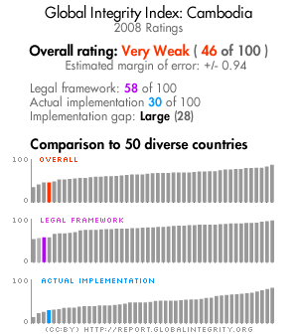
The effects of the Khmer Rouge can still be seen in Cambodian politics, and have shaped the way administrators in the country rule over their citizens. As Evan Gottesman, author of Cambodia After the Khmer Rouge, writes, “Cambodia’s leaders have accepted a new level of political discourse, but they do so only to the extent that it does not jeopardize their power. This strategic, self-serving adaptation has, in fact, been the hallmark of their rule since 1979 [the fall of the Khmer Rouge]” (Gottesman). After seeing how quickly the Khmer Rouge rose to power, it is understandable that Cambodian politicians feel the need to secure their positions. However, the government’s refusal to acknowledge criticisms has limited the freedom and futures of Cambodians. Despite a relatively smooth political transition within the past fifteen years, the country lacks the necessary opportunities for expression and freedom from corruption.
Though its history is plagued with political strife, genocide, and terror, Cambodia operates today as a parliamentary representative democracy under a constitutional monarchy. The constitution of Cambodia was promulgated in 1993, and guarantees universal suffrage to both men and women at 18 years of age. The Global Integrity Report 2008 gave Cambodia a score of 86 out of 100 for public participation in elections and received a score of 75 for election integrity. Though the elections were by no means perfect, Cambodia’s score of 75 is rather striking considering the United States received a score of 82 this past year, and that an exceptionally high score is 92 (Canada). Neighboring countries Vietnam and Thailand scored 62 and 56 respectively, making Cambodia more developed in this aspect of political life.
Cambodia’s king, Norodom Sihamoni, operates more as a symbolic figurehead than as an actual political leader. The government has executive, legislative, and judiciary branches, with Hun Sen acting as Prime Minister. “His [PM Hun Sen’s] Cambodian People's Party (CPP) uses its control of the National Assembly as well as the military, courts, and police to remove and outmaneuver all opposition” (The UN Refugee Agency). The CPP has also guaranteed political victory by rewarding citizen support with “gifts,” such as bags of rice, from numerous headquarters scattered throughout Cambodia. Even if opposing parties managed to overcome both formal and informal government barriers, it would be nearly impossible to compete with the widespread resources and influence the CPP has managed to gain over the years.
Even with its tremendous progress, Cambodia is not considered to be anywhere close to an open and accessible democracy. In the words of Gottesman, “…Cambodian democracy often seems like an abstraction. The government ignores reports of corruption and human rights abuses. The courts remain corrupt, politicized, and for most citizens, geographically inaccessible and prohibitively expensive. Soldiers and police are never prosecuted for abuses, prompting nongovernmental organizations to write lengthy reports on the problem of impunity, reports that themselves are ignored” (Gottesman).
In its 2009 Freedom in the World report, Freedom House characterized Cambodia as being a country which is politically “not free.” Out of a possible score of 7 (with 7 being the worst), Cambodia received a 6 for political rights and a score of 5 for civil liberties. The government does not tolerate criticisms of the state or fully recognize freedom of speech and long periods of detainment for political opposition are commonplace (The UN Refugee Agency). In 2008, Transparency International ranked Cambodia 166 among 180 countries for high levels of corruption (Transparency International). In comparison to its neighbors, Cambodia was measured to have higher levels of corruption than Vietnam, Thailand, and Laos (Transparency International) (See Figure 1). The Global Integrity Report 2008, which also measure levels of corruption in governments, has categorized Cambodia’s integrity as “very weak.” The score assessed for Cambodia (pictured above) is 46 out of a possible score of 100, and in comparison to 50 other diverse countries, Cambodia scored well below average. Additionally, Global Integrity gave Cambodia a score of 22 out of 100 for public access to information. This is largely due to the fact that the media in Cambodia practices self-censorship and fears governmental repercussions.
Socially and politically, discrimination against minorities, especially Cham Muslims, is a widespread problem. Women, who were once highly respected in ancient Cambodia, are today the victims of prevalent economic and social discrimination. Domestic violence and rape commonly occur, yet police attention or justice is either rare or non-existent. Sex trafficking has become a colossal problem in Cambodia. Due to little or no economic prospects, Cambodian women from the countryside move to cities such as Phnom Penh to earn a living through prostitution. Additionally, prostitutes have been brought into the country from neighboring Thailand and Vietnam to work in cities where “sex tourism” turns big profits. Traffickers purposefully addict their workers to drugs in order to ensure that they will remain dependent on the brothel for income, drugs, and livelihood. In February 2008, legislation was passed to enable police raids on brothels, however, studies have shown that police have abused this right to bribe and blackmail prostitutes and brothel owners (Global Integrity).
Displacement and forced evictions have also violated the rights of Cambodians, especially within this past year. Issues of land ownership are heavily debated in a country struggling with the aftermath of the Khmer Rouge, which destroyed all property deeds during its reign. After the Khmer Rouge was overthrown, families who survived the genocide began squatting on available land, with no evidence of their previous property. Today the government has the final say on approving or rejecting claims on land ownership. Amnesty International estimates that in 2009, at least 27 forced evictions affected 23,000 people, all of whom were among the nation’s poorest. Additionally, 150,000 Cambodians are estimated to be at risk to losing their rural property. All of these involuntary relocations have been denied by the Cambodian government, with 150 land activists being detained (Amnesty International, 2009). As of 2009, the anti-corruption law was not passed, despite the pressures faced from international donors of aid to Cambodia. Over 40 NGOs and over a million Cambodians signed a petition to have the law passed in May, but any developments have yet to be seen (Transparency International).
A country is not developed if there are not opportunities for political expression and freedom. In terms of political issues, Cambodia is far from being developed. High levels of corruption plague the government, which allows for many injustices to be committed against the Cambodian population. Despite considerable development in election integrity, political opposition in the form of social freedoms and political parties are silenced, which creates obstacles for political opportunity in Cambodia. There is however, great promise for future development, with a population with high levels of participation and a culture of resilience, considering the ghosts which haunt Cambodia’s past. Politician Sam Rainsy, leader of the Sam Rainsy Party, criticized the CPP, saying, "They made this empty promise so that they have time to commit corruption; it is a strategy to delay. It has been 10 years already. Thieves can't catch thieves...” (Transparency International).

Figure 1: 2008 Transparency International CPI

Country | Country Rank | 2007 CPI Score
Thailand | 80 | 3.5
Vietnam | 121 | 2.7
Cambodia | 162 | 1.8
Laos | 151 | 2.0
U.S.A. | 18 | 7.3

Economic Measures:

As with all other aspects of life in Cambodia, the economy was greatly affected by the Khmer Rouge government and the genocide that occurred under Pol Pot. By 1979, the entire commercial infrastructure, including roads, bridges, railroads, and telephone networks needed to be entirely reconstructed. Cambodia’s human capital also took a huge hit as the technocrats were practically decimated and many other people were unable to resume economic activity due to malnutrition and overall poor health. Eventually capitalism started to reemerge through private trading with Thailand, and this ongoing relationship has continued to influence Cambodia’s economic policies. In 1980, the government went through the very difficult process of reintroducing the riel and transitioning the society from using primarily rice as currency to printed money. In 1988, as the government finally conceded that a planned economy was not working, Hun Sen proclaimed, “Cambodia is quietly reforming the management of its economy. We are moving from the left to the right” (Gottesman 280).
Even after this shift from a planned to a market economy, Cambodia remains one of the poorest countries in Asia. Although it has experienced recent GDP growth, Cambodia has the lowest GDP per capita and the highest poverty rates when compared to geographically similar countries. According to the World Bank, Cambodia’s GDP per capita, PPP (constant international $) in 2008 was $1,760. This puts Cambodia’s GDP per capita, PPP (constant 2005 international $) rank at 187th out of 228 countries in the world, barely surpassing North Korea (CIA). Countries such as Nigeria, Sudan, Pakistan and Honduras, countries very poor and underdeveloped in their own right, all have a GDP per capita PPP higher than that of Cambodia. Compared to the 1998 GDP per capita, PPP (constant 2005 international $) of $863, GDP per capita, PPP has more than doubled over ten years. Although this is very positive growth, when looking at other countries in Southeast Asia such as Laos, Vietnam, and Thailand, one can see that Cambodia still has a long way to go. (See Figure 2) While GDP per capita PPP has surpassed that of the LDCs, and is slowly but surely closing in on Laos, this should not be viewed as a victory necessarily because Cambodia still lags far behind Vietnam and extremely far behind Thailand. The cultural, religious, geographic and other similarities suggest that there should not be such a large gap among the GDPs per capita PPP of these Southeast Asian countries.
Figure 2
Source: World Bank Indicators, 2009

According to the United Nations, Cambodia, along with countries such as Haiti, Afghanistan, Rwanda and Sudan, are classified as Least Developed Countries (UN-OHRLLS). While Cambodia’s GDP per capita, PPP (constant 2005 international $) is higher than that of the LDCs, which is $1,253, this very slight advantage of only $500 indicates that Cambodia really is one of the poorest countries in the world (See Figure 2). Seeing this comparison to the world and some of its bordering countries in Southeast Asia, it is clear that, in terms of GDP per capita PPP (constant 2005 international $), Cambodia is an extremely underdeveloped country.
Not only does Cambodia have a very low GDP per capita (PPP), but it is also distributed rather unequally. On the GINI Index Cambodia received a 43 in 2007, which makes it the 51st most unequal country in the world, worse than Thailand ranked 55th, Vietnam ranked 78th, and Laos ranked 88th (CIA, 2010). When looking at the income share held by the highest 10% and the income held by the lowest 10%, it is easy to see that coupled with the extreme inequality; the population earning the lowest incomes is living in extreme poverty (See Figure 3).
Figure 3

Source: World Development Indicators, 2009
While these figures show that income inequality is roughly the same throughout Southeast Asia, since the GDP per capita of all of these countries is higher than that of Cambodia, the 3-4% of the income in all of these countries will be higher than the 3% of income in Cambodia. Therefore Cambodians are really the poorest of the poor. According to the World Bank, in 2004 the percentage of the population living at or below $1.25 a day was 40%. While this is still a large number, especially compared to Thailand (2%) and Vietnam (24%), one could say that this is not a majority of the country (See Figure 4). When looking at the population living below $2.00 a day, however, there is a staggering jump in Cambodia to 68% of the population. $0.75 more income per day only marginally makes a person or family better off and therefore it is safe to say that almost 2/3 of the population of Cambodia lives in poverty (The World Bank Group).
Figure 4

Source: World Development Indicators, 2009
Cambodia’s low income can be partially explained by the nearly complete lack of an industrial sector (only 2% of total employment) and an unusually small service sector (9%). Instead, Cambodia’s labor force of 8.5 million is employed mostly in agriculture and an even larger portion of the population engages in some sort of self-employed subsistence farming. Not surprisingly then, Cambodia’s population is largely rural (78%), which makes Lipton’s urban bias an especially significant feature of the economic and political landscape. As shown in Figure 4, the percentage of the rural population below the poverty line is more than twice as high as the percentage of the urban population below the poverty line.

Figure 4

Source: World Development Indicators, 2009

Regional income inequality in Cambodia falls right along the lines of the urban/rural divide. Looking at the map below, one can see that in the city of Phnom Penh there is only 4.6% poverty. The region with the next lowest level of poverty is the coastal regions at 26.8%, indicating that access to water has an impact on reducing poverty by not only increasing the ability for trade, fishing and tourism, but also making the land more fertile and productive for agriculture. In the plateau/mountain region there exists 52% poverty because not only is this a very rural zone and obviously there will be more poverty, but because of quality of the land in mountainous regions, agriculture will ultimately be less efficient and productive.
While Cambodia’s unemployment rate is reported to be low at 3.5%, this number is very misleading because employed people are still very poor. Although most of the population may be employed, they are not earning nearly enough money to sustain themselves or to afford education and health care, which we see as essential to being considered a developed country (CIA).

Figure 5- Incidence of poverty by broad geographic zones, 2003-2004
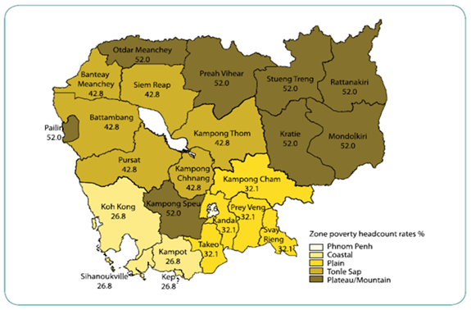
Source: UNDP Cambodia Human Development Report, 2007
While the income level, based on the GDP per capita, has improved in recent years, it is still extremely low compared to the rest of the world. Cambodia is far from being considered “developed” with such a low income per person and such widespread poverty which is then compounded by the problem of inequality. Because of this huge income gap and distribution problem, Cambodia lacks a middle class which according to Marxists and Radicals will have the incentive to invest money, properly direct social capital, and press for democracy. As demonstrated by Cambodia’s 1-gap, 2-gap, and 3-gap, Cambodia’s high GDP growth is due to foreign investment and aid, as opposed to domestic savings and efficient investment. This dependence on foreign capital is undesirable and unlikely to be sustainable (See Appendix). When compared with its neighboring countries, Thailand, Laos and Vietnam, Cambodia is by far the poorest. Cambodia’s GDP and level of income is not allowing its people to provide basic human needs and therefore is considered underdeveloped in this area by our definition.

Education:
Figure 15: Number of teachers, 1970 and 1980
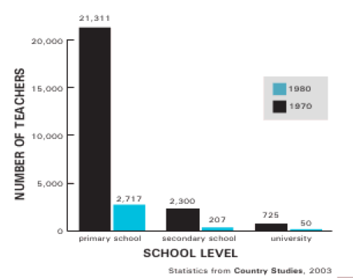
In viewing development as opportunity, the next aspect in need of assessment is education within Cambodia. As is evident throughout the various facets of Cambodian life that we have evaluated thus far, the effects of the Khmer Rouge regime is still apparent in the education sector today. Cambodia’s contemporary educational system has only been around for less than a century and has developed quite deliberately due to various changes within the political and social system over time. It was not until the 1930's that secondary education became available to both males and females, and not until the 1950's that all forms of education and learning centers were enlarged and developed in order to include a wider cross-section of provinces within Cambodia. Unfortunately, the majority of the progress that was made up until the 1970's ended with the civil war, which led to the rule of the Khmer Rouge regime. The Khmer Rouge was notorious in their efforts to revolutionize Cambodia's citizens, emphasizing labor over education. Those who had obtained a higher education were killed, driven out of the country, or forced to work in labor camps.
Figure 15 illustrates the drastic change in the number of teachers before and after the regime. More often than not citizens would have to lie and refrain from speaking so as not to reveal they have been educated. As Alexander Hinton recounts the grievous memories of a young Cambodian girl who survived through the regime in his book, Why Did They Kill? Cambodia in the Shadow of Genocide, the extent to which educators were intolerable toward the Khmer Rouge is visible.
The regime took part in demolishing institutional infrastructure within the educational sector including schools, books, etc. While education as a whole was not completely banned, it was in principle the colonial education that was practiced prior to the Khmer Rouge regime that was viewed as suspicious, in part adding to the many teachers who fled or died during their rule. All students were regarded with suspicion, and those who were regarded as “the enemy” were executed. It is estimated that only 15% of educated Cambodians survived the mistreatment throughout the regime (Gottesman).
It should be no surprise therefore, that in 2007 the adult literacy rate was only 75% (68% Female/86% Male). The 1980's and 1990's were a long period of both relief and major reconstruction, and with the aid of “Vietnamese, Soviet, and other foreign professors and curriculum advisors, the PRK managed to reestablish a network of schools and university faculties. It was one of the regime’s greatest achievements” (Gottesman). Despite all of the external aid and optimism for a new and improved sector, the results were disappointing. Efforts made at recruiting educated intellectuals (referring to those who have attained a high school diploma) into the state apparatus were inefficient, as most ‘intellectuals’ had already fled to the Thai border in fear that the PRK would only repeat the communist policies of Democratic Kampuchea (Gottesman). “As one Vietnamese advisor reported back to Hanoi, the “intellectuals” were ideologically unsound, “isolated from the public,” uninterested in the collective benefit,”” being very cynical in nature as they had no respect for their rulers who lead the country with what they believed to be “so little knowledge” (Gottesman). In 2006, conscription laws for the army changed the requirement of military service from 5 years to 18 months. We believe that this military service requirement takes a big toll on education, as this disrupts students’ educations before they have worked in their area of expertise, reducing the likelihood of pursuing what they were once studying (Gottesman).
It is quite evident that the history of the Khmer Rouge lies at the heart of many development problems within the education sector in Cambodia today, affecting the infrastructure, the quality of education, the number of instructors, as well as the number of students where schools actually are available.
In 2000, the Education for All (EFA) Assessment, an international government planning process, featured the leading dilemmas in the education sector, including enrollment rates, costs of services, government spending, and the quality of education overall. Below is a summary of the findings taken from the EFA 2000 Report :
» Progress towards the EFA goals is slow, especially since Early Childhood Care and Development activities generally are limited to formal pre-schooling. Programs for children aged 0-3 years are undefined and scanty.
» Remote areas are generally disadvantaged in the provision of education. Education indicators are all low. Pupils learning achievement is low, especially in the remote areas with more girls dropping out of school than boys do.
» Literacy and non-formal education do not receive enough attention with mass media education program for better living. In addition, existing programs are highly limited in both content and reach.
» Technical and vocational education is limited to urban areas. Available training does not attract the youth and the fit between the skills taught and market needs is poor.
» Quality of basic education generally is low and access limited. Those in the far-flung remote and mountainous areas, the poor and ethnic minorities are still largely excluded from all forms of educational opportunities and experiences

It became evident that due to the state of classrooms in rural areas, the lack of programs for disadvantaged children, and the overwhelming lack of teachers, a new policy was in need to untangle the great mess that was apparent for the past 20 years. With the help of the Ministry of Health, the Cambodian government was able to begin a new policy development process that set goals for upcoming years (Ministry of Education, Youth, and Sport). These include a wide variety of targets ranging from increasing expenditures on education, to decreasing the pupil-teacher ratio, to decreasing the repetition and dropout rate, etc.
While education had “nowhere to go but up” during the past 3 decades and has shown improved over the past 10 years, it has not happened as rapidly as one would hope. Although there have been some improvements in the gender gap, there are still many disparities in educational attainment levels when comparing the different provinces of Cambodia. As noted above, in 2007 the adult literacy rate was at 75%, but ten years prior to that, in 1997 it was at a mere 67% which does show noticeable improvement. The gender gap has decreased from 22.5% to 18.1% in the same time span.
When comparing public expenditures as a percentage of GDP to adult literacy rates, it is quite visible that Thailand, which spends twice as much on education as Cambodia does, also has a literacy rate noticeably higher than that of Cambodia (Figures 16 and 17).

Figure 16: Public Spending on Figure 17: Public Spending on
Education (% GDP) Education (% Gov’t Expenditures)

Source: World Development Indicators, 2009
Also, in 2007 when compared to all other East Asian and Pacific countries, Cambodia's primary completion rate is significantly lower, at 85%, up from 47.2% in 2000, while the others' is at 99.8%. Despite the relatively higher primary completion rate, the progression rate to secondary schools was a mere 30.6% in 2006, indicating a massive drop off. The gross enrollment rate (%), or the number of students enrolled in all forms of education as a percentage of the official population of school age students was 40.4 for Cambodia in 2007, compared to 73.1 for all other East Asian and Pacific countries.
The following data are obtained from the National Education Congress summary report:
2008-2009 Academic Year Statistics:
Total BA/BSc Students | 110,000 | Female | 40,204 (36.5%)
Total Associate | 14,857 | Female | 4,321 (29%)
Graduate of BA/BSc | 16,277 | Female | 5,504 (33.5%)
Graduate of Associate | 6,946 | Female | 1,950 (29%)

It is evident that while females are not completely absent from higher education as a whole, they merely make up a third of tertiary enrollment, which leaves plenty of room for development.
Figure 18- Ratio of female to male enrollments in tertiary educaiton

Source: World Development Indicators, 2009
It is evident that while females are not completely absent from higher education as a whole, they merely make up a third of tertiary enrollment, which deprives half the population from realizing their full potential. The opportunity to attain the basic right to an education is absent from Cambodian society today. Therefore, in assessing Cambodia's current state with our working definition of development, the education sector while vastly convalescent over the past three decades, remains inadequate. Figure 18 clearly illustrates the differences between Cambodia and its neighboring countries, emphasizing the clear gap between male and female education and how far behind Cambodia is in comparison to both Laos and Thailand with respect to female enrollment in tertiary education.
While much progress has been made throughout the decades since the devastation of the Khmer Rouge regime, there still remains a wide discrepancy between male and female enrollment rates which prevents the opportunity for advancement in the social realm for many females. Even as the literacy rate improves and more educational institutions are built, the gap is persisting, which indicates a need for development to provide more opportunities for the school age population, especially for females in Cambodia today.

Health:

Cambodia has made notable progress in health outcomes over the past two decades. From 1990-2006, the infant mortality rate decreased from 85 to 65, the under-5 mortality rate decreased from 116 to 82, and the adult mortality rate declined from 263 to 257 (WHO). During this same period, life expectancy increased from 59 years to 62 years, and malnutrition declined in prevalence in children under age 5 (The World Bank Group).
Figure 19: Mortality rates

 | 1990 | 2000 | 2006
Infant mortality rate | 85 | 78 | 65
Under-5 mortality rate | 116 | 104 | 82
Adult mortality rate | 263 | 307 | 257
Source: World Health Statistics, 2008

Figure 20: Life expectancy (2006) Figure 21: Maternal Mortality Ratio (2006)

Source: World Health Statistics, 2008
Source: World Health Statistics, 2008

Despite this progress, Cambodia continues to rank lower than its neighbors on virtually all major health indicators. As shown in Figure 20, in 2006, life expectancy was 10 years less in Cambodia than in Vietnam or Thailand. Women in Cambodia were 3.6 times more likely to die in childbirth than Vietnamese women and nearly five times more likely to die in childbirth than women in Thailand (Figure 21). Similarly, with the exception of Laos, Cambodia had the highest adult mortality rate, under-5 mortality rate, and infant mortality rate out of all of these countries (Figure 22).
Figure 22: Mortality Rates (2006)

Source: World Health Statistics, 2008

According to the World Health Organization, the top five causes of death in 2002 were HIV/AIDS (10%), tuberculosis (8%), diarrheal diseases (7%), perinatal conditions (7%), and lower respiratory infections (5%) (Figure 23). Among children, vaccine-preventable diseases, diarrhea, pneumonia, and respiratory infections are the leading causes of death (Unicef). Among people 15-49 years old, the prevalence of HIV/AIDS has greatly decreased, from a peak rate of 3.0% in 1997 to 0.8% in 2007. In particular, rates of HIV/AIDS have declined among high-risk groups such as brothel-based sex workers (from 43% in 1997 to 21% in 2003), non-brothel-based sex workers (from 18% in 1998 to 12% in 2003), and male police officers (from 4% in 1998 to 3% in 2003). This progress is largely attributed to government initiatives promoting 100% condom use and increasing the availability of services related to the care and treatment of sexually transmitted infections. The Ministry of Health has also introduced voluntary, confidential counseling and testing as an important intervention in HIV prevention strategies. If present interventions are sustained, projections indicate that HIV prevalence should continue to decline, stabilizing at 0.6% by 2011 (World Health Organization).
Figure 23- Top 10 causes of Death in 2002
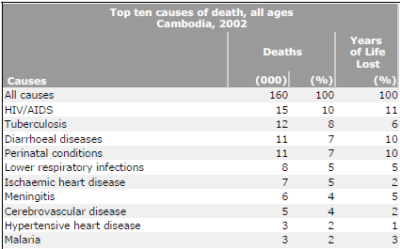
Source: http://www.who.int/whosis/mort/profiles/mort_wpro_khm_cambodia.pdf

One major health priority is improving the status of maternal health in Cambodia. Each year, approximately 2,900 women and girls die from pregnancy-related complications, and 58,000 to 87,000 Cambodian women and girls needlessly suffer from disabilities related to pregnancy and childbirth (USAID). With an average of four women dying during childbirth every day, Cambodia has the third highest maternal death rate in Southeast Asia, after Laos and East Timor” (WHO). Although progress has been made in increasing the availability of obstetric care, a vast majority of Cambodian women still do not have access to quality, long-term reproductive health care and family planning services. In 2005, only 44% of births were attended by a skilled health professional (The World Bank Group). Twenty-one percent of women receive absolutely no prenatal care. Moreover, there is a significant urban bias in access to safe motherhood services, as shown in Figure 24. The data in Figure 24 come from a 1999 study on maternal and neonatal heath services conducted by 750 reproductive health experts. On a scale of 0 to 100 (with 0 as the worst and 100 as the best), this study demonstrated large disparities in rural and urban access ratings, particularly for the treatment of obstructed labor (8 vs. 90, respectively), 24-hour hospitalization (15 vs. 86), and treatment for postpartum hemorrhage (15 vs. 85). Taken together with Cambodia’s high maternal mortality rate of 540, it is clear that basic maternal health needs are not being met.
Figure 24- Comparisons of access to services for rural and urban areas in Cambodia
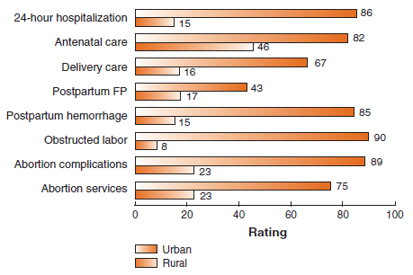
Source: http://pdf.usaid.gov/pdf_docs/PNACR871.pdf
Although child nutrition has improved in Cambodia, the prevalence of malnutrition also remains alarming high. As shown in Figure 24, Cambodian children exhibit four times more instances of underweight and nearly 3 times more cases of stunting than children in Thailand. In 2006, 44% of children under 5 years old exhibited stunted growth, and 28% of the population was underweight. Malnutrition is associated with multiple health problems such as delayed mental and motor development in children and increased risk of developing coronary heart disease, diabetes, and high blood pressure as an adult. Because malnutrition compromises the immune system, children who are moderately underweight are more than four times more likely to die from infectious disease, when compared to well-nourished children (United Nations Development Programme). While malnutrition affects all age groups, it is concentrated among poor people and those with inadequate access to health education, clean water, and proper sanitation.
Figure 24: Country Comparison of Malnutrition prevalence (2006)

Source: World Development Indicators, 2009
*All values given for the year 2006, except for Lao PDR, which is from the year 2000.

This intersection between poverty and poor health is apparent in Cambodia’s existing health disparities. In particular, vast health disparities exist by income, geographical location, and education. For example, an examination of child mortality rates reveals significant differences across each of these measures. According to the World Health Organization, the under-5 mortality rate was 111.0 in rural areas, as compared with 75.7 in urban areas in 2005. When comparing levels of education and wealth, the under-5 mortality rate was 2.6 times higher for mothers of lowest educational levels when compared to mothers of the highest education levels, and 3.0 times higher when comparing mothers of lowest and highest income levels (Figure 25). This means that before a Cambodian child even reaches the age of 5, her health will be influenced significantly by such factors as where she was born, what her parents earn, and whether her mother had the opportunity to pursue an education.

Figure 25: Under-5 mortality rate by income, location, and mother’s education

Under-5 mortality rate:
Highest and lowest quintiles
Wealth/asset quintiles | Lowest | Highest | Ratio
 | 127.0 | 43.0 | 3.0
Urban/Rural | Rural | Urban | Ratio
 | 111.0 | 75.7 | 1.5
Mother’s education quintiles | Lowest | Highest | Ratio
 | 135.7 | 53.0 | 2.6
* All values for the year 2005 (Source: World Health Statistics 2008)

Location is also a powerful determinant of health, in terms of access to clean water and sanitation facilities. In 2006, only 28% of the population had access to improved sanitation facilities. These facilities were available to 62% of the urban population, as opposed to only 19% of the rural population. Similarly, 80% of urban residents had access to an improved water source, in comparison to only 61% of the rural population. In the absence of potable drinking water, villagers in rural areas must often resort to drinking water from lake and rivers, increasing the risk of acquiring diarrhea and other preventable water-borne illnesses (Figure 26).
Figure 26: Access to sanitation and drinking water

 | %
Population with sustainable access to improved drinking water (% rural) | 61
Population with sustainable access to improved drinking water (% urban) | 80
Population with sustainable access to improved sanitation (% rural) | 19
Population with sustainable access to improved sanitation (% urban) | 62
* All values for the year 2006
Source: World Health Statistics, 2008

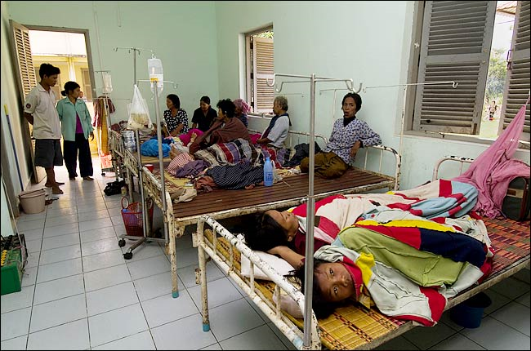
Currently, the Cambodian health system lacks funding and health care personnel, which severely limits people’s access to adequate health care services. Although there is no universal standard that can be used to assess the size of the health workforce needed to address the health care needs of a given population, it is estimated that countries with fewer than 25 health care professionals (physicians, nurses, and midwives) per 10,000 people fail to achieve adequate coverage rates for primary health care interventions that have been prioritized by the Millennium Development Goals framework (World Health Organization). As shown in Figure 8, in 2000, Cambodia had only 2 physicians, 9 nursing and midwifery personnel, and <1 dentistry personnel per 10,000 population in the year 2000 (WHO).
Figure 27:
Health Care Workforce | Value
Dentistry personnel density (per 10,000 population) | <1
Number of dentistry personnel | 209
Nursing and midwifery personnel density (per 10,000 population) | 9
Number of nursing and midwifery personnel | 11,125
Physician density (per 10,000 population) | 2
Number of physicians | 2,047

Source: World Health Statistics, 2008

In 2005, total health expenditures per capita (PPP $ international) were $167. Of these health expenditures, government expenditures accounted for only 24.2 percent, out-of-pocket expenditures accounted for 60.1 percent, and 15.7 percent were accounted for by other private sources like NGOs (Figure 28). Comparably, individuals therefore pay a disproportionately high amount of out-of-pocket expenses to cover health care costs. With 68% of the population living on less than $2/day, health costs therefore pose a massive barrier to health care, indebting many who receive health services and deterring others from seeking out any type of health care.

Figure 28: Total Health Expenditures in 2005

Source: World Health Statistics, 2008

Taking into account present data, the health status of Cambodia is in poor shape. Not only do Cambodians lack access to clean water, proper sanitation, and adequate health care services, but they lack a public health system to cover the few health care costs they may incur as well. Despite improvements in life expectancy and infant mortality, Cambodia’s health status trails far behind its Southeast Asian neighbors and remains among the lowest in the Asia-Pacific region. Most importantly, any progress that has been made has been uneven. Children from lower-income, less educated backgrounds suffer much worse health outcomes, and health disparities in rural versus urban areas persist.
Our development approach is based on the premise that every person has the right to a long and healthy life. An individual’s health should not be determined by his or her level of education, income, or geographical location. In a world where obesity has become epidemic, it is inexcusable that malnutrition continues to limit the educational and physical capacities of Cambodians. Addressing these fundamental health issues is therefore a crucial element of our development proposal.

What is Cambodia’s Development Potential?

After examining our four factors of development (political development, economic measures, education, and health) we have come to the conclusion that Cambodian people lack basic human needs as well as social and economic opportunity. When compared to neighboring countries in Southeast Asia, Cambodia lags behind is almost every respect. Despite progress in election participation and integrity, Cambodia’s government is still plagued with corruption, which impedes on political and social opportunities. Although Cambodia’s GDP per capita PPP has doubled over the past ten years, it is still the lowest of all its neighbors to which we have compared it. In terms of education, Cambodia has an extremely large gender disparity in all levels of schooling when compared to Laos, Vietnam, and Thailand. While Cambodia has made recent improvements in life expectancy and infant mortality, significant disparities still exist based in income, wealth, and geographic location. After examining these areas of underdevelopment, we are now able to look toward creating a sustainable project to address the most vital of these concerns.
While Cambodia is underdeveloped in all of the aforementioned areas, we feel the most pressing issue is the lack of adequate healthcare. Health is a basic human need and is the foundation for human potential. The areas of income, education, and political freedoms cannot begin to be developed without a healthy and nourished population. According to Shimider, “Denied [vital nutrients] in the womb and in infancy, children suffer irreversible brain and nervous system damage, even if they appear well-fed” (Wines). Adequate healthcare allows students to receive the most benefit from their education. With a proper education, students will then be able to obtain better jobs and therefore a higher income. By raising the overall standard of living, Cambodians can then concentrate on securing political freedoms and voicing their own concerns. Development is a chain reaction; the establishment of proper healthcare will lay the groundwork for future development in other areas.

Project Proposal

Cambodia’s alarming maternal death rate, along with our prioritization of health care as the foundation for sustainable development, has led us to focus on a project that will increase the number of certified midwives in Cambodia. According to the Cambodia’s National Maternal Child Health Center, there were 370,000 births but only 3,300 trained midwives in Cambodia in 2009. As described earlier, Cambodia is in dire need of trained birth attendants, particularly in rural areas.
We feel that midwives are the most promising weapon in combating maternal death rates. When trained properly, midwives can provide the life-saving health services to Cambodian women while breaking down cultural reservations normally associated with hospitals and other forms of healthcare providers. The Ministry of Health notes that, “Traditional beliefs that negatively influence delivery practices, health seeking behavior, and child feeding practices remain prevalent across the country, more so in rural areas and in families with low and very low income” (Cambodia Ministry of Planning). Keeping this information in mind, our project will aim to increase the availability of midwife services to rural women in Cambodia, who are often unaware of the benefits of midwives or unable to access them due to transportation issues.
Our proposal recommends the building of a women’s center in a rural village (Location TBD) that would serve to train new primary/secondary midwives, retrain current midwives, provide information to young local women of university/government midwife programs, and serve as a community resource for local women who need advice or assistance in the areas of pregnancy, antenatal care, and family planning. This project would be very cost-effective and sustainable, because it would require limited training materials and rely on experienced midwives to train new and lesser experienced women in their local community. The community center would provide a preferential option for poor families and help to build social capital in a country still recovering from the aftermath of the Khmer Rouge. By addressing this unmet health need, we hope to eliminate barriers to maternal health care and ensure that each woman has the resources for a safe and healthy pregnancy.

APPENDIX

1-Gap Analysis

The following analysis examines the role that investment has had on Cambodia’s economic growth. Using the Harrod-Domar equation, we will look at investment and domestic savings levels to assess whether Cambodia’s investment levels are adequate to meet target growth rates and determine whether the 1-gap is a significant barrier to development goals.
The Harrod-Domar model is a simple equation that relates GDP growth and investment. It is defined as ΔGDP = (1/k)*I, with ΔGDP as annual percentage of GDP growth, k as the expected output from any investment, and I as gross fixed capital formation as a percentage of GDP. For comparative purposes, our team looked at corresponding data for other countries, including neighboring Southeast Asian countries (Laos, Thailand, Vietnam) and a country with similar GDP growth (China). All values were obtained from the period 1994-2007 and are contained in Figure 6.
Figure 6: Harrod-Domar Variables, 1994-2007
Country | GDP growth (annual %) | Gross fixed capital formation  (% of GDP) | K (GFCF/GDP growth) | Gross domestic savings  (% GDP)
Cambodia | 9 | 16 | 1.98 | 6
Lao PDR | 7 | 31 | 4.63 | 19
Thailand | 4 | 29 | 2.46 | 33
Vietnam | 8 | 29 | 3.96 | 25
China | 10 | 37 | 3.78 | 44
Source: World Development Indicators, 2009

As shown in Figure 6, Cambodia experienced high GDP growth, which was surpassed only by China in our country comparison. Since Cambodia’s current growth rate is already so high, we believe it is a realistic and acceptable target growth rate for the future. To maintain this rate of GDP growth, investment should remain at 16%, according to the Harrod-Domar equation. However, from 1994-2007, Cambodia’s domestic savings rate was only 6%. The 1-GAP (i.e., desired investment minus available domestic savings) was therefore 10%. For growth to continue at 9%, this means that Cambodia will require external financing for 10% of its investment.
Figure 7 illustrates the relationship between GDP growth and investment for Cambodia, our comparison countries, and country aggregates by wealth (HIC, HIPC, LDC, LIC). As shown, Cambodia achieved comparably higher GDP growth than every wealth aggregate and almost every other country, despite having the lowest investment levels. Given its relatively low k value of 1.98, Cambodia appears to demonstrate high returns on investment (See Figure 6). Although China has shown slightly higher GDP growth, its investment was over double that of Cambodia’s. In other words, China has been able to achieve higher GDP growth than Cambodia, but only through higher investment levels.
Figure 7: GDP growth vs. investment, 1994-2007
Key:

HIC = High Income Countries
HIPC = Heavily Indebted Poor Countries
LDC = Least developed Countries
LIC = Low Income Countries

Source: World Development Indicators, 2009

Figure 8 illustrates Cambodia’s investment and savings levels from 1994-2007. During this period, gross domestic savings has been consistently lower than gross fixed capital formation, which means that most of its desired investment has come through foreign capital and external financing.
Figure 8: Investment and domestic savings levels, 1994-2007

Source: World Development Indicators, 2009

To maintain current growth rates, we believe that Cambodia will continue to require external finance. However, the Cambodian government should be cautious against fostering a dependence on foreign capital. As Paul Krugman has written, sustainable economic growth is only possible when increased investment is accompanied by greater efficiency (Krugman). Although current investment patterns have been sufficient to achieve high GDP growth, Cambodians will need to increase saving and invest efficiently in order to achieve long-term growth.
That said, we would like to acknowledge the fact that this 1-gap analysis has focused only on economic growth and is unable to acknowledge the broad, complex dimensions of poverty and human development that we are interested in. While Cambodia may have experienced high GDP growth in recent years, it continues to fare poorly in the areas of health, education, and political rights. While the Harrod-Domar model provides useful insight into a nation’s macroeconomic performance, it must only be considered in association with other areas of development.

2-Gap Analysis

The two gap is the difference between a country’s available hard currency and actual sources of foreign exchange. Although our focus remains on social aspects of development, we acknowledge that the health of a country’s economy determines the success of programs aimed at sustainability. The 2-gap involves an analysis of balance of payments, currency, and liabilities. Specifically in the components of balance of payment accounting that we will focus on include: current account balance (includes trade balances, net factor payments, and transfers), the capital account (includes foreign direct investment), financing items (includes reserve assets, debt).
In terms of trade, Cambodia runs a deficit that has continued to increase in the past five years. As of 2008, Cambodia’s exports were 42.9% of GDP and its imports were 59.5% of GDP. The current trade deficit (the difference between exports and imports) was -1.239 billion dollars, which is 16.6% of GDP. Using 18% of GDP as a benchmark for an unsustainable level of deficit, Cambodia’s 15% of GDP deficit is by no means sustainable. Cambodia exports clothing, timber, rubber, rice, fish, tobacco, and footwear. As for imports, Cambodia brings in petroleum, cigarettes, gold, construction materials, machinery, motor vehicles, and pharmaceutical products. We reviewed the exports and imports in order to determine what Cambodia could expand upon domestically in order to reduce the trade deficit and further stabilize the Riel. Two major industries that we believe can have an impact on the deficit are petroleum and tobacco. Cambodia’s recent discovery of oil reserves and natural gas hold great promise for revenue and economic growth. “Cambodia’s annual oil revenue should begin at about 174 million dollars in 2011 and climb to about 1.7 billion by 2021…” Therefore Cambodia should decrease its petroleum imports and focus on this newfound industry, which also holds great promise for attracting foreign direct investment. In addition, this large of an increase in revenue would allow Cambodia to eliminate its trade deficit. As for the tobacco industry, instead of importing cigarettes from abroad, Cambodia should begin to look for ways to develop its own processing plants to supply domestic cigarettes to its population. This would limit imports and ultimately decrease the trade deficit.
As seen in the chart below, Cambodia continues to import more goods and services than they export, leaving them a negative resource balance. This number has continued to increase over the past decade, with the current resource balance at -$1.239 billion (2008). In addition, Cambodia's net income and current account balance is also in the red and has continued to increase over the years. The current account balance is especially alarming, as it has doubled within one year from 2007-2008.
Figure 9- Balance of Payments
Balance of Payments
(in U.S. Millions of $) | 1998 | 2007 | 2008
Exports of goods and services | 978 | 5636 | 6356
Imports of goods and services | 1386 | 6404 | 7594
Resource Balance | -409 | -768 | -1239
Net Income | -60 | -348 | -409
Net Current Transfers | 293 | 572 | 594
Current Account Balance | -175 | -543 | -1053
Finance Items | 206 | 969 | 1411
Changes in Net Reserves | -61 | -426 | -358

Cambodia’s Riel was first issued in 1955 and is a floating currency. After the overthrow of Khmer Rouge, the Riel was reissued in 1980. As seen in the figure below, during years of 1990-1993, the value of the Riel dramatically decreased.

Figure 10- Exchange Rate, 1994-2004

Source: World Development Indicators

This trend continued at a less drastic rate until 1998, when the Riel finally began to stabilize. For the past ten years, the Riel has been relatively stable, only depreciating at small increments annually with very little to no volatility. This stability is largely connected with the Cambodian government’s commitment to currency stability.
“Exchange market intervention by the central bank to limit depreciation of the domestic currency and maintain the Riel around 4100 per U.S. dollar has slowed growth in foreign exchange reserves this year. Still, reserves rose modestly from a year earlier to 2.2 billion dollars by the end of June 2009. Cambodia’s real effective exchange rate appreciated to 2-3% in June 2009 from a year earlier. Prices are down 4.9% in June from a year before, reflecting the sharp downward correction in food and fuel prices. Upward pressures on inflation might reemerge as international prices of commodities rebound and depreciation pressures continue. In addition to the Riel, the U.S. dollar is widely used in Cambodia with little difficulty.”

As of 2007 in the East Asia and Pacific region Cambodia was the 3rd largest recipient of US foreign aid, borrowing $62 million for a wide range of issues, the majority being directed toward health programs. In terms of debt, the external debt in 2008 as a percentage of GDP is 34.8, while the total outstanding debt is $3.76 billion. This is a vast improvement from previous years in which debt levels had risen to 165% of GNI. One-third of Cambodia’s public debt is owed to Russia and the United States; the latter's debt stems from shipments of agricultural commodities such as cotton and rice. “According to the World Bank and the IMF, Cambodia’s debt is on a sustainable path and the risk of debt distress is judged ‘moderate,’ an improvement from the 2006 assessment that Cambodia’s risk was ‘high,’ thanks to higher-than-expected GDP growth and additional large-scale concessional financing from creditors such as China and South Korea.”
As Cambodia’s economy and currency is becoming more stable, the country has become much more attractive for Foreign Direct Investment. According to the World Bank, in 2008 Cambodia received $ 815 million in Foreign Direct Investment. Although this is down from 2007’s FDI level of $866 million, FDI flows to Cambodia have dramatically increased over the past few years, as they were only $121 million in 2004. From 1994-2004, almost 50% of Cambodia’s FDI comes from the ASEAN countries, with Malaysia accounting for 36.7% of total FDI inflow. Greater China (PRC, Taiwan, Hong Kong) accounts for the next largest source of FDI inflows into Cambodia at 26.7%, followed by the United States and the European Union. Manufacturing-related foreign direct investment accounts for a large portion of total FDI with wood and wood products accounting for over 20% of total foreign direct investment and garment-related FDI constituting almost 25% if total FDI inflows.
Although large amounts of FDI do mean capital outflows in the future, Cambodia can and should expand Foreign Direct Investment at this point in time. There are continuing opportunities in the garment industry and new opportunities especially in oil and minerals. Cambodia’s recent discovery of oil reserves has already prompted some investment by international companies, many Chinese ones in particular. If the government is smart about this opportunity and does not allow the profits to only benefit a few wealthy elites, foreign direct investment in the oil industry could really benefit the country.
As the Riel has begun to stabilize, Cambodia has made a slight improvement in closing the 2-gap over the past few years. While currently the debt levels are manageable, external finance, even though it is needed to close the 1-gap, should not be tolerated for an extended period of time because it would halt or possibly reverse the progress Cambodia has and is projected to continue to make in the future. There is no real way for such an underdeveloped country to avoid external finance and with a deficit that is at the moment unsustainable what Cambodia really needs to concentrate on is both lowering their import levels on products which could potentially be produced at home and raising their export levels by investing in areas such as agriculture to increase efficiency. While Cambodia has made some progress towards improving its financial health there is still a long way to go. Although we recognize that the presence of a 2-gap is not necessarily beneficial, to achieve our definition of sustainable development we do not see any need to suggest a policy proposal to address this issue and feel that Cambodia will continue down a path of decreasing its 2-gap.

3-Gap Analysis

The 3-gap is defined as the difference between required government expenditures and available government revenues. In 2008, Cambodia’s government expenditures totaled $1.6 billion, with total revenue reaching $1.3 billion. Based on these values, the 3-gap was therefore a budget deficit of -$0.3 billion, or -0.7% of GDP.
Figure 11: Revenues, Expenditures, and Budgetary Surplus/Deficit

Source: http://www.adb.org/Documents/Books/Key_Indicators/2009/pdf/cam.pdf

As shown in Figure 11, Cambodia has routinely run budget deficits like this throughout the past two decades. While budget deficits have been as large as -7.5% of GDP in 1995, the gap between government revenues and expenditures has narrowed in recent years. This is a positive observation that suggests that Cambodia’s debt has been manageable and revenue has begun to catch up with recent economic growth.
There are several possible reasons why Cambodia has encountered budget deficits. First, revenues may be low because tax administration and collection is poor in Cambodia, and the economy is largely dependent on informal sectors such as agriculture, which are untaxed. Each year, smuggling in Cambodia robs the government of large amounts of revenue. For example, beer, which is smuggled in from Thailand and Singapore into Cambodia, is estimated to cost the government $22 million in lost tax revenue (ABC News).
As Figure 12 illustrates, Cambodia’s revenue making capabilities are poor. In 2005, Cambodia’s government revenues were less than 11% of GDP, placing Cambodia as the lowest among rated sovereigns in the Asia-Pacific region (Dean and Joiner). According to Standard & Poor’s credit rating system, Cambodia has a sovereign debt rating of B+, placing it in a similar range as Sri Lanka and Pakistan but below that of its neighbors Thailand and Vietnam. Cambodia’s credit rating indicates that its outlook is stable. To improve its credit rating, Cambodia must reduce barriers to investment and improve government revenue raising capabilities.
Figure 12
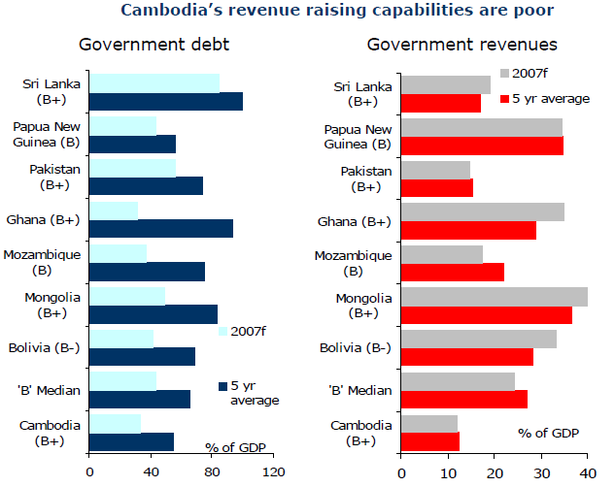
Original source: Standard & Poor’s, National Institute of Statistics of Cambodia, IMF
Taken from: http://www.anz.com/documents/economics/CambodiaEconomicUpdateJun07.pdf

Figures 13 and Figure 14 look at specific sources of revenue and expenditures in Cambodia. In 2008, revenue was derived primarily from taxes (71%) and grants (28%), and the greatest expenditures were made on defense (21.7%), general public services (18.5%), education (13.9%), and health (10.3%). Cambodia’s reliance on foreign aid as a source of revenue is problematic. Each year, Cambodia receives an average of $600 million dollars, or half of its national budget, from foreign donors. Moreover, about one-third of Cambodia’s public spending is financed by aid. This reliance on foreign aid has contributed to Cambodia’s national debt and is likely to be unsustainable.
Currently, military expenditures make up over one-fifth of total government expenditures. We feel that the Cambodian people would benefit greatly if the government could decrease military spending and reallocate these resources towards education and health services instead. Thailand, a country similar to the size of Cambodia, currently allots 25% of their government expenditures to education alone and boasts better health and educational outcomes than Cambodia. If the same prioritization were to be given to health and education in Cambodia, we believe the welfare of its population would greatly increase.
Figure 13

Source: http://www.adb.org/Documents/Books/Key_Indicators/2009/pdf/cam.pdf

Figure 14

Source: http://www.adb.org/Documents/Books/Key_Indicators/2009/pdf/cam.pdf

Works Cited
ABC News. Cambodia losing millions to beer smuggling. 11 May 2007. 29 March 2010 <http://www.abc.net.au/news/stories/2007/05/11/1920904.htm?site=news>.
Cambodia Ministry of Planning. Comprehensive Mid-Term Review. January 2006. 4 April 2010 <http://www.un.org/special-rep/ohrlls/ldc/MTR/Cambodia.pdf>.
CIA. The World Factbook. 2010. <https://www.cia.gov/library/publications/the-world-factbook/geos/cb.html>.
Dean, Katie and Alex Joiner. Cambodia Economic Update. 7 June 2007. 29 March 2010 <http://www.anz.com/documents/economics/CambodiaEconomicUpdateJun07.pdf>.
Global Integrity. Cambodia. 2008. <http://report.globalintegrity.org/Cambodia/2008>.
Gottesman, Evan. Cambodia After the Khmer Rouge: Inside the Politics of Nation Building. New Haven: Yale University Press, 2003.
Goulet, Denix. "Development... or Liberation?" International Development Review 13.3 (1971).
Kiernan, Ben. The Pol Pot Regime. New Haven: Yale University Press, 2002.
Krugman, Paul. "The myth of Asia's miracle." Foreign Affairs 73.6 (1994): 62-78.
Lipton, Michael. Why Poor People Stay Poor: Urban Bias in World Development. Harvard University Press, 1977.
Ministry of Education, Youth, and Sport. National education congress summary report on the education, youth, and sport performance for the academic year 2007-08 and academic year 2008-09 goals. <http://www.moeys.gov.kh/index.php>.
Moon, Bruce E. "Basic Human Needs." Moon, Bruce E. The Political Economy of Basic Human Needs. Cornell University Press, 1991.
Seers, Dudley. "The meaning of development." International Development Revie 11.4 (1969): 2-6.
Sen, Amartya. Development as Freedom. New York: Random House, 1999.
The UN Refugee Agency. UNHCR Cambodia Report. 2009. <http://www.unhcr.org/refworld/publisher,FREEHOU,,KHM,4a6452c823,0.html>.
The World Bank Group. World Bank Indicators. 2009. <https://publications.worldbank.org/register/WDI?return_url=%2fextop%2fsubscriptions%2fWDI%2f>.
Transparency International. 2010. <http://www.transparency.org >.
Unicef. Cambodia- Statistics. 1 April 2010 <http://www.unicef.org/infobycountry/cambodia_statistics.html>.
United Nations Development Programme. Human Development Report. New York: UNDP, 2005.
UN-OHRLLS. Least Developed Countries. 2010. <http://www.unohrlls.org/en/ldc/related/62/>.
USAID. Cambodia. 29 March 2010 <http://pdf.usaid.gov/pdf_docs/PNACR871.pdf>.
WHO. World Health Statistics. Geneva: World Health Organization, 2008.
Wilber, Charles K. and Kenneth P. Jameson. Paradigms of Economic Development and Beyond. Notre Dame: University of Notre Dame Press, 1975.
Wines, Michael. "Malnutrition is Cheatin its Survivors, and Africa's Future." The New York Times 28 December 2006.
World Health Organization. December 2005. 1 April 2010 <http://www.who.int/hiv/HIVCP_KHM.pdf>.
—. World Health Report 2006- Working together for health. Geneva: World Health Organization, 2006.

Gini index measures the extent to which the distribution of income (or, in some cases, consumption expenditure) among individuals or households within an economy deviates from a perfectly equal distribution. A Gini index of 0 represents perfect equality, while an index of 100 implies perfect inequality.
Data only available for 2002
Data only available for 2004
Data only available for 2002
Data for Lao PDR not available.
Employees are people who work for a public or private employer and receive remuneration in wages, salary, commission, tips, piece rates, or pay in kind.
National poverty rate is the percentage of the population living below the national poverty line. National estimates are based on population-weighted subgroup estimates from household surveys. Source: World Bank staff estimates based on the World Bank's country poverty assessments
Source: http://limchheng.files.wordpress.com/2008/11/teachers-voices.pdf
Infant mortality rate is defined as the probability of dying between birth and exactly 1 year of age, expressed per 1000 births.
Under-5 mortality rate is defined as the probability of dying by age 5 per 1000 births.
Adult mortality rate is defined as the probability of dying between 15 to 60 years per 1000 population.
Malnutrition is defined as slower body growth among children: smaller height-to-age ratio (stunted) and/or lower weight-to-age ratio (underweight) for children under age 5
Maternal mortality ratio is defined as the number of maternal deaths per 100,000 births during a specified time period, usually 1 year (WHO)
Improved sanitation includes connection to a public sewer, connection to septic systems, pour-flush latrines, simple pit latrines, and ventilated improved pit latrines. Not considered as improved sanitation are service or bucket latrines, public latrines, and open latrines (World Health Organization).
Improved water sources include household connections, public standpipes, boreholes, protected dug wells, protected springs, and rainwater collections. Unimproved water sources are unprotected wells, unprotected springs, vendor-provided water, bottled water (unless water for other uses is available from an improved source), and tanker truck-provided water (World Health Organization).
CIA World Fact Book
Huffington Post
World Bank -http://devdata.worldbank.org/AAG/khm_aag.pdf
This figure is composed of Direct investment, portfolio investment, financial derivative, foreign aid(net loans), and other investments
World Bank
Ibid
Asian Development Bank
Ibid
US Department of State- http://www.cambodiatribunal.org/CTM/US_CB_2-14-08.pdf
World Bank
Cambodian Investment Board- http://www.phileconsociety.org/portals/0/eaea11/eaea5b-1.pdf
U.S. Department of State, 2010
Standard & Poor’s credit ratings are designed to provide relative rankings of creditworthiness. Credit ratings range from the highest rating of AAA to the lowest rating of D (Used to indicate payment default).

