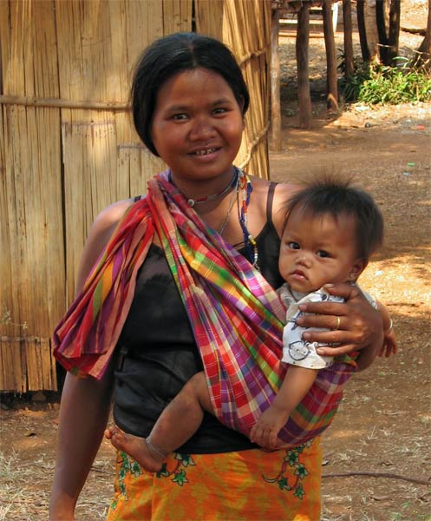
Maternal
Advocacy for
Rural
Cambodia

Lauren Collins, C.N.M
Kara Gustafson, J.D
Annie Hong, M.D.
Busra Ozturk, Ph.D

Table of Contents

- Introductory Letter 3
- Defining Development 4
- Historical Context: Khmer Rouge 5
- Political Development 7
- Economic Development 9
- Education 13
- Health 15
  - Leading Causes of Death 16
  - Malnutrition 17
  - Health Disparities 18
  - Maternal Health 20
  - Health Care: Workforce, Financing 21
  - A Summary 23
- Why Maternal Health Matters 23
- What Current NGOs are Doing 25
- Project Proposal 28
- How MARC is Different 39
- Why Ratanakiri? 30
- Background on Midwifery 33
- Services MARC Would Provide 36
  - Phase 1: Ban Lung Women’s Center (BLWC) 36
  - Phase 2: Mobile Health Outreach 37
- Budget 38
- Conclusion 41
- Works Cited 42

Ms. Thoraya Ahmed Obaid
United Nations Population Fund Executive Director,
UN Under-Secretary-General
220 East 42nd St.
New York, NY 10017 U.S.A.

Dear Executive Director Obaid,

Thank you for taking interest in the Maternal Advocacy for Rural Cambodia (MARC) and our efforts to improve the status of maternal health in rural Cambodia. We admire your commitment to making motherhood safe, and we feel that your mission mirrors our goals and objectives in Cambodia.

After researching elements of Cambodia’s underdevelopment, we have found Cambodia’s high maternal mortality rates to be one of the country’s most pressing health concerns. As your organization has advocated, “No woman should die giving life.”

Our project proposal aims to provide competent, readily available midwives to women in Ratanakiri Province. To address the lack of adequate health care services available in rural locations, we have chosen Ratanakiri because it is the most isolated province and maintains the highest maternal and infant mortality rates in the country. With your help, we hope to create a women’s health center, which will provide access to health services and educational resources to the community. Since we are aware that Cambodia is one of the 23 countries that you have identified as having the greatest need for increased maternal health services, we feel that a center in Cambodia would help you reach the Millennium Development Goal of reducing maternal mortality worldwide by 75% by 2015.

We agree with your philosophy that midwifery is an essential part of a comprehensive maternal health approach. While the UNFPA has invested in maternal health services in Cambodia, our organization would provide services complementary to your existing programs.

Attached is a copy of our project proposal. We hope to collaborate with you in our efforts to provide maternal and newborn health services in the poorest villages of Cambodia.

Thank you for your consideration. We look forward to working with you in the near future.

Sincerely,

Lauren Collins, MPH/CNM Kara Gustafson, J.D.
Co-Founder Co-Founder

Annie Hong, M.D. Busra Ozturk, Ph.D.
Co-Founder Co-Founder

Defining Development
In order to assess and alleviate Cambodia's obstacles to progress we have defined development as reducing deprivation and expanding opportunity (Sen). Deprivation refers to absence of basic necessities, such as adequate food, water, health care, shelter, employment, education, and access to basic infrastructure (Moon; Seers). In addressing issues of poverty, these basic needs must first be met. Opportunity refers to the broader spectrum of human capabilities and potential. Specifically, this approach seeks to empower individuals and enable people to shape their own futures.
Our definition of development places people, as opposed to wealth, at the center of each of our objectives. Development is a complex, multi-dimensional concept that requires a multi-pronged approach. For the purpose of this paper, we will examine several key variables: income, education, health care, and political rights. Key to this approach is the recognition that development strategies must be specifically crafted to the unique social context of the country under evaluation. No single variable can truly describe the current conditions of a country or society. However, taking into account multiple variables, it is possible to gain an accurate portrayal of the particular problems and potential solutions available.
Defining development as opportunity has enabled us to create a sustainable project proposal that will improve the quality of life in rural Cambodia. In this proposal, we will describe Cambodia’s current state of development and recent progress, diagnose why it still remains among the world’s poorest nations, and highlight the greatest priorities in alleviating poverty. We will then lay out a development proposal to improve maternal health in Cambodia through increasing the availability of trained midwives to rural villagers.

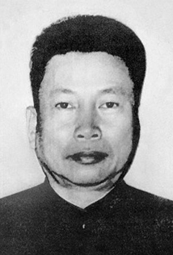
Historical Context: Khmer Rouge
There are many ways to explain Cambodia’s current state: low-lying corruption, poor economic planning, a lack of transparency in the government, and so forth. Although all of these explanations have truth to them, one cannot begin to analyze Cambodia’s predicament without an understanding of the devastation wrought by Pol Pot (pictured to the right) and the Khmer Rouge. In fact, the majority of development concerns surrounding Cambodia stem from the Khmer Rouge’s removal of the country’s foundation: the economy, education, healthcare, and social-cultural systems.
Pol Pot, leader of the Khmer Rouge, came to age in a time where Vietnam’s influences on Cambodia were quite substantial and communist ideology was rampant. Pol Pot and his closest companions, who were educated in Paris, desired to establish a government, in Cambodia (later known as Democratic Kampuchea) that would emphasize the country’s independence and a return to “true” Khmer origins: peasantry. To transition the monarchy of Norodom Sihanouk to Democratic Kampuchea, “all cities were evacuated, hospitals cleared, schools closed, factories emptied, money abolished, monasteries shut, libraries scattered” (Kiernan). For years, freedom of movement, of the press, of worship, organization, and discussion was completely erased from Cambodians. The family structure, of vital importance to Khmer culture, was destroyed. Parents were separated from their children, who were taught to distrust and spy on their parents. Human communication and interdependence completely disappeared.
As Ben Kiernan, author of The Pol Pot Regime explains, “A whole nation was kidnapped and besieged from within.” Cambodia was sealed off with the closing of borders, foreign embassies, and press agencies. Radios, newspapers, and all other forms of communication were seized and immediately destroyed. The speaking of foreign languages was strictly forbidden. As Kiernan writes, “[People] quickly learned that any display of knowledge or skill, if ‘contaminated’ by foreign influence (as in normal twentieth-century societies), was folly in Democratic Kampuchea” (Kiernan). Those who were educated or showed signs of being educated (e.g. wearing glasses) were often executed, for only peasants were desired by the regime. The consequences of these actions still remain in Cambodia today, where there are few teachers, health professionals, entrepreneurs, or senior monks.
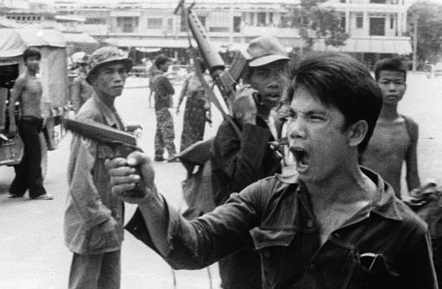
Two groups of Cambodians, old and new people were pinned against each other, making it nearly impossible for Khmers to trust one another. Old people were Khmer Rouge cadres and peasants, with new people being former urban residents. The regime’s motto for the “new” people was, “To keep you is no gain; to lose you is no loss.” Minorities, which included Cham Muslims, Chinese, and Vietnamese were either expelled from the country or executed. With the cities deserted, rural Cambodia was transformed into a prison camp state. Millions of Cambodians were forced into hard labor in rice fields, with long hours and barely anything to eat. The worker’s forced efforts successfully transformed the Cambodian countryside: replacing tiny dikes and irrigation systems, removing walls of earth to make straight canals, and establishing paddies, creating hectares of rice land.
In the end, over 1.7 million Cambodians would die in the four years Democratic Kampuchea ruled. In 1979, Vietnamese forces invaded Cambodia after a failed pre-emptive attack on their country, ordered by Pol Pot. The Khmer Rouge was ousted and replaced by the original king, Norodom Sihanouk. The Khmer Rouge remained largely intact, despite being a government in exile, and for years after their official fall the rebel group made multiple attempts to rule from the outskirts of Cambodia.
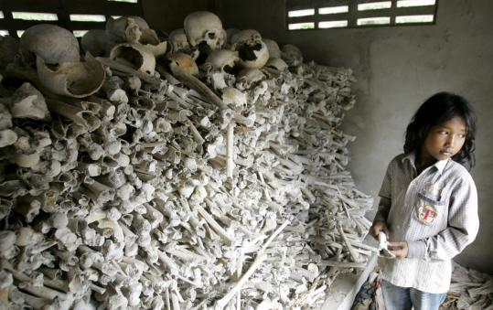
Although Pol Pot died in 1998, the tremendous effects of the Khmer Rouge are still felt throughout Cambodia today. The massive destruction, murder, and feelings of mistrust the Khmer Rouge enacted have prevented the state from developing alongside of its neighbors. It speaks for the strength of the Khmer people that the country has managed to develop tremendously in multiple ways. Though they may still have a long way to go, Cambodia has managed to overcome the impossible with great stride and promise.

Political development:
The effects of the Khmer Rouge can still be seen in Cambodian politics, and have shaped the way administrators in the country rule over their citizens. As Evan Gottesman, author of Cambodia After the Khmer Rouge, writes, “Cambodia’s leaders have accepted a new level of political discourse, but they do so only to the extent that it does not jeopardize their power. This strategic, self-serving adaptation has, in fact, been the hallmark of their rule since 1979 [the fall of the Khmer Rouge]” (Gottesman). After seeing how quickly the Khmer Rouge rose to power, it is understandable that Cambodian politicians feel the need to secure their positions. However, the government’s refusal to acknowledge criticisms has limited the freedom and futures of Cambodians. Despite a relatively smooth political transition within the past fifteen years, the country lacks the necessary opportunities for expression and freedom from corruption.
Cambodia operates today as a parliamentary representative democracy under a constitutional monarchy. The constitution of Cambodia was promulgated in 1993, and guarantees universal suffrage to both men and women at 18 years of age. The Global Integrity Report 2008 gave Cambodia a score of 86 out of 100 for public participation in elections and received a score of 75 for election integrity. Though the elections were by no means perfect, Cambodia’s score of 75 is rather striking considering the United States received a score of 82 this past year, and that an exceptionally high score is 92 (Canada). Neighboring countries Vietnam and Thailand scored 62 and 56 respectively, making Cambodia more developed in this aspect of political life.
Cambodia’s king, Norodom Sihamoni, operates more as a symbolic figurehead than as an actual political leader. The real source of power lays with Hun Sen, the Prime Minister. “His Cambodian People's Party (CPP) uses its control of the National Assembly as well as the military, courts, and police to remove and outmaneuver all opposition” (The UN Refugee Agency). The CPP has also guaranteed political victory by rewarding citizen support with “gifts,” such as bags of rice, from numerous headquarters scattered throughout Cambodia. Even if opposing parties managed to overcome both formal and informal government barriers, it would be nearly impossible to compete with the widespread resources and influence the CPP has managed to gain over the years.
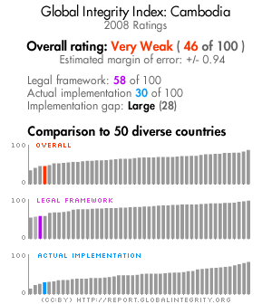
Even with its tremendous progress, Cambodia is not considered to be anywhere close to an open and accessible democracy. In the words of Gottesman, “…Cambodian democracy often seems like an abstraction. The government ignores reports of corruption and human rights abuses. The courts remain corrupt, politicized, and for most citizens, geographically inaccessible and prohibitively expensive. Soldiers and police are never prosecuted for abuses, prompting nongovernmental organizations to write lengthy reports on the problem of impunity, reports that themselves are ignored” (Gottesman).
In its 2009 Freedom in the World report, Freedom House characterized Cambodia as being a country which is politically “not free.” Out of a possible score of 7 (with 7 being the worst), Cambodia received a 6 for political rights and a score of 5 for civil liberties. The government does not tolerate criticisms of the state or fully recognize freedom of speech and long periods of detainment for political opposition are commonplace (The UN Refugee Agency). In 2008, Transparency International ranked Cambodia 166 among 180 countries for high levels of corruption (Transparency International). In comparison to its neighbors, Cambodia was measured to have higher levels of corruption than Vietnam, Thailand, and Laos (Transparency International) (See Figure 1). The Global Integrity Report 2008, which also measure levels of corruption in governments, has categorized Cambodia’s integrity as “very weak.” The score assessed for Cambodia (pictured above) is 46 out of a possible score of 100, and in comparison to 50 other diverse countries, Cambodia scored well below average.
Women, who were once highly respected in ancient Cambodia, are today the victims of prevalent economic and social discrimination. Sex trafficking has become a colossal problem in Cambodia. Due to little or no economic prospects, Cambodian women from the countryside move to cities such as Phnom Penh to earn a living through prostitution. Additionally, prostitutes have been brought into the country from neighboring Thailand and Vietnam to work in cities where “sex tourism” turns big profits. Traffickers purposefully addict their workers to drugs in order to ensure that they will remain dependent on the brothel for income, drugs, and livelihood. In February 2008, legislation was passed to enable police raids on brothels, however, studies have shown that police have abused this right to bribe and blackmail prostitutes and brothel owners (Global Integrity).
A country is not developed if there are not opportunities for political expression and freedom. In terms of political issues, Cambodia is far from being developed. High levels of corruption plague the government, which allows for many injustices to be committed against the Cambodian population. Despite considerable development in election integrity, political opposition in the form of social freedoms and political parties are silenced, which creates obstacles for political opportunity in Cambodia. There is however, great promise for future development, with a population with high levels of participation and a culture of resilience, considering the ghosts which haunt Cambodia’s past.
Figure 1: 2008 Transparency International CPI
Country | Country Rank | 2007 CPI Score
Thailand | 80 | 3.5
Vietnam | 121 | 2.7
Cambodia | 162 | 1.8
Laos | 151 | 2.0
U.S.A. | 18 | 7.3

Economic Development:

Cambodia is by far one of the poorest countries in Asia. Although it has experienced recent GDP growth, Cambodia has the lowest GDP per capita and the highest poverty rates when compared to geographically similar countries. According to the World Bank, Cambodia’s GDP per capita, PPP (constant international $) in 2008 was $1,760, with a rank of 187th out of 228 countries (CIA). Compared to the 1998 GDP per capita, PPP (constant 2005 international $) of $863, GDP per capita, PPP has more than doubled over ten years. Although this is very positive growth, when looking at other countries in Southeast Asia such as Laos, Vietnam, and Thailand, one can see that Cambodia is still far behind. (See Figure 2)
Figure 2
Source: World Bank Indicators, 2009

According to the United Nations, Cambodia is classified as a Least Developed Country, along with other such countries as Haiti, Afghanistan, Rwanda and Sudan (UN-OHRLLS). While Cambodia’s GDP per capita, PPP (constant 2005 international $) is higher than that of the LDCs, which is $1,253, this very slight advantage of only $500 indicates that Cambodia really is one of the poorest countries in the world (See Figure 2). Seeing this comparison to the world and some of its bordering countries in Southeast Asia, it is clear that, in terms of GDP per capita PPP (constant 2005 international $), Cambodia is an extremely underdeveloped country.
Not only does Cambodia have a very low GDP per capita (PPP), but income is also distributed rather unequally. On the GINI Index Cambodia received a 43 in 2007, making it the 51st most unequal country in the world, worse than Thailand (ranked 55th), Vietnam (ranked 78th), and Laos (ranked 88th) (CIA, 2010).
While these figures show that income inequality is roughly the same throughout Southeast Asia (since the GDP per capita of all of these countries is higher than that of Cambodia), the 3-4% of the income in all of these countries will be higher than the 3% of income in Cambodia. Therefore Cambodians are really the poorest of the poor. According to the World Bank, in 2004 the percentage of the population living at or below $1.25 a day was 40%. When looking at the population living below $2.00 a day, however, there is a staggering jump in Cambodia to 68% of the population. $0.75 more income per day only marginally makes a person or family better off, so it is safe to say that almost 2/3 of the population of Cambodia lives in poverty (The World Bank Group).

Figure 3

Source: World Development Indicators, 2009

Cambodia’s population is largely rural (78%), which makes Lipton’s urban bias an especially significant feature of the economic and political landscape. As shown in Figure 4, the percentage of the rural population below the poverty line is more than twice as high as the percentage of the urban population below the poverty line.

Figure 4

Source: World Development Indicators, 2009
Regional income inequality in Cambodia also falls right along these lines of the urban/rural divide. Looking at the map below, one can see that in the city of Phnom Penh there is only 4.6% poverty. In the plateau/mountain region there exists 52% poverty because not only is this a very rural zone and obviously there will be more poverty, but because of quality of the land in mountainous regions, agriculture will ultimately be less efficient and productive.
Figure 5- Incidence of poverty by broad geographic zones, 2003-2004
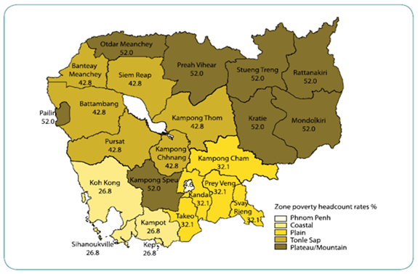
Source: UNDP Cambodia Human Development Report, 2007
While the income level, based on the GDP per capita, has improved in recent years, it is still extremely low compared to the rest of the world. Cambodia is far from being considered “developed” with such a low income per person and such widespread poverty which is then compounded by the problem of inequality. When compared with its neighboring countries, Thailand, Laos and Vietnam, Cambodia is by far the poorest. Cambodia’s GDP and level of income is not allowing its people to provide basic human needs and therefore is considered underdeveloped in this area by our definition.

Education:
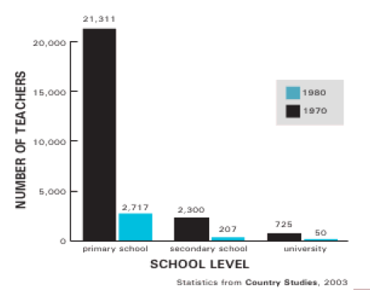
As with other aspects of development in Cambodia, the devastating effects of the Khmer Rouge regime are still apparent in the education sector today. Cambodia’s contemporary educational system has only existed for less than a century and has developed quite deliberately due to various changes within the political and social system over time. Unfortunately, the majority of the progress that was made up until the 1970's ended with the civil war, which led to the rule of the Khmer Rouge regime.
Figure 6: Number of teachers, 1970 and 1980
The Khmer Rouge was notorious in their efforts to revolutionize Cambodia's citizens, emphasizing labor over education. People who had obtained a higher education were killed, driven out of the country, or forced to work in labor camps. Figure 6 illustrates the drastic change in the number of teachers before and after the regime. More often than not citizens would have to lie and refrain from speaking so as not to reveal they have been educated.
The regime took part in demolishing institutional infrastructure and materials within the educational sector such as schools and books. While education as a whole was not completely banned, in principle the colonial education that was practiced prior to the Khmer Rouge regime was viewed as suspicious, leading to many teachers who fled or died during their rule. In the end, it is estimated that only 15% of educated Cambodians survived the mistreatment throughout the regime (Gottesman).
It should be no surprise therefore, that in 2007 the adult literacy rate was only 75% (68% Female/86% Male). The 1980's and 1990's were a long period of both relief and major reconstruction, exemplifying “one of the regime’s greatest achievements” (Gottesman). Despite all of the external aid and optimism for a new and improved sector, the results were disappointing. Efforts made at recruiting educated intellectuals (referring to those who have attained a high school diploma) into the state apparatus were inefficient, as most ‘intellectuals’ had already fled to the Thai border in fear that the PRK would only repeat the communist policies of Democratic Kampuchea (Gottesman). As one Vietnamese advisor reported back to Hanoi, the “intellectuals” were ideologically unsound, isolated from the public, and uninterested in the collective benefit, being very cynical in nature as they had no respect for their rulers who [led] the country with what they believed to be “so little knowledge” (Gottesman). In 2006, conscription laws for the army changed the requirement of military service from 5 years to 18 months. We believe that this military service requirement takes a big toll on education, as it disrupts students’ educations before they have worked in their area of expertise, reducing the likelihood of pursuing what they were once studying (Gottesman).
It is quite evident that the history of the Khmer Rouge lies at the heart of many development problems within the education sector in Cambodia today, affecting the infrastructure, the quality of education, the number of instructors, as well as the number of students where schools actually are available. While education had had “nowhere to go but up” after the past 3 decades, improvements have not happened as rapidly as one would hope. Although there have been some improvements in the gender gap in education, there are still many disparities in educational attainment levels when comparing the different provinces of Cambodia.
When compared to all other East Asian and Pacific countries, Cambodia’s completion rates of primary and secondary school are significantly lower. In 2007, Cambodia's primary completion rate was 85%, in comparison to 99.8% in the rest of East Asia and the Pacific. Although Cambodia’s primary completion rate has increased in recent years (up from 47.2% in 2000), the country’s progression rate to secondary schools was a mere 30.6% in 2006, indicating a massive drop off. The gross enrollment rate (%), or the number of students enrolled in all forms of education as a percentage of the official population of school age students, was 40.4 for Cambodia in 2007, compared to 73.1 for all other East Asian and Pacific countries.
While females are not completely absent from higher education as a whole, they make up merely a third of tertiary enrollment. The opportunity to attain the basic right to an education is absent from Cambodian society today. Therefore, in assessing Cambodia's current state with our working definition of development, the education sector while vastly convalescent over the past three decades, remains inadequate.
While much progress has been made throughout the decades since the devastation of the Khmer Rouge regime, there still remains a wide discrepancy between male and female enrollment rates which prevents the opportunity for advancement in the social realm for many females. Even as the literacy rate improves and more educational institutions are built, the gap is persisting, which indicates a need for development to provide more opportunities for the school age population, especially for females in Cambodia today.

Health:
Figure 7: Life Expectancy (2006)

Cambodia has made notable progress in health outcomes over the past two decades. From 1990-2006, the infant mortality rate decreased from 85 to 65, the under-5 mortality rate decreased from 116 to 82, and the adult mortality rate declined from 263 to 257 (WHO). During this same period, life expectancy increased from 59 years to 62 years, and malnutrition declined in prevalence in children under age 5 (The World Bank Group).
Despite this progress, Cambodia continues to rank lower than its neighbors on virtually all major health indicators. With a life expectancy of only 62 years, Cambodia ranks 177th out of 224 countries. As shown in Figure 7, in 2006, life expectancy was 10 years less in Cambodia than in Vietnam or Thailand. Similarly, with the exception of Laos, Cambodia had the highest adult mortality rate, under-5 mortality rate, and infant mortality rate out of all of these countries (Figure 9).

Figure 8: Mortality rates

 | 1990 | 2000 | 2006
Infant mortality rate | 85 | 78 | 65
Under-5 mortality rate | 116 | 104 | 82
Adult mortality rate | 263 | 307 | 257

Source: World Health Statistics, 2008

Figure 9: Mortality Rates (2006)

Source: World Health Statistics, 2008

Leading Causes of Death:

According to the World Health Organization, the top five causes of death in 2002 were HIV/AIDS (10%), tuberculosis (8%), diarrheal diseases (7%), perinatal conditions (7%), and lower respiratory infections (5%) (Figure 10). Among children, vaccine-preventable diseases, diarrhea, pneumonia, and respiratory infections are the leading causes of death (Unicef). Among people 15-49 years old, the prevalence of HIV/AIDS has greatly decreased, from a peak rate of 3.0% in 1997 to 0.8% in 2007. In particular, rates of HIV/AIDS have declined among high-risk groups such as brothel-based sex workers (from 43% in 1997 to 21% in 2003), non-brothel-based sex workers (from 18% in 1998 to 12% in 2003), and male police officers (from 4% in 1998 to 3% in 2003). This progress is largely attributed to government initiatives promoting 100% condom use and increasing the availability of services related to the care and treatment of sexually transmitted infections. The Ministry of Health has also introduced voluntary, confidential counseling and testing as an important intervention in HIV prevention strategies. If present interventions are sustained, projections indicate that HIV prevalence should continue to decline, stabilizing at 0.6% by 2011 (World Health Organization).
Figure 10- Top 10 causes of Death in 2002
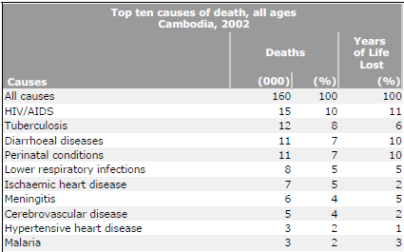
Source: http://www.who.int/whosis/mort/profiles/mort_wpro_khm_cambodia.pdf

Malnutrition

Although child nutrition has improved in Cambodia, the prevalence of malnutrition also remains alarming high. As shown in Figure 11, Cambodian children exhibit four times more instances of underweight and nearly 3 times more cases of stunting than children in Thailand. In 2006, 44% of children under 5 years old exhibited stunted growth, and 28% of the population was underweight. Malnutrition is associated with multiple health problems such as delayed mental and motor development in children and increased risk of developing coronary heart disease, diabetes, and high blood pressure as an adult. Because malnutrition compromises the immune system, children who are moderately underweight are more than four times more likely to die from infectious disease, when compared to well-nourished children (United Nations Development Programme). While malnutrition affects all age groups, it is concentrated among poor people and those with inadequate access to health education, clean water, and proper sanitation.

Figure 11: Country Comparison of Malnutrition prevalence (2006)

Source: World Development Indicators, 2009
*All values given for the year 2006, except for Lao PDR, which is from the year 2000.

Health Disparities:

While the aforementioned health issues are problematic throughout Cambodia, the burden of death and disease rests largely on the poor and disempowered, as clearly demonstrated in Cambodia’s existing health disparities. As shown in Figure 12, child mortality rates reveal significant differences by income, geographical location, and education. According to the World Health Organization, the under-5 mortality rate was 111.0 in rural areas, as compared with 75.7 in urban areas in 2005. When comparing levels of education and wealth, the under-5 mortality rate was 2.6 times higher for mothers of lowest educational levels when compared to mothers of the highest education level, and 3.0 times higher when comparing mothers of lowest and highest income levels. This means that before a Cambodian child even reaches the age of 5, her health will be influenced significantly by such factors as where she was born, what her parents earn, and whether her mother had the opportunity to pursue an education.

Figure 12: Under-5 mortality rate by income, location, and mother’s education

Under-5 mortality rate:
Highest and lowest quintiles
Wealth/asset quintiles | Lowest | Highest | Ratio
 | 127.0 | 43.0 | 3.0
Urban/Rural | Rural | Urban | Ratio
 | 111.0 | 75.7 | 1.5
Mother’s education quintiles | Lowest | Highest | Ratio
 | 135.7 | 53.0 | 2.6
* All values for the year 2005 (Source: World Health Statistics 2008)

Location is also a powerful determinant of health, in terms of access to clean water and sanitation facilities. In 2006, only 28% of the population had access to improved sanitation facilities. These facilities were available to 62% of the urban population, as opposed to only 19% of the rural population. Similarly, 80% of urban residents had access to an improved water source, in comparison to only 61% of the rural population. In the absence of potable drinking water, villagers in rural areas must often resort to drinking water from lake and rivers, increasing the risk of acquiring diarrhea and other preventable water-borne illnesses (Figure 13).

Figure 13: Access to sanitation and drinking water

 | %
Population with sustainable access to improved drinking water (% rural) | 61
Population with sustainable access to improved drinking water (% urban) | 80
Population with sustainable access to improved sanitation (% rural) | 19
Population with sustainable access to improved sanitation (% urban) | 62
* All values for the year 2006
Source: World Health Statistics, 2008

Maternal Health:

One major health priority is improving the status of maternal health in Cambodia. Each year, approximately 2,900 Cambodian women and girls die from pregnancy-related complications (accounting for 18% of all deaths among Cambodian women aged 15-49 years), and 58,000 to 87,000 women and girls needlessly suffer from disabilities related to pregnancy and childbirth (USAID). With an average of eight women and girls dying during childbirth every day, Cambodia has the third highest maternal death rate in Southeast Asia, after Laos and East Timor. Moreover, the lifetime risk of dying from pregnancy-related complications is 2%. In other words, one in every 50 Cambodian women will die because of pregnancy-related complications (Yanagisawa, Oum and Wakai).
In 2006, the maternal mortality ratio was an astounding 540 deaths per 100,000 births. To compare, the maternal mortality ratio in the United States that same year was 11. Compared to its neighbors, women in Cambodia were 3.6 times more likely to die in childbirth than Vietnamese women and nearly five times more likely to die in childbirth than women in Thailand (Figure 14).
Figure 14: Maternal Mortality Ratio (2006) ¹⁷

Although progress has been made in increasing the availability of obstetric care, a vast majority of Cambodian women still do not have access to quality, long-term reproductive health care and family planning services. In 2005, only 44% of births were attended by a skilled health professional (The World Bank Group). Twenty-one percent of women receive absolutely no prenatal care. Moreover, there is a significant urban bias in access to safe motherhood services, as shown in Figure 15.
The data in Figure 15 come from a 1999 study on maternal and neonatal heath services conducted by 750 reproductive health experts. On a scale of 0 to 100 (with 0 as the worst and 100 as the best), this study demonstrated large disparities in rural and urban access ratings, particularly for the treatment of obstructed labor (8 vs. 90, respectively), 24-hour hospitalization (15 vs. 86), and treatment for postpartum hemorrhage (15 vs. 85). Taken together with Cambodia’s high maternal mortality rate of 540, it is clear that basic maternal health needs are not being met.

Figure 15- Comparisons of access to services for rural and urban areas in Cambodia
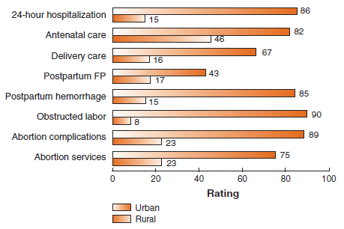
Source: http://pdf.usaid.gov/pdf_docs/PNACR871.pdf

Health Care System: Workforce, Financing
Currently, the Cambodian health system lacks funding and health care personnel, which severely limits people’s access to adequate health care services. Although there is no universal standard that can be used to assess the size of the health workforce needed to address the health care needs of a given population, it is estimated that countries with fewer than 25 health care professionals (physicians, nurses, and midwives) per 10,000 people fail to achieve adequate coverage rates for primary health care interventions that have been prioritized by the Millennium Development Goals framework (World Health Organization). As shown in Figure 28, in 2000, Cambodia had only 2 physicians, 9 nursing and midwifery personnel, and <1 dentistry personnel per 10,000 population in the year 2000 (WHO).
Figure 16:
Health Care Workforce | Value
Dentistry personnel density (per 10,000 population) | <1
Number of dentistry personnel | 209
Nursing and midwifery personnel density (per 10,000 population) | 9
Number of nursing and midwifery personnel | 11,125
Physician density (per 10,000 population) | 2
Number of physicians | 2,047

Source: World Health Statistics, 2008

In 2005, total health expenditures per capita (PPP $ international) were $167. Of these health expenditures, government expenditures accounted for only 24.2 percent, out-of-pocket expenditures accounted for 60.1 percent, and 15.7 percent were accounted for by other private sources like NGOs (Figure 17). Comparably, individuals therefore pay a disproportionately high amount of out-of-pocket expenses to cover health care costs. With 68% of the population living on less than $2/day, health costs therefore pose a massive barrier to health care, indebting many who receive health services and deterring others from seeking out any type of health care.

Figure 17: Total Health Expenditures in 2005

Source: World Health Statistics, 2008

Health Care: A Summary
Taking into account present data, the health status of Cambodia is in poor shape. Not only do Cambodians lack access to clean water, proper sanitation, and adequate health care services, but they lack a public health system to cover the few health care costs they may incur as well. Despite improvements in life expectancy and infant mortality, Cambodia’s health status trails far behind its Southeast Asian neighbors and remains among the lowest in the Asia-Pacific region. Most importantly, any progress that has been made has been uneven. Children from lower-income, less educated backgrounds suffer much worse health outcomes, and health disparities in rural versus urban areas persist.
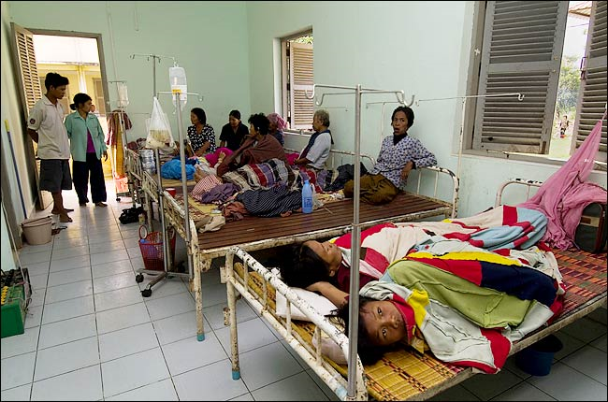
Our development approach is based on the premise that every person has the right to a long and healthy life. An individual’s health should not be determined by his or her level of education, income, or geographical location. While maternal death is virtually unheard of in developed countries, each year, preventable pregnancy-related complications continue to deprive thousands of Cambodian women and children from a long, healthy life. Addressing these fundamental health issues is therefore a crucial element of our development proposal.

Why Maternal Health Matters:
As one of the eight Millennium Development Goals, improving maternal health is itself an important achievement. At the same time, improved maternal health has a large impact on other aspects of development as well. The presence of a healthy mother in the household provides cohesion and stability on the household and does not burden the father or older siblings with taking care of a newborn and having to sacrifice time spent working to earn income for the family. An increased maternal mortality rate also reduces the number of able-bodied people in the workforce. According to the Department for International Development, maternal death is the leading cause of death for girls ages 15-19 in developing countries (Department for International Development). In a country such as Cambodia with half the population under the age of 21 years, they cannot afford to be losing such a large portion of the work-force at such a young age.
In addition to maternal deaths, pregnancy-related complications that result from lack of trained personal during delivery can cause life-long disability, pain, and even socio-economic exclusion. Many women in developing countries such as Cambodia also suffer from post-natal depression which can impact not only their own mental and physical health, but that of their child.
While the benefit to the mother of receiving improved maternal healthcare is immense, the health benefits children receive from improved maternal healthcare have a much larger impact on society and development as a whole. The mother’s nutrition during pregnancy has a direct impact on a child’s cognitive and physical development as well as on the survival chances of a newborn. “Denied [vital nutrients] in the womb and in infancy, children suffer irreversible brain and nervous system damage, even if they appear well-fed” (Wines). Because of a lack of antenatal care, many mothers in Cambodia do not know the correct foods to eat while pregnant and are not taking in the vitamins and minerals essential for proper development of their baby. As a result, many children are stunted and malnourished. Because of this stunting, children are not only unable to concentrate in class, but physically unable to learn and absorb information as much as they may want to or try. Prenatal and antenatal care for mothers can help lower the number of stunted and malnourished children and help them get the most out of their time in school.
By laying the foundation for proper child physical and cognitive development through the provision of proper maternal healthcare, maternal health leads the way for progress and growth in other areas of development. The healthier children are, the more they will benefit from receiving an education. Properly educated children then are more likely to get a better, higher-paying job and they are therefore in a better socio-economic position than they previously were. Following from this are all sorts of development in the areas of the economy and politics because once people are making enough money to not be concerned about starving to death, they can start thinking about things such as political freedoms. The most important aspect of maternal health being a necessary requisite for development is that it places the emphasis on cultivating a healthy population and the eventual establishment of a “for the people, by the people” sustainable development approach. Development is a chain reaction; the establishment of proper maternal healthcare will lay the groundwork for future development in other areas.

What are current Non-Profits/NGOs doing?

Cambodia Midwives Association (CMA):

The CMA provides free educational materials (modules, DVDs, and videos) on midwifery. Modules were released in 1996 and 2007 and designed to complement clinical tools and tools for management, planning, and training. Scholarly publications and articles related to maternal and newborn health can also be found on their website, http://www.internationalmidwives.org.
Contact information for the Cambodia Midwives Association is as follows:
Cambodia Midwives Association (CMA)
P.O. Box 976
Phnom Penh
Cambodia
Phone: +855 23 626 98 Email: cma@forum.org.kh
Fax: +855 23 248 75

Cambodian Women Health Organization (CWHO):

The Cambodian Women Health Organization (CWHO) was founded in 2005 by obstetrician-gynecologist Dr. Hay Meas, along with a team of Cambodian expatriate health care professionals in the United States, Canada, and France. CWHO focuses on developing funding and programs to deliver free quality health care services to poor women in Cambodia. Since 2005, CWHO has implemented two pilot programs in Kampong Thom Province, training a total of 52 rural midwives. The organization’s long-term goal is to establish a rural maternal health care center, operated under the supervision of a directing MD and staffed by CWHO trained health care professionals and rural midwives. The maternal health center would provide comprehensive maternal services starting from conception to post-partum services and beyond, including; training for health care professionals to become certified midlevel nurse midwives, primary rural midwives, and traditional rural midwives; pregnancy examinations (e.g. comprehensive prenatal care, laboratory blood screening, and ultrasound to detect possible deficiencies or diseases), postpartum care and annual gynecologic screening, on-site delivery services, post-partum services during the first 2 months after delivery, and group counseling for health maintenance and infant care. CWHO maintains staff and fundraising activities in Seattle, Washington. More information can be found on their website, http://c-who.org.

Health Unlimited in Ratanakiri:

Health Unlimited is an International NGO established in 1984 which has projects that span over 15 developing countries. The organization primarily partners with communities and policymakers to run projects aimed at improving maternal health, increasing HIV/AIDS prevalence, and reducing various illnesses such as TB and malaria. The program in Ratanakiri has been running for 14 years, employing 65 local staff, all funded by various donors. Their efforts have supported over 100,000 poor and indigenous people throughout the province. Their referral hospital and 10 health centers are currently the primary source of maternal care in Ratanakiri. The organization emphasizes the participation of rural women in giving the minorities a voice, and a safe space to come together, and learn more with the numerous outreach programs available to all . Health Unlimited has built a strong foundation of trust with rural villagers, a task that may not be easy for us to overcome. We therefore hope to partner with Health Unlimited in order to ease the initial process of establishing MARC as a credible NGO. More information can be found on their website,
http://www.healthunlimited.org/programs/asia/cambodia.

Reproductive and Child Health Alliance (RACHA):
RACHA is a Cambodian-based NGO that was founded in 2003. The organization focuses on maternal, newborn, and child health; family planning; HIV/AIDS, and infectious disease (primarily tuberculosis and malaria). It works in eight provinces, 164 health centers, and 2,329 villages, serving an estimated population of more than 2 million people. RACHA does not provide independent health services or operate health facilities, but instead operates within the Ministry of Health (MoH) service network to identify program priorities, implement effective intervention programs, influence national policy, and advocate for relevant community-based health programs. RACHA has become a well-respected authority on community health programming and maintains partnerships with key departments of the MoH (such as the National Maternal and Child Health Center [NHMCHC] and the National Centre for Health Promotion [NCHP]); provincial and district health departments; local community structures (such as the Village Health Support Groups and Commune Councils); and global partnerships such as ACCESS, BASICS, and A2Z. RACHA’s website served as a major resource for information on midwifery in the formation of this report. More information can be found on RACHA’s website, http://rc.racha.org.kh/.

Reproductive Health Association of Cambodia (RHAC):
RHAC is a Cambodian NGO that focuses on sexual and reproductive health, maternal and child health, TB, and HIV/AIDS. It was founded in 1996 and currently offers health services at 16 clinical sites (9 clinics and 7 health posts) in Phnom Penh, Battambang, Preah Sihanouk, Kampong Cham, Kampong Speu, Kampoung Chhnang, Svay Rieng, Prey Veng, Siem Reap, Takeo, Mondulkiri, and Pailin.
The maternal and reproductive health services offered include:
- Family planning services, including pill, condom, injectable, IUD, Norplant, and voluntary surgical contraceptives(VSC)
- Antenatal Care and Postnatal Care
- Emergency Contraception
- Rape victim support, including diagnosis, treatment, counseling, and referral
- Early diagnosis and treatment of cervical carcinoma
- Post-abortion care and manual vacuum aspiration
- Counseling on menopause
- Counseling and screening for infertility
- Voluntary and confidential counseling and testing
- Diagnosis and treatment of sexually transmitted diseases/reproductive tract infections
- Prevention of mother-to-child transmission of HIV/AIDS
- Premarital screening, counseling, and testing

Specific maternal and child health programs also include child immunizations, bi-annual distribution of vitamin A capsules, and improved treatment of major illnesses among young children such as acute respiratory infections and diarrhea. RHAC maintains a robust outreach program, with volunteers working in 6 provinces and 3 municipalities, serving approximately 3,300,000 people in 3,480 villages and 223 health centers.
Financial and technical support is received through the following services:
- United States Agency for International Development (USAID)
- Global Fund to Fight AIDS, Tuberculosis, and Malaria (GFATM)
- United Nations Population Fund (UNFPA)
- European Commission (EC)
- Ministry of Health (MoH)
- International Planned Parenthood Federation (IPPF)
- Japan Trust Fund (JTF)
- Japanese Organization for International Cooperation in Family Planning (JOICEP)
- Japanese Organization for International Cooperation in Family Planning (JOICFP)
- Australian Family Planning Association
- World AIDS Foundation

More information can be found on their website, http://www.rhac.org.kh/index.php.

Project Proposal

Cambodia’s alarming maternal death rate, along with our prioritization of health care as the foundation for sustainable development, has led us to focus on a project that will increase the number of certified midwives in Cambodia. According to the Cambodia’s National Maternal Child Health Center, there were 370,000 births but only 3,300 trained midwives in Cambodia in 2009. As described earlier, Cambodia is in dire need of trained birth attendants, particularly in rural areas.
We feel that midwives are the most promising weapon in combating maternal death rates. When trained properly, midwives can provide the life-saving health services to Cambodian women while breaking down cultural reservations normally associated with hospitals and other forms of healthcare providers. The Ministry of Health notes that, “Traditional beliefs that negatively influence delivery practices, health seeking behavior, and child feeding practices remain prevalent across the country, more so in rural areas and in families with low and very low income” (Cambodia Ministry of Planning). Keeping this information in mind, our project will aim to increase the availability of midwife services to rural women in Cambodia, who are often unaware of the benefits of midwives or unable to access them due to transportation issues.
Our proposal recommends the building of a women’s center in a rural village that would serve to train new primary/secondary midwives, retrain current midwives, provide information to young local women of university/government midwife programs, and serve as a community resource for local women who need advice or assistance in the areas of pregnancy, antenatal care, and family planning. This project would be very cost-effective and sustainable, because it would require limited training materials and rely on experienced midwives to train new and lesser experienced women in their local community. The community center would provide a preferential option for poor families and help to build social capital in a country still recovering from the aftermath of the Khmer Rouge. By addressing this unmet health need, we hope to eliminate barriers to maternal health care and ensure that each woman has the resources for a safe and healthy pregnancy.

How MARC is Different from Other Initiatives:

While other NGOs in Cambodia also focus on maternal health, MARC is unique in several respects. First, our pilot project would provide midwifery training that expands upon current programs that are offered. Current government-sponsored midwifery training programs are not comprehensive and do not meet minimum standards of basic and essential midwifery competencies. According to Cambodia’s Comprehensive Midwifery Review (2006), 40% of midwives surveyed did not feel confident in basic midwifery skills such as conducting a normal birth or assessing a newborn after a delivery (Cambodia Ministry of Planning). To address this concern, there is a strong need to ensure that midwives are trained in minimum competencies and periodically refresh and update their knowledge and skills.
By targeting rural villagers in Ratanakiri Province, MARC also targets a population that has been overlooked by other organizations. Women in rural communities suffer the worst health outcomes and demonstrate the greatest need for skilled health professionals and health care services. Through various outreach activities and the eventual creation of a mobile health clinic, MARC seeks to bring these resources to the most vulnerable and isolated people of Cambodia.
Finally, MARC hopes to foster communication among maternal health organizations and the Ministry of Health. Through partnerships with the Ministry of Health and other NGOs, we hope to collaborate in our efforts and bridge the gaps between knowledge and action.

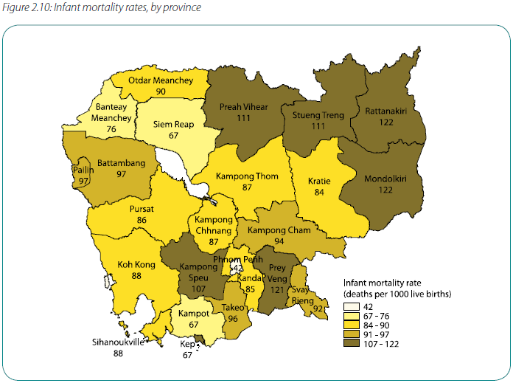
Why Ratanakiri?
Figure 18: Infant Mortality Rates by Province
For the purpose of this project, we have chosen to focus on improving maternal health services in Ratanakiri, a province located in northeastern Cambodia that borders Laos and Vietnam. Ratanakiri is distinguished from other provinces in Cambodia by its indigenous majority, which is composed of at least eight different ethnic groups comprising 65% of the province’s total 150,000 inhabitants. This largely indigenous population is marginalized both physically and culturally, due to the physical remoteness of Ratanakiri and the discrimination that indigenous people experience from Khmer people. These barriers constrain women from seeking out treatment and accessing various health services. Given its weak infrastructure, limited public health facilities, and relatively low number of trained health professionals and available health services, we have identified Ratanakiri as the least developed province in Cambodia, therefore deserving the most attention.

Maternal and Child Health in Ratanakiri:
Indigenous women in Ratinikiri face multiple risk factors during their reproductive years that negatively impact their health and the health of their children. These include:
- Young Age at First Birth- Ratanakiri has one of the highest pregnancy rates in the country among teenage girls, with 20% of births occurring among women between the ages of 15 and 19 years, compared to a national average of 8%. Giving birth at an early age before a woman’s body has fully matured can lead to dangerous complications during pregnancy and childbirth.
- Short Birth Intervals- Over 30% of women in Ratanakiri give birth within 24 months of their previous child. Short birth intervals often have a negative impact on the health of the child and the mother.
- High Fertility Rate- The average woman in Ratanakiri gives birth to 6 children in her lifetime, compared to a national fertility rate of 4 births per woman. High fertility rates can pose danger to a woman’s risk of pregnancy-related complications, especially for older women.
- High Levels of Malnutrition- According to a 2002 nutrition study by Health Unlimited (an NGO based in Ratinikiri), 18% of mothers were underweight and 38% were less than 57 inches (148 cm) in height. Malnourished women are at high risk of experiencing complications during delivery and birth, irrespective of their specific obstetric or gynecological history.
- High Rates of Anemia- The Cambodian Demographic and Health Survey (2000) found that 63% of women between the ages of 15-49 years in Ratanakiri and Mondulkiri provinces were anemic, a condition that increases risks of complications during pregnancy and childbirth.
- High Levels of Malaria- Malaria is prevalent in most hilly and forested areas of Cambodia such as Ratinikiri. Because pregnancy compromises the immune system, pregnant women are at an increased risk of contracting malaria and subsequently facing miscarriages, stillbirths, and other birth complications.
In addition to its startling maternal health statistics, Ratanakiri maintains very poor health outcomes among infants and children. As shown in Figure 18, Ratanakiri has the highest infant mortality rate in the nation, with nearly one in four children dying before the age of 5. Additionally the province has the highest malnutrition levels and the 2nd highest stunting rate in Cambodia, as shown in Figure 19.

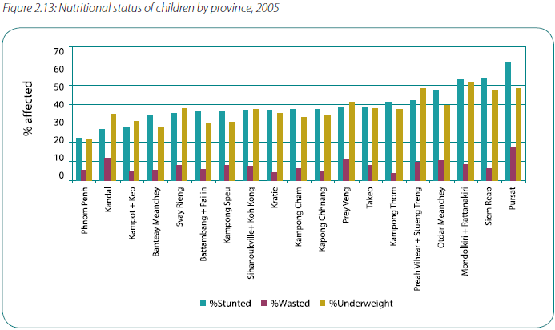
Figure 19- Nutritional status of children by province (2005)

Barriers to Health Care:

Many barriers prevent women in Ratanakiri from accessing maternal health services, including money, transportation, availability of resources, discrimination, and cultural and language barriers.
- Money is the most widely cited barrier to accessing health care, since the majority of people in indigenous communities live at subsistence levels, with limited access to cash.
- The second major barrier is transportation to a health center or hospital. Currently the entire province of Ratanakiri has only one referral hospital (located in the provincial capital of Ban Lung), 10 health centers, and 17 health posts. While the referral hospital does have an ambulance, its referral service is lengthy and too costly for the average person living in Ratanakiri.
- The availability of skilled health professionals and resources is limited. Even if a villager acquires enough money to get to the referral hospital, proper care is not guaranteed for the patient. Most health centers lack adequate equipment and supplies, and there are
only 6 certified midwives in the entire province.
- Discrimination is apparent between health staff and indigenous patients. Studies have revealed that indigenous people prefer not to go to the hospital because the health staff label them as “backward, uneducated, and stubborn”.
- Language is a significant barrier for ethnic minorities. Ninety-eight percent of the indigenous population cannot functionally speak Khmer (Action Research to Advocacy Initiative).
- Traditional beliefs associated with illness can prevent or delay indigenous people from seeking health care, especially in obstetric emergencies. For example, in cases of severe illness, indigenous people may be required to perform ritualistic sacrifices to ancestor spirits before leaving their village. For this reason, many women prefer to give birth at home, in the presence of a Traditional Birth Attendant (TBA) or midwife, as opposed to traveling to a health clinic.
Based on this information, it is clear that there are many obstacles preventing women accessing proper maternal health care in Ratanakiri. With the highest fertility rates and highest infant and maternal mortality in the nation, this province’s basic necessities of maternal and child health care services are not being met. By training more midwives/TBAs and educating women in these marginalized villages, we will be creating the foundation for the future generation of Cambodians.

Background on Midwifery

Midwives are skilled, trained healthcare professionals who provide advice and care for expectant mothers. Midwives carry out examinations during a pregnancy and offer advice and instruction for pregnant mothers before and after delivery. At the time of birth, midwives are there to support the mother and perform the delivery, and are expected to be prepared for various complications that can occur from labor. After the delivery, midwives can also provide care for both mother and baby, giving support for the first couple months of the baby’s life. An example of postnatal support would be instruction on breastfeeding.
It is important to recognize the difference between midwives and trained birth assistants (TBAs), who do not receive the same type of training as a midwife. Their primary role should be limited to assisting women who deliver alone at home, with tasks such as receiving the baby and tying off the umbilical cord. However, many TBAs, especially in the Ratanakiri Province, perform the role of midwives in their communities without having the proper training to assure that delivery is safe for both mother and infant.
As of 2008, there were only 3, 184 trained midwives in Cambodia. The Ministry of Health currently offers two programs to aspiring midwives, which results in certification as a Primary or Secondary midwife. Primary midwives only receive a year of training, which requires them to learn the basics of prenatal, postnatal health, and delivery processes. Secondary midwives receive longer training, with three years education in nursing, and an additional year of exclusive midwifery training. Each midwife can monitor 75 births a month, however, because most midwives live in urban areas, they are often inaccessible to thousands of mothers in need giving birth each year.
The average age of both Primary and Secondary midwives are 39 years, which in Cambodia, is an age nearing retirement. Because most active midwives are older, there is a serious age gap between older and younger women in the field. This age gap is most likely due to the government’s decision to stop all midwifery programs in the mid-90s (the reasoning for which is unclear). Because midwifery programs only resumed in 2002, there is a significant lack of midwives in their late 20s/early 30s. This has resulted in increasing rates of attrition, which threaten to significantly decrease the number of active midwives in the future. The Ministry of Health projects that in 2010, the amount of midwives active in Cambodia will decrease to 2,797. The table below shows some of the differences between the education and employment of Secondary and Primary Midwives.

Figure 20. Demographic description of sub-sample
Total (58 midwives) | Primary Midwives (28) | Secondary Midwives (32)
Average age | 39.2 | 39.3
Average Years experience since qualification | 14.5 (range 1-25) | 16.1 (range 2-26)
Average Years of education before midwifery | 6.2 | 8.8
Average Reported # births attended (last 12 months) | 35.2 (range 5-60) | 66.2 (range 0-220)
Average Reported days of in-service training | 37.2 | 31.9
Site of current practice | 1@health post  25@ health centre | 4 @ private clinic  11@ referral hospital  17@ health centre

Although Secondary and Primary midwives are trained and employed differently in the country, both groups have been found to have received insufficient training in emergency complications, sanitation, and bedside manners, which has led to increased rates of maternal mortality and a mixed sentiment of the field. Here is an observation made by the Ministry of Health fieldworkers that underscore some of the major problems facing midwifery in Cambodia,
While the midwife wore gloves during her vaginal examinations of the mother, she touched unclean things in the room between examinations. The laboring woman was not allowed to have more than one family member present with her in the room used for the birth, although the room was large enough to accommodate 3 or 4. Throughout the second stage of labor the woman remained flat on her back on a bed (know to be harmful). Fetal heart tones or maternal vital signs were not assessed during the 30-40 minutes that the team were in the room before the birth. The midwife rarely spoke with the woman or her family member and rarely had eye contact with the woman or touched the woman during second stage or actual birth to give reassurance… She then placed the baby on a clean sarong on an adjacent table and covered the body, but not the baby’s head. She did not assess the baby after birth, or appear to realize that the baby had some degree of cyanosis. The midwife did massage the uterus after she noted clots coming from the vagina, but did not at that time try to deliver the placenta, as expected had she been following evidence-based standards and protocols. The midwife did not acknowledge any of the woman’s family or offer any reassurance to them that all was well.

The Ministry of Health also found that the majority of midwives who had received training on dealing with emergency situations were not confident in their ability to remedy the situation. One necessary skill midwives should have is confidence and ability in infant resuscitation. Out of 185 midwives surveyed, 70% did not feel confident to perform the skill, 23% of midwives did not know how to perform the skill, and 91% of midwives demonstrated observed lack of competence in the skill. The figure below shows the inadequacies in recognizing and managing emergency situations,
Figure 21:

“While primary midwives assessed themselves lower than secondary midwives in all the 27 competencies, in several competencies, notably taking an antenatal history (ANC) and assisting with immediate breastfeeding (Asst BF), their self-assessments were similar. (Chart 4.3)”

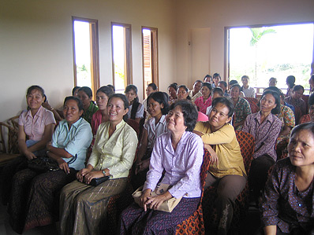
Services MARC Would Provide:
There are two phases of MARC’s pilot program that aim to reduce maternal mortality in the Ratanakiri Province while also increasing the accessibility and quality of healthcare in the region:
- Ban Lung Women’s Center (BLWC)
- Mobile Outreach

Phase 1: Ban Lung Women’s Center (BLWC)
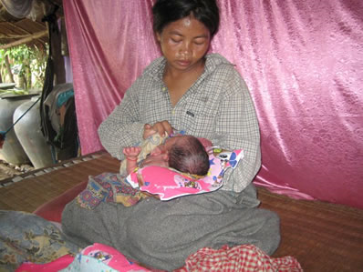
The first phase of MARC will be the creation of the Ban Lung Women’s Center (BLWC). This women’s center is designed to be a resource for local midwives, TBAs, and expectant mothers in the greater Ratanakiri area. The BLWC will be run by two local women who provide administrative support and will allow the center to be accessible to the community all day, every day. Additionally, a permanent midwife will be available on-site to assure that women in emergency situations have a consistent source of care. The on-site midwife will be there to provide prenatal and postnatal check-ups for both mother and baby and also be available for any questions and/or concerns that may arise.
Our rural community women’s health center would provide the following services:
  - Retraining of midwives/TBAs- The center will serve as the main meeting center for the retraining of midwives and TBAs. Retraining will be held as a 1-week course aimed at teaching skills that midwives do not learn in government programs, including infant resuscitation, management of emergency complications, simulated exercises for testing ability in Life Saving Skills (LSS), and proper bedside manners. MARC requires that midwives on staff (approximately 10) demonstrate competency by participating in refresher courses each year.
  - Educational programs for expectant mothers- In addition to midwife services, the BWC will offer classes for rural women. Studies have shown that women who get care during pregnancy are more likely to seek the help of a skilled assistant during labor (Yanagisawa, Oum and Wakai). Possible classes include, “The Importance of Breastfeeding,” “What to Eat When You’re Expecting,” and “Caring For Your Newborn.”
  - Prenatal and postnatal care- Access to prenatal vitamins and midwife support will be available. All services will be free of charge.
  - Transportation to urban health centers- When the time for delivery actually arrives, our services will match women with midwives, who will be able to assist labor in the family home. If an emergency occurs which cannot be properly managed by a midwife, transportation services will be arranged to drive the patient to the local hospital in Banlung. All of these services will be provided at no cost to women in Ratanakiri, which takes a huge burden off the women in the community, the majority of which normally cannot afford the services of midwives.
  - Free educational materials and resources- For midwives and TBAs, resources such as booklets, videos, and trained staff will be available to instruct or refresh the women on relevant skills.

Phase 2: Mobile Outreach Program
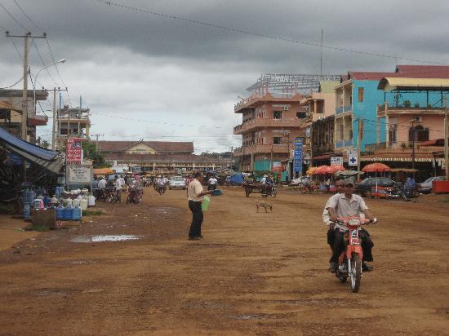
The second phase of MARC entails the creation and deployment of a mobile outreach program that would offer our BLWC services to the greater Ratanakiri Province. Since we recognize that Ban Lung is only home to about 17% of the province, we would like to expand our services to reach the greater population of women. MARC will purchase a van that will be able to store necessary supplies and will be available for our midwives for travel to neighboring cities such as Veun Sai and Lamphot. In this way, our mobile health clinic will provide health care to even the most remote of locations, with our midwives bringing prenatal vitamins, support, and services to aid women throughout pregnancy and labor. This mobile outreach will also be useful in bringing midwives from other cities in Ratanakiri to our BWC if they are interested in our retraining programs and other resources.
We feel that in order to achieve substantial, widespread results, it is essential for MARC and our midwives to be in constant communication with the Ministry of Health’s current programs. This will be a two-way relationship in which government trained midwives and teachers could use our services, and our midwives could attend classes and conferences in Phnom Penh. This bridges the current gap between NGO/non-profit work in the country and Cambodian government.
We envision our center as a safe haven for all women in the community who have the desire to educate themselves and others about maternal/infant health. We hope that this center will increase the confidence of rural women in the services offered by TBAs and midwives, while providing essential services to women in Ratanakiri.

Budget:
To finance the creation of a community center and mobile health clinic in Ban Lung, we have drawn up a tentative budget outlining the anticipated start-up costs and subsequent annual costs of operation. We are asking for a donation of $20,000 from the UNFPA in order to finance the construction of a new building which will be the base of our organization.
To ensure that our organization creates a financially sustainable program in Ratanakiri, we are excited to announce our newest partnership with renowned fashion designer and philanthropist Marc Jacobs. Our new campaign with MARC by Marc Jacobs, entitled MARC for Mothers, will promote a new line of baby bags, with a portion of the proceeds donated to our organization. We anticipate the success of this line because MARC by Marc Jacobs already has many baby bags in his current collections and has already established a consumer base for this type of product. Mothers who purchase these baby bags are likely to sympathize with our cause and be willing to spend slightly more money to support maternal health. Based on the current cost of MARC by Marc Jacobs baby bags, we estimate the bags to cost around $478 (a price that is slightly higher than retail price, to account for a donation). While details are still being finalized, we hope to gain 10% of the profits from each bag sold, amounting to $47.80 per bag. In order to launch the line of baby bags, any purchaser of the bag will be entered to win a trip for two to Cambodia for through a limited-time promotion, including a one-day visit to the Ban Lung Women’s Center so that the woman would be able to see exactly how her donation had benefited the rural women of Ratanakiri.
MARC by Marc Jacobs plans to design the bags to represent Cambodia in a creative and fun way by making the inside lining of the bag a colorful map of the country. We will also use the sale of the bags as a tool to gain recognition for our organization, as there will be a brief description about MARC in each of the bags and contact information if purchasers would like to make subsequent donations. We also plan to insert into the bags a small card with facts about maternal health in Cambodia in order to raise awareness of how serious a problem it is in Cambodia.
Because of the nature of our objectives, our center would require multiple rooms with various functions. Our ideal center would include a kitchen, library/resource room, office, guestroom to accommodate women overnight, prenatal/postnatal screening room, and large classroom for training sessions (See Floor Plan below). The center would be operated daily by an administrative staff member and an on-site certified midwife. Because our on-site midwife would be permanently working through our center, we would pay her a higher salary than the other midwives employed through our organization. In total, we expect to employ 11 midwives, producing an annual expense of $14,340 for our employees’ salaries. Since the average salary for a midwife employed by the government is only $8 per month, we believe that our higher salaries would provide an incentive for recruiting and retaining local midwives. Additionally, we the co-founders of MARC would work on a volunteer basis to manage the operations and finances for the time-being. To coordinate donations and ongoing relationships between funding sources, a member of the staff would remain in the United States, while the remainder of us would be stationed in Cambodia.
Our budget is contingent on the donation of materials and funding from expected donors, including prenatal vitamins, pamphlets, instructional videos/DVDs, and contraceptives. These materials are relatively inexpensive, so in the event that we are unable to procure sufficient donations, we do not expect our expenses to deviate substantially from this initial budget. We
After the building of the center itself, our next major expense will be the purchase of a van to transport women in the event of an obstetric emergency during childbirth. In the future, we also hope to transform the van into a mobile health clinic for outreach activities targeting women in neighboring areas unable to access hospitals or health centers in Ban Lung (Phase II). We plan to purchase a used van with an initial cost of approximately $7,000. After this initial purchase of this van, minimal costs will be needed to cover gas and maintenance costs.

Tentative Budget:

* Construction of new building $20,000
Food (During re-trainings)
2 meals pp x 10 people x 2 times/yr x 7 d = $280
Training materials
TV/DVD player $100
Brochures $500
Video/DVDs $0
Educational modules $0
Materials
Prenatal vitamins $0
Contraceptives $1,500
Miscellaneous $500
Salaries
11 midwives; $1200/yr x 10 = $12,000
1 standby midwife on-site $1,500
1 administrative worker; $70/mo. X 12 = $840
Transportation
Van $7,000
Gas $600
Maintenance Costs $500
Start-Up Cost: $45,320
Subsequent Annual Costs: $18,220

Floor Plan:

Conclusion

To set the stage for further development in Cambodia, we see a need to invest in the creation of a rural community center that focuses on maternal health in Ratanakiri. Although there are a small number of health centers and clinics throughout this province, none focus on the training of competent birth attendants and midwives and the provision of maternal health services in the most rural areas of Ratanakiri. We feel that the rural areas of this province are in most need for maternal health services because of their isolation from health centers and the social exclusion of their indigenous communities. Given the region’s high maternal mortality rates and present lack of skilled midwives and maternal health services, there is great potential for improvement if action is taken now.
As one of the eight Millennium Development Goals, reducing the maternal mortality by three-quarters by the year 2015 is a global objective that is still far from being reached. Prioritization must be given to maternal health, not only because of its relatively slow progress, but because of its link to other aspects of development as well. Because maternal health is directly related to infant and child health, it is foundational to all of the Millennium Development Goals. A sick or malnourished mother passes on health risks to her child that can negatively impact that child’s early physical and cognitive development. Maternal deaths deprive children from the love and care of their mothers, forcing children to grow up in a world with much harsher life prospects and greater responsibilities that hinder their greatest potential.
With an average of 8 women dying in childbirth each day, Cambodia needs further assistance in order to make strides in maternal health. Our project proposal offers an opportunity to change Cambodia’s current state in a very positive way. Each maternal death that is averted offers greater opportunities for that women and her child. With your assistance, we will be able to create a community resource for expectant mothers in rural Cambodia. Together, we can ensure that the poorest and most marginalized women in Cambodia enjoy their right to health and .pave the way for a more promising future in Cambodia.

Works Cited
Action Research to Advocacy Initiative. "Indigenous Women Working Towards Improved Maternal Health." May 2006. <http://web.archive.org/web/20070108122006/http://www.healthunlimited.org/aboutus/ARAIreport.pdf>.
BMJ. Effect of Maternal Mental Health on Infant Growth in Low Income Countries: New Evidence from South Asia . 2010 <http://www.bmj.com/cgi/content/full/328/7443/820>
Cambodia Ministry of Planning. Comprehensive Mid-Term Review. January 2006. 4 April 2010 <http://www.un.org/special-rep/ohrlls/ldc/MTR/Cambodia.pdf>.
CIA. The World Factbook. 2010. <https://www.cia.gov/library/publications/the-world-factbook/geos/cb.html>.
Department for International Development. Millenium Development Goals. 27 4 2010 <http://www.dfid.gov.uk/global-issues/millennium-development-goals/5-improve-maternal-health/>.
Global Integrity. Cambodia. 2008. <http://report.globalintegrity.org/Cambodia/2008>.
Gottesman, Evan. Cambodia After the Khmer Rouge: Inside the Politics of Nation Building. New Haven: Yale University Press, 2003.
Kiernan, Ben. The Pol Pot Regime. New Haven: Yale University Press, 2002.
Lipton, Michael. Why Poor People Stay Poor: Urban Bias in World Development. Harvard University Press, 1977.
Ministry of Education, Youth, and Sport. National education congress summary report on the education, youth, and sport performance for the academic year 2007-08 and academic year 2008-09 goals. <http://www.moeys.gov.kh/index.php>.
Moon, Bruce E. "Basic Human Needs." Moon, Bruce E. The Political Economy of Basic Human Needs. Cornell University Press, 1991.
National Institute of Statistics. Cambodia Demographic and Health Survey. Phnom Penh, Cambodia; Calverton, Maryland USA: Directorate General for Health [Cambodia] and ORC Macro, 2000.
Seers, Dudley. "The meaning of development." International Development Revie 11.4 (1969): 2-6.
Sen, Amartya. Development as Freedom. New York: Random House, 1999.
The UN Refugee Agency. UNHCR Cambodia Report. 2009. <http://www.unhcr.org/refworld/publisher,FREEHOU,,KHM,4a6452c823,0.html>.
The World Bank Group. World Bank Indicators. 2009. <https://publications.worldbank.org/register/WDI?return_url=%2fextop%2fsubscriptions%2fWDI%2f>.
Transparency International. 2010. <http://www.transparency.org >.
UNFPA. Expectation and Delivery: Investing in Midwives and Others with Midwifery Skills. New York: UNFPA, 2006.
Unicef. Cambodia- Statistics. 1 April 2010 <http://www.unicef.org/infobycountry/cambodia_statistics.html>.
United Nations Development Programme. Human Development Report. New York: UNDP, 2005.
UN-OHRLLS. Least Developed Countries. 2010. <http://www.unohrlls.org/en/ldc/related/62/>.
USAID. Cambodia. 29 March 2010 <http://pdf.usaid.gov/pdf_docs/PNACR871.pdf>.
WHO. World Health Statistics. Geneva: World Health Organization, 2008.
Wines, Michael. "Malnutrition is Cheatin its Survivors, and Africa's Future." The New York Times 28 December 2006.
World Health Organization. December 2005. 1 April 2010 <http://www.who.int/hiv/HIVCP_KHM.pdf>.
—. World Health Report 2006- Working together for health. Geneva: World Health Organization, 2006.
Yanagisawa, Satoko, Sophal Oum and Susumu Wakai. "Determinants of skilled birth attendance in rural Cambodia." Tropical Medicine and International Health 11.2 (2006): 238-251.

Gini index measures the extent to which the distribution of income (or, in some cases, consumption expenditure) among individuals or households within an economy deviates from a perfectly equal distribution. A Gini index of 0 represents perfect equality, while an index of 100 implies perfect inequality.
Data only available for 2002
Data only available for 2004
Data only available for 2002
Data for Lao PDR not available.
National poverty rate is the percentage of the population living below the national poverty line. National estimates are based on population-weighted subgroup estimates from household surveys. Source: World Bank staff estimates based on the World Bank's country poverty assessments
Source: http://limchheng.files.wordpress.com/2008/11/teachers-voices.pdf
Infant mortality rate is defined as the probability of dying between birth and exactly 1 year of age, expressed per 1000 births.
Under-5 mortality rate is defined as the probability of dying by age 5 per 1000 births.
Adult mortality rate is defined as the probability of dying between 15 to 60 years per 1000 population.
Malnutrition is defined as slower body growth among children: smaller height-to-age ratio (stunted) and/or lower weight-to-age ratio (underweight) for children under age 5
https://www.cia.gov/library/publications/the-world-factbook/rankorder/2102rank.html
World Health Statistics, 2008
Improved sanitation includes connection to a public sewer, connection to septic systems, pour-flush latrines, simple pit latrines, and ventilated improved pit latrines. Not considered as improved sanitation are service or bucket latrines, public latrines, and open latrines (World Health Organization).
Improved water sources include household connections, public standpipes, boreholes, protected dug wells, protected springs, and rainwater collections. Unimproved water sources are unprotected wells, unprotected springs, vendor-provided water, bottled water (unless water for other uses is available from an improved source), and tanker truck-provided water (World Health Organization).
Maternal mortality ratio is defined as the number of maternal deaths per 100,000 births during a specified time period, usually 1 year (WHO)
World Development Indicators, 2009
The following maternal health statistics were obtained from the Cambodia Demographic and Health Survey (2000) and a report by the Action Research to Advocacy Initiative (ARAI) entitled Indigenous Women Working Towards Improved Maternal Health (May 2006), which is available online at http://web.archive.org/web/20070108122006/http://www.healthunlimited.org/aboutus/ARAIreport.pdf.
UNDP Human Development Report (2007)
http://cambodiamirror.wordpress.com/2008/06/30/monday-3062008-for-health-or-sickness-reasons-another-delay-with-apologies/
Comprehensive Midwifery Review, 2006
Comprehensive Midwifery Review, 2006
Comprehensive Midwifery Review, 2006
Comprehensive Midwifery Review, 2006

